Decentralized RAG: Combining Retrieval Augmented Generation with Blockchains

Reed White (12367576)

Github: <https://github.com/mist861/5576-Blockchain>

# Week 4 Report

The following progress has been made during this sprint (week 4):

* Proof-of-Concept Smart Contract (DocumentStore.sol)
  + Some defects were cleaned up
* Proof-of-Concept Web3.js Interaction Script (corpus_interact.js)
  + Some defects were cleaned up
* RAG (5576-0001_project_rag.ipynb)
  + A Jupyter notebook has been created to begin designing the RAG. The RAG currently functions, but of course this is not the final deliverable intended to be ran on production hardware (that will be in the form of an executable python script)
* HTML Corpus Interaction Administrative Frontend (corpus_server.js/corpus_index.html)
  + The HTML was cleaned up to be slightly prettier.
  + MetaMask integration has been implemented since the beginning, but as proof: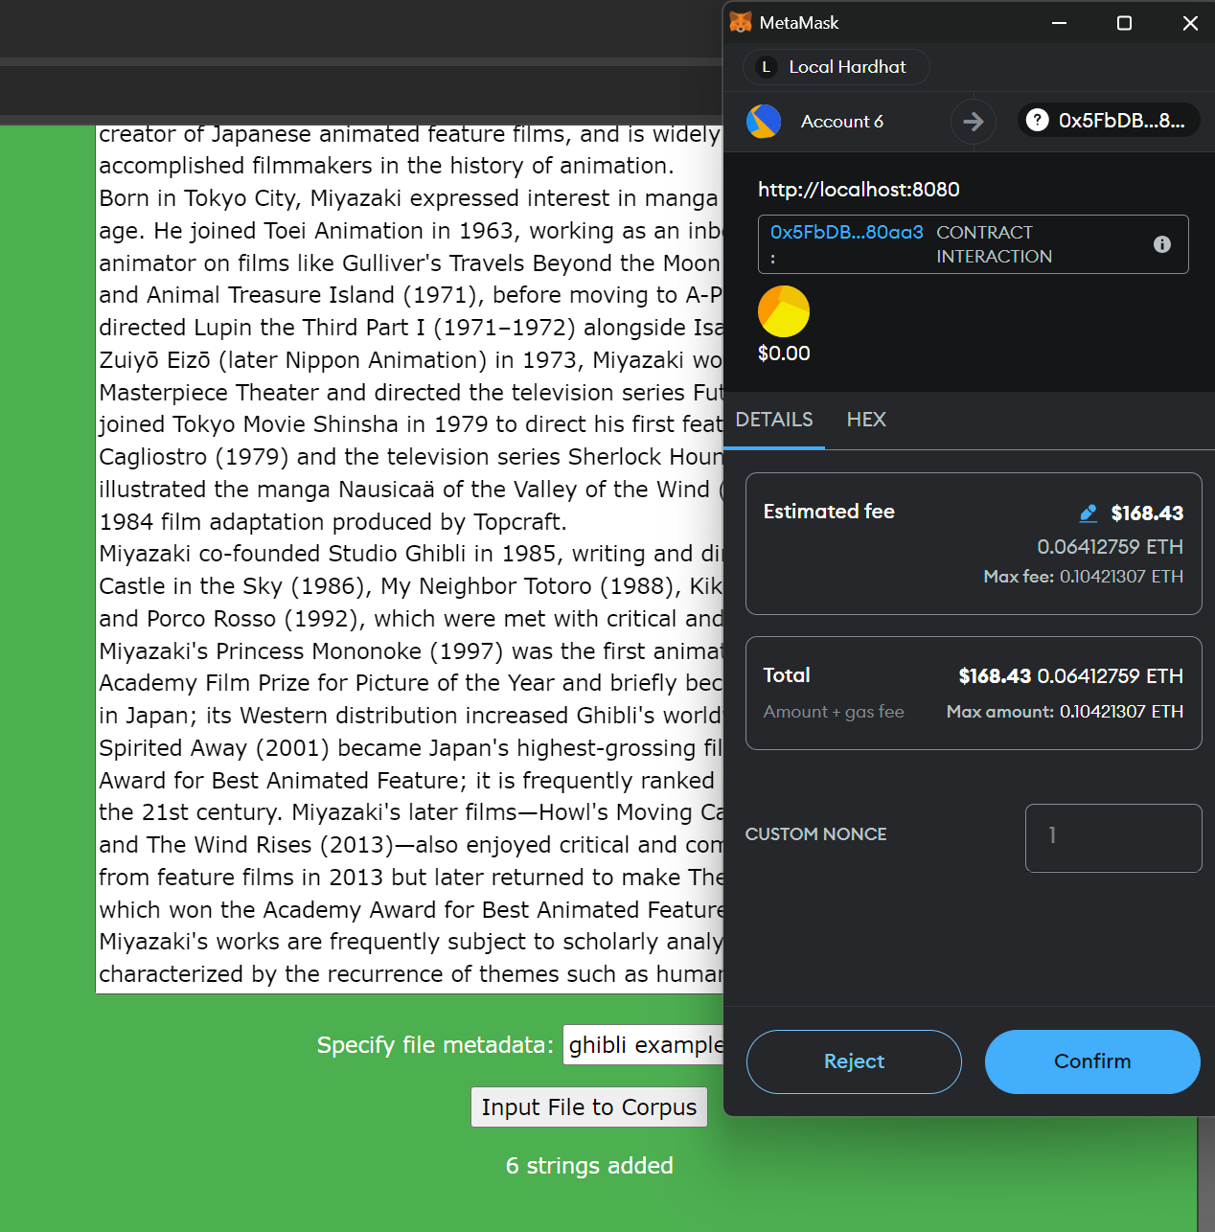

As is shown in the above screenshot, this simple proof-of-concept is exceedingly expensive and absolutely will not function in a public blockchain. For a private, internal blockchain (distributed across a company’s datacenters) where the ETH/token is entirely made up (more of an estimate of system cost than an actual cost in USD) it may still be doable, but again is more likely to be feasible using separate off-chain storage.

This project was deployed via Hardhat and Node.js in an Ubuntu system with NPM installed, using the commands located in the README.md file in the project root directory.

Additionally, project documentation has been started:

* Architecture
  + This describes the connectivity between system modules and various user flows.
* User Manual
  + This describes how users interact with the system. Currently only shows how Administrator Users manage the corpus.