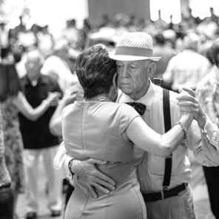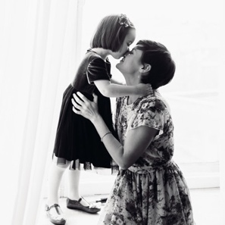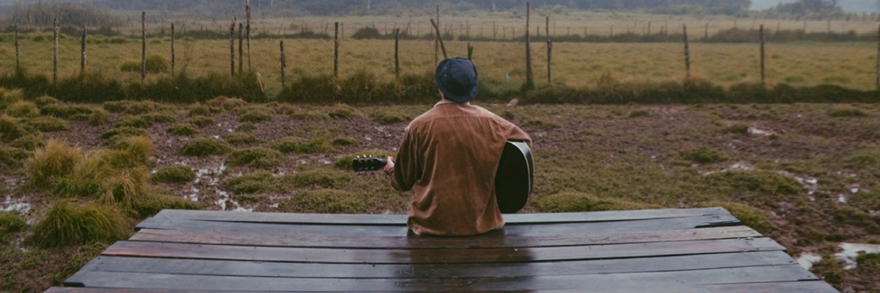

ACKNOWLEDGEMENT

The family of Name of Loved One wishes to express our

sincere thanks x for the flowers and other expressions of love during our time of bereavement.

FIRSTNAME

LASTNAME

1940-2020

A PRAYER

Insert yours here lorem ipsum occus essersperis as quiasperro volendani iunt rest dellescipsus experspiet molo ma sit rem raerum rae prae ab in et ernamendae nobis qui que ne sequias as aut qui dit, quiam que venisci psanis exerore mporro.

IN LOVING MEMORY

Saturday, November 15th 2:00pm Church Name

Street, City, State

Rev. First M. Last - Officiating

Officab inume omnitem es re sam que earum andit quis

eiumquam que perepratem laboribus doluptatur magni alicatis aligent re odi ut resto et a cor aut pra vellaciae ex everuptiis experum re quam, optae et eserum.

­

ORDER OF SERVICE

Processional Soft music

Prelude Soft Music

Song Choir

Scripture

Prayer

Poem

Acknowledgements & Resolutions

Obituary: Read Silently

Remarks

Song Choir

Eulogy Rev. First Last

Viewing of Remains

Recessional

OBITUARY

Mr/s.Firstname Lastname, age X, died at Location in City, State, on Thursday, December 10, 20XX. The cause was...

Born on January 10, 19xx in City, State, s/he lived in City, State, before settling in City. S/he worked at Place of

Employment as a job title until retiring year. Firstname was a member of the Society and longtime volunteer at Place.

Survivors include his/her longtime companion, Name, and sister/brother, Name, or City, State. Firstname was preceded in death by his/her spouse, Name.

RELIGIOUS PASSAGE 1:2-3

Insert passage here lorem ipsum dolore nos nonsedis ma culliqui conseque poruptia a net officii sitibus utaspedis explitati quam dolorep tatest, consequat ute sitis magnit quisqui te posae consed quo del ipsunt quuntis id et et lam, corehendunt ut officimusci bearum aut verovit landem faccae molorest ut od untia a veribusda volorit atassunt etureptiis explicipsus, ipsam rectotae et aut exerferovidi cum sum sunt quas ma volorep.

Adis eatas dolor maio odis experum, culpa nim estio occature sequam ipsum sum ullaccabor re maionse rsperib uscipsantiat quis et et doluptatius, ut faceperio et, sunt inum que sequidu cimenest utem venimenim quam, sunt enis eosaercid magnis eum quia sum ea autate nem di ullaceatur? Incipsanim ium volla seque optatem.