Case study 1

**Product:** Sports Camera

**Product name:** GoPro HER0 10 Pro

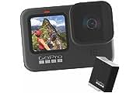

**Online Source:** Amazon, Flipkart  **,** eBay, Alibaba

Amazon prize: Rs.27,490

Flipkart prize:Rs.24,490

eBay prize : Rs. 24,599

Alibaba prize : Rs. 22,999

**Offline source:** Canon showrooms, Camera Showrooms, GoPro official Outlet

Showroom prize:52,500

**Quality:**

* High Quality
* Same Quality in offline & online Market

**Marketing:**

* No physical marketing is done
* Digital marketing through

1. Google ads
2. Flipkart
3. Amazon
4. Youtube tech Influencers
5. Instagram ads

**Product:** Mouse

**Product name:** HP Z3700 Wireless Optical Mouse with USB receiver

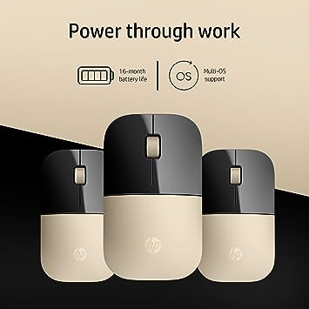

**Online Source:** Amazon, Flipkart

Amazon prize: Rs.899

Flipkart prize: Rs.749

eBay prize : Rs. 699

Alibaba prize : Rs. 999

**Offline source:**  Croma, Reliance Digital

Croma prize: Rs.799

Reliance Digital: Rs.899

**Quality:**

* High Quality
* Same Quality in offline & online Market

**Marketing:**

* No physical marketing is done
* Digital marketing through

1. Google ads
2. Flipkart
3. Amazon

**Product:** HeadPhone

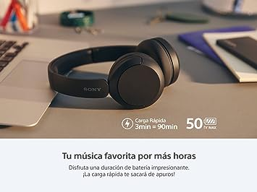

**Product Name:** (Refurbished) Sony WH-CH520, Wireless On-Ear Bluetooth Headphones with Mic, Upto 50 Hours Playtime, DSEE

**Online Source:** Amazon, Flipkart

Amazon prize: Rs.3145

Flipkart prize:Rs.4213

eBay prize : Rs. 4,599

Alibaba prize : Rs. 4,999

**Offline source:** Croma, Reliance Digital

Croma prize: Rs.7895

Reliance Digital: Rs.4521

**Quality:**

* High Quality
* Same Quality in offline & online Market

**Marketing:**

•Physical Marketing 1. Sony Official Outlet

•Digital Marketing is Done on

1.Google Ad

2.Amazon

3.Flipcart

4.Youtube Tech Influencers.