**Course: AIDI 2004**

**Student: Ramon Silva Vilarins**

**Activity: Lab #1**

* **Step 1**

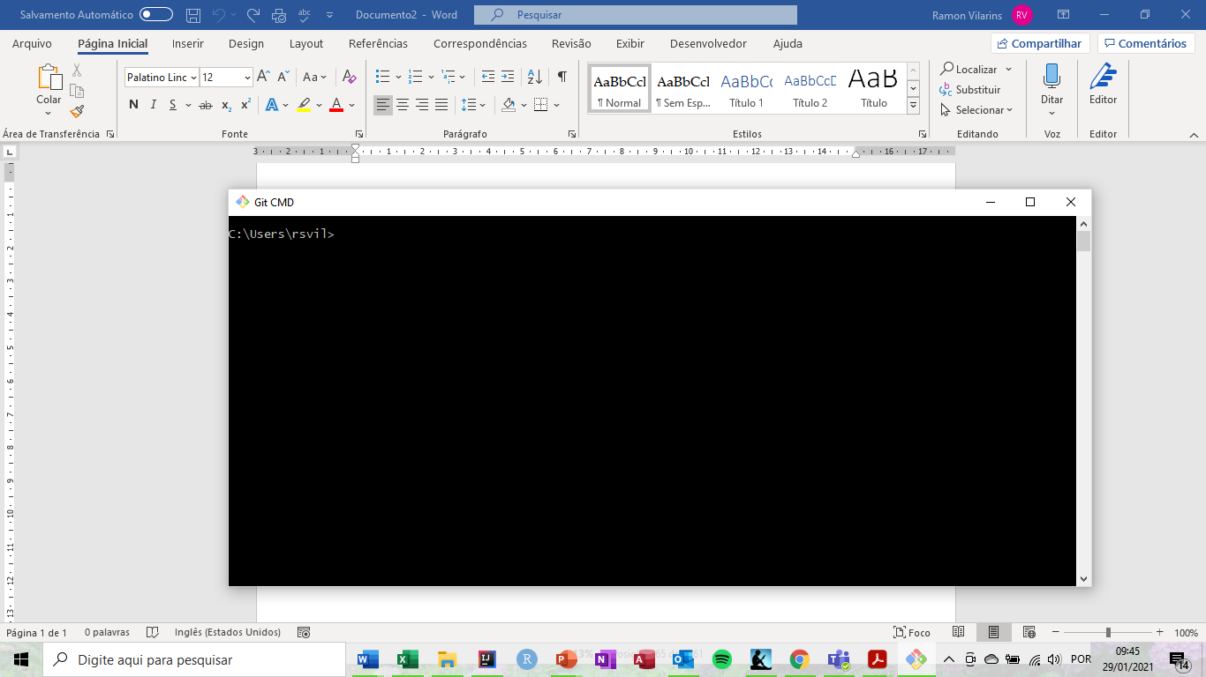

* **Step 2**

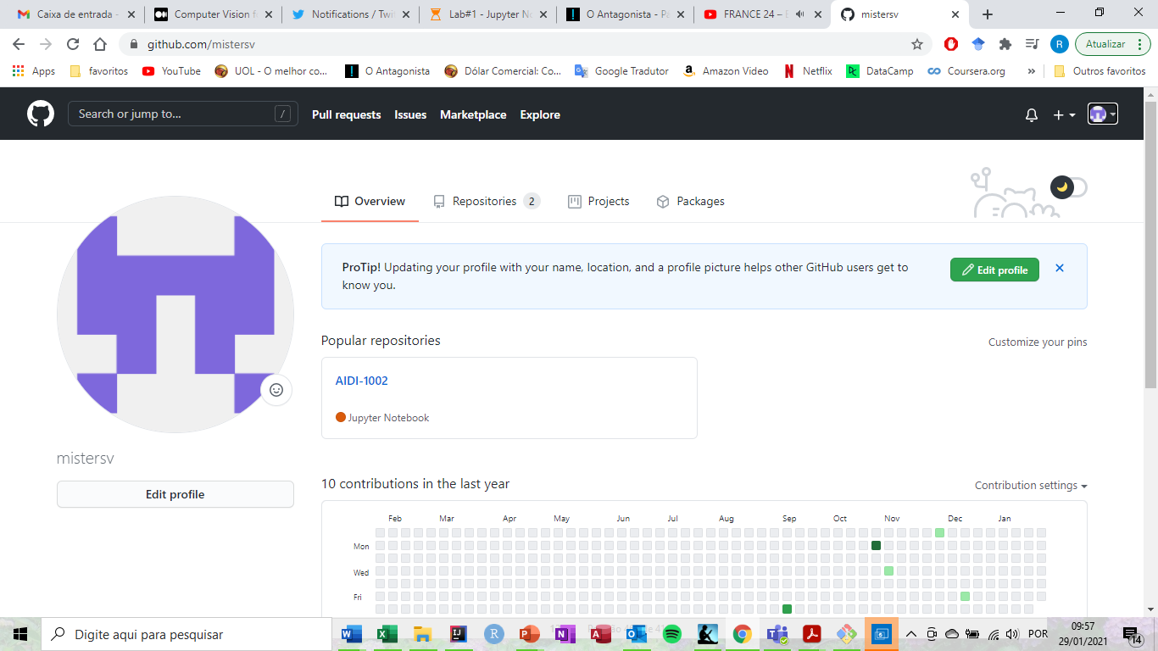

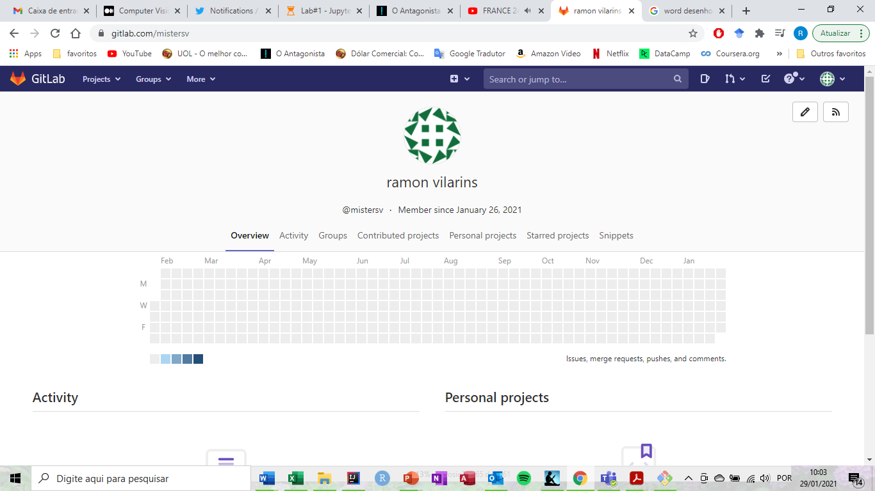

* **Step 3**

My option is the GitHub. The reasons why I choose this version control system are: easier to use, more popular, greater number of videos on YouTube.

* **Step 4**

Created the file coin_toss.py

* **Step 5**



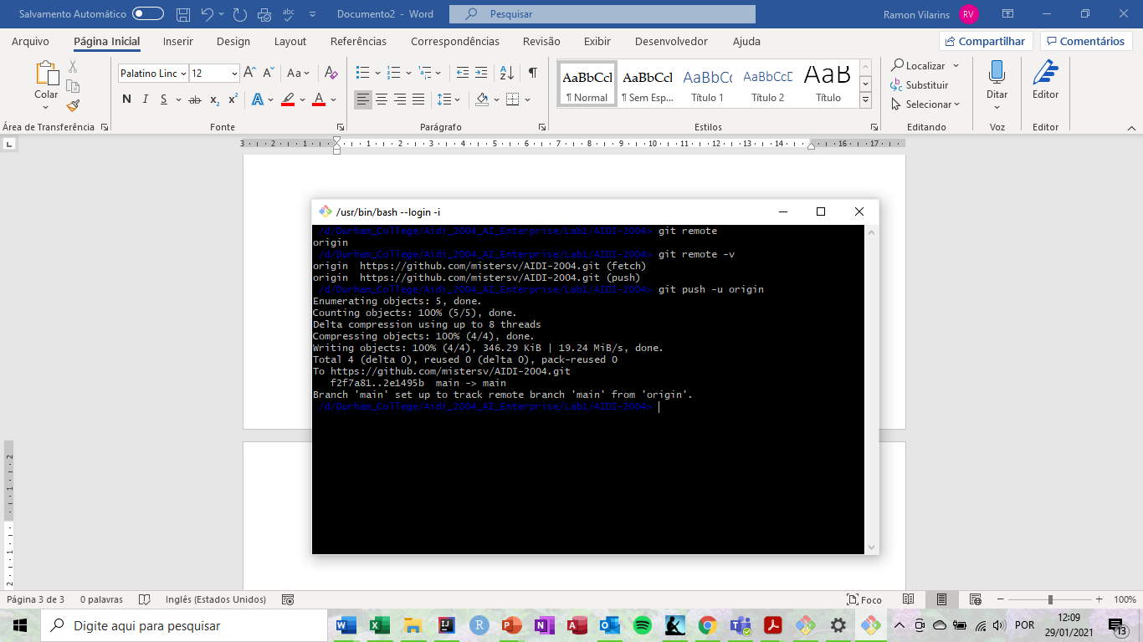

* **Step 6**

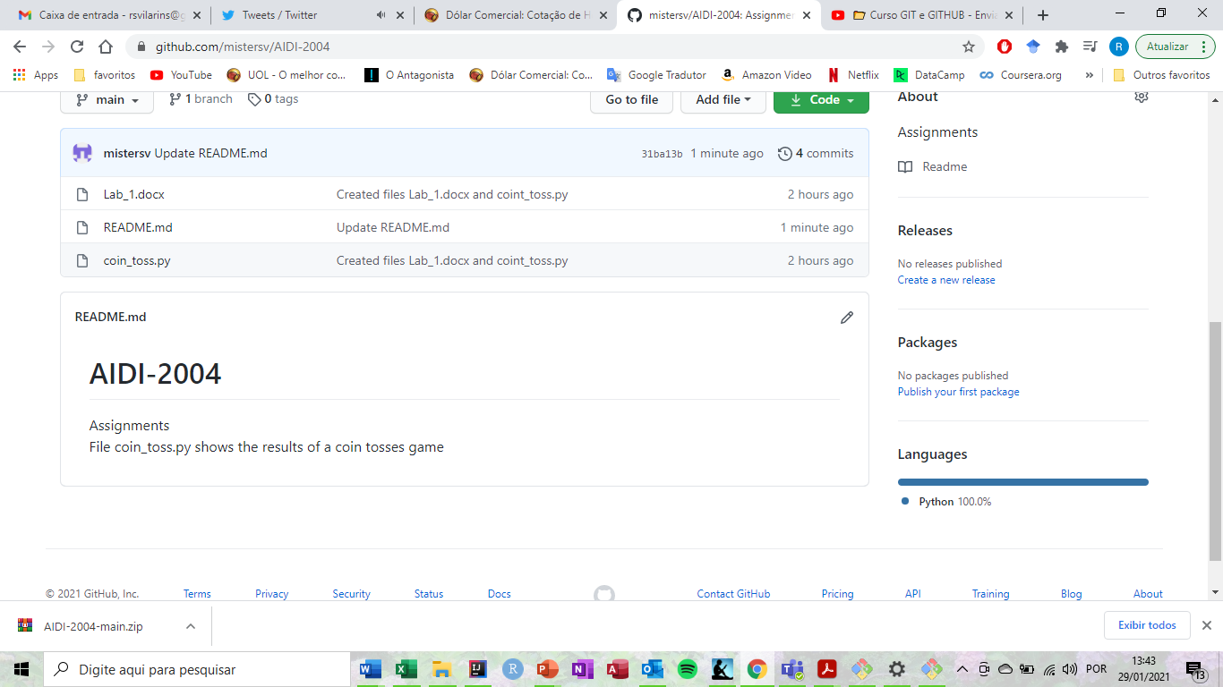

* **Step 7**

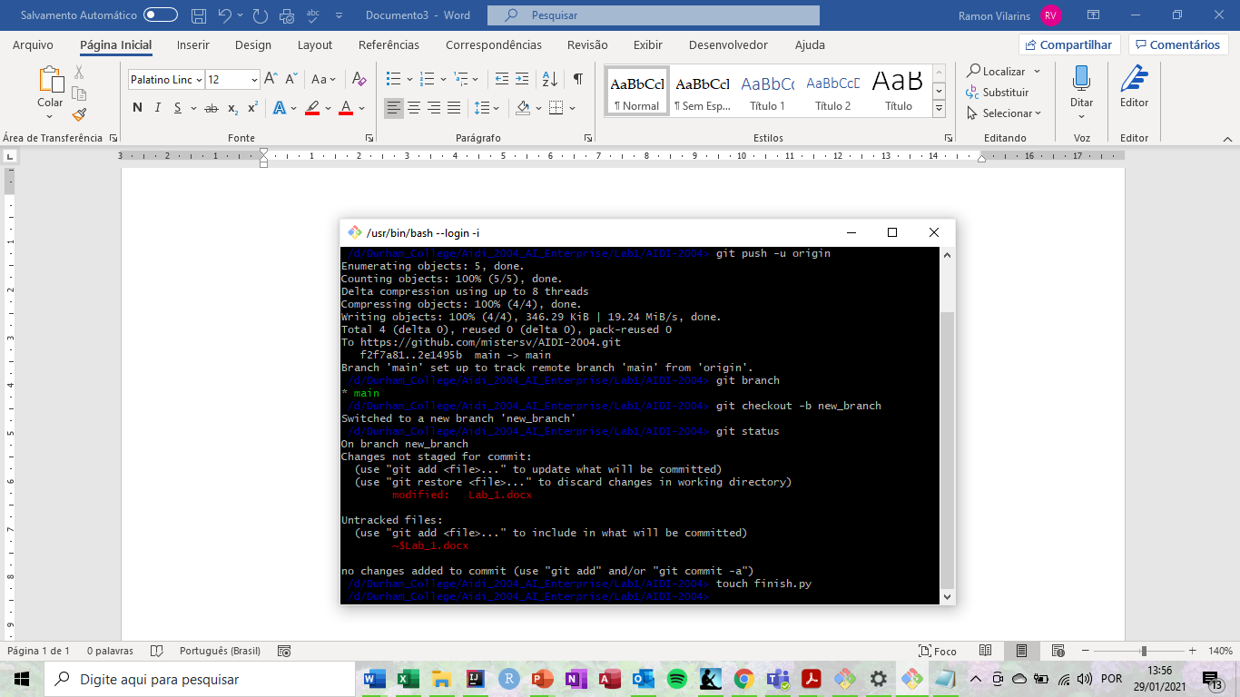

* **Step 8**

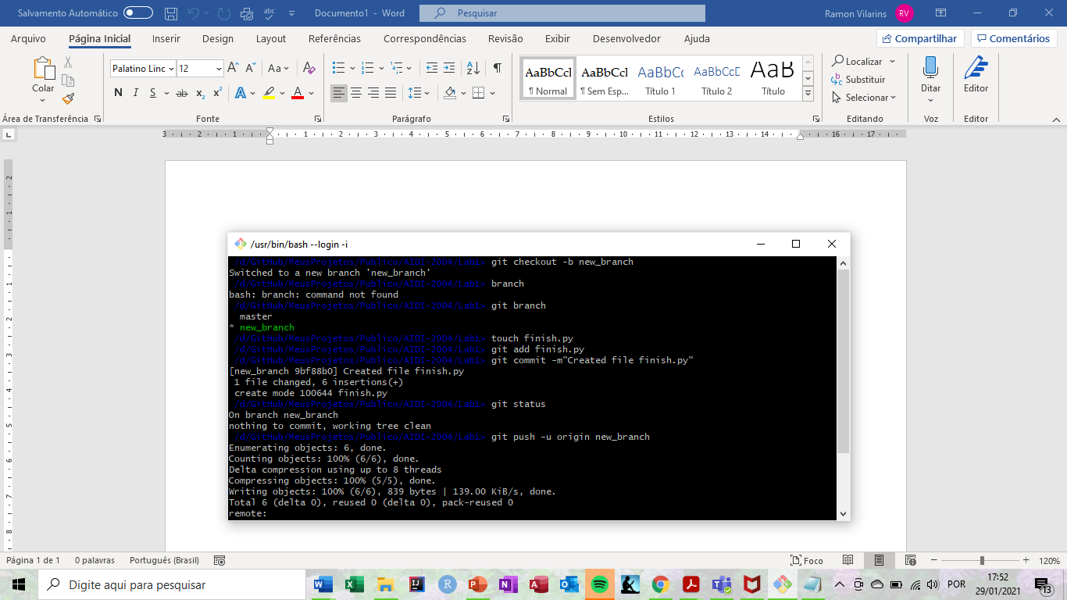

* **Step 9**

