Thanks for your purchase.

First of all, you have to get DOTWEEN from the Asset Store :

http://u3d.as/aZ1

(it’s free)

1/ Import Dotween from the asset store : http://u3d.as/aZ1

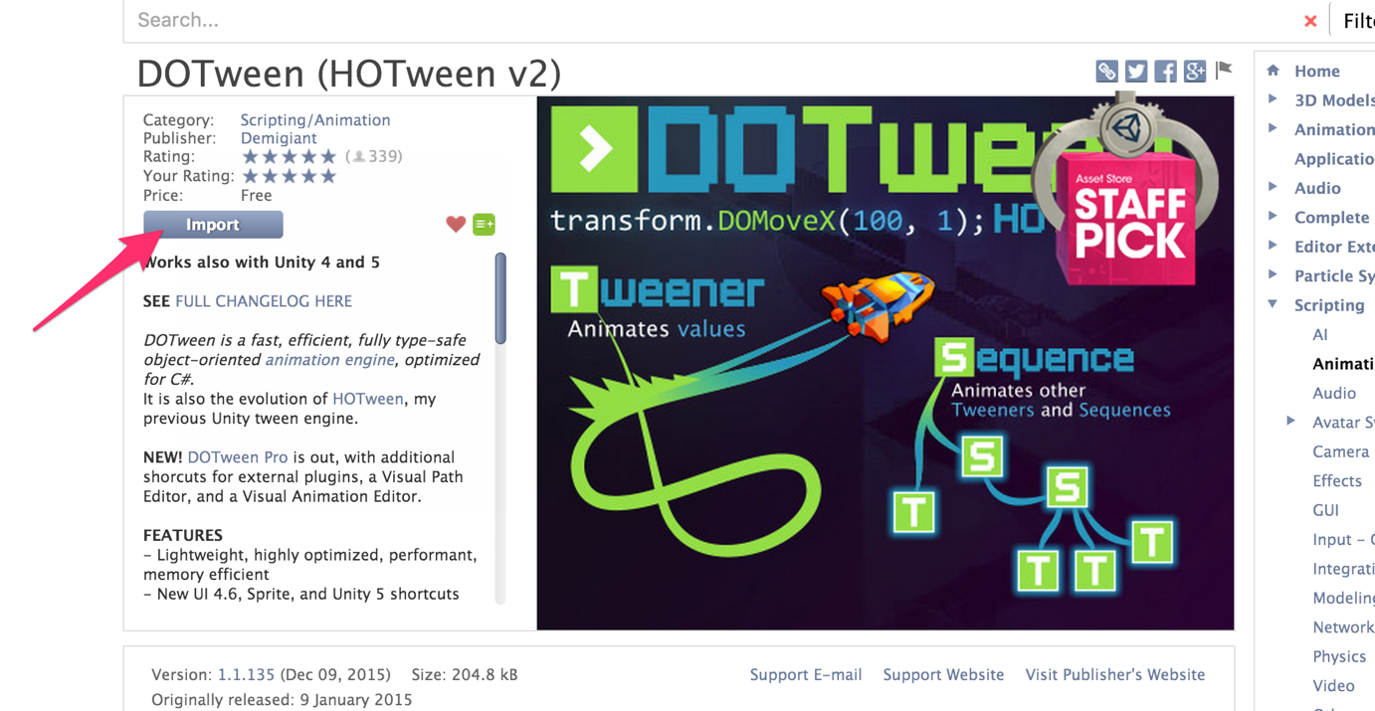

2/ Import the package into Unity
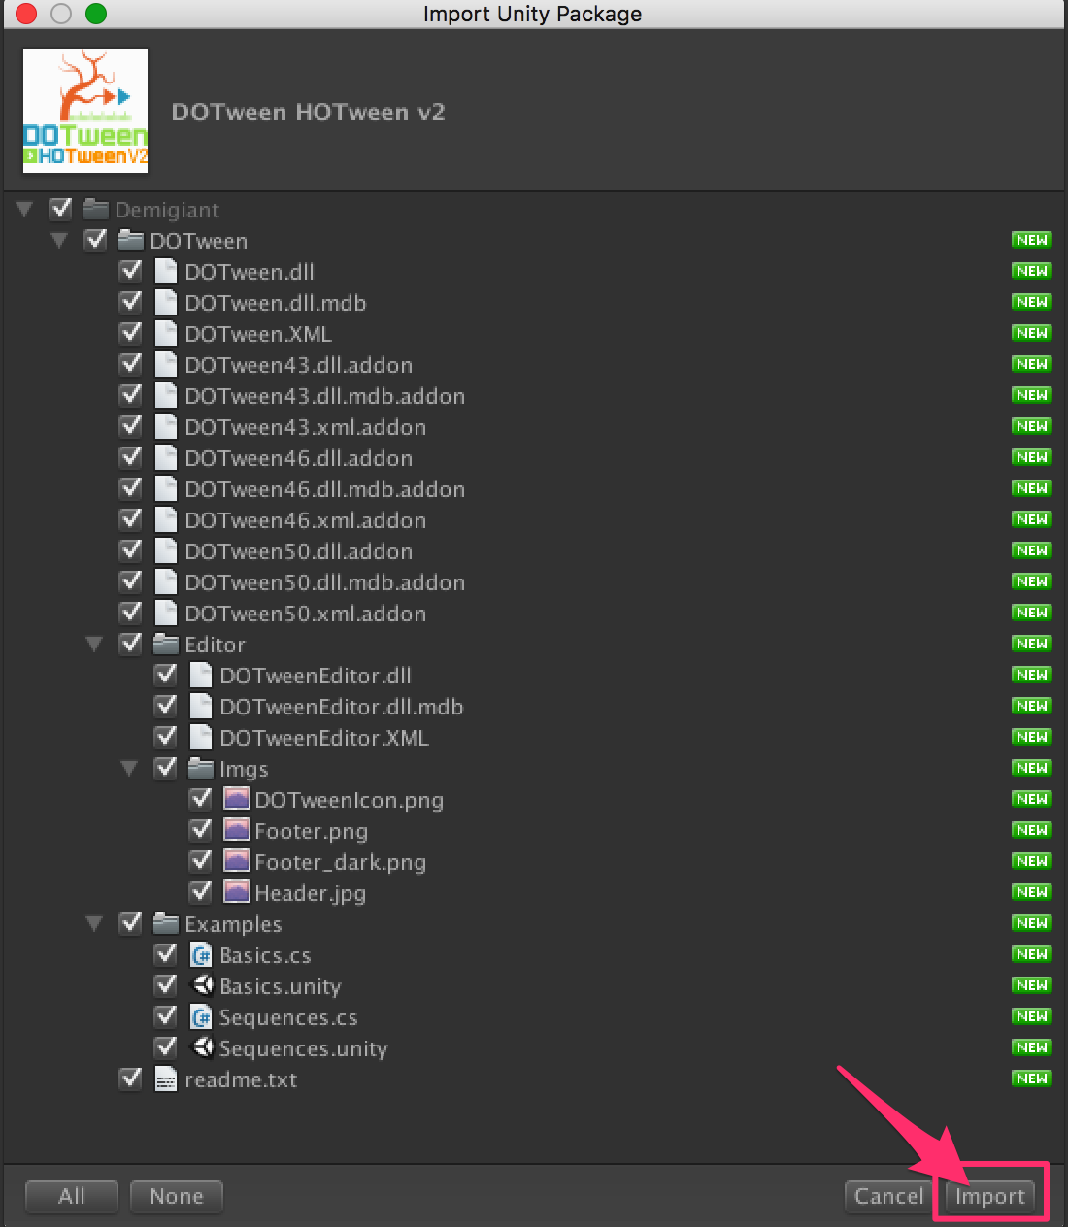

3/If you don’t see the « Tools » in the top of the Unity Screen, please do this :
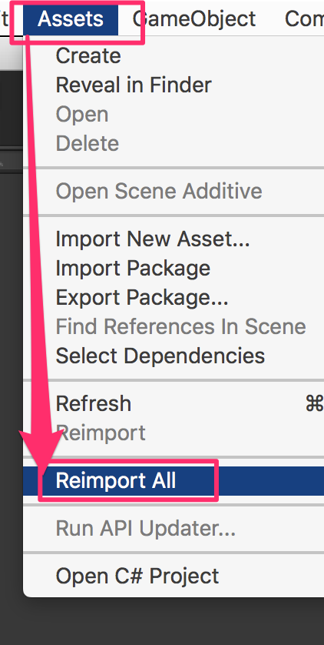

4/Now you have the « Tools ». Open it and click on « DOTween Utility Panel ».

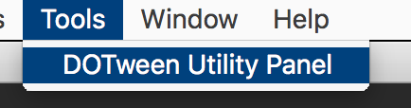

5/Click on « Setup DOTween ».
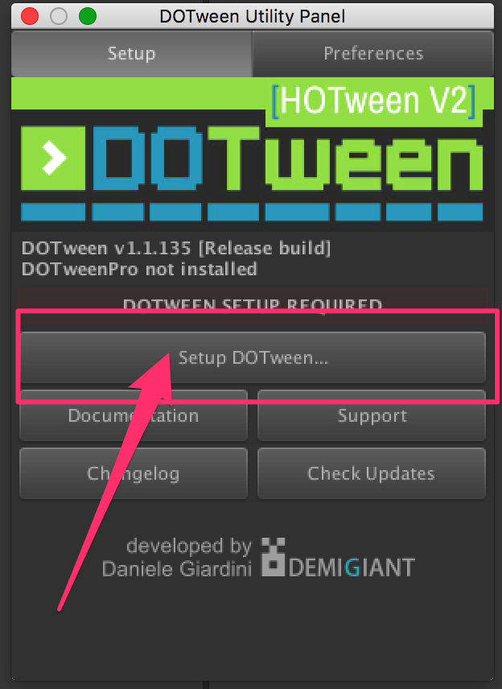

6/And to finish, click on the « OK » button.
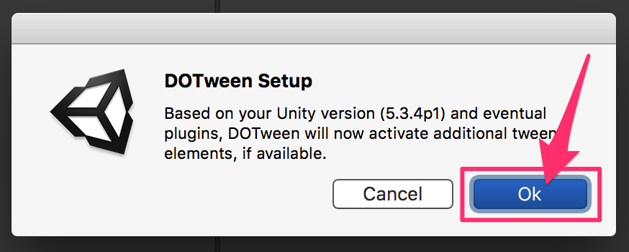

SOURCE CODE DOCUMENTATION AVAILABLE HERE :

https://dl.dropboxusercontent.com/u/8289407/SwitchTheGravity/Documentation/html/annotated.html

To begin, open the scene « SwitchTheGravity ».

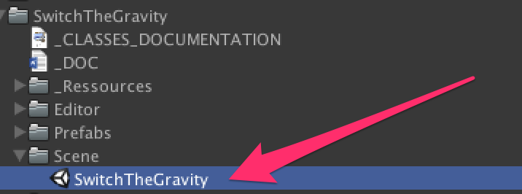

Music & FX:
If you want to change them, just drop your new audio file in the editor.

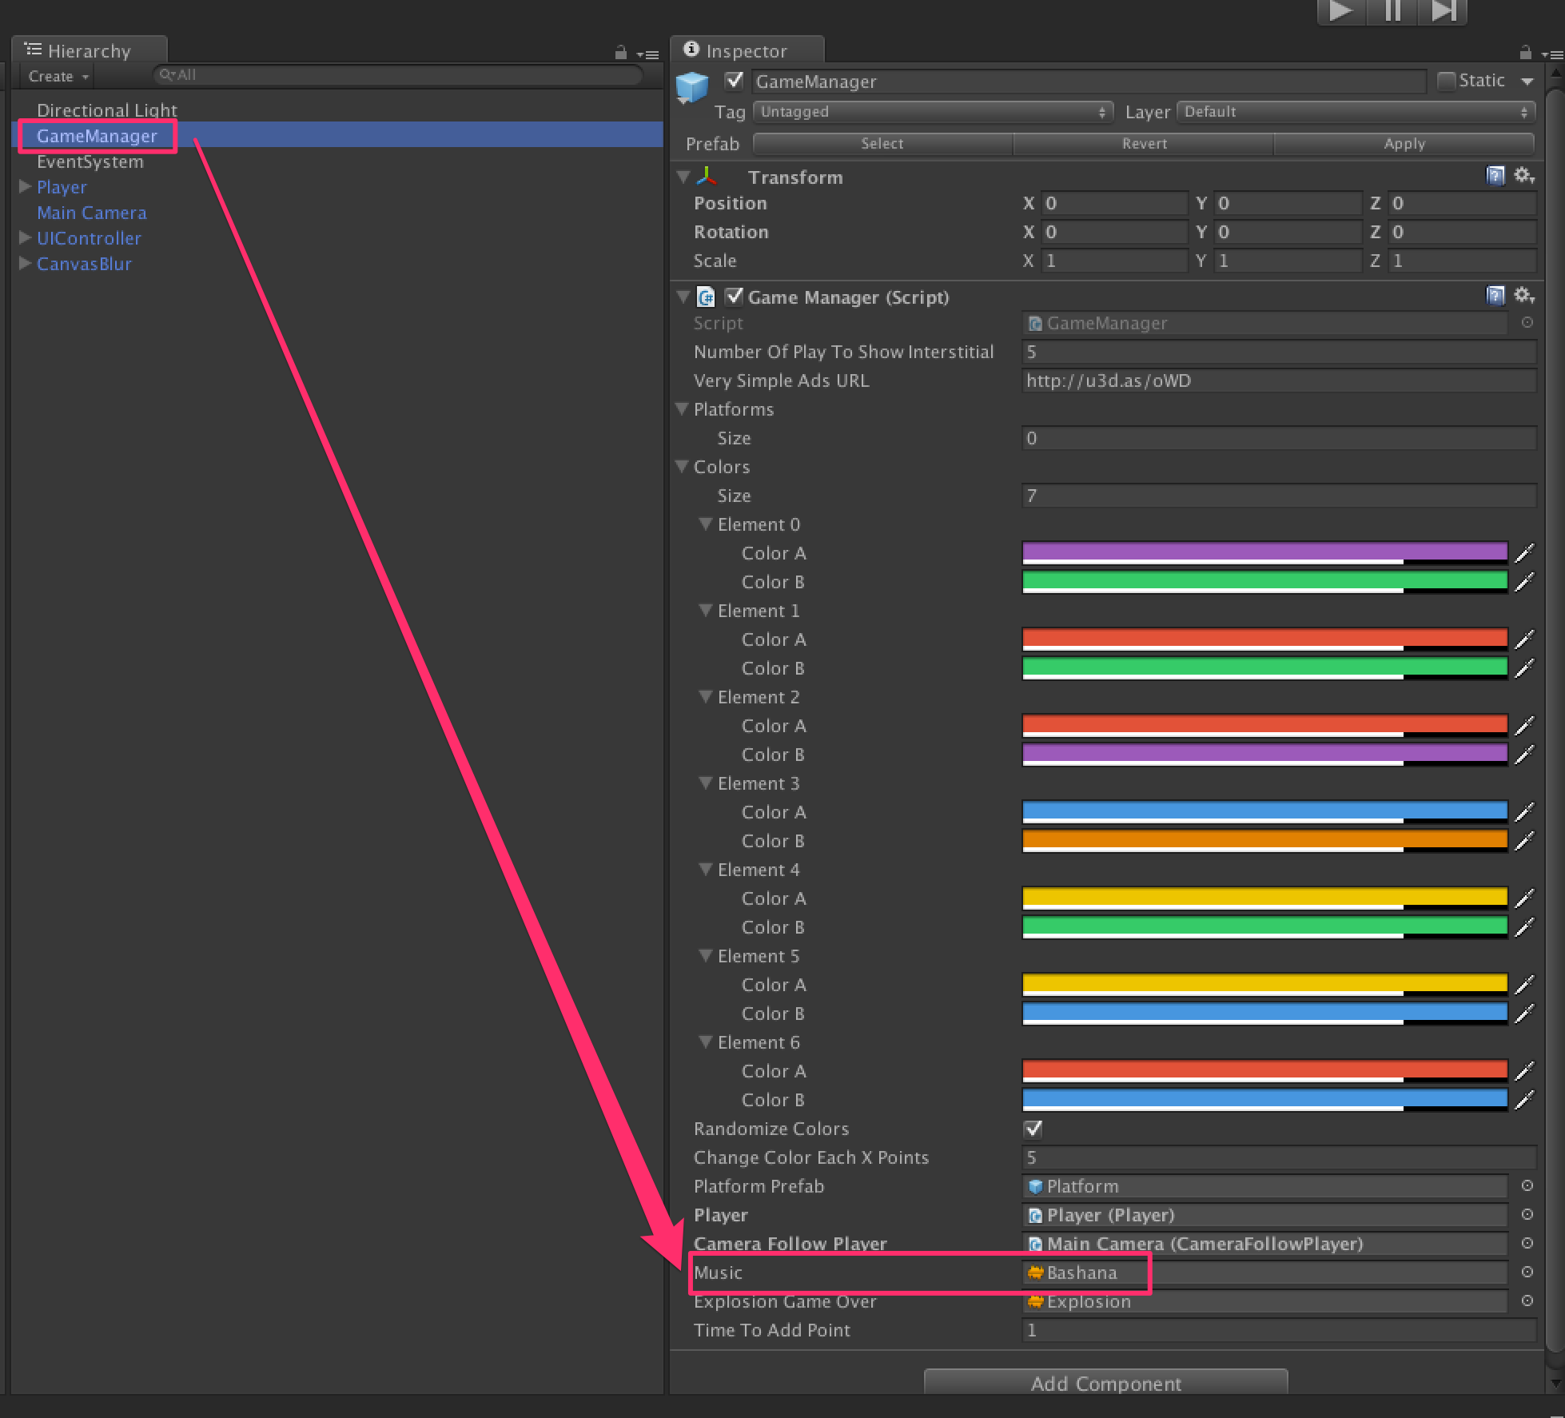
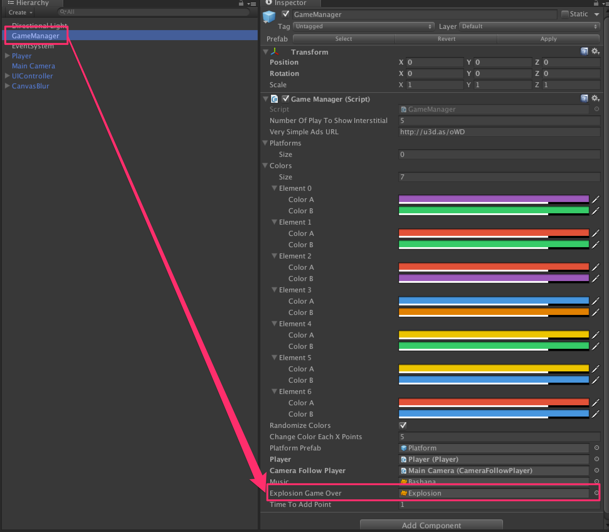

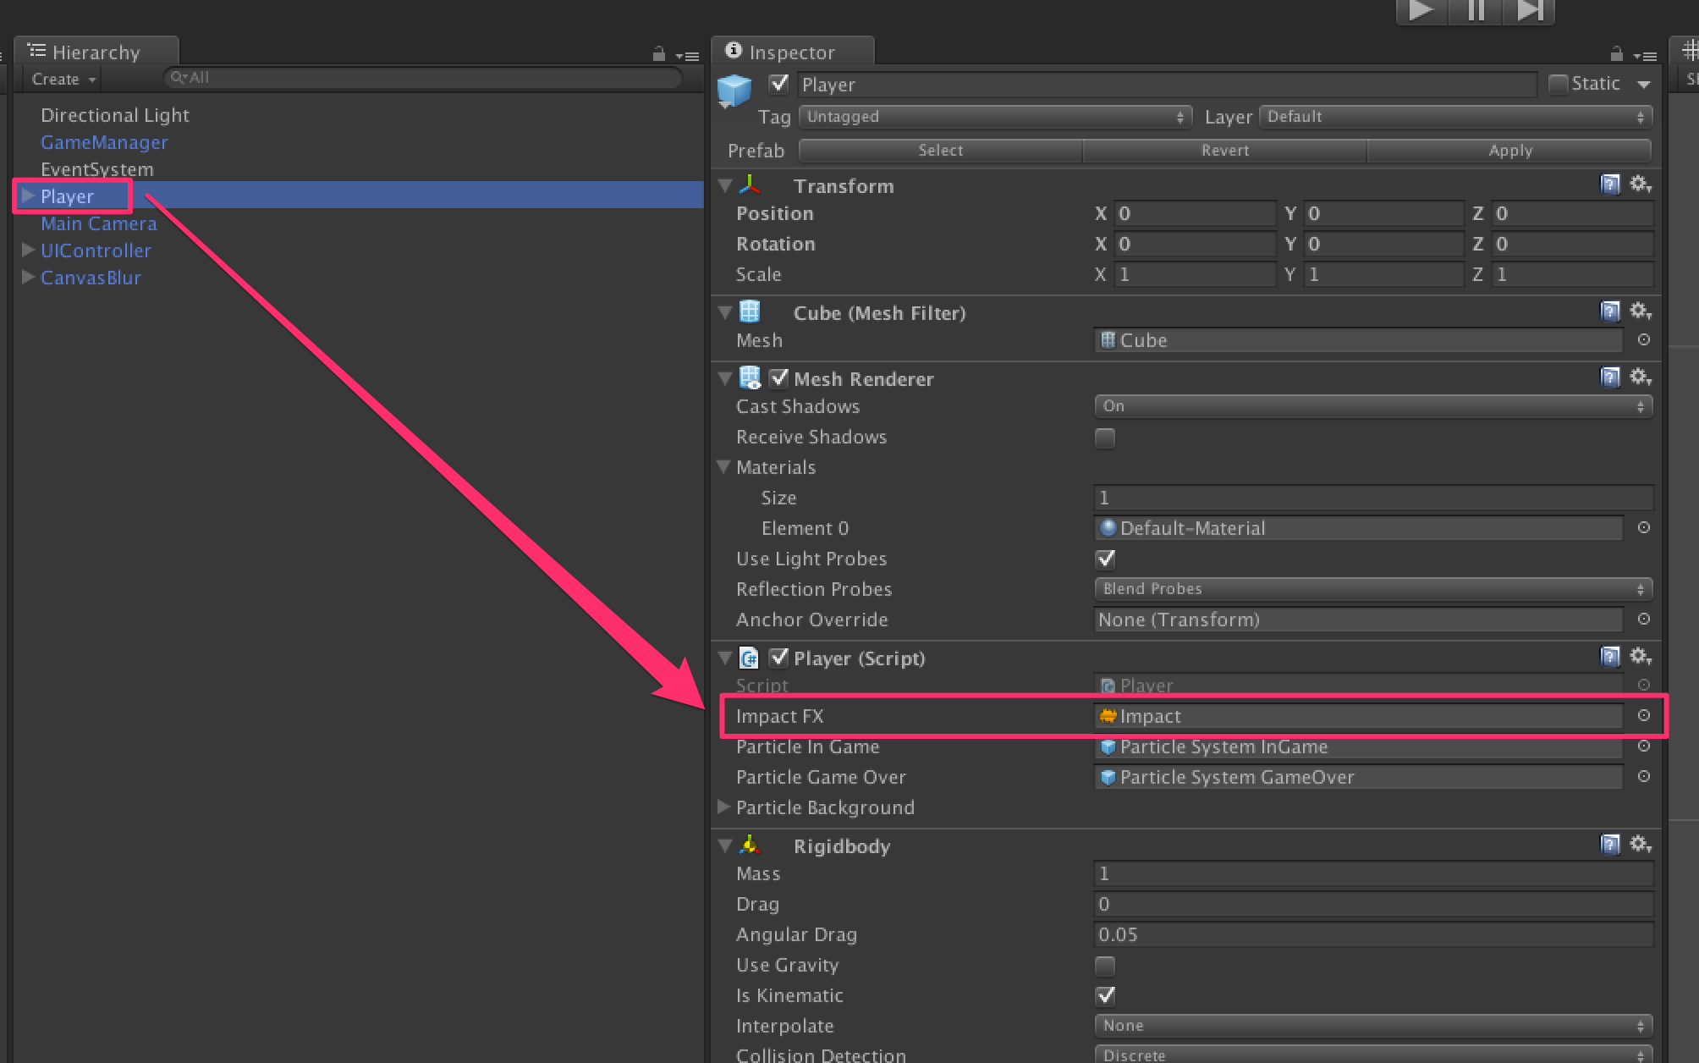
The player :

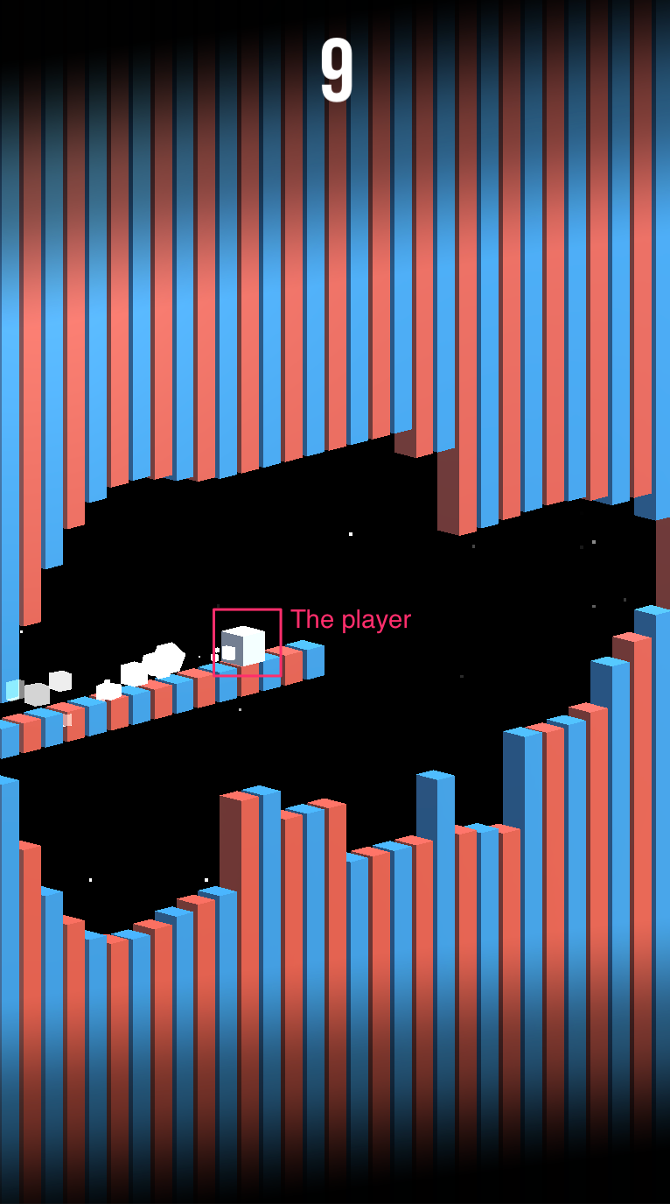

To modify the renderer, or the particles, have a look to the editor :

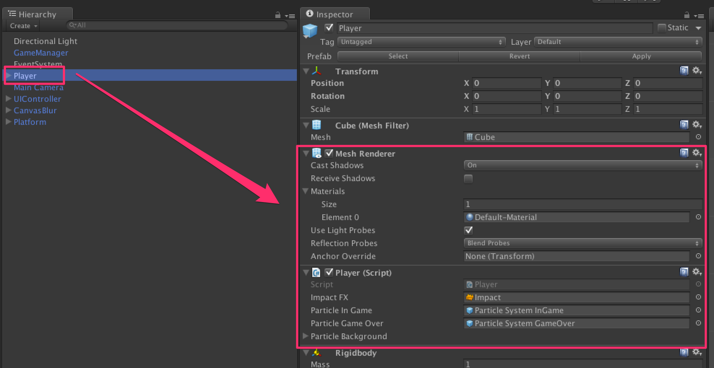
Platform :

The platform is composed by 3 elements : top, center and bottom.
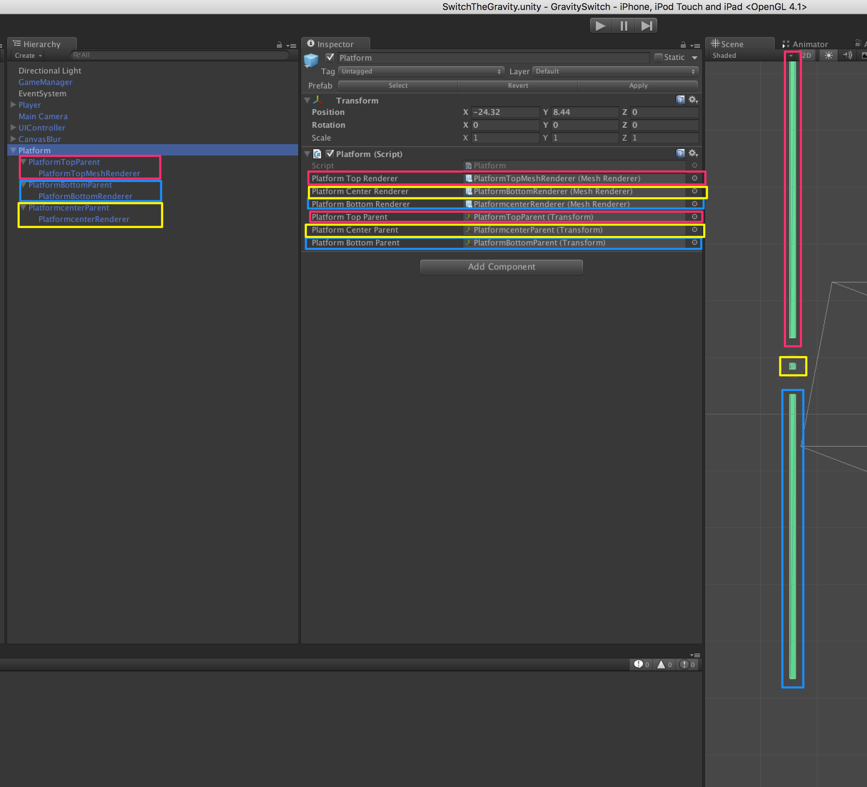

CONSTANTS:

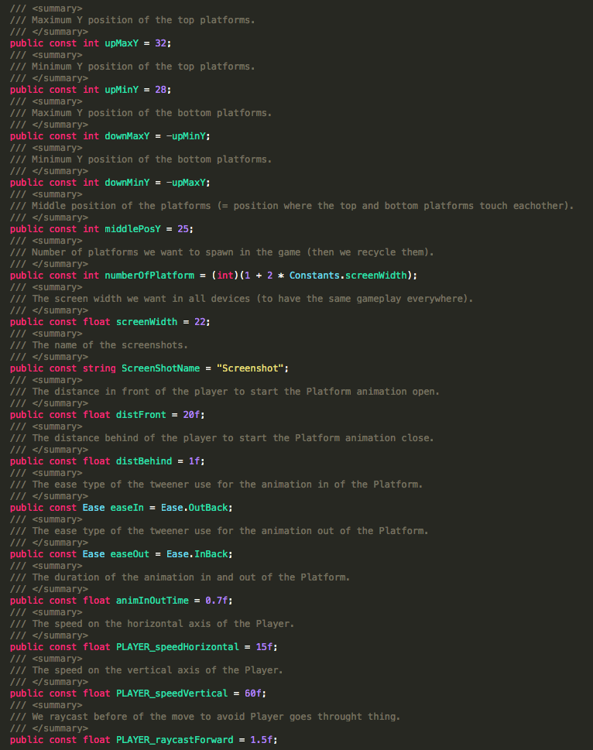

ADS :
Everything is done for you : « Very Simple Ads » is already implemented.
Get it here : http://u3d.as/oWD

LEADERBOARD:
Everything is done for you : « Very Simple Ads » is already implemented.
Get it here : http://u3d.as/qxf

Thanks !

Our other assets : http://u3d.as/9cs
Contact : contact@app-advisory.com

