# FM with General Message

To derive the equation for an FM wave, we have 3 starting points:

1. The idea of frequency modulation is that the instantaneous frequency is varied linearly with the baseband signal . Thus for a general message  the idea of FM is:



where the constant  represents the frequency sensitivity of the modulator, expressed in hertz per volt.

1. Recall that a general signal is written:



where has a linear variation at rate and a time varying part 

1. Recall the instantaneous frequency of a signal is:



Combining these 3 starting points, we can write:





The FM signal can be written in standard IQ format:





Thus for FM:



# FM with Sinusoidal Message

Now consider a sinusoidal modulating wave defined by



We re-derive the equation for the FM wave with the same 3 starting points.

1. The idea of FM is that the instantaneous frequency of the resulting FM wave equals:



where . Thus the message causes the frequency to vary above and below the carrier frequency . The quantity Δf is called the frequency deviation.

1. A general signal:



1. The instantaneous frequency of a signal is:



Combining these 3 starting points, we can write:



Where  is called the modulation index of the FM wave.

Thus the FM wave itself is given In terms of β by:



If β is small we have narrowband FM (NBFM) and if β is large (compared to one radian) we have wideband FM.

Thus for a sinusoidal modulating wave  the FM wave can be written:



where:



# FM with Sinusoidal Message and

When β is small compared to one radian, i.e., the FM wave may be approximated using  to obtain



Thus for 



Comparing the waveforms of NBFM and AM, we observe that a NBFM signal wave requires essentially the same transmission bandwidth (i.e., 2*fm*) as an AM wave.

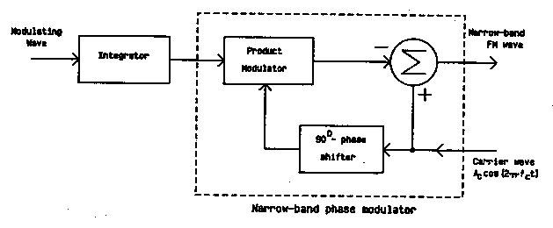

Figure 1 Narrow-band Phase Modulator

# Power Spectrum and Bandwidth of an FM Signal

Expanding in the form of a Fourier series, we get:



where *Jn(β)* is the Bessel function of the first kind of order *n.*

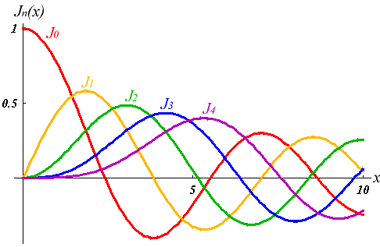

Figure 2 Bessel Functions

The discrete spectrum of the FM wave is obtained as



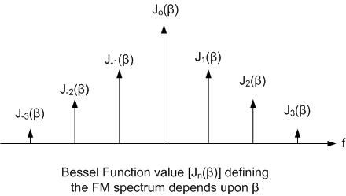

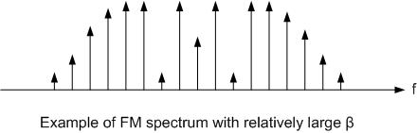

To visualize the spectrum, we note that:



and:



Also, for small values of , we have:



and:



The average power of an FM wave developed across a 1 ohm resistor is given by:



For practical purposes, the bandwidth of the FM wave corresponds to the bandwidth containing 98% of the signal power.

The effective bandwidth of the FM signal is approximately given by Carson's formula:



# Frequency Demodulation

Frequency demodulation extracts the original message wave from the frequency-modulated wave. We describe two basic devices, the analog-like frequency discriminator and a digital FM demodulator.

# Frequency Discriminator

How to extract the message from an FM signal? We consider four intuitive approaches.

**Intuition 1: Differentiation**

We know that from the idea of FM so that 

Since  with (constant) we see that if we differentiate we will get a term in that looks like 

Thus we differentiateas a first step to extract the message. Assuming *Ac* is constant we have:





This expression is in the form of an AM signal



with envelope  with and phase 

The resulting AM signal can be demodulated by an envelope detector to obtain DC plus the message. The envelope detector ignores the phase.

Note that if the FM signal has is not constant (e.g. due to channel fading or noise), then differentiation will not work, since for this case



To make is constant, we can use a limiter (e.g. with back to back diodes) ahead of the discriminator. The limiter limits (clips) the input signal so that it is of constant amplitude. The output of the limiter looks like a square wave with changing frequency, and will contain harmonics at odd multiples of . The limiter must be followed by a bandpass filter at to restore the signal 

A block diagram of this FM demodulator is



**Intuition 2: Linear Amplitude vs. Frequency Characteristic**

We know that from the idea of FM . If we have a circuit that has output amplitude that increases linearly with frequency, then the circuit output amplitude will vary in step with the message.

One such circuit is the ideal differentiator, with a transfer function given by *H(f) = j2π f.*

*Proof:* If  then 

The action of an ideal differentiator (Figure 3(a)) can be approximated by any device whose magnitude transfer function is reasonably linear, within the range of frequencies of interest. In Figure 3(b) an RL circuit approximation to a differentiator is used followed by an envelope detector. A bandpass version of this circuit is shown in Figure 3(c). These discriminators are known as slope detectors. A more linear response can be obtained by taking the difference between two bandpass magnitude responses, as is done by the balanced discriminator shown in Figure 3(d).

In all cases (a)-(d), a limiter and bandpass filter is required ahead of the discriminator

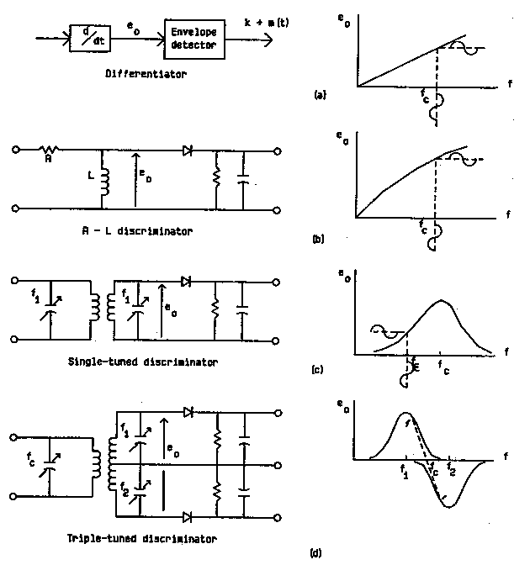

Figure 3 FM Detectors

**Intuition 3: Zero Crossing Counter**

The message information is contained in the time (location) of the zero crossings, and the amplitude can be ignored.

**Intuition 4: Phase Locked Loop**

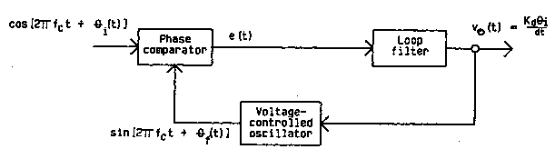

Figure 4 Phase-Locked Loop

This circuit uses ideas from the Costas loop receiver used for DSB. The circuit comprises a phase comparator (multiplier), low pass (loop) filter and voltage controlled oscillator (equivalent to an FM modulator).

With signal input and FM modulator (VCO) output , the phase comparator (multiplier) output signal  plus double frequency terms. With high gain in the loop filter, and the VCO output frequency is the same as the input signal frequency. Thus the VCO input must be the same as the message. The loop filter output voltage is proportional to the instantaneous frequency of the input, and FM demodulation is achieved.

# Digital FM Demodulator

A digital FM demodulator starts with the I and Q outputs of a general IQ receiver. Recall for an FM signal:





To extract from  we show two methods that can be implemented in software.

# I(t), Q(t) as Real Signals

Formula: 

Block diagram: 

Proof:



# I(t) + jQ(t) as a Complex Signal



Formula:



Where:



represents one sample delay

Block diagram:



Proof:

