# AM Receiver

The transmitted AM signal is of the form:



whereis a constant phase. The AM receiver recoversfrom. One method is to recover and subtract the DC component to obtain.

To show how this is done in software with the USRP and GNURadio Companion (GRC), recall that the USRP source block has a complex output with real and imaginary components.

We can write the AM signalas the real part of a complex signal:

,

where the complex envelope:



Thus the USRP source block with frequency set to  will have outputs:

, .

To obtain, we take the magnitude of the complex envelope, thus we can write:



This shows that we can recover $a\left(t\right)=1+k_{a}m(t)$ regardless of the value of .

The GRC *Complex to Magnitude* block allows us to obtain the magnitude of the complex envelope by performing the function.

If there is frequency offset, then, but as we have just seen,is not affected by the value ofand thus not affected by any frequency offset .

The USRP multiplies the real valued radio frequency signal by  to generate . This process is called *complex downmixing* and is equivalent to the standard IQ receiver shown in Figure 1.



Figure Complex Mixer

Recall:



The spectrum of the real radio frequency (RF) signal will be symmetric about zero. After complex downmixing, the resulting signal is complex and the frequency spectrumis no longer symmetric about zero.

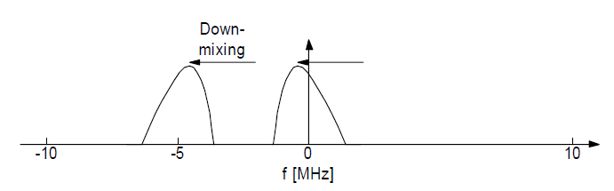

Figure Downmixing

The complex signal output from the USRP source block  is bandlimited to the sampling rate of the USRP source block. The USRP source block output can be recorded to a file and used again at a later time. This file source will have the same sampling rate and bandwidth as the USRP sink block used to record it.

With a sampling rate of 256 kHz and complex samples, the bandwidth will be 256 kHz (because the complex signal spectrum is not symmetric and does not have redundant mirror-image positive and negative frequencies).

AM radio broadcast signals have a bandwidth of KHz and the carrier frequencies are spaced apart by 10 KHz in North America (9 KHz elsewhere), e.g. there can be carriers at 710, 720, 730 KHz, etc.

With a file source sampled at 256 kHz, there can be as many as 24 different AM broadcast signals.

The AM broadcast signal with carrier frequency  ( is set in the USRP source block) will appear at zero Hz after the downconversion (at the USRP source output). Other signals at carrier frequencies kHz will appear at multiples of KHz away from zero Hz

We need to create a filter to select the one signal we want (the one with carrier frequency  that now appears at 0 Hz). A low pass filter with 5 KHz cutoff frequency will do the job, since all the other signals are centered at frequencies at least 10 KHz away from zero Hz.

To “tune in” (receive) one of the other signals, we can shift the spectrum of the USRP source output by KHz by multiplying the complex signal by , so that the signal that first appeared at Hz now appears at zero Hz.

# DSB-SC Transmitter

A double sideband signal can be written as  If the message , then 

The signal contains frequencies at , but no carrier at , i.e. the carrier is suppressed.

# SSB Transmitter

An analytic signal is defined as , where is the Hilbert transform of . The Hilbert transform is a special kind of non-causal filter with impulse response  that shifts each sinusoidal component of by 90 degrees.

A single sideband signal can be written as



Thus the complex envelope is an analytic signal created from the (real) message . To create an SSB signal at  using these equations, we can:

1. Take the Hilbert transform of the message.
2. Create the analytic signal .
3. Upconvert it to the desired carrier frequency by multiplying by 
4. Take the real part.

The upconversion to a radio frequency (RF) wave at (steps 3 and 4) is the function of the *USRP Sink* block. Thus an SSB signal is generated by a USRP sink block (standard IQ transmitter) with inputs 

# SSB Receiver

We consider two SSB receiver architectures.

1. multiply the real SSB signal by and low pass filter to get  This is done in analog receivers.

2. Weaver demodulator: downconvert the real SSB signal to using the USRP source block, but with a frequency offset  relative to  [thus in this case ]. Then implement  where  is a frequency in the approximate middle of the message bandwidth, e.g. 1500 Hz for a 300-3000 Hz voice signal.

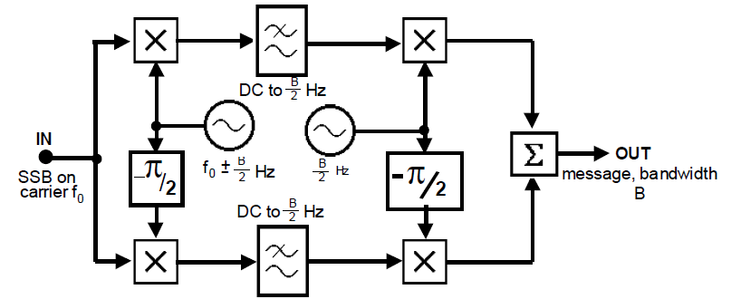

USRP downmixer GNURadio mixer