**BANK MANAGEMENT SYSTEM**

**PROJECT REPORT**

SUBMITTED IN PARTIAL FULFILLMENT OF THE REQUIREMENT FOR THE AWARD OF THE DEGREE OF

# BACHELOR OF TECHNOLOGY

**Computer Science and Engineering**

SUBMITTED BY

(Vishal Gupta -2103490100038)

September-2022



# Dr. APJ Abdul Kalam Technical University, Uttar Pradesh

LUCKNOW, INDIA

**TABLE OF CONTENTS**

**TOPIC**

1. **INTRODUCTION**
   1. C Programming Language
   2. Applications of C
2. **SYSTEM REQUIRED**
   1. Software Requirements
   2. Hardware Requirements
3. **IMPLEMENTATION AND RESULTS**
   1. Flowchart
   2. Result

**CONCLUSION**

**REFERENCES**

**ORGANIZATION OF THE REPORT**

The report is divided into various chapters and is organized as follows:

**1.Abstract**

An abstract is a short summary of a longer work (such as a thesis, a dissertation or a research paper). The abstracts concisely reports the aims and outcomes of your research, so that readers know exactly what your paper is about.

**2.Introduction**

This chapter includes brief introduction to C Programming Language and its applications

**3. System Requirements**

This chapter includes hardware and software requirements necessary for the execution of the project.

**4.Implementation and Results**

This chapter includes the program code of the project and the results of successful runs of the code.

**5. Conclusion**

This section includes the conclusion about the project.

**6. References**

This section includes the bibliographical references used for the development of the project.

**ABSTRACT**

This is a “Bank Management System” project which is created using C programming language. We can use this simple mini project to boost our programming skills and understand logic. The Bank Management System allows the Customer’s to create a New Account. The account can be accessed by the bank by putting the correct password. Bank can also see the information of all the account holders at same time. Customer can also deposit or withdraw money from the bank. The record of any individual customer can be seen by just typing the account number or the customer’s name. We can also make changes in someone’s record at any time we want. It is also possible to delete anyone’s account by just typing the account number of an individual. The code is very user friendly and simple to use.

**INTRODUCTION**

* 1. **C Programming Language**

The C programming language  is a low-level (close to the computer) computer programming language that was developed to do system programming for the operating system UNIX and is an imperative programming language. C was developed in the early 1970s by Ken Thompson and Dennis Ritchie at Bell Labs. It is a procedural language, which means that people can write their programs as a series of step-by-step instructions. C is a compiled language. This means that the computer doesn't have to build the application every time it is opened.

Because the ideas behind C are kept close to the design of the computer, the compiler (program builder) can generate machine code/native code for the computer. Programs built in machine code can be very fast. C has a variety of uses. From writing simple console applications, to even operating systems, such as Linux, MacOS and UNIX. The language itself has very few keywords, and most things are done using libraries, which are collections of code made to be reused. C has a big standard library called stdio.h which stands for standard input/output.

* **C Header Files**

There are 2 types of header files such as :-

**Standard Library Header Files :-** These are pre-existing header files which are available in C.

**User-Defined Header Files :-** The header files which are defined by the user then they are called user-defined header files. The #define directive is used to define a header file.

* **Features of C -**

## 1) Simple

C is a simple language in the sense that it provides a **structured approach** (to break the problem into parts), **the rich set of library functions, data types**, etc.

## 2) Machine Independent or Portable

Unlike assembly language, c programs **can be executed on different machines** with some machine specific changes. Therefore, C is a machine independent language.

## 3) Mid-level programming language

Although, C is **intended to do low-level programming**. It is used to develop system applications such as kernel, driver, etc. It **also supports the features of a high-level language.** That is why it is known as mid-level language.

## 4) Structured programming language

C is a structured programming language in the sense that **we can break the program into parts using functions**. So, it is easy to understand and modify. Functions also provide code reusability.

5) **Rich Library**

C **provides a lot of inbuilt functions** that make the development fast.

6) **Memory Management**

It supports the feature of **dynamic memory allocation**. In C language, we can free the allocated memory at any time by calling the **free()** function.

7) **Speed**

The compilation and execution time of C language is fast since there are lesser inbuilt functions and hence the lesser overhead.

## 8) Pointer

C provides the feature of pointers. We can directly interact with the memory by using the pointers. We **can use pointers for memory, structures, functions, array**, etc.

## 9) Recursion

In C, we **can call the function within the function**. It provides code reusability for every function. Recursion enables us to use the approach of backtracking.

## 10) Extensible

C language is extensible because it **can easily adopt new features**.

1.2 **Applications of C**

C has a wide range of real-world applications, including the following:

* Development of video games
* Applications using graphical user interfaces
* Databases and computer operating systems
* Browsers on the internet
* Computational and graphical methods
* Banking
* Cloud computing and distributed systems
* Compilers
* Embedded systems are systems that are integrated into a larger system.
* Integrated software libraries for enterprises
* Server applications on a large scale
* Compilers of code

**SYSTEM REQUIREMENT**

2.1 **Software Requirement**

* Dev C++ - Version 4.9.2 - Release 2021-05-19
* Turbo C++ -Version-3.7.8.9

2.2 **Hardware Requirement**

* Operating System:

Window 7 and later

* **Processor:**

Intel Pentium and later

* **Disk Space:**

1GB or more

**IMPLEMENTATION AND RESULTS**

3.1 **FLOWCHART**

Login password

rrqwrqf

Main menu

Transaction

Delete a/c

Check detail

Update a/c

New a/c

a/c exist?

a/c exist?

a/c exist?

a/c exist?

a/c exist?

Deleted

W or D?

View details

Create a/c

Upd. Info.

View lists

Withdraw

Deposited

Ph. Or add.?

Add. updated

Phn. updated

Exit

* 1. *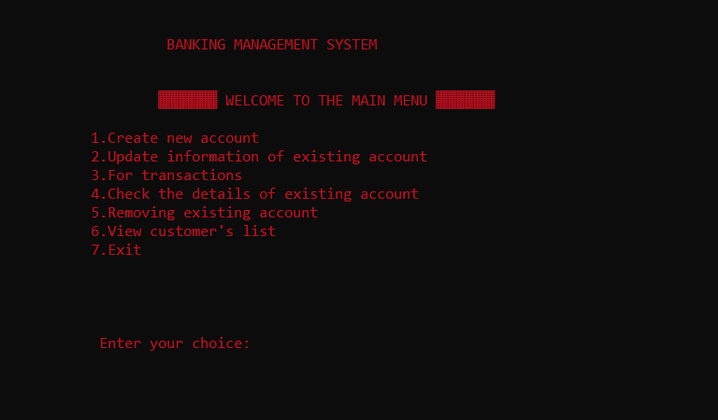***RESULT**

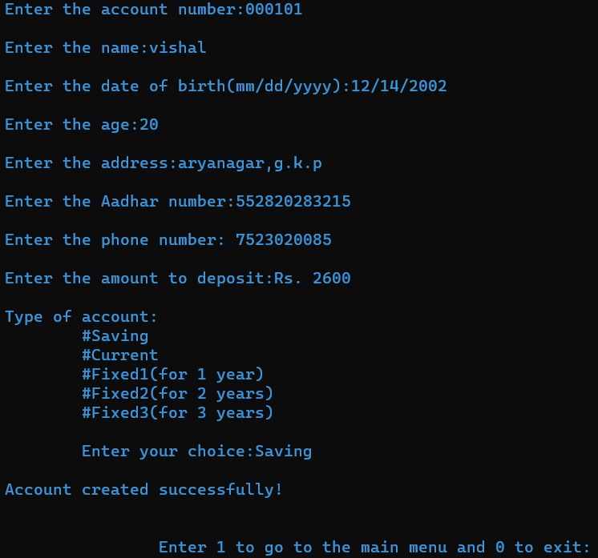

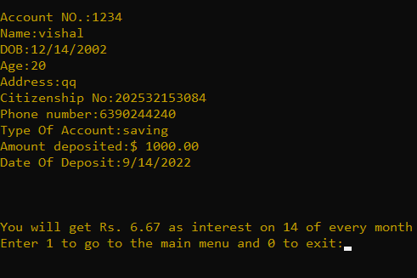

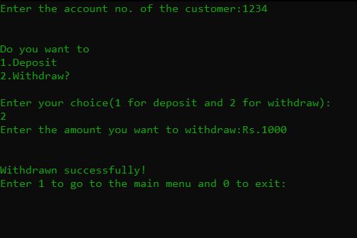

**CONCLUSION**

The project Bank Management System (BMS) is for computerizing the working in a Bank. The software takes care of all the requirements of an average Bank and is capable to provide easy and effective storage of information related to Customers that come up to the Bank. It helps to store all kind of information of the Customer like their name, gender, age, contact number, address, and Account number. Overall it is a mini project that can store, edit, and delete data very easily.

**REFERENCES**

• www.wikipedia.com

• www.interviewbit.com

• YouTube: Code with Harry

• Let Us C by Yashwant Kanetkar 15th edition. 2018