SOFTWARE REQUIREMENTS SPECIFICATION
Beyond Classroom
Enterprise EdTech Platform

Document Title | Beyond Classroom — Software Requirements Specification
Version | 1.0.0
Date | June 2026
Prepared By | Architecture & Systems Team
Classification | Confidential — Internal & Investor Review
Status | Ready for Stakeholder Review

CONFIDENTIALITY NOTICE
This document contains proprietary information belonging to Beyond Classroom. No part of this document may be reproduced, distributed, or transmitted in any form without prior written permission.

Table of Contents

1. Introduction

1.1 Purpose
This Software Requirements Specification (SRS) defines the functional and non-functional requirements, system architecture, data model, and interface design of Beyond Classroom, an enterprise-grade EdTech platform. It is intended to serve as the authoritative reference for engineering, quality assurance, and stakeholder review during design, development, and pitch evaluation of the product.
The document consolidates the platform's architecture, business logic, security posture, and operational requirements into a single, traceable specification suitable for technical due diligence, investor review, and onboarding of new engineering contributors.

1.2 Document Conventions
- Requirement identifiers follow the pattern FR-<MODULE>-<NN> for functional requirements (e.g., FR-PAY-03) and NFR-<CATEGORY>-<NN> for non-functional requirements.
- Priority levels are classified as High (must-have for launch), Medium (required for full feature parity), or Low (planned enhancement).
- The keyword “shall” denotes a mandatory, testable system behavior, consistent with IEEE 830 conventions for requirements specifications.
- Code-style text (e.g., purchasedCourses, /api/auth/login) refers to literal field names, routes, or identifiers in the implementation.

1.3 Intended Audience
This document is written for the following audiences:
- Engineering & Architecture Teams — implementation reference for backend, frontend, and database design.
- Product & QA Teams — source of truth for acceptance criteria and test scenario design.
- Investors & Technical Reviewers — architectural and security due diligence during pitch or audit.
- DevOps & Deployment Engineers — environment configuration and release requirements.

1.4 Project Scope
Beyond Classroom delivers premium educational content, mock examinations, and structured learning packages to students through a responsive web application. The platform bridges traditional learning with digital accessibility via curated course packages, a robust assessment engine, secure payment processing, role-based access control, and a promoter-driven affiliate network.
In scope for this release:
- Public course catalog, package bundles, and marketing surfaces.
- Student learning portal including protected class playback, PDFs, and quizzes.
- Mock examination engine with timed attempts, negative marking, and partial grading.
- Razorpay-integrated checkout supporting promotional codes and fractional discounts.
- Admin portal for course, user, and package management.
- Promoter/affiliate network with referral tracking and commission calculation.
Out of scope for this release:
- Native mobile applications (the platform is delivered as a responsive web application).
- Third-party LMS interoperability (SCORM/xAPI) and live-class video conferencing beyond existing Zoom service hooks.

1.5 References
- Beyond Classroom Enterprise Documentation Package, Architecture & Systems Team, v1.0.0, June 2026.
- IEEE Std 830-1998 — Recommended Practice for Software Requirements Specifications (structural reference).
- Razorpay Payment Gateway API Documentation.
- MongoDB / Mongoose Object Data Modeling Documentation.

2. Overall Description

2.1 Product Perspective
Beyond Classroom is a self-contained, decoupled web application composed of a Next.js front end and a Node.js/Express REST API back end, persisting data in MongoDB. It is not a component of a larger system; it integrates with a small number of well-defined external services — Razorpay for payments, SMTP for transactional email, and local or cloud object storage for static assets and uploads.

2.2 Product Functions Summary
- Curated Course Packages: Administrators can bundle multiple courses into purchasable packages with unified pricing.
- Robust Assessment Engine: Mock exams, practice tests, and detailed result analysis with negative marking and partial grading.
- Secure Payments: Integrated Razorpay checkout with custom promotional code logic and fractional discount support.
- Role-Based Access Control: A secure portal distinguishing Admin, Student, and Promoter roles.
- Promoter Network: An affiliate system allowing promoters to onboard students and track referral commissions.

2.3 User Classes and Characteristics
The platform recognizes five distinct user classes, detailed fully in Section 8 (Roles & Permissions). At a high level:
User Class | Description | Technical Sophistication
Guest | Unauthenticated visitor browsing the public catalog. | Low
Student (user) | Registered learner who purchases and consumes course content. | Low–Medium
Promoter | Affiliate who refers students and earns commission. | Medium
Admin | Operates the platform: content, users, payments, analytics. | Medium–High
Super Admin | Reserved for global system configuration. | High

2.4 Operating Environment
- Client: Modern evergreen web browsers (Chrome, Edge, Safari, Firefox) on desktop and mobile, requiring no client installation.
- Frontend Runtime: Next.js (App Router) application server supporting SSR and SSG.
- Backend Runtime: Node.js with Express.js, deployed as a stateless REST API service.
- Data Tier: MongoDB, accessed exclusively through Mongoose schemas and models.
- Network: All client–server and server–gateway communication occurs over HTTPS.

2.5 Design and Implementation Constraints
- The system must use server-side amount calculation for all payment flows; client-supplied prices are never trusted.
- Razorpay requires all transaction amounts in the smallest currency unit (paise); conversion must be exact to avoid floating-point drift.
- Concurrent multi-device sessions for a single account are explicitly disallowed by design (single active session policy).
- File uploads are constrained to a 250 MB limit per request, enforced via Multer middleware.
- The USE_MEMORY_DB development flag must never be enabled in production, as it causes data loss on server restart.

2.6 Assumptions and Dependencies
- Razorpay remains the platform's payment processor of record for INR transactions.
- MongoDB Atlas (or an equivalent managed MongoDB service) provides scheduled backups and high availability.
- A valid SMTP relay (EMAIL_USER / EMAIL_PASS) is provisioned for transactional email delivery.
- Production deployments disable in-memory database mode and supply all environment variables listed in Section 10.1.

3. System Architecture
Beyond Classroom uses a decoupled, modern JavaScript stack (MERN-inspired, substituting Next.js for the presentation tier to gain server-side rendering and static generation capabilities).

3.1 High-Level Architecture Diagram
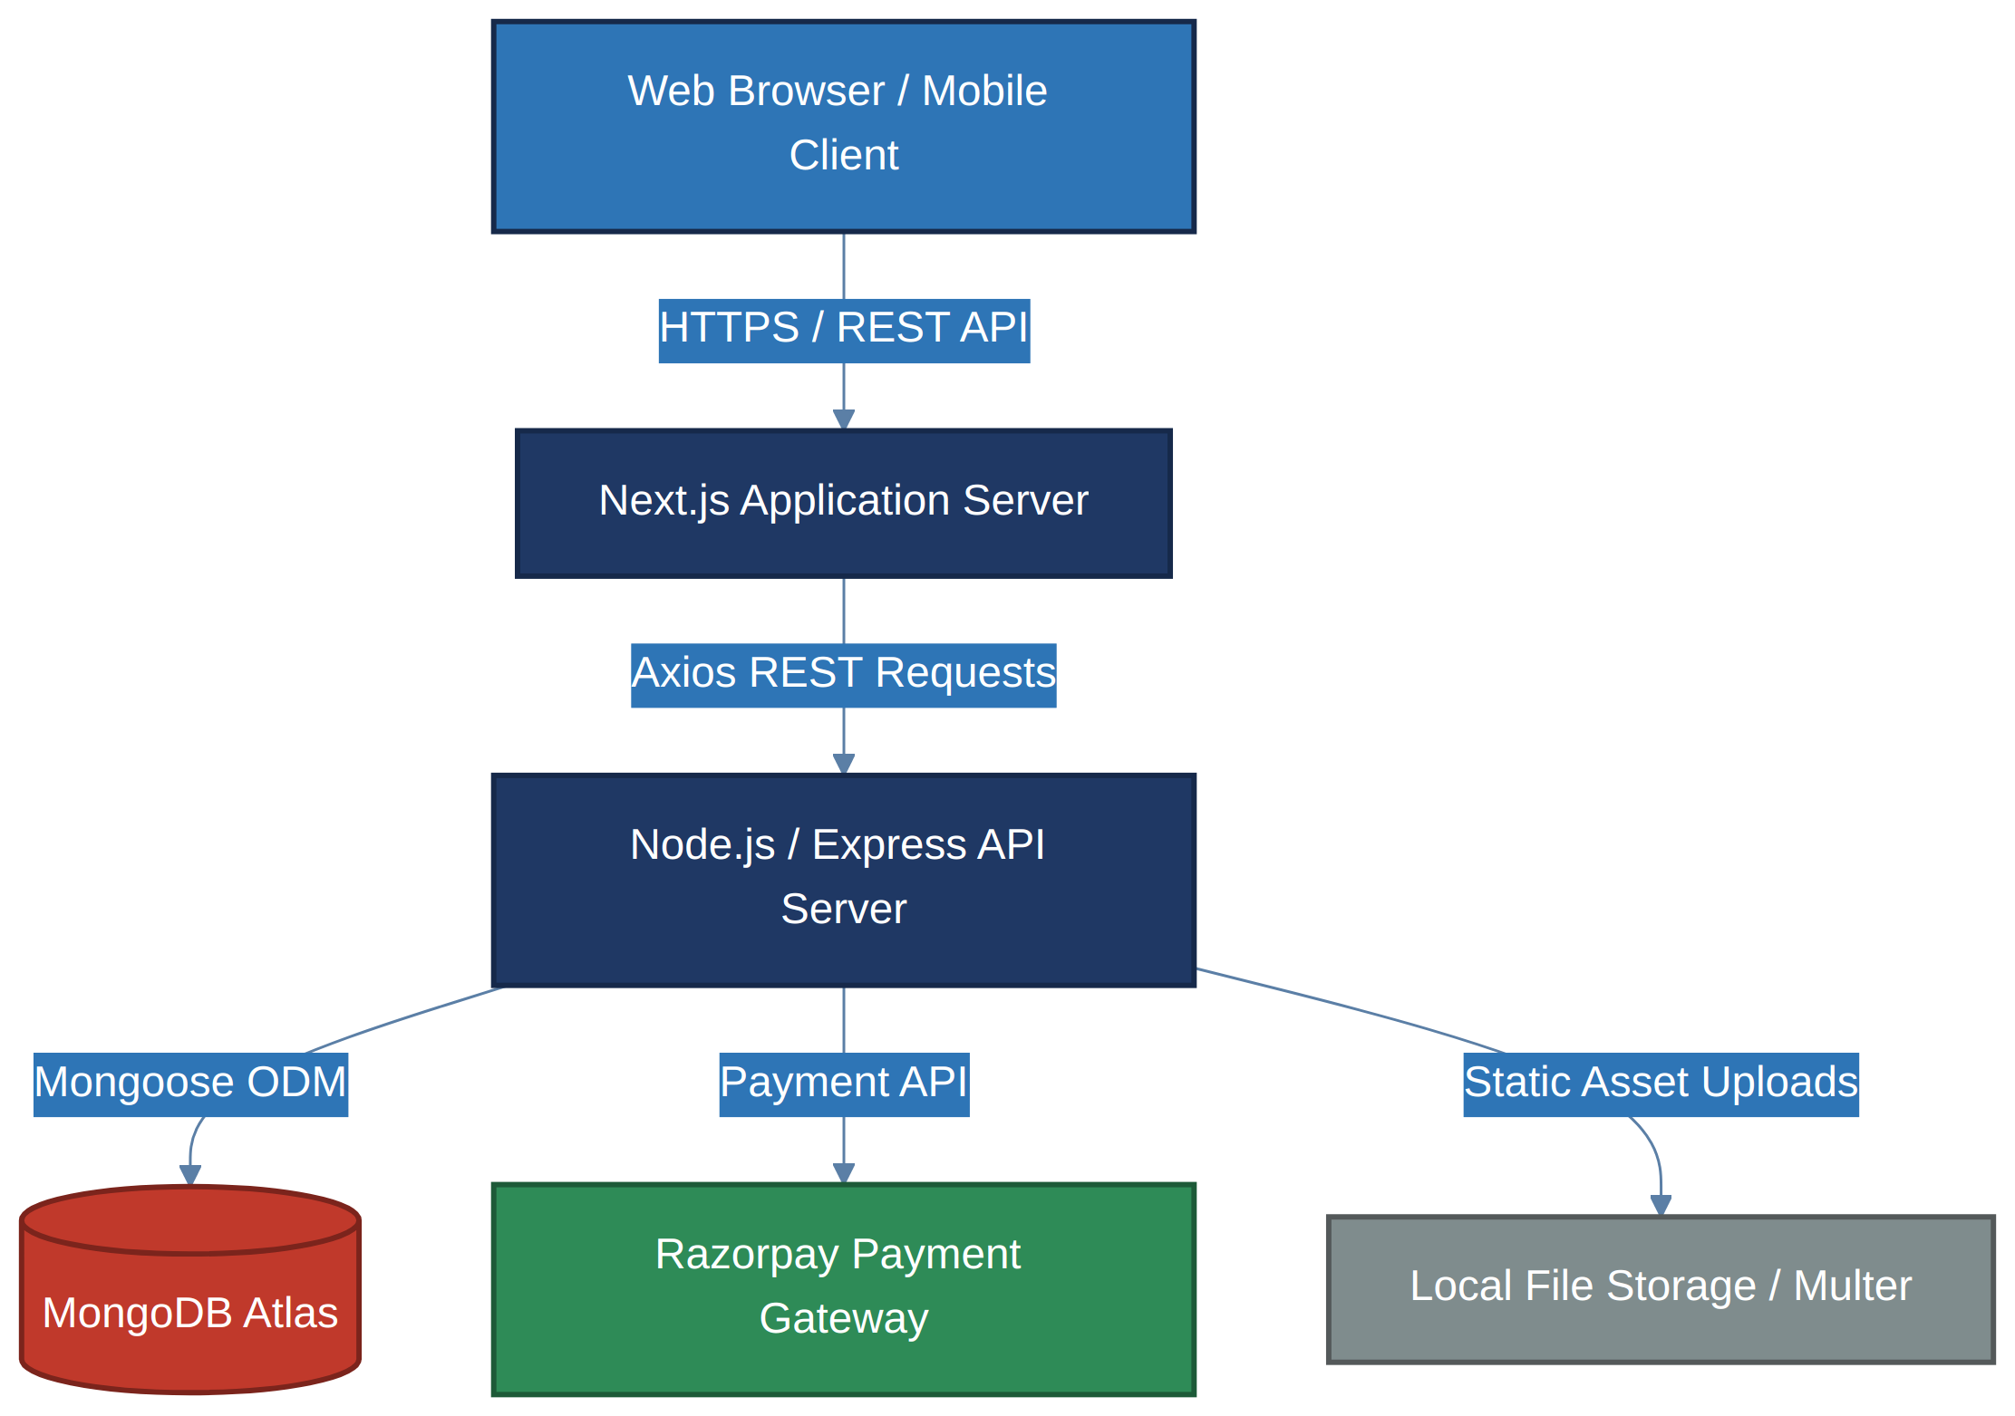
Figure 3.1 — High-Level System Architecture

3.2 Technology Stack
Layer | Technology | Purpose
Frontend | Next.js (App Router), React, Tailwind CSS | Server-side rendering, responsive UI, dynamic routing.
State Management | Redux Toolkit | Global state for user sessions, cart, and active modals.
Animations | Framer Motion | Fluid micro-animations for UI transitions and modals.
Backend | Node.js, Express.js | High-performance RESTful API service.
Database | MongoDB (Mongoose) | NoSQL document storage for flexible schemas (Courses, Exams, Users).
Authentication | JWT (JSON Web Tokens), bcryptjs | Secure, stateless authentication and password hashing.
Payment | Razorpay SDK | Processing INR payments, packages, and custom course bundles.

3.3 Repository / Module Structure
The codebase is organized as two top-level applications sharing a common domain model, summarized below.
beyondclassroom final/
├── beyondclassroom-backend/
│ ├── public/ # Static assets and uploads
│ └── server/
│ ├── constants/ # Reusable constants (e.g., categories)
│ ├── controllers/ # Route logic (payment, auth, exams, etc.)
│ ├── database/ # db.js (Mongoose connection & schema definitions)
│ ├── middleware/ # Auth (protect, admin), Trial, etc.
│ ├── routes/ # Express route definitions
│ ├── services/ # Email, Zoom, Referrals, etc.
│ ├── .env # Environment variables (Mongo, Razorpay, Zoom)
│ └── server-simple.js # Main Express entry point
└── beyondclassroom-frontend/
├── app/ # Next.js App Router pages
│ ├── admin/ # Admin dashboard routes
│ ├── auth/ # Login, Register, Forgot Password
│ ├── courses/ # Course listing and detail pages
│ ├── dashboard/ # User dashboard
│ ├── packages/ # Package viewing and checkout
│ └── ...
├── components/ # Reusable React components
│ ├── marketing/ # Landing page components
│ ├── ui/ # Buttons, inputs, modals
│ ├── CourseCard.js # Standard course display
│ ├── PaymentModal.js # Razorpay checkout wrapper
│ └── ...
└── store/ # Redux state slices

4. Data Architecture
The platform persists all domain data in MongoDB, accessed through Mongoose schemas defined in server/database/db.js.

4.1 Entity-Relationship Diagram
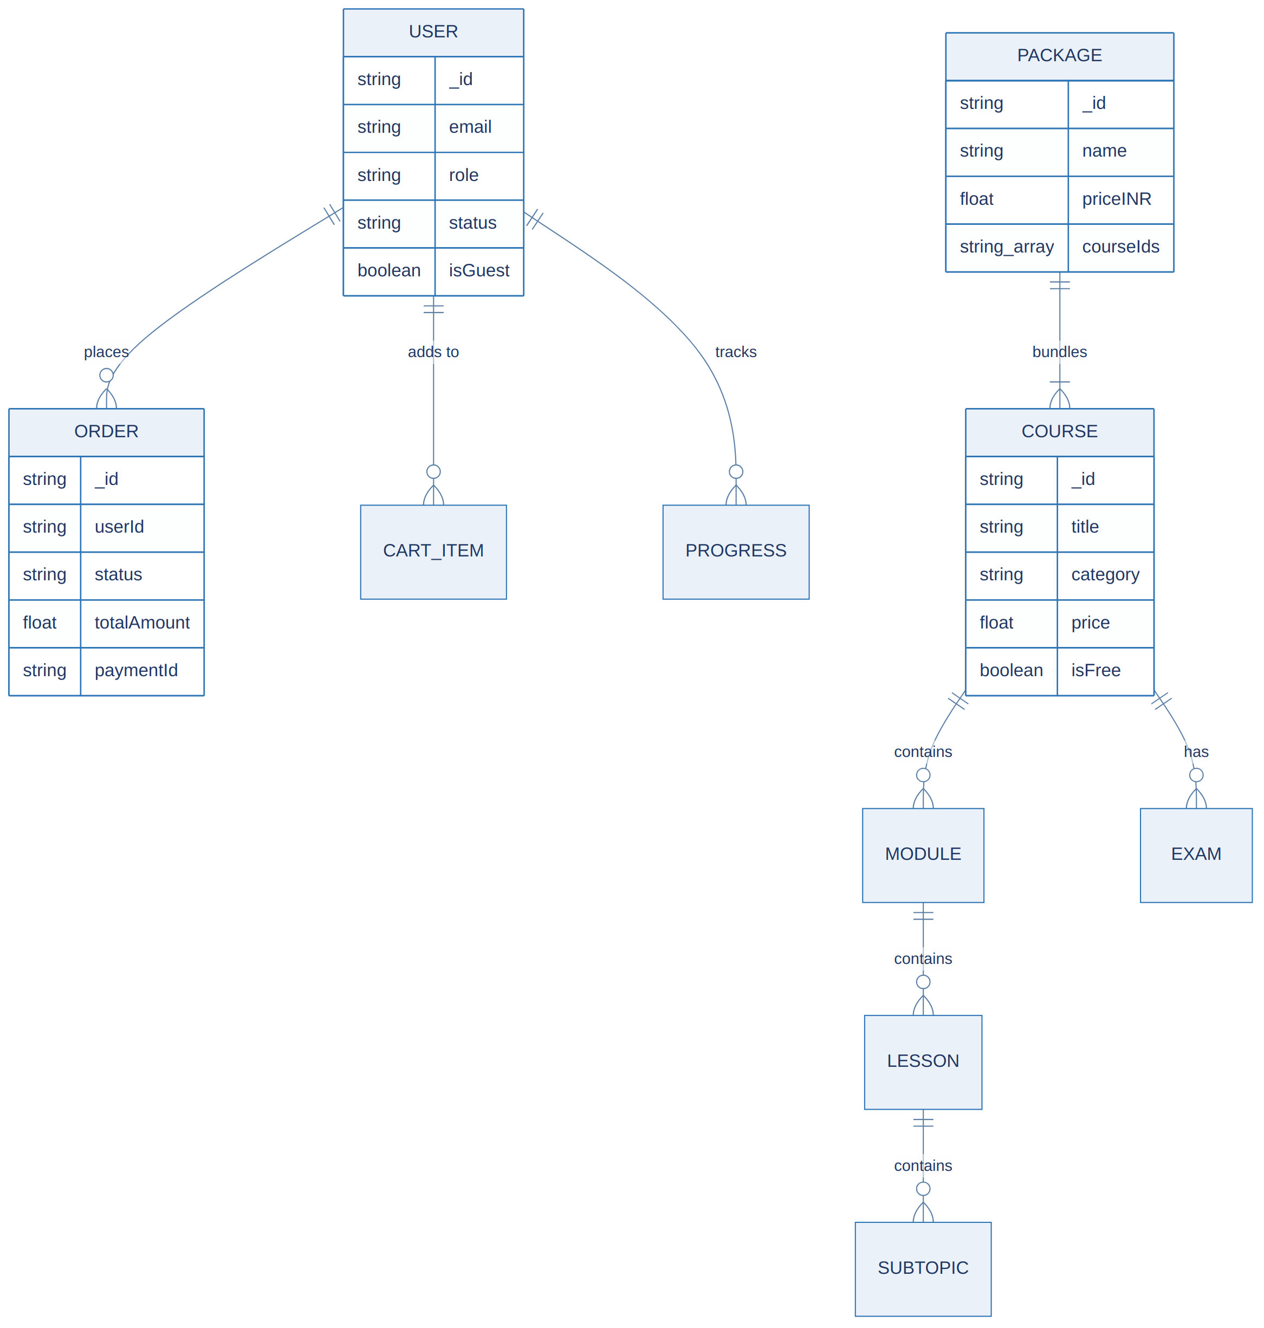
Figure 4.1 — Core Entity-Relationship Diagram

4.2 Core Domain Models

users Collection
Stores all user types (Admin, Student, Promoter).
- Validation Rules: email must be unique and sparse; role defaults to user.
- Key Fields: purchasedCourses (array of strings), referralCode, trialExpired.

courses Collection
Stores the primary learning materials.
- Key Fields: title, price, discountPrice, status (draft/published), topics.

packages Collection
Bundles multiple courses together for a single price.
- Key Fields: name, priceINR, courseIds (array of course IDs).
- Business Logic Note: When fetching a package via the API (/packages/:id?populate=true), the backend performs a bulk $in query to populate all associated courses, modules, and lessons in O(1) time, preventing N+1 query bottlenecks.

payments Collection
Tracks individual payment intents and completions.
- Key Fields: userId, courseId, packageId, amount, razorpayOrderId, razorpayPaymentId, status.

4.3 Secondary Domain Models

4.3.1 Course Content Hierarchy
- modules — Organizes sections within a course. Contains courseId, order, duration, and an isLocked flag.
- lessons — Associated with moduleId. Supports rich text content or videoUrl.
- subtopics — Associated with lessonId. Stores document (single file) or documents (array) for PDF downloads and reference materials.

4.3.2 Examination & Quizzes
- exams — Contains courseId, sections (array of grouped questions), startDate, endDate, duration, totalMarks, and passingMarks.
- examAttempts — Captures a student's examId, answers (JSON structure of selected choices), score, status, and submittedAt.
- practices — Short-form quizzes attached directly to lessonId, containing question, options, correctAnswer, and explanation.

4.3.3 Administration & Custom Requests
- customRequests — Tracks complex student inquiries with nested fields for selectedModules, roadmap, budget, quotedPrice, and adminNote, supporting custom educational package requests.

5. Functional Requirements
This section enumerates the platform's functional requirements, organized by module and traceable to the business logic and screen behavior described in the engineering documentation. Each requirement is assigned a priority reflecting its criticality to a production launch.

5.1 Authentication & Session Management
ID | Requirement | Priority
FR-AUTH-01 | The system shall allow users to register via email and password, normalizing email to lowercase and trimming whitespace before storage. | High
FR-AUTH-02 | The system shall hash all passwords using bcrypt with a cost factor of 12 prior to persistence. | High
FR-AUTH-03 | The system shall authenticate users via POST /api/auth/login, validating credentials with bcrypt.compare() and issuing a JWT with 7-day expiry upon success. | High
FR-AUTH-04 | The system shall maintain an activeSessionId per user and invalidate sessions on other devices upon a new login (single concurrent session enforcement). | Medium
FR-AUTH-05 | The system shall provide a forced-login mechanism allowing a user to rotate activeSessionId and log out all other active devices. | Medium
FR-AUTH-06 | The frontend shall persist the issued JWT client-side and dispatch an authenticated session state to the global Redux store. | High

5.2 Course Catalog & Discovery
ID | Requirement | Priority
FR-CAT-01 | The system shall allow Admin users to create, edit, and publish courses with attributes including title, price, discountPrice, category, and status (draft/published). | High
FR-CAT-02 | The system shall display a Course Detail screen (/courses/[id]) presenting curriculum, modules, and subtopics to all visitor types. | High
FR-CAT-03 | The system shall present “Add to Cart,” “Buy Now,” and “Request Customization” actions on each course detail page. | High
FR-CAT-04 | When a course belongs to a Package, the system shall dynamically present a Package Picker modal offering the bundled upgrade option. | Medium
FR-CAT-05 | The system shall organize course content hierarchically as Modules > Lessons > Subtopics, each supporting an isLocked flag, rich text or video content, and single or multiple document attachments. | High

5.3 Cart & Checkout
ID | Requirement | Priority
FR-CART-01 | The system shall allow authenticated users to add and remove paid or free courses from a persistent server-side cart (/api/cart), synchronized with local Redux state. | High
FR-CART-02 | Guest users shall be permitted to browse and add items to a cart but shall be required to register or log in before completing checkout. | High
FR-CART-03 | The Cart screen shall invoke the Payment Modal directly for any paid course or package in the cart. | High

5.4 Payment Processing
ID | Requirement | Priority
FR-PAY-01 | The system shall calculate the final payable amount server-side by applying promotional or discount codes as a percentage of the base price. | High
FR-PAY-02 | The system shall convert the final amount to paise (amount × 100) with exact rounding before submission to Razorpay to eliminate floating-point drift. | High
FR-PAY-03 | For orders where a 100% discount reduces the payable amount to zero, the system shall generate a mock order identifier (order_mock_*) and bypass Razorpay signature verification to grant immediate course access. | Medium
FR-PAY-04 | The system shall create a Razorpay order via orders.create() and persist a corresponding Payment record with status Pending prior to presenting the checkout modal. | High
FR-PAY-05 | The system shall verify payment authenticity using HMAC-SHA signature verification (crypto.createHmac) before marking a Payment as Successful and granting course access. | High
FR-PAY-06 | The Payment Modal shall block checkout submission if the computed amount evaluates to NaN, and shall reject application of expired promotional codes. | High

5.5 Course Access & Learning Experience
ID | Requirement | Priority
FR-LEARN-01 | The system shall determine a user's access to a course by cross-referencing the requested courseId against the user's purchasedCourses array. | High
FR-LEARN-02 | The system shall allow users to activate a 3-day free trial per course; access shall be validated by comparing trialEndsAt against the current server date on every protected request. | Medium
FR-LEARN-03 | Upon trial expiry, the system shall automatically lock course modules while retaining the user's existing progress records. | Medium
FR-LEARN-04 | The Class Player (/learn/[courseId]) shall provide video playback, PDF rendering, and embedded quizzes within a distraction-free interface. | High
FR-LEARN-05 | The Class Player shall be wrapped by a ScreenProtection component that disables right-click context menus, Ctrl+C, and DOM-inspection shortcuts. | Medium

5.6 Examination Engine
ID | Requirement | Priority
FR-EXAM-01 | The system shall support creation of exams scoped to a course with sections of grouped questions, configurable startDate, endDate, duration, totalMarks, and passingMarks. | High
FR-EXAM-02 | The Exam Player shall restrict access to the configured availability window and present a countdown timer during an active attempt. | High
FR-EXAM-03 | The system shall validate the structure of submitted answer payloads prior to scoring an exam attempt. | High
FR-EXAM-04 | The system shall support negative marking and partial grading when scoring exam attempts. | Medium
FR-EXAM-05 | The system shall support short-form practice quizzes attached directly to individual lessons, each containing a question, options, correct answer, and explanation. | Medium

5.7 Admin Portal
ID | Requirement | Priority
FR-ADM-01 | The system shall restrict all /api/admin/* routes to users with role === 'admin' via an isAdmin middleware guard. | High
FR-ADM-02 | The Admin Dashboard shall aggregate and display platform statistics including total user counts, total sales, and active course counts. | Medium
FR-ADM-03 | The system shall provide full CRUD operations on the courses collection through the Course Editor, propagating changes to the public catalog immediately. | High
FR-ADM-04 | The system shall allow Admins to suspend user accounts, manually reset passwords, and override individual trial limits via the User Management screen. | Medium
FR-ADM-05 | The system shall allow Admins to bundle existing published courses into a new Package from the Admin Dashboard. | Medium

5.8 Promoter / Affiliate Network
ID | Requirement | Priority
FR-PROM-01 | The system shall maintain a separate registration schema for Promoter accounts. | Medium
FR-PROM-02 | When a new user registers using a valid referralCode, the system shall create a referrals record linking the student to the originating Promoter. | Medium
FR-PROM-03 | Upon successful checkout of a referred user, the system shall asynchronously trigger recordReferralCommission to calculate commission based on the Promoter's commissionRate (default 20%). | Medium
FR-PROM-04 | Promoters shall be able to generate referral links, view their onboarded students, and request commission withdrawals through dedicated /api/promoters/* routes. | Medium

5.9 Custom Requests
ID | Requirement | Priority
FR-CUST-01 | The system shall allow students to submit custom course package requests capturing selectedModules and budget. | Low
FR-CUST-02 | The system shall require Admin input of a roadmap and quotedPrice via the Dashboard before a student can view the final quote for a custom request. | Low

6. System Workflows
This section illustrates the platform's most critical end-to-end workflows as sequence and module-map diagrams, supporting the functional requirements defined in Section 5.

6.1 Authentication Sequence
Realizes FR-AUTH-01 through FR-AUTH-06.
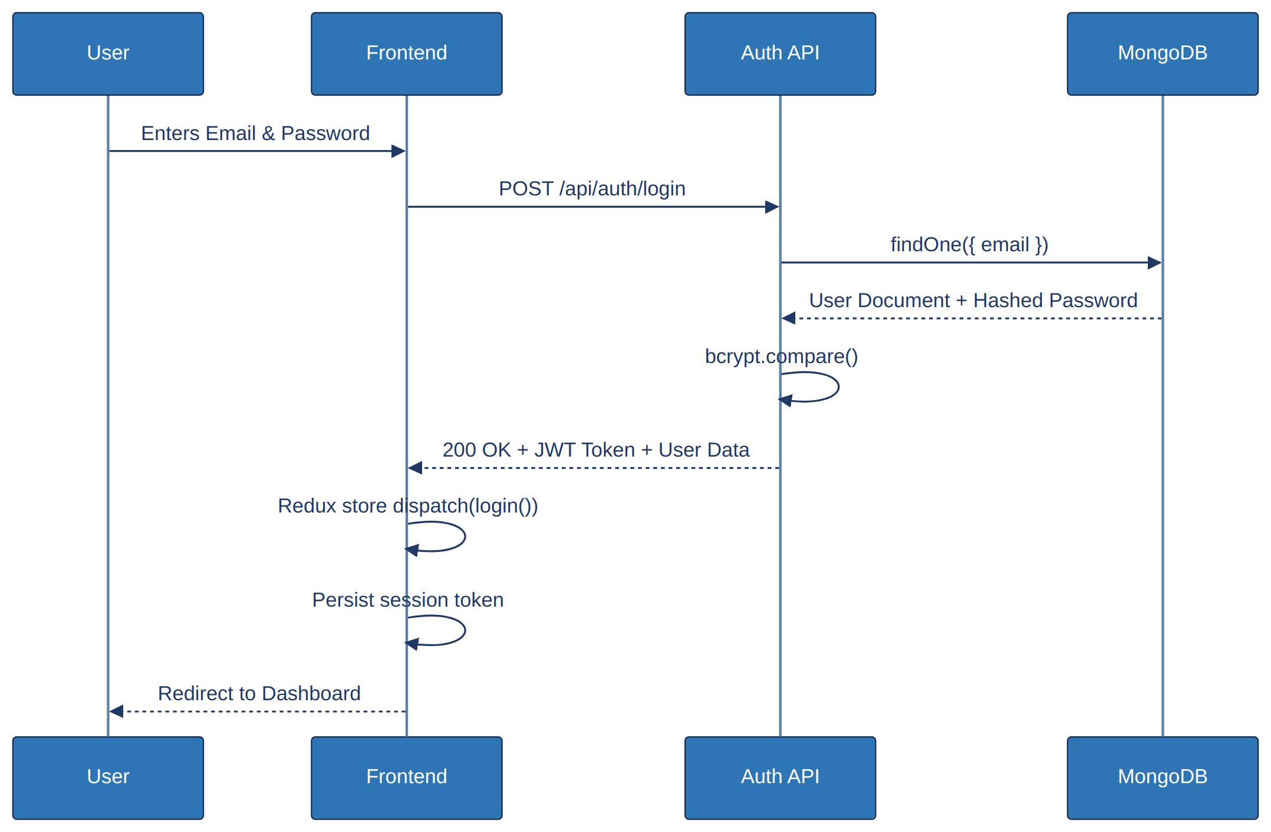
Figure 6.1 — Authentication Flow

6.2 Payment Checkout Sequence
Realizes FR-PAY-01 through FR-PAY-06.
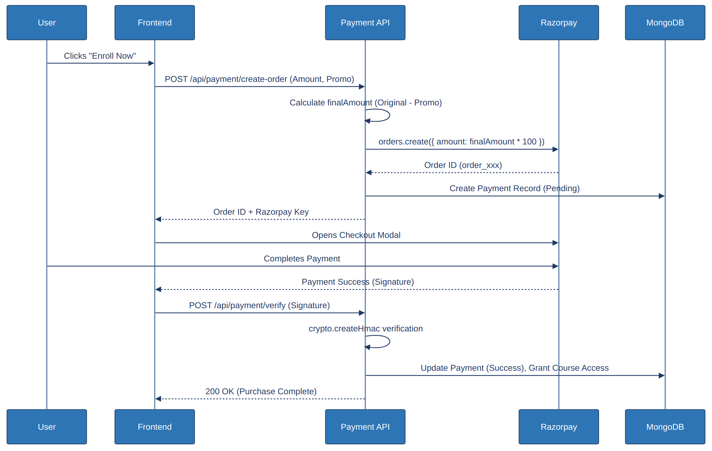
Figure 6.2 — Payment Checkout Flow

6.3 Screen / Module Map
Summarizes the navigable surfaces of the Public, Student, and Admin portals referenced throughout Section 5 and Section 7.
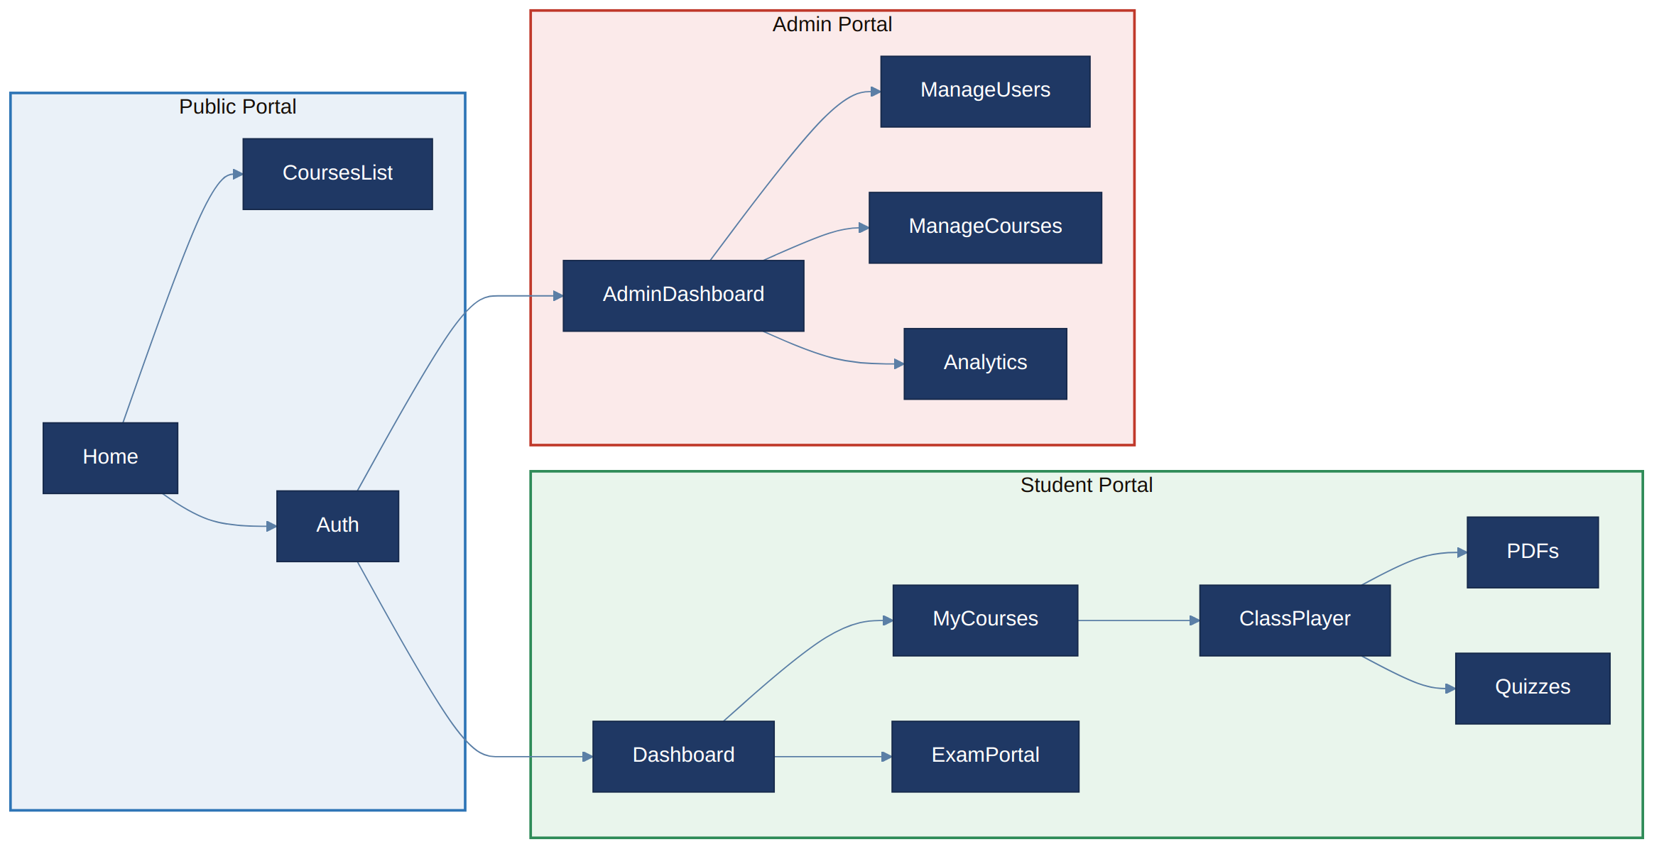
Figure 6.3 — Screen / Module Map

7. External Interface Requirements

7.1 User Interfaces
Key screens are summarized below; full behavioral detail is provided in Section 5.
Screen | Route | Purpose
Landing Page | / | Marketing shell displaying featured courses, packages, and testimonials.
Login / Register | /auth/login, /auth/register | JWT-based authentication with multi-device session control.
Course Detail | /courses/[id] | Curriculum display, cart actions, and package upgrade prompts.
Package Detail | /packages/[id] | Bundled offering view with O(1) bulk-populated nested content.
Cart | /cart | Checkout entry point invoking the Payment Modal.
Student Dashboard | /dashboard | Lists unlocked courses based on purchasedCourses.
Class Player | /learn/[courseId] | Protected video, PDF, and quiz playback environment.
Exam Player | /exams/[examId] | Timer-restricted testing interface with submission validation.
Admin Dashboard | /admin | Aggregated platform statistics and management entry point.

7.2 Software Interfaces
- Razorpay SDK: Used for order creation, checkout modal presentation, and HMAC signature verification of completed payments.
- MongoDB / Mongoose: The sole system of record, accessed exclusively through Mongoose models — no direct driver queries.
- SMTP Email Service: Used for transactional email (account, payment, and custom-request notifications) via EMAIL_USER / EMAIL_PASS credentials.
- Local / Cloud File Storage: Multer-based uploads served from the public/ directory; production deployments should migrate to object storage (see Section 12).

7.3 Communication Interfaces
- All client–frontend and frontend–backend communication occurs over HTTPS using JSON request and response payloads.
- The frontend communicates with the backend exclusively through Axios-based REST calls; no GraphQL or RPC layer is present.
- CORS is restricted to the configured FRONTEND_URL and approved production domains.

8. Roles & Permissions
The platform enforces strict Role-Based Access Control (RBAC) at both the middleware layer (Node.js) and the component layer (React).

8.1 Role Capability Matrix
Role | Capabilities | Protected Route Access
Guest | Browse catalog, view public pages, add to cart (registration required to checkout). | None
Student (user) | Access purchased courses, take exams, upload assignments, submit custom requests. | /api/cart, /api/profile, /api/exams/*
Promoter | Generate referral links, view onboarded students, request commission withdrawals. | /api/promoters/*
Admin | Full system access: create/edit courses, approve custom requests, manage users. | /api/admin/*
Super Admin | Reserved for system configuration and global settings adjustments. | All routes

8.2 Permission Matrix
Resource | Admin | Student | Super Admin
Courses | Create / Read / Update / Delete | Read (if purchased) | Full access
Payments | Read / Refund | Create / Read (own records only) | Full access
Settings | — | — | Update

9. Non-Functional Requirements

9.1 Security Requirements
ID | Requirement | Priority
NFR-SEC-01 | CORS shall be strictly limited to the configured FRONTEND_URL and approved production domains to prevent cross-origin exploitation. | High
NFR-SEC-02 | JWTs shall be generated via jsonwebtoken with a 7-day expiry; activeSessionId shall be validated on every request to forcibly log out hijacked or shared accounts. | High
NFR-SEC-03 | The /learn/ portal shall apply a ScreenProtection overlay disabling right-click context menus and Ctrl+C commands to deter casual content copying. | Medium
NFR-SEC-04 | Passwords shall be hashed with bcrypt.hash(..., 12); emails shall be normalized to lowercase and trimmed before persistence. | High
NFR-SEC-05 | File uploads shall be validated through Multer at /api/upload with a hard limit of 250 MB per request. | Medium
NFR-SEC-06 | A rate limiter (e.g., express-rate-limit) shall be applied to /api/auth/login to mitigate brute-force password guessing. | High

9.2 Performance Requirements
ID | Requirement | Priority
NFR-PERF-01 | Package detail retrieval shall use a bulk $in aggregation (?populate=true) to fetch nested courses, modules, and lessons in O(1) queries, avoiding N+1 bottlenecks. | High
NFR-PERF-02 | Images shall be served through the Next.js Image component to minimize initial payload size. | Medium
NFR-PERF-03 | Static assets (PDFs, thumbnails) should be migrated from local public/ storage to AWS S3 / CloudFront in production to reduce Express.js thread blocking. | Medium

9.3 Reliability & Error Handling
ID | Requirement | Priority
NFR-REL-01 | All Express controllers shall use try/catch blocks returning a uniform JSON error contract: { success: false, message: 'Reason' }. | High
NFR-REL-02 | Frontend layouts shall be wrapped by an ErrorBoundary component to catch and gracefully recover from React rendering crashes. | Medium
NFR-REL-03 | Production deployments shall disable USE_MEMORY_DB to prevent data loss on server restart. | High
NFR-REL-04 | Database backups shall rely on MongoDB Atlas scheduled snapshots rather than manual JSON exports, given the size of the activityLogs and users collections. | Medium

9.4 Maintainability
- Controllers, routes, services, and middleware are separated into distinct directories to support independent iteration without cross-module coupling.
- New nested entities (e.g., additional document arrays inside Subtopics) shall use $in aggregation routes rather than client-side Promise.all loops, to avoid reintroducing N+1 query patterns.
- The activityLogs collection shall be periodically archived (entries older than 90 days) via a scheduled job to bound collection growth.

9.5 Usability
- The interface shall remain fully responsive across desktop and mobile viewports using Tailwind CSS utility classes.
- UI state transitions (modals, route changes) shall use Framer Motion to provide fluid, low-latency micro-animations.

10. Deployment & Environment Requirements

10.1 Environment Configuration
The following environment variables must be provided to the Node.js server for a successful production deployment:
PORT=5000
NODE_ENV=production
JWT_SECRET=strong_secure_random_string
MONGODB_URI=mongodb+srv://<username>:<password>@cluster...
FRONTEND_URL=https://your-frontend-domain.com
EMAIL_USER=admin@beyondclassroom.com
EMAIL_PASS=smtp_password
RAZORPAY_KEY_ID=rzp_live_...
RAZORPAY_KEY_SECRET=rzp_secret_...

10.2 CI/CD Recommendations
- Frontend (Next.js): Deploy on Vercel or Netlify for out-of-the-box image optimization and edge caching. Build command: npm run build.
- Backend (Node.js): Deploy on Render, Railway, or AWS Elastic Beanstalk. Ensure the public/ folder has correct read/write permissions if using local storage for uploads.

10.3 Maintenance & Troubleshooting
- Multi-Device Login Error: Instruct the user to force login, which rotates activeSessionId and invalidates previous devices.
- N+1 Query Slowdowns: When adding new nested entities (e.g., new document arrays inside Subtopics), ensure the backend route uses $in aggregations (populate=true) rather than firing Promise.all loops client-side.
- Database Backup: Use MongoDB Atlas scheduled snapshots; avoid manual .json exports due to the size of the activityLogs and users collections.

11. Testing & Quality Assurance

11.1 Key Test Scenarios

11.2 Acceptance Criteria
- All High-priority functional requirements in Section 5 must pass scripted verification before production release.
- Zero-rupee orders (100% discount) must correctly bypass Razorpay signature verification while still recording a valid Payment entry and granting course access.
- Trial expiry must lock module content while preserving the user's prior progress records without data loss.
- Admin-restricted routes must return an authorization failure for any request lacking role === 'admin', verified across all /api/admin/* endpoints.

12. Known Limitations & Future Enhancements

13. Glossary
- JWT: JSON Web Token. Used for securely transmitting authentication information between client and server.
- SSR / SSG: Server-Side Rendering / Static Site Generation. Next.js features that improve SEO and initial load speed.
- Mongoose: An Object Data Modeling (ODM) library for MongoDB and Node.js.
- Razorpay: The primary payment gateway used for processing INR transactions.
- Promoter: An affiliate user who earns commission by referring new students.
- RBAC: Role-Based Access Control — restricting system functionality based on a user's assigned role.
- N+1 Query: A performance anti-pattern where one query triggers N additional queries per related record, mitigated here via $in bulk aggregation.

14. Appendix

14.1 Essential Libraries / Third-Party Dependencies
Library | Purpose
express | Web framework for Node.js.
mongoose | MongoDB Object Data Modeling (ODM) library.
framer-motion | React animation library.
redux-toolkit | Standardized Redux state management.
lucide-react | Iconography used throughout the UI.

14.2 License & Confidentiality
This software is proprietary. The codebase may not be open-sourced or distributed without the explicit consent of the Beyond Classroom executive team. This document contains proprietary information belonging to Beyond Classroom; no part of it may be reproduced, distributed, or transmitted in any form without prior written permission.

