**EXPERIMENT - 2**

**-TEAM 16**

1. **Development of a relational model :**

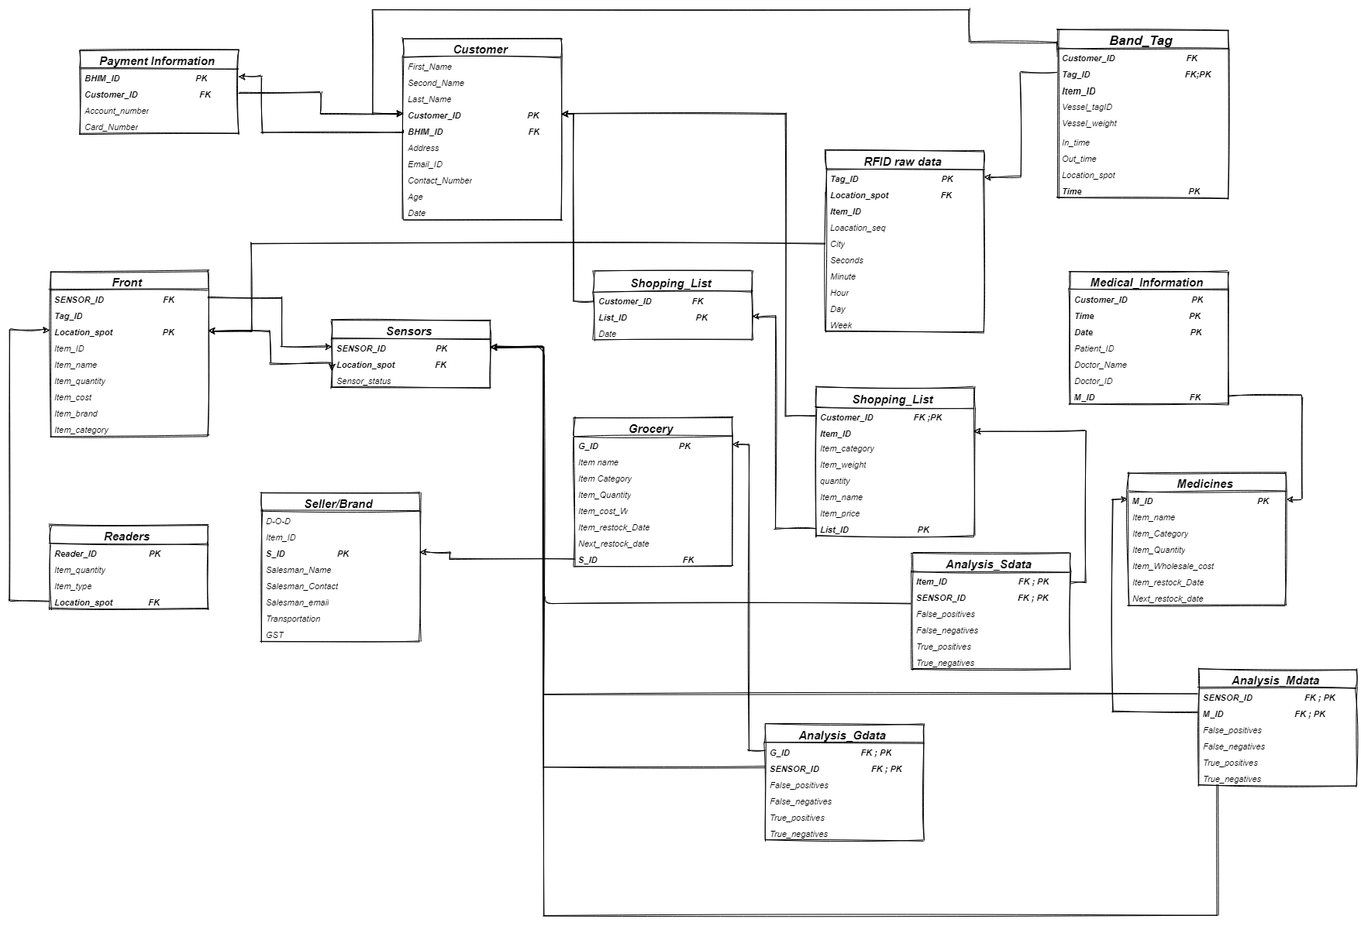

1. **Identify the super-key (up to 10), candidate-key, primary key and foreign key for the identified relations.**

|  |  |  |  |  |
| --- | --- | --- | --- | --- |
| **Table Name** | **Super Key** | **Primary Key** | **Candidate Key** | **Foreign Key** |
| Customer | Customer_ID,  BHIM_ID Account_number | Customer_ID, BHIM_ID | BHIM_ID | Account_number |
| Payment_information | Account_number  Card_number  BHIM_ID | Account_number |  | Customer_ID, |
| Shopping_list | Item_ID  Item_category | Item_ID |  | List_ID |
| List | List_ID | List_ID |  | Customer_ID |
| Medical_information | Doctor_ID  Time  Patient_ID | Mediclaim_number, Patient_ID | Mediclaim_number | Medicine_ID, Customer_ID |
| Band_Tag | Tag_ID, Time , Customer_ID;  Tag_ID, Time, Customer_ID,Vessel Tag_ID; | Tag_ID, Time |  | Tag_ID,Customer_ID |
| RFID_raw_data | Tag_ID, Location_seq;  Tag_ID, Location_seq;  Tag_ID, Location_seq, Day,Hour,Minutes | Tag_ID | Location_seq | Location_spot |
| Analysis_Sdata | Sensor_ID,Item_ID,  False_negatives,  True_positives,  False_positives,  True_negatives; | Sensor_ID,Item_ID |  | Sensor_ID,Item_ID |
| Readers | Reader_ID,Item_type; | Reader_ID |  | Location_spot |
| Analysis_Mdata | Sensor_ID,M_ID,  False_negatives,  True_positives,  False_positives,  True_negatives; | Sensor_ID,M_ID |  | Sensor_ID,M_ID |
| Analysis_Gdata | Sensor_ID,G_ID,  False_negatives,  True_positives,  False_positives,  True_negatives; | Sensor_ID,G_ID |  | Sensor_ID,G_ID |
| Sensors | Sensor_ID,Sensor_status | Sensor_ID |  | Location_spot |
| Medicine | M_ID, Item_name | M_ID | Item_name | - |
| Grocery | G_ID, Item_name | G_ID | Item_name | S_ID |
| Seller | S_ID | S_ID | Salesman_contact | - |
| Front | Address, Sensor_ID, Tag_ID, Item_ID | Address | Sensor_ID, Tag_ID, Item_ID | Sensor_ID |