Configure EIGRP Protocol in Packet Tracer

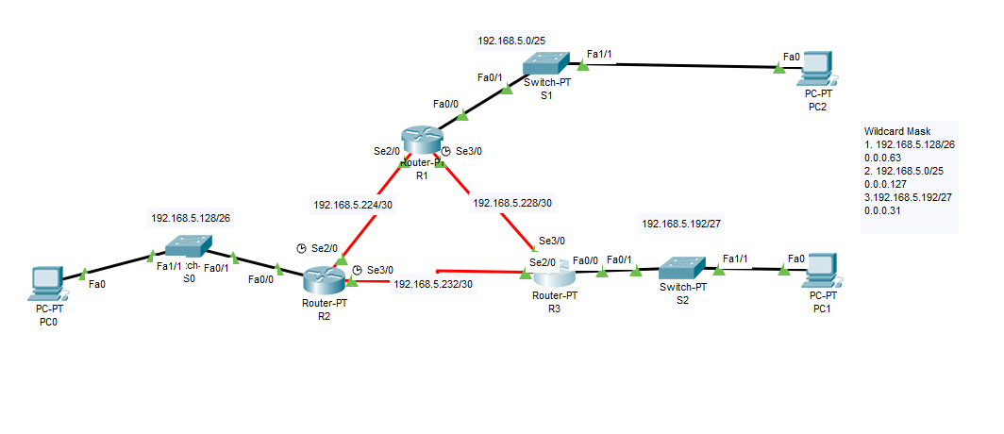

Configure R1:

R1(config)#router eigrp 10

R1(config-router)#no auto-summary

R1(config-router)#network 192.168.5.224 0.0.0.3

R1(config-router)#network 192.168.5.228 0.0.0.3

R1(config-router)#network 192.168.5.0 0.0.0.127

Configure R2:

R2(config)#router eigrp 10

R2(config-router)#no auto-summary

R2(config-router)#network 192.168.5.128 0.0.0.63

R2(config-router)#network 192.168.5.224 0.0.0.3

R2(config-router)#192.168.5.232 0.0.0.3

Configure R3:

R3(config)#router eigrp 10

R3(config-router)#no auto-summary

R3(config-router)#network 192.168.5.232 0.0.0.3

R3(config-router)#network 192.168.5.228 0.0.0.3

R3(config-router)#network 192.168.5.192 0.0.0.31

Verify EIGRP:

R1#show ip eigrp neighbors ------shows all EIGRP neighbors.

R1#show ip route eigrp------------shows only EIGRP entries in the routing table.

R1#show ip route------------------- shows the entire route table.

R1#show ip eigrp topology--------Shows entries in the EIGRP topology table.

**Disabling Automatic Summarization**

* The ***auto-summary*** command permits EIGRP to automatically summarize at major network boundaries
* The ***no auto-summary*** command is used to disable automatic summarization
  + This causes all EIGRP neighbors to send updates that will not be automatically summarized
    - this will cause changes to appear in both

-routing tables

-topology tables