**Session 11: Implementation of VLAN using Packet Tracer**

VLAN:

VLAN is a logical grouping of networking devices. When we create VLAN, we actually break large broadcast domains into smaller broadcast domains. Consider VLAN as a subnet. Same as two different subnets cannot communicate with each other without a router, different VLANs also require a router to communicate.

Advantage of VLAN

VLAN provides following advantages:-

* Solve broadcast problem
* Reduce the size of broadcast domains
* Allow us to add additional layer of security
* Make device management easier
* Allow us to implement the logical grouping of devices by function instead of location

## VLAN Membership

VLAN membership can be assigned to a device by one of two methods

1. Static
2. Dynamic

These methods decide how a switch will associate its ports with VLANs.

### Static

Assigning VLANs statically is the most common and secure method. It is pretty easy to set up and supervise. In this method we manually assign VLAN to switch ports. VLANs configured in this way are usually known as port-based VLANs.

Static method is the most secure method also. As any switch port that we have assigned a VLAN will keep this association always unless we manually change it. It works really well in a networking environment where any user movement within the network needs to be controlled.

### Dynamic

In the dynamic method, VLANs are assigned to ports automatically depending on the connected device. In this method we have configured one switch from the network as a server. Server contains device specific information like MAC address, IP address etc. This information is mapped with VLAN. Switch acting as a server is known as VMPS (VLAN Membership Policy Server). Only high end switches can be configured as VMPS. Low end switch works as a client and retrieves VLAN information from VMPS.

Dynamic VLANs support plug and play movability. For example if we move a PC from one port to another port, the new switch port will automatically be configured to the VLAN which the user belongs to. In the static method we have to do this process manually.

## VLAN Connections

During the configuration of VLAN on port, we need to know what type of connection it has.

Switch supports two types of VLAN connection

* Access link
* Trunk link

### Access link

Access link connection is the connection where the switch port is connected with a device that has a standardized Ethernet NIC. Standard NIC only understands IEEE 802.3 or Ethernet II frames. Access link connection can only be assigned with a single VLAN. That means all devices connected to this port will be in the same broadcast domain.

For example, twenty users are connected to a hub, and we connect that hub with an access link port on switch, then all of these users belong to the same VLAN. If we want to keep ten users in another VLAN, then we have to purchase another hub. We need to plug in those ten users in that hub and then connect it with another access link port on the switch.

### Trunk link

Trunk link connection is the connection where the switch port is connected with a device that is capable of understanding multiple VLANs. Usually trunk link connection is used to connect two switches or switch to router. Remember earlier in this article I said that VLAN can span anywhere in the network, that happens due to trunk link connection. Trunking allows us to send or receive VLAN information across the network. To support trunking, the original Ethernet frame is modified to carry VLAN information.

Switch supports two types of Ethernet trunking methods:

* ISL [ Inter Switch Link, Cisco’s proprietary protocol for Ethernet ]
* Dot1q [ IEEE’s 802.1Q, protocol for Ethernet]

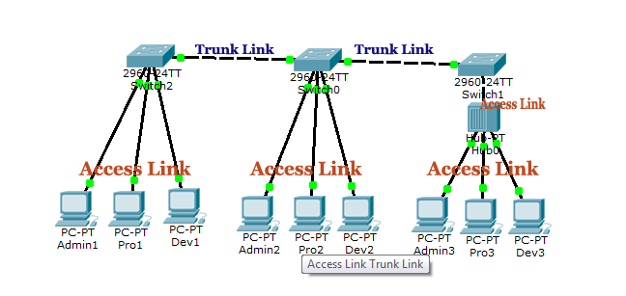

VLAN Configuration:

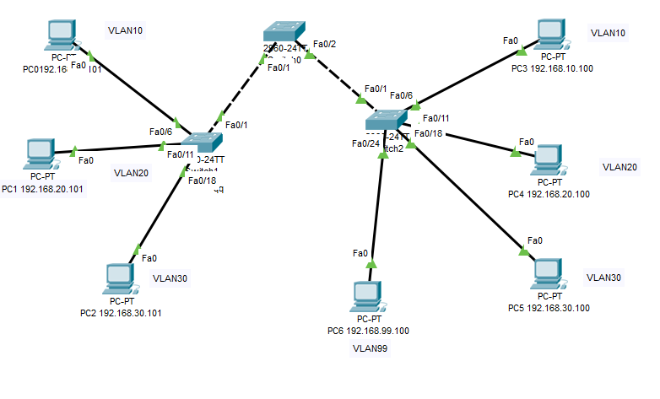

PC Configuration:

| Device | IP Address | Subnet Mask | VLAN | Connected With |
| --- | --- | --- | --- | --- |
| PC0 | 192.168.10.101 | 255.255.255.0 | VLAN 10 | Connected with switch 1 on fa0/6 |
| PC1 | 192.168.20.101 | 255.255.255.0 | VLAN 20 | Connected with switch 1 on fa011 |
| PC2 | 192.168.30.101 | 255.255.255.0 | VLAN 30 | Connected with switch 1 on fa0/18 |
| PC3 | 192.168.10.100 | 255.255.255.0 | VLAN 10 | Connected with switch 1 on fa0/6 |
| PC4 | 192.168.20.100 | 255.255.255.0 | VLAN 20 | Connected with switch 1 on fa0/11 |
| PC5 | 192.168.30.100 | 255.255.255.0 | VLAN 30 | Connected with switch 1 on fa0/18 |
| PC6 | 192.168.99.100 | 255.255.255.0 | VLAN 99 | Connected with switch 1 on fa0/24 |

Switch 0 Configuration

| Port | Connected To | VLAN | Link |
| --- | --- | --- | --- |
| Fa0/1 | Switch 1 | 10,20,30 | Trunk |
| Fa0/1 | Switch 2 | 10,20,30, 99 | Trunk |

Switch 1 Configuration

| Port | Connected To | VLAN | Link |
| --- | --- | --- | --- |
| Fa0/1 | Switch 0 | 10,20,30 | Trunk |
| Fa0/6 | PC0 | 10 | Access |
| Fa0/11 | PC1 | 20 | Access |
| Fa0/18 | PC2 | 30 | Access |

Switch 2 Configuration

| Port | Connected To | VLAN | Link |
| --- | --- | --- | --- |
| Fa0/1 | Switch 0 | 10,20,30 | Trunk |
| Fa0/6 | PC0 | 10 | Access |
| Fa0/11 | PC1 | 20 | Access |
| Fa0/18 | PC2 | 30 | Access |

Configure VLAN in all three switches:

S0(config)#vlan 10

S0(config-vlan)#name Lab1

S0(config-vlan)#exit

S0(config)#vlan 20

S0(config-vlan)#name Lab2

S0(config-vlan)#exit

S0(config)#vlan 30

S0(config-vlan)#name Lab2

S0(config-vlan)#exit

S0(config)#vlan 99

S0(config-vlan)#name mgt

S0(config-vlan)#exit

Now configure the mode trunk to all interfaces of the switches that connect to another switch. The commands are:

S0(config)#int range fastEthernet 0/1-2

S0(config-if)#switchport mode trunk

S0(config-if)#switchport trunk native vlan 99

S1(config)#interface fastEthernet 0/1

S1(config-if)#switchport mode trunk

S1(config-if)#switchport trunk native vlan 99

S2(config)#interface fastEthernet 0/1

S2(config-if)#switchport mode trunk

S2(config-if)#switchport trunk native vlan 99

Now configure the mode access to all interfaces of the switches that connect to another switch. The commands are:

S0(config)#int range fastEthernet 0/6-10

S0(config-if-range)#switchport mode access

S0(config-if-range)#switchport access vlan 10

S0(config-if-range)#int range fastEthernet 0/11-17

S0(config-if-range)#switchport mode access

S0(config-if-range)#switchport access vlan 20

S0(config-if-range)#int range fastEthernet 0/18-23

S0(config-if-range)#switchport mode access

S0(config-if-range)#switchport access vlan 30

S0(config-if-range)#exit

S0(config)#interface fastEthernet 0/24

S0(config-if)#switchport mode access

S0(config-if)#switchport access vlan 99

S0(config-if)#end

S1(config)#int range fastEthernet 0/6-10

S1(config-if-range)#switchport mode access

S1(config-if-range)#switchport access vlan 10

S1(config-if-range)#int range fastEthernet 0/11-17

S1(config-if-range)#switchport mode access

S1(config-if-range)#switchport access vlan 20

S1(config-if-range)#int range fastEthernet 0/18-23

S1(config-if-range)#switchport mode access

S1(config-if-range)#switchport access vlan 30

S1(config-if-range)#exit

S1(config)#interface fastEthernet 0/24

S1(config-if)#switchport mode access

S1(config-if)#switchport access vlan 99

S1(config-if)#end

S2(config)#int range fastEthernet 0/6-10

S2(config-if-range)#switchport mode access

S2(config-if-range)#switchport access vlan 10

S2(config-if-range)#int range fastEthernet 0/11-17

S2(config-if-range)#switchport mode access

S2(config-if-range)#switchport access vlan 20

S2(config-if-range)#int range fastEthernet 0/18-23

S2(config-if-range)#switchport mode access

S2(config-if-range)#switchport access vlan 30

S2(config-if-range)#exit

S2(config)#interface fastEthernet 0/24

S2(config-if)#switchport mode access

S2(config-if)#switchport access vlan 99

S2(config-if)#end

**Verify VLAN:**

S0#show vlan brief

S0#show interfaces trunk

**Configure Router:**

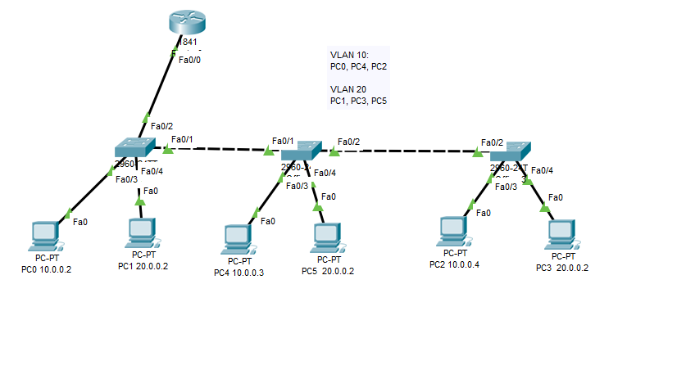

Router(config)#interface fastEthernet 0/0

Router(config-if)#no ip address

Router(config-if)#no shutdown

Router(config-if)#exit

Router(config)#interface fastEthernet 0/0.10

Router(config-subif)#encapsulation dot1Q 10

Router(config-subif)#ip address 10.0.0.1 255.0.0.0

Router(config-subif)#exit

Router(config)#interface fastEthernet 0/0.20

Router(config-subif)#encapsulation dot1Q 20

Router(config-subif)#ip address 20.0.0.1 255.0.0.0

Router(config-subif)#exit

* In the above configuration we broke up a single physical interface [FastEthernet 0/0] into two logical interfaces, known as sub-interfaces. Router supports up to 1000 interfaces including both physical and logical.
* By default the interface link works as an access link. We need to change it into a trunk link. encapsulation commands specify the trunk type and associate VLAN with sub-interface.
* In the next step we assigned an IP address to our sub-interface.