Report of Checkpoint 1
112062630 蘇敬詠 JING-YONG, SU
Notice: My code executes normally only when all registers in edsim51 are clean (i.e. zero) before running.

1.

(a) screenshot for $ make clean↓

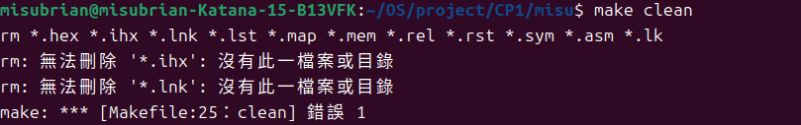
(b) screenshot for $ make ↓

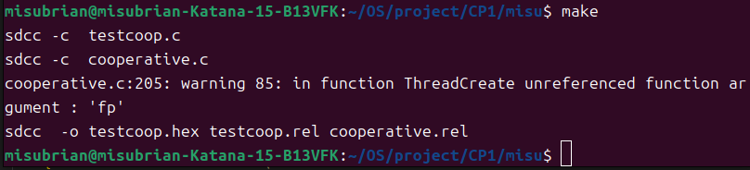
2.
(a) Before jumping to create main thread:
Address of main (0x0062) is passed as parameter.
The stack point is still the bootstrap position , i.e. 0x07, now. ↓
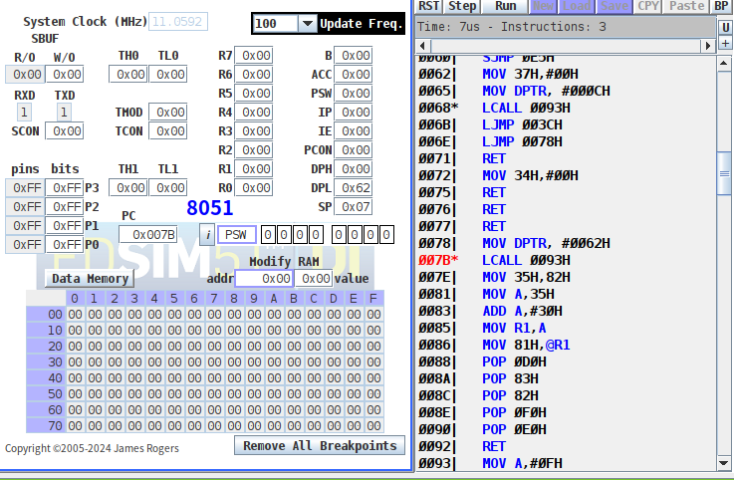

After jumping to ThreadCreate(main):
SP becomes 0x09 because the return address of bootstrap is pushed.↓
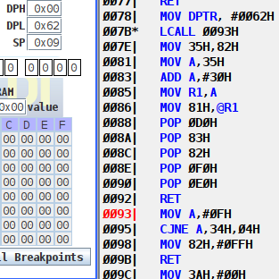

When finish creating main:
The stack point is at 0x46, which is in the range of 0x3F~0x4F, that is, stack of thread 0.
Also, we have the address of main (0x0062) in 0x40, 0x41. ↓
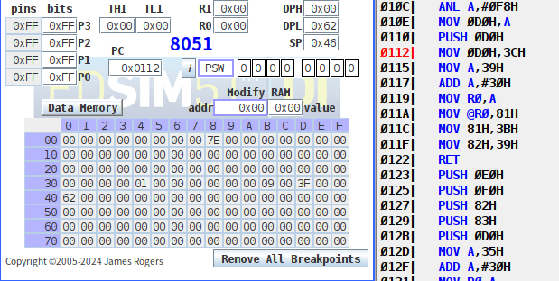

Finally, restore the stack of bootstrap and return.↓

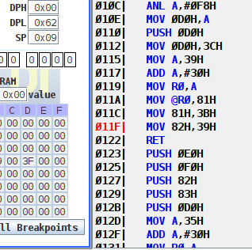

(b) Before jumping to create Producer (thread 1) ↓

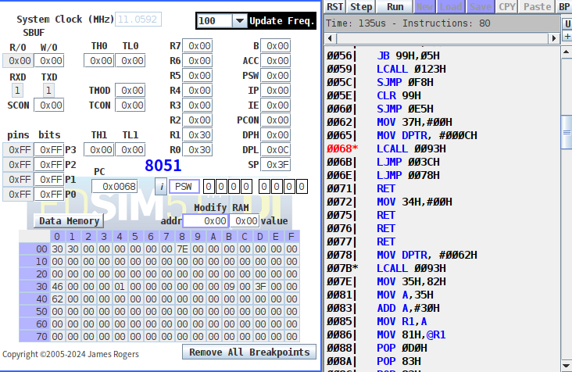

After initializing the stack of producer, SP is at 0x56. ↓

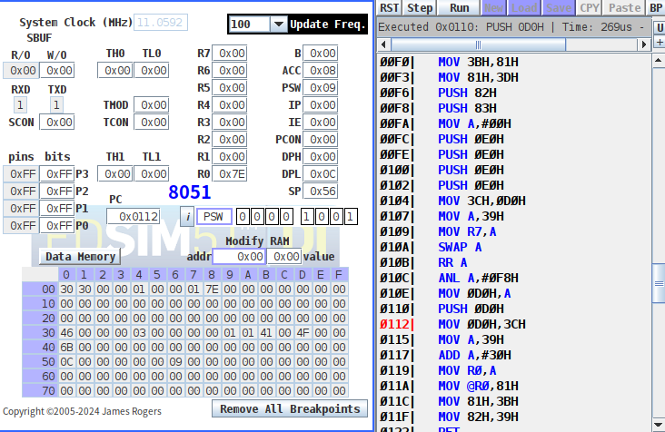
We have address of producer (0x000C) in 0x50, 0x51.

(c) Consumer is running now, because this section of assembly code is initializing the UART, and the current thread ID (0x35) is 0. ↓

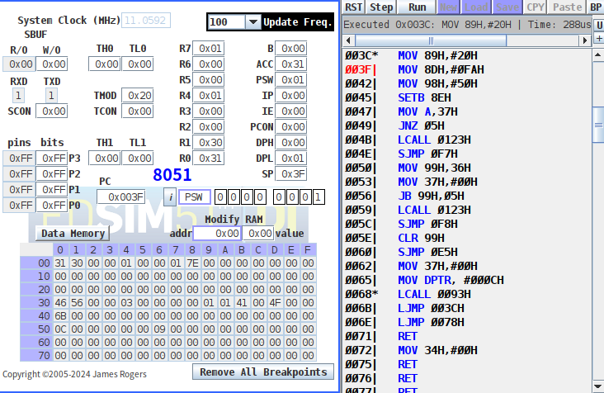

(d) Producer is running, because the current thread ID is 1. ↓
