Report of Project Checkpoint 2
112062630 JING-YONG, SU 蘇敬詠

1. Screenshots for compilation
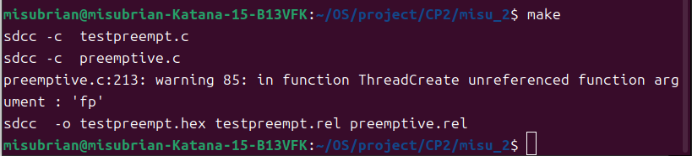
2. (a)
(i)
Before ThreadCreate(main), the stack point is 0x07(initial stack).
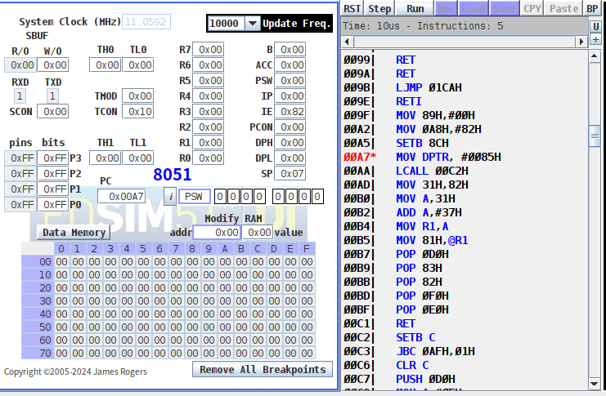
When ThreadCreate(main) is running, the stack point become 0x09 due to the return address is pushed.
After finishing creation of main, the stack point 0x46 is saved to savedSP[0] (i.e. 0x37). Then, the stack is recovered to initial stack.
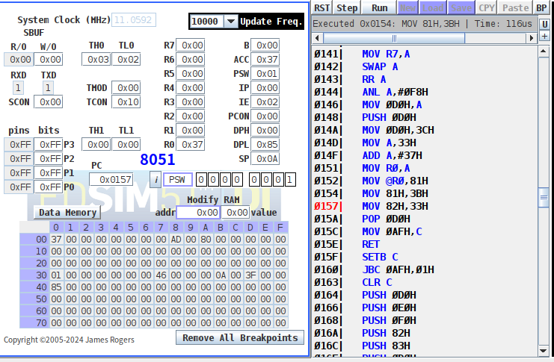
(ii) Screenshot before ThreadCreate(producer). SP = 0x3F is the stack of thread 0 (main).
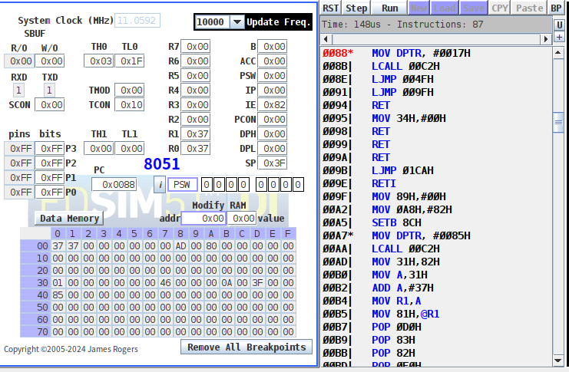
SP becomes 0x42 later due to pushing return address.
Then, jump to stack of thread 1 at 0x4F in order to create producer.
Finally, stack point of producer (0x56) is saved to 0x38 and is recovered to SP of main (0x42).
2. (b)
Producer is running, due to <PSW.4, PSW.3> = 01.
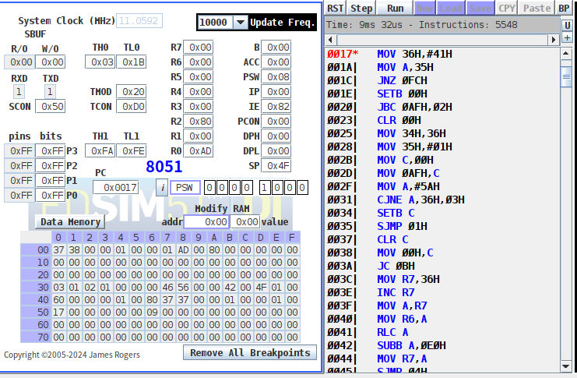

2. (c)
Consumer is running, because <PSW.4, PSW.3> = 00. Also, this section is initializing the UART.

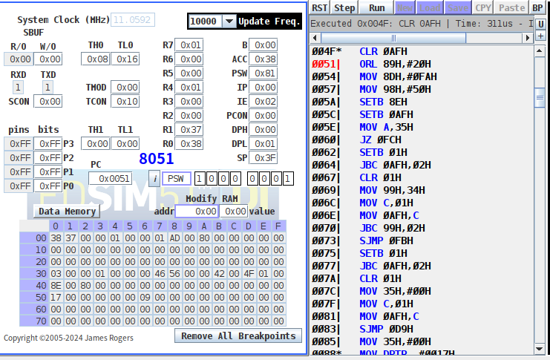
2. (d)
We can know that the interrupt is triggering on a regular basis by:
(i) Setting the break point at address of myTimer0Handler or the ISR. We can observe that program will jump to myTimer0Handler when (TH0, TL0) = (0x00, 0x04) i.e. timer0 has just been rolled over.
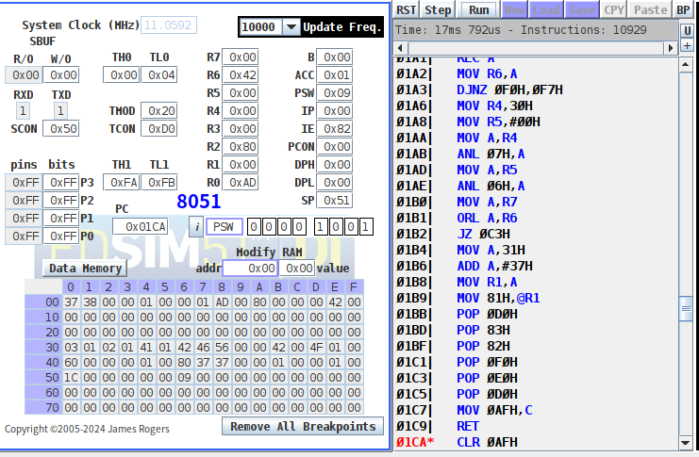
(ii)
The fact that the program is switching between producer and consumer.

