Report of Project Checkpoint 3

112062630 JING-YONG, SU 蘇敬詠

1. Screenshots for compilation
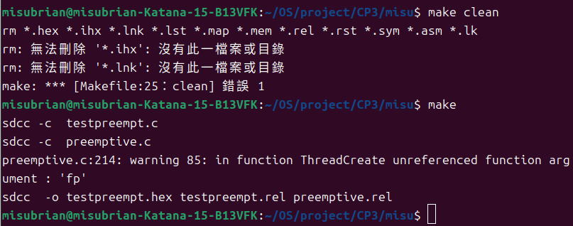

2.
Addresses:
Producer: 0x001D
Consumer: 0x007F
Semaphore full: 0x3C
Semaphore empty: 0x3D
Semaphore mutex: 0x3E

(a)
(I) Producer starts running. Initially, full = 0, empty = 3, mutex = 1.
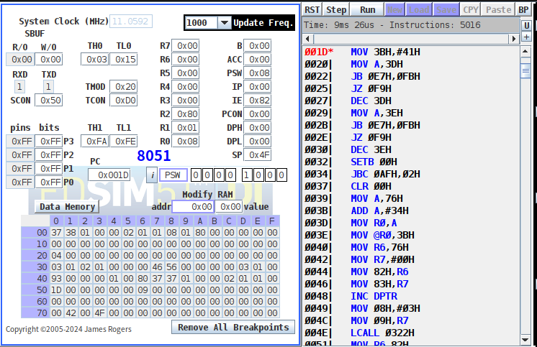
(ii) Producer is in its critical section because mutex = 0.
It has gotten out of “wait(empty)”, therefore, “empty” has been minus one. Now full = 2, and empty = 0.
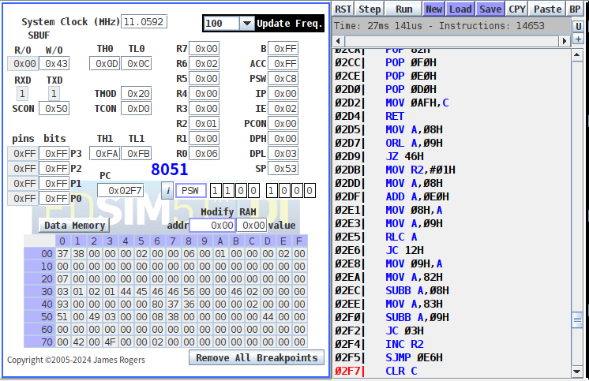
(iii) The mutex has been unlocked.
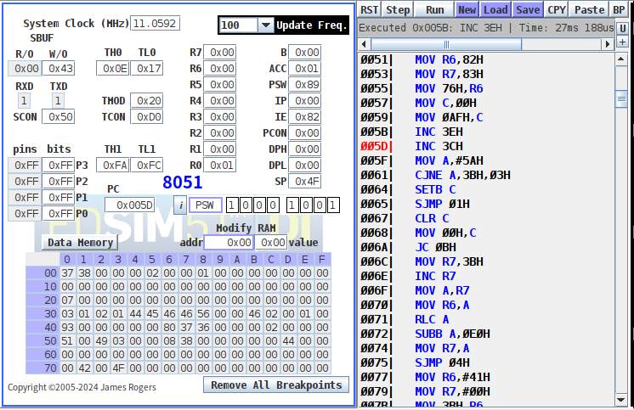
(iv) After signal(full), full = 3.
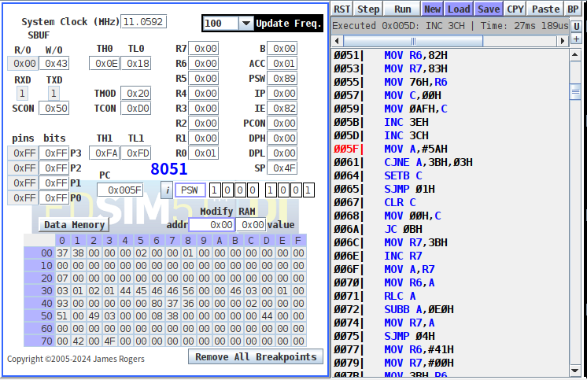

(v) After a while, producer is running now, but it gets stuck due to full = 3, i.e. buffer is full now.
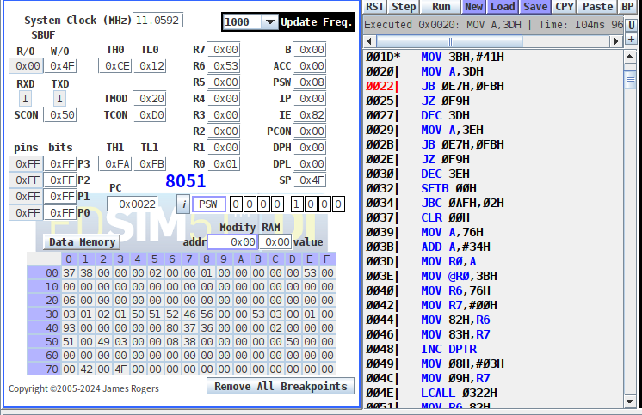

2. (b)
(I) Consumer starts running. Initially, full = 0, empty = 3, and mutex = 1.
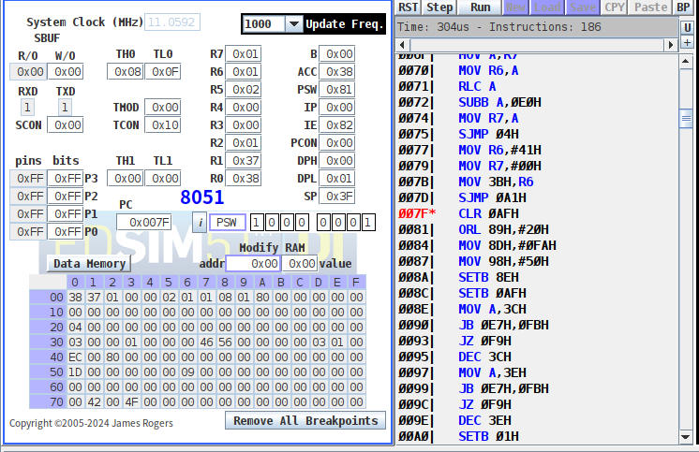
(ii) Consumer is in its critical section because mutex = 0.
It has gotten out of “wait(full)”, therefore, full has been minus one. Now full = 0, and empty = 2.
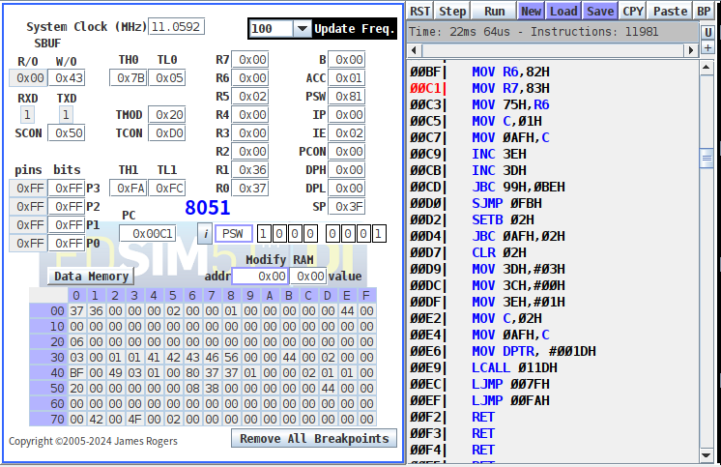
(iii) After exiting critical section, empty becomes 3 and mutex becomes 1.
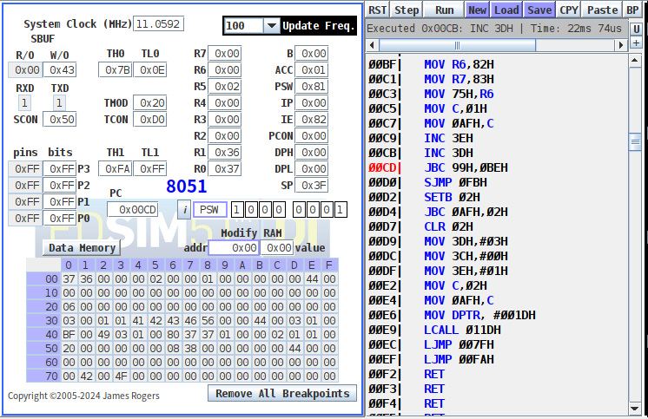

(iv) After a while, consumer is running but gets stuck, because the buffer is empty now. (empty = 3)
