Report of Project Checkpoint 4

112062630 JING-YONG, SU 蘇敬詠

1. Screenshots for compilation

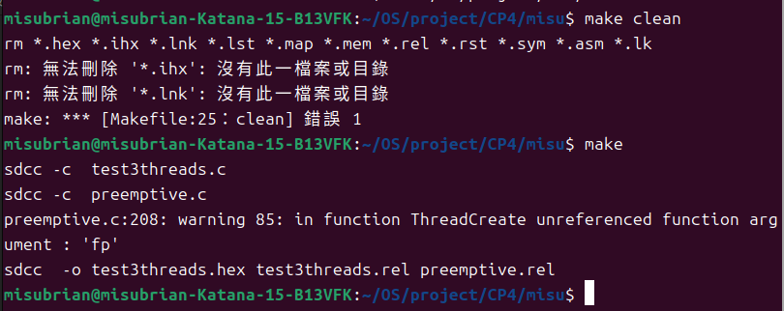

2.
Addresses:
Producer1: 0x001D
Producer2: 0x0092
Consumer: 0x0107
myTimer0Handler: 0x02A9
Semaphore full: 0x3C
Semaphore empty: 0x3D
Semaphore mutex: 0x3E
turn: 0x77 (1 for turn of producer1, 2 for producer2)

(a)
(i) Producer1 starts running. Initially, full = 0, empty = 3, mutex = 1.

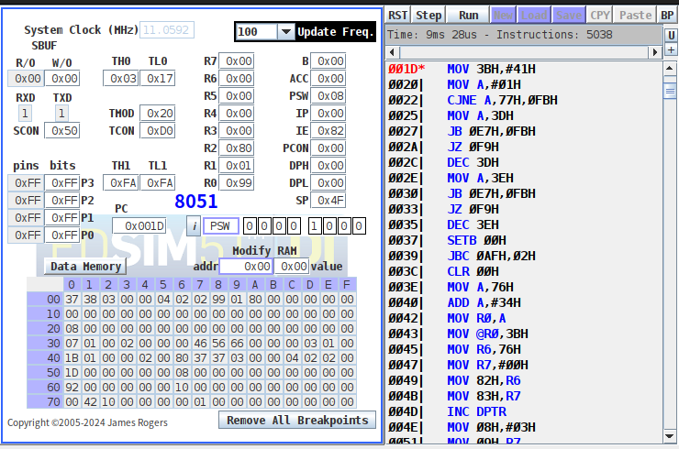
(ii) Producer1 is running. It’s in its critical section because mutex = 0.
It has gotten out of “wait(empty)”, therefore, “empty” has been minus one. Now full = 0, and empty = 2.
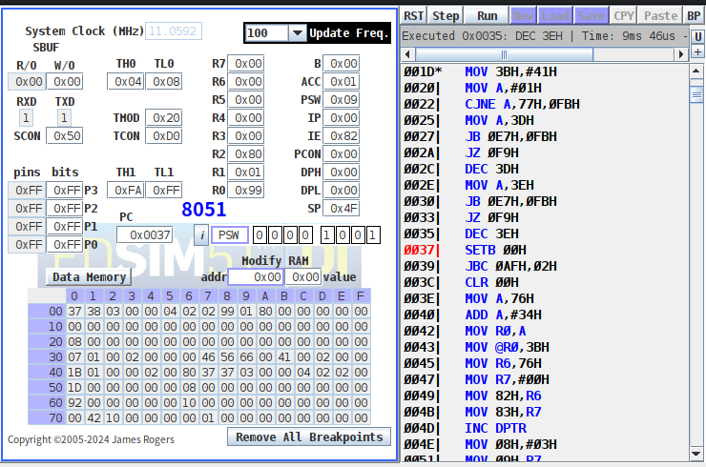
(iii) The mutex has been unlocked. After signal(full), full = 1.
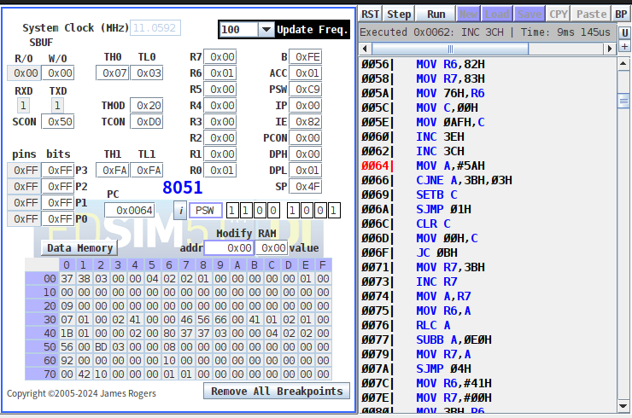

(iv) Producer1 is running now, but it get stuck because it’s the turn of producer2 now. (turn = 2)
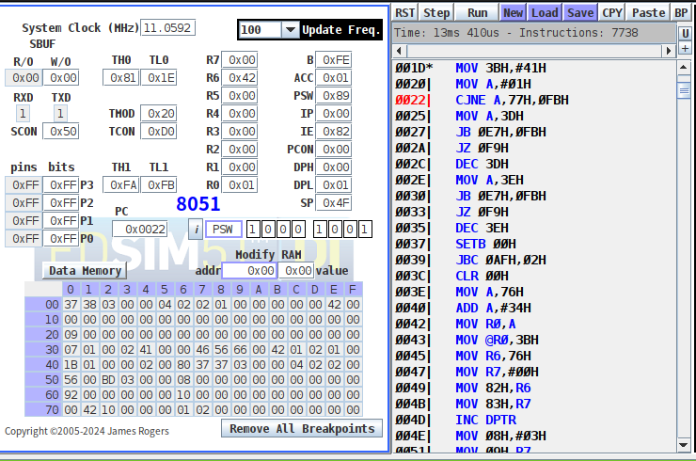
2. (b)
(I) Producer2 starts running. Initially, full = 1, empty = 2, mutex = 1.
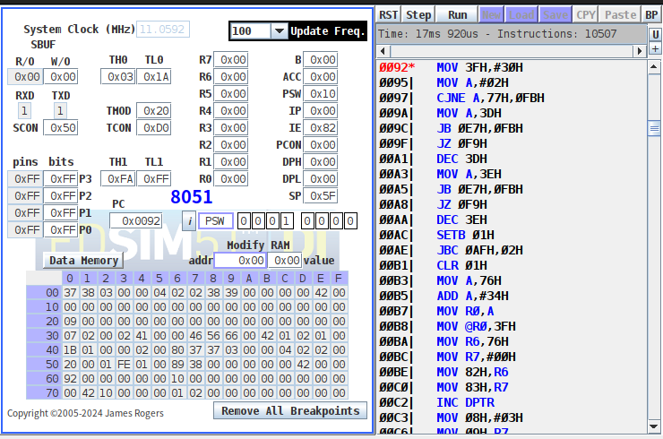
(ii) Producer2 is running. It’s in its critical section because mutex = 0.
It has gotten out of “wait(empty)”, therefore, “empty” has been minus one. Now full = 1, and empty = 1.
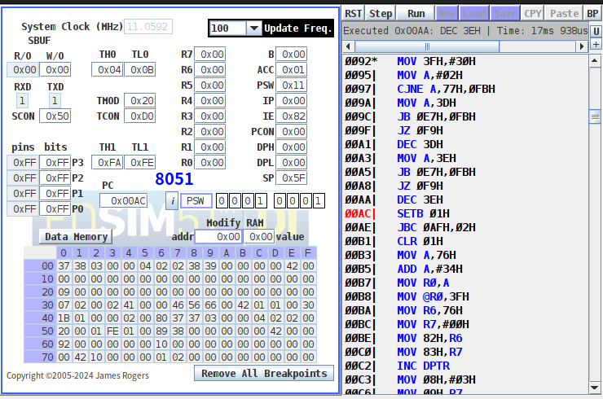
(iii) The mutex has been unlocked.
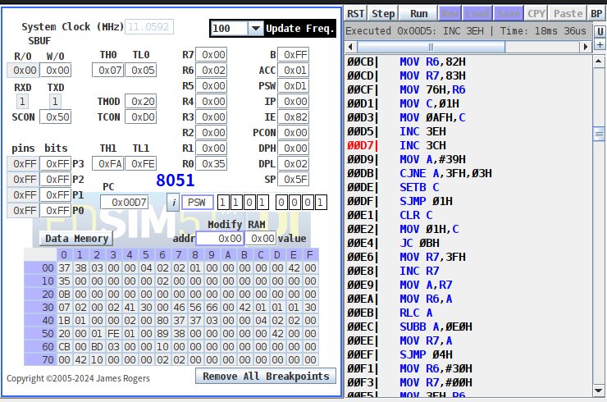
(iv) After exiting critical section i.e. signal(full), full = 2.
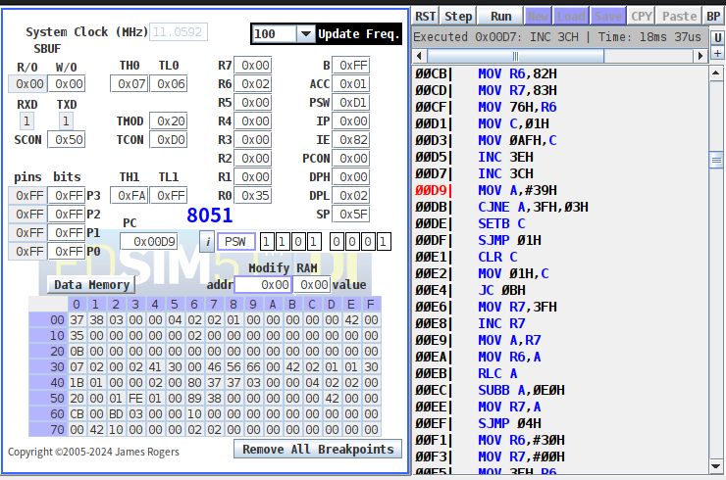
(v) Producer2 is running now, but it get stuck because it’s the turn of producer1 now. (turn = 1)
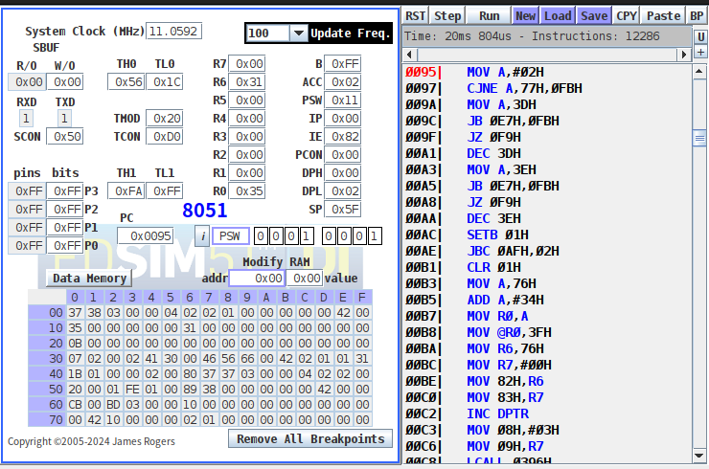

2. (c)
(I) Consumer starts running. Initially, full = 0, empty = 3, and mutex = 1.
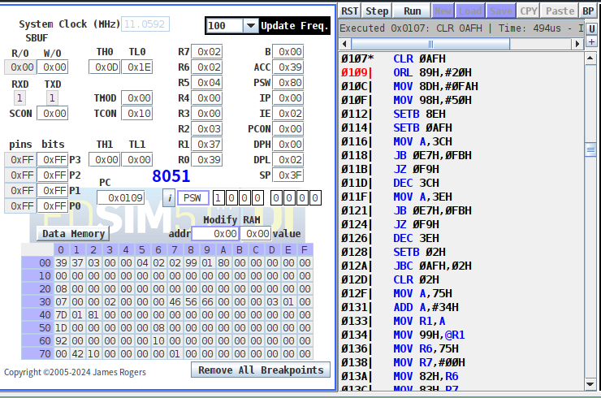
(ii) Consumer is in its critical section because mutex = 0.
It has gotten out of “wait(full)”, therefore, full has been minus one. Now full = 1, and empty = 1.
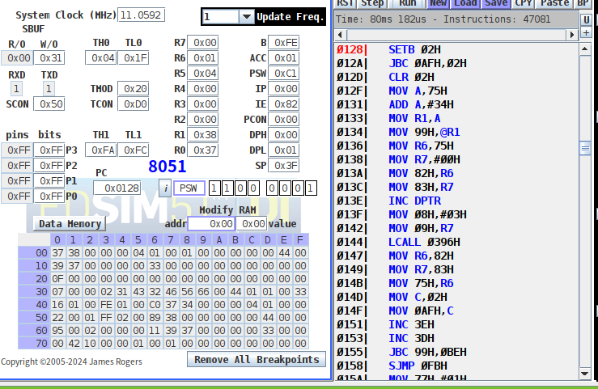
(iii) After exiting critical section, empty becomes 2 and mutex becomes 1.
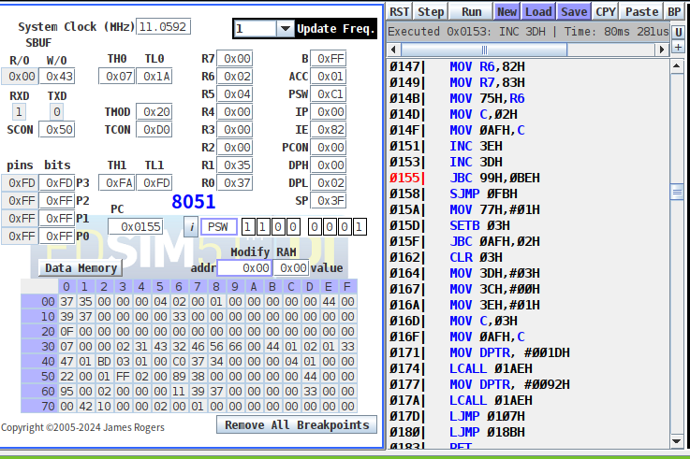

(iv) After a while, consumer is running but gets stuck, because the buffer is empty now. (empty = 3)
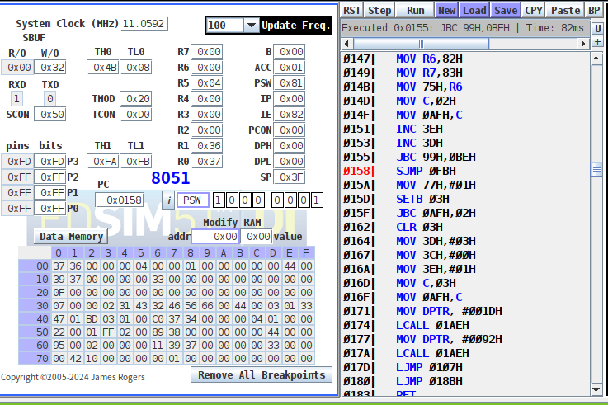

3. (a) Unfair version:
If we create producer1 earlier than producer2, then the buffer always be filled with items (A~Z) from producer1. The reason is that the period of timer is long enough for producer1 to full the buffer. There’s no chance for producer2 to get out from wait(empty).

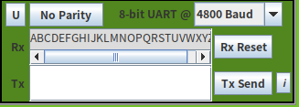

If we create producer2 first, then we get all output with 0~9.

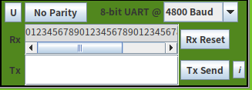

3. (b) Fair version:
Use a shared variable called “turn” to control. Initially, turn is set to 1.
If turn = 1, producer1 can execute the producing code, otherwise, producer2 can execute the producing code. Whenever producer1 finishes producing, it gives the chance for producer2 by setting turn = 2, and vice versa.
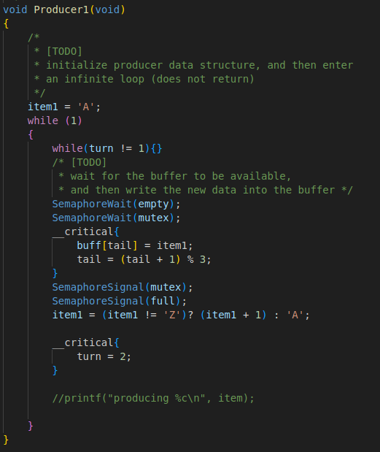
The UART will look like this:

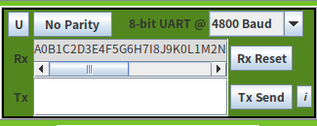

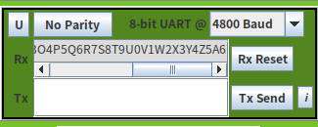

Clearly, it’s completely fair because producer 1 and 2 take turns to execute.

