Report of Project Checkpoint 5

112062630 JING-YONG, SU 蘇敬詠
Part 1.
1. Screenshots for compilation
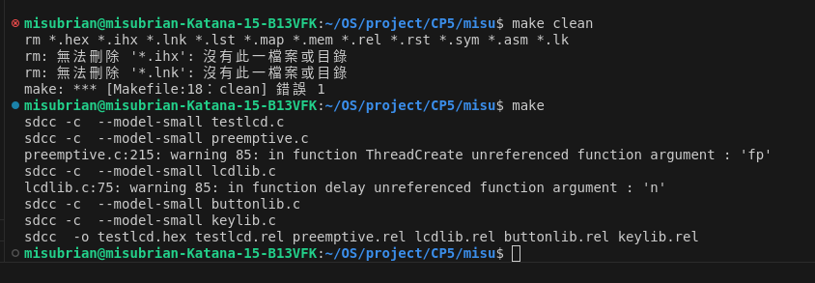

2.

(a) Bottom Part
(i) Return TRUE if any of bit of P2 is zero(i.e. pull-down), equivalent with P2 != 0xFF.

(ii) ButtonToChar(): Check from MSB to LSB of P2 is 0 or not first. Therefore, we can always return the largest number even when several buttons are pushed.

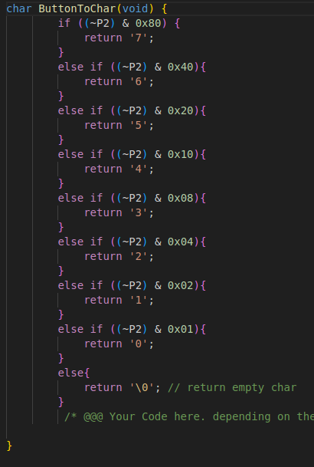

2. (b) Producer(1&2) function:
(I) Get input from button or keypad.
(ii) To avoid from repeatedly enqueue an number when button haven’t been released, I add the spin lock in front and end of the code.
(iii) Cancel the “turn” method done in CP4 because we can control the order and fairness by how to push the buttons.
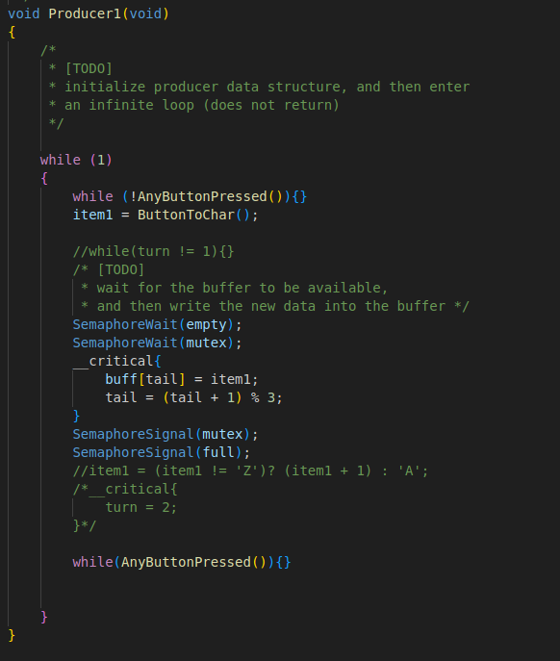

3. Modification on SemaphoreWaitBody:
Disable the interrupt to avoid race condition. Moreover, yield when it failed to get the semaphore.
The red rectangle below represents the section of while loop.
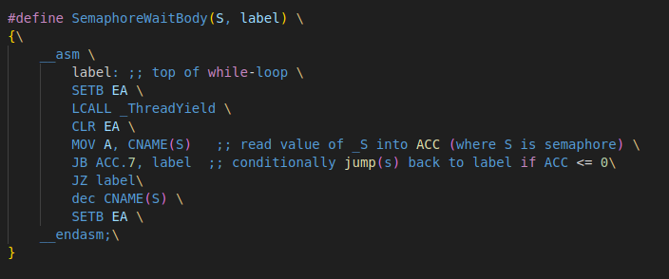
4. Notes:
My assignment runs properly with a single producer, and I can see the keys I press displayed on the LCD. However, I regret that my program does not function correctly with two producers. Nevertheless, I have submitted it for evaluation, leaving it to the discretion of the teaching assistants. I respect their decisions and am very grateful to the TAs who actively and patiently assisted and discussed the issues with me.

