Nama: Oscar Kurniawan Manule
NPM: 0706272080
Asisten: Ivonne (IMI)
PR 1 Sistem Cerdas

1.7 Examine the AI literature to discover whether the following tasks can currently be solved by computers:
a. Playing a decent game of table tennis (ping-pong)
b. Driving in the center of Cairo
c. Buying a week’s worth of groceries at the market
d. Buying a week’s worth of groceries at the web
e. Playing a decent game of bridge at a competitive level.
f. Discovering and proving new mathematical theorems
g. Writing an intentionally funny story.
h. Giving competent legal advice in a specialized area of law
i. Translating spoken English into spoken Swedish in real time.
j. Performing a complex surgical operation

Solution:

- The problem can currently be solved by computer. In 1988, Russel L. Andersson makes a research in a robot ping-pong player. Robot ping-pong player experiments in a real-time intelligent control. That robot could respond to human opponent in a real time. Literature: Andersson L. Russel. A Robot Ping-Pong Player Experiments in Real-Time Intelligent Control. MIT Press. 1988
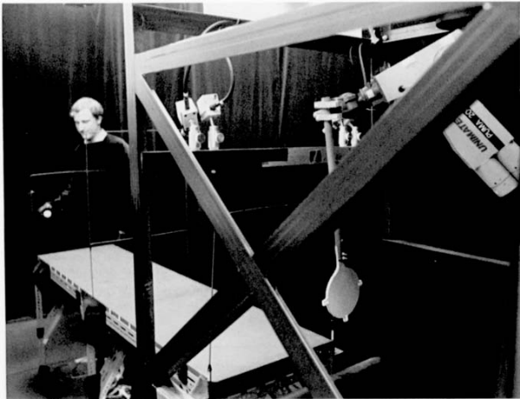
- Currently, there is no commercial implementation for full autodriving car even in Cairo but there are some implementations on researches. For Example: a research product named CyCab. It need many years on research and yet still ongoing but perhaps we will see it in a reality even in Cairo for some years ahead. Literature: C. Pradalier et al., "The CyCab: A Car-Like Robot Navigating Autonomously and Safely among Pedestrians," Robotics and Autonomous Systems, vol. 50, no. 1, 2005, pp. 51–68
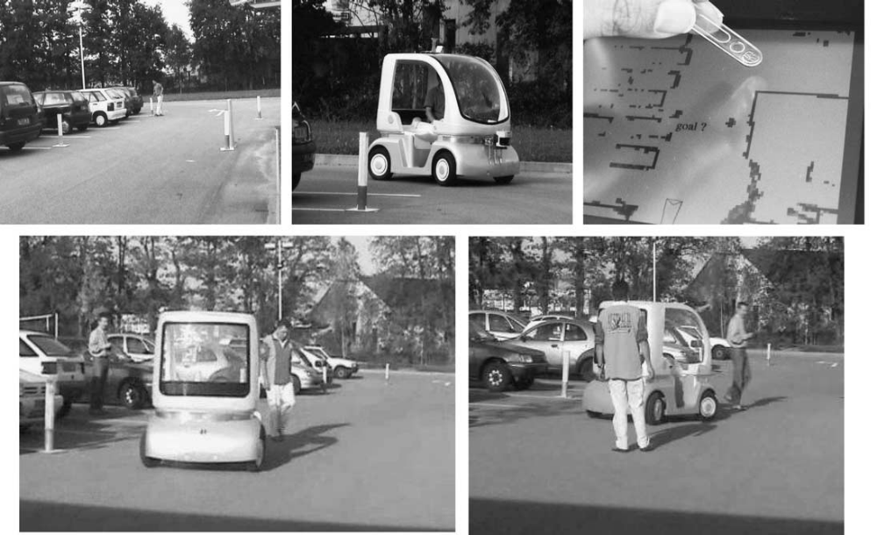
- Currently, there is no commercial implementation but there is a research work that is trying to implement it. It will cost more years ahead until commercial release. Kwang Hyoun Joo, Tetsuo Kinoshita, Norio Shiratori, "Agent-Based Grocery Shopping System Based on User's Preference," icpads, pp.499, Seventh International Conference on Parallel and Distributed Systems Workshops (ICPADS'00 Workshops), 2000
- Currently, Samsung is trying to implement an intelligent refrigerator to be able sending list of stuff to grocery store. This technology based on RFID.
- It has been released for commercial computer-based bridge game. One approach of this problem used AI planning techniques. Stephen J. Smith, Dana Nau, and Thomas Throop. “Success in Spades: Using AI Planning Techniques to Win the World Championship of Computer Bridge.” AI Magazine, June 1998.
- There is a literature (journal) that shown a computer prover for a new theorem even find a new theorem. Dongming Wang. “A new theorem discovered by computer prover.” Springer. Nov 1, 1989.
- There is no implementation for a complete funny story. Therefore, there are some proceedings that contain researches on joke generating like building a lexical database for an interactive joke generator. These researches could lead to implementation for a complete funny story generated by computer. Ruli Manurung, Dave O'Mara, Helen Pain, Graeme Ritchie and Annalu Waller (2006). “Building a lexical database for an interactive joke-generator.” In Proceedings of the Fifth International Conference on Language Resources and Evaluation (LREC 2006), Genoa, Italy, 24-26 May 2006
- There is an implementation within specific constraint. Zurek, Thomasz and Kruk, Emil. “Supporting of legal reasoning for cases which are not strictly regulated by law.” In Proceedings of the 12th International Conference on Artificial Intelligence and Law. 2009.
- There is an implementation found in the paper below. Kozo Oi , Eiichiro Sumira , Osamu Furuse , Hitoshi Iida , Tetsuya Higuchit. “Real-Time Spoken Language Translation Using Associative Processors” 1994
- Performing a complex surgery now can be done by automated robot. Russell H. Taylor, Fellow, IEEE, and Dan Stoianovici. “Medical Robotics in Computer-Integrated Surgery.” In IEEE TRANSACTIONS ON ROBOTICS AND AUTOMATION, VOL. 19, NO. 5, OCTOBER 2003

2.4 Let us examine the rationality of various vacuum-cleaner agent functions
a. Show that a simple vacuum-cleaner agent function described in Figure 2.3 is indeed rational under the assumptions listed on page 36
b. Describe a rational agent function for the modified performance measure that deducts one point for each movement. Does the corresponding agent program require internal state?
c. Discuss possible agent designs for the cases in which clean squares can become dirty and the geography of the environment is unknown. Does it make sense for the agent to learn from its experience in these cases? If so, what should it learn?

Solution:

- Every action that results clean floor in every step of this agent cost one energy. Therefore, the agent can measure only one thousand actions/percept sequences that results clean floor that allowed until the system turned down. All dirt must be cleaned out before the lifetime is over.
Case 1: Agent in Square A, Square A and Square B are clean
For Every Agents, the optimum cost for this operation is 0
Case 2: Agent in Square A, Square A is dirty while Square B is not
The cost required to clean the dirt is one therefore there is no other agents that can solved in more optimum cost.
Case 3: Agent in Square A, Square A is remain clean while Square B is dirty
The cost required to clean the dirt is two therefore there is no other agents that can solved in more optimum cost.
Case 4: Agent in Square A, Both Squares are dirty
The cost that there is no other agents that can do in more optimum one is three.
The agent doesn’t out from its environment and suck and clean when it finds that the floor is dirty (according to the table). The most applied operations are LEFT, RIGHT, SUCK which comply the assumptions.
- Each movement (LEFT, RIGHT, SUCK) is considered to cost one energy so if both are clean the agent should not do anything. Internal state is needed to note any movement applied to the current world.
Percept Sequence | Action
[A,Clean] | Right
[A, Dirty] | Suck
[B, Clean] | Left
[B, Dirty] | Suck
[A, Clean][A, Clean] | Right
. | .
. | .
[A,Clean][B,Clean] | NOP
. | .
. | .
 | .
[A,Clean][A, Clean][B, Dirty] | Suck
[A, Clean][A,Clean][B, Dirty] | NOP
. | .
. | .
. | .

- Yes, it does. The design should record the path passed and action done by the agent. The agent should aware the location that out of reach within the environment that should be considered as out of environment so it should backtrack and try another possibility. The agent can apply maze traversal algorithm like right-handed or left-handed algorithm or any modified so that all squares are traveled.

2.7 Implement a performance-measuring environment simulator for the vacuum-cleaner world depicted in Figure 2.2 and specified on page 36. Your implementation should be modular, so that the sensors, actuators

Solution:

See folder SourceCodes

