Project Title: Foundation Models for Automated Design of Energy Flow Systems

Application Stage: Phase I

PI: Misun Min (Argonne National Laboratory); Co-PIs: Sven Leyffer (ANL), Dillon Shaver (ANL); Tzanio Kolev (Lawrence Livermore National Laboratory); Julian Andrej (LLNL), Ricardo Vinuesa (University of Michigan); Paul Fischer (University of Illinois Urbana-Champaign); Luke Olson (UIUC); Elia Merzari (Pennsylvania State University)

This project develops an AI-driven design and control framework for energy-relevant fluid flow systems using training data from the high-fidelity simulation codes Nek5000/RS and MFEM, developed at ANL and LLNL under the Department of Energy’s Exascale Computing Project. Phase I focuses on building foundation models capable of predicting performance and durability metrics under varying operating conditions and geometric parameters. The workflow integrates large-scale simulation datasets with an agentic-AI framework to enable rapid optimization and adaptive control strategies. The Phase I deliverable will demonstrate low-cost real-time prediction for representative energy components (e.g., heat exchangers and reactor-core assemblies), which can be placed in a design optimization loop.

Current approaches to reactor-component analysis require thousands of GPU hours per configuration to assess device performance at a single parameter point (for example flow-rate or pressure-drop). The knowledge gained is generally not transferable to other configurations, so the process must be repeated for each case. The proposed approach will incorporate simulation data (velocity, pressure, temperature at prescribed spatial grid points) through an autoencoder that compresses the spatially-related data to build a common latent space across all the candidate training sets. The latent space representation will be used to predict the solution fields (through decoding) when new mesh geometries are fed in through the encoder. The overall process will be designed to meet fidelity requirements for essential quantities of interest (QOIs) such as thermal gradients and pressure drops.

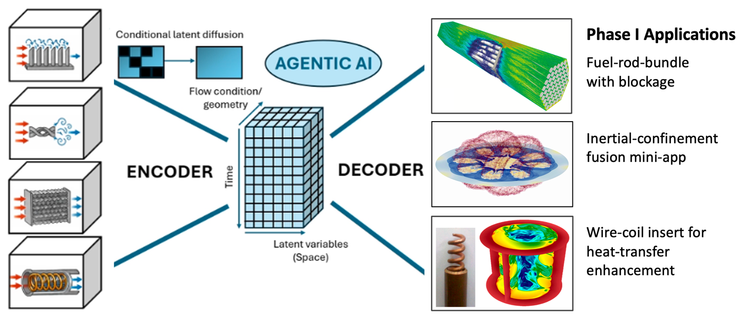

Figure 1. Schematic representation of the proposed method combining a foundation model with agentic AI. A wide range of high-quality fluid-flow datasets are used to train a foundation model, which encodes all the cases into a common latent space. Conditional latent diffusion is used to learn the distribution across cases in the latent space. Spatio-temporal data for a new geometry can be quickly produced in the latent space, and decoded back to the physical space. The agentic AI framework has access to this foundation model and the various optimizers, orchestrating the optimization/design process, which is significantly accelerated.

