April 14, 2026

Dr. Misun Min
Mathematics and Computer Science Division
Argonne National Laboratory
9700 S Cass Ave
Lemont, IL 60439
Subject: Letter of Collaboration to participating in “Foundation Models for Automated Design of Energy Flow Systems,” submitted in response to the DOE “Genesis Mission” RFA (DE-FOA-0003612)

Dear Dr. Min,

If your application entitled Foundation Models for Automated Design of Energy Flow Systems, is selected for funding under the RFA DE-FOA-0003612, The Genesis Mission: Transforming Science and Energy with AI, it is my intent to collaborate in this research by helping to define benchmarks of direct relevance to liquid-metal reactors and to ensure the project's relevance to industrial nuclear engineering heat transfer applications.

Thank you for the opportunity to participate.

Sincerely,

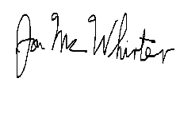
Jon McWhirter, PhD, PE
Chief Engineer, Thermal Hydraulics
TerraPower LLC
15800 Northup Way
Bellevue, WA 98008

