Foundation Models for Automated Design of Energy Flow Systems
PI: Misun Min (Argonne National Laboratory); Co-I’s: Sven Leyffer (ANL), Dillon Shaver (ANL); Tzanio Kolev (Lawrence Livermore National Laboratory); Ricardo Vinuesa (U. Michigan); Paul Fischer (U. Illinois); Luke Olson (U. Illinois); Elia Merzari (Penn State Univ).

This project develops an AI-driven design and control framework for energy-relevant fluid flow systems using training data from the high-fidelity simulation codes, Nek500/RS and MFEM, developed at ANL and LLNL under the Department of Energy’s Exascale Computing Project. Phase I focuses on building foundation models capable of predicting performance and durability metrics under varying operating conditions and geometric parameters. The workflow integrates large-scale simulation datasets with an agentic-AI framework to enable rapid optimization and adaptive control strategies. The Phase I deliverable will demonstrate low-cost real-time prediction for representative energy components (e.g., heat exchangers and reactor-core assemblies), which can placed in a design optimization loop.

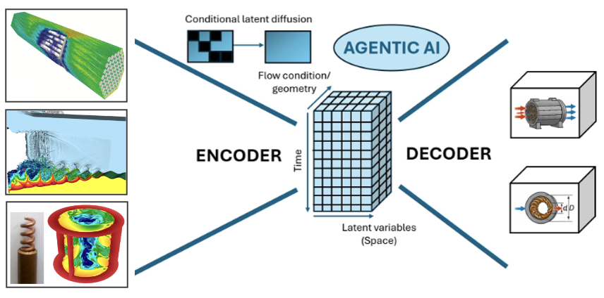
AI-driven workflow: validated simulation data (left) is processed through a graph-neural-network autoencoder to develop a compressed common latent space representation (center), which permits, in a matter of seconds, reconstrunction of solutions that are mapped to new geometries (right). High-accuracy QOIs can be derived in the fine-scale data and be encoded into the latent space so that they do not need to be derived directly from the low-costs surrogates.

Current approaches to reactor-component analysis require thousands of GPU hours per configuration to assess device performance at a single parameter point (for example flow-rate or pressure-drop). The knowledge gained is generally not transferable to other configurations, so the process must be repeated for each case. The proposed approach will incorporate simulation data (velocity, pressure, temperature at prescribed spatial grid points) through an autoencoder that compresses the spatially-related data to build a common latent space across all the candidate training sets. The latent space representation will be used to predict the solution fields (through decoding) when new mesh geometries are fed in through the encoder. The overall process will be designed to meet fidelity requirements for essential quantities of interest (QOIs) such as thermal gradients and pressure drops.
nd audited by Cognizant Federal Agency.

