下拉状态栏:
1.下拉状态栏的亮度条：
frameworks/base/packages/SystemUI/src/com/android/systemui/qs/QSPanel.java
mBrightnessView
对应布局文件：quick_settings_brightness_dialog.xml
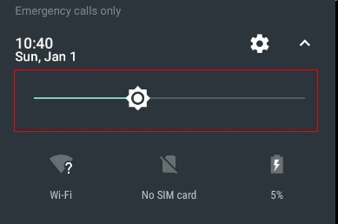

2.滑动亮度条后过渡到桌面的亮度条
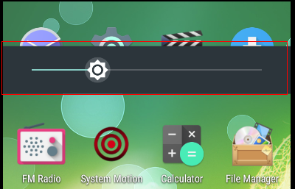

frameworks/base/packages/SystemUI/src/com/android/systemui/statusbar/phone/PhoneStatusBar.java
protected void inflateStatusBarWindow(Context context) {
mStatusBarWindow = (StatusBarWindowView) View.inflate(context,
R.layout.super_status_bar, null);
}
mStatusBarWindow
对应布局文件：super_status_bar.xml
布局文件中对应项： <include layout="@layout/brightness_mirror" />
3.亮度条中的滑动条样式修改
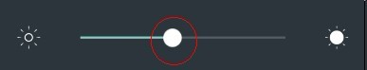
frameworks/base/packages/SystemUI/src/com/android/systemui/settings/ToggleSlider.java
布局文件：status_bar_toggle_slider.xml
4.下拉状态栏的图标块
有两处
/frameworks/base/packages/SystemUI/src/com/android/systemui/qs/tiles/***Tile.java
对应的Vector矢量图文件命名为ic_qs_xxx.xml
AirplaneModeTile:飞行模式，默认有动画的。用图片替换要把动画在代码中注释掉。
BatteryTile:电池。用BatteryMeterDrawable自定义view画出来的。
BluetoothTile:蓝牙
CastTile:投射
CellularTile:移动数据网络，无sim卡
ColorInversionTile:反色
DataSaverTile:流量节省程序
DataUsageDetailView:默认没显示，数据使用细节
DndTile:勿扰 do not disturb
FlashlightTile:手电筒
HotspotTile:热点
IntentTile:默认没显示，不知道长啥样
LocationTile:位置信息
RotationLockTile:自动旋转，纵向
ScreenShotTile:截图
UserDetailItemView:默认没显示，不知道长啥样
UserDetailView:默认没显示，不知道长啥样
UserTile:默认没显示，不知道长啥样
WifiTile:Wlan
WorkModeTile:默认没显示，不知道长啥样
还有MTK的
/frameworks/base/packages/SystemUI/src/com/mediatek/systemui/qs/tiles/***Tile.java
HotKnotTile
ApnSettingsTile
DualSimSettingsTile
MobileDataTile
QsIconWrapper
SimDataConnectionTile
5.增删下拉状态栏的图标块
frameworks/base/packages/SystemUI/res/values/config.xml中修改
<!-- The default tiles to display in QuickSettings -->
<!-- M: add hotknot tile -->
<string name="quick_settings_tiles_default" translatable="false">
wifi,cell,battery,dnd,flashlight,rotation,bt,airplane,location,hotknot,screenshot
</string>
6.WLAN图标块点击后信号强度
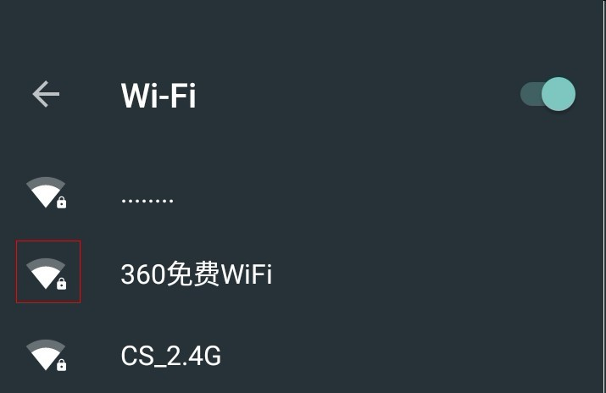
frameworks/base/packages/SystemUI/src/com/android/systemui/statusbar/policy/AccessPointControllerImpl.java
private static final int[] ICONS = {
R.drawable.ic_qs_wifi_full_0,
R.drawable.ic_qs_wifi_full_1,
R.drawable.ic_qs_wifi_full_2,
R.drawable.ic_qs_wifi_full_3,
R.drawable.ic_qs_wifi_full_4,
};
7.修改手机信号强度图
frameworks/base/packages/SystemUI/src/com/android/systemui/statusbar/policy/TelephonyIcons.java
static final int[][] QS_TELEPHONY_SIGNAL_STRENGTH = {
{ R.drawable.ic_qs_signal_0,
R.drawable.ic_qs_signal_1,
R.drawable.ic_qs_signal_2,
R.drawable.ic_qs_signal_3,
R.drawable.ic_qs_signal_4 },
{ R.drawable.ic_qs_signal_full_0,
R.drawable.ic_qs_signal_full_1,
R.drawable.ic_qs_signal_full_2,
R.drawable.ic_qs_signal_full_3,
R.drawable.ic_qs_signal_full_4 }
};
8.单条通知栏ｕｉ修改
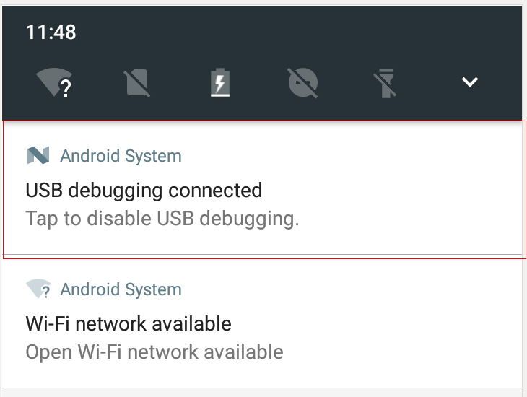
修改两个位置：
位置１：
frameworks/base/packages/SystemUI/src/com/android/systemui/statusbar/ActivatableNotificationView.java
protected void onFinishInflate() {}中
修改下面两句
mBackgroundNormal.setCustomBackground
mBackgroundDimmed.setCustomBackground
同时让下面两个方法为空
private void updateOutlineAlpha() {}
public void setFakeShadowIntensity(float shadowIntensity, float outlineAlpha, int shadowYEnd,
int outlineTranslation) {}
位置２：
frameworks/base/packages/SystemUI/src/com/android/systemui/statusbar/stack/NotificationStackScrollLayout.java
这个是个ViewGroup，它在onDraw里面还画了次背景。需要干掉这个背景。
让下面这个方法为空。
private void updateBackground() {}
protected void onDraw(Canvas canvas) {}中注销掉下面这句
canvas.drawRect(0, mCurrentBounds.top, getWidth(), mCurrentBounds.bottom, mBackgroundPaint);
修改后效果：
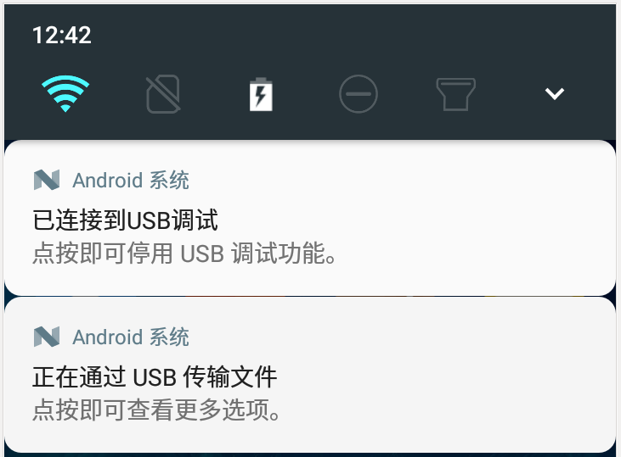
9.多条通知栏的背景修改
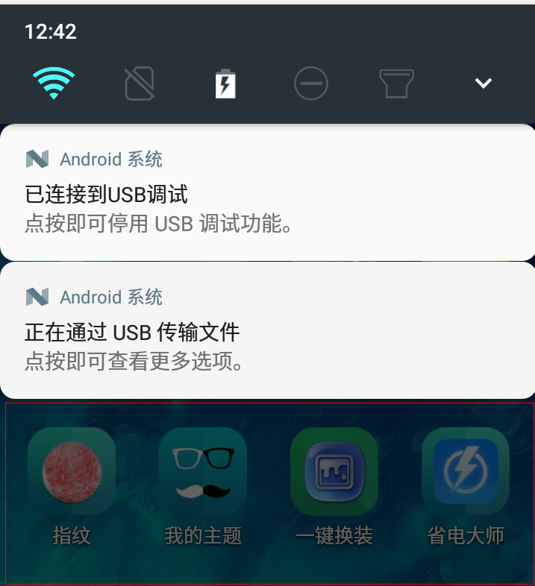

frameworks/base/packages/SystemUI/src/com/android/systemui/statusbar/phone/NotificationPanelView
默认背景就是当前界面截图加了个黑色透明度。
这个要谨改，因为会影响到按下power键唤醒屏幕时候的锁屏。如果把背景设成黑色，可能power键唤醒屏幕后，多条通知栏的背景是黑的。
10.删除修改显示布局边界，GPU呈现模式分析，Nearby
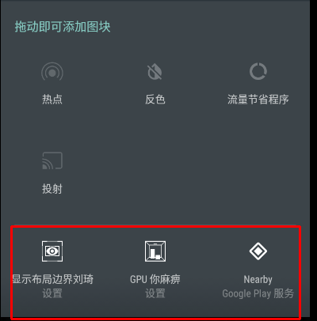

GPU呈现模式分析，显示布局边界都是packages/apps/Settings中的
在AndroidManifest.xml中可以找到
<service
android:name=".qstile.DevelopmentTiles$ShowLayout"
android:label="@string/debug_layout"
android:icon="@drawable/tile_icon_show_layout"
android:permission="android.permission.BIND_QUICK_SETTINGS_TILE"
android:enabled="false">
<intent-filter>
<action android:name="android.service.quicksettings.action.QS_TILE" />
</intent-filter>
</service>
<service
android:name=".qstile.DevelopmentTiles$GPUProfiling"
android:label="@string/track_frame_time"
android:icon="@drawable/tile_icon_graphics"
android:permission="android.permission.BIND_QUICK_SETTINGS_TILE"
android:enabled="false">
<intent-filter>
<action android:name="android.service.quicksettings.action.QS_TILE" />
</intent-filter>
</service>
label对应的string在framework/base/packages/SettingsLib中
icon对应的drawable在packages/apps/Settings中
packages/apps/Settings/src/com/android/settings/qstile/DevelopmentTiles.java
Nearby是谷歌的玩意，修改的话也能修改，就是加判定在TileQueryHelper.java中修改，当然上面的
GPU呈现模式分析，显示布局边界也可以这么修改。只不过不建议用这种方式修改。
删除这三个东西：
frameworks/base/packages/SystemUI/src/com/android/systemui/qs/customize/TileQueryHelper.java
中
private class QueryTilesTask extends
AsyncTask<Collection<QSTile<?>>, Void, Collection<TileInfo>> {}
doInBackground{}中
List<ResolveInfo> services = pm.queryIntentServicesAsUser(
new Intent(TileService.ACTION_QS_TILE), 0, ActivityManager.getCurrentUser());
这句修改为
//lqp
//List<ResolveInfo> services = pm.queryIntentServicesAsUser(
// new Intent(TileService.ACTION_QS_TILE), 0, ActivityManager.getCurrentUser());
List<ResolveInfo> services = new ArrayList<ResolveInfo>();

