Settings设置
packages/apps/Settings
framework/base/packages/SettingsLib
framework/base/packages/SettingsProvider
1.Settings常见页面对应文件以及布局
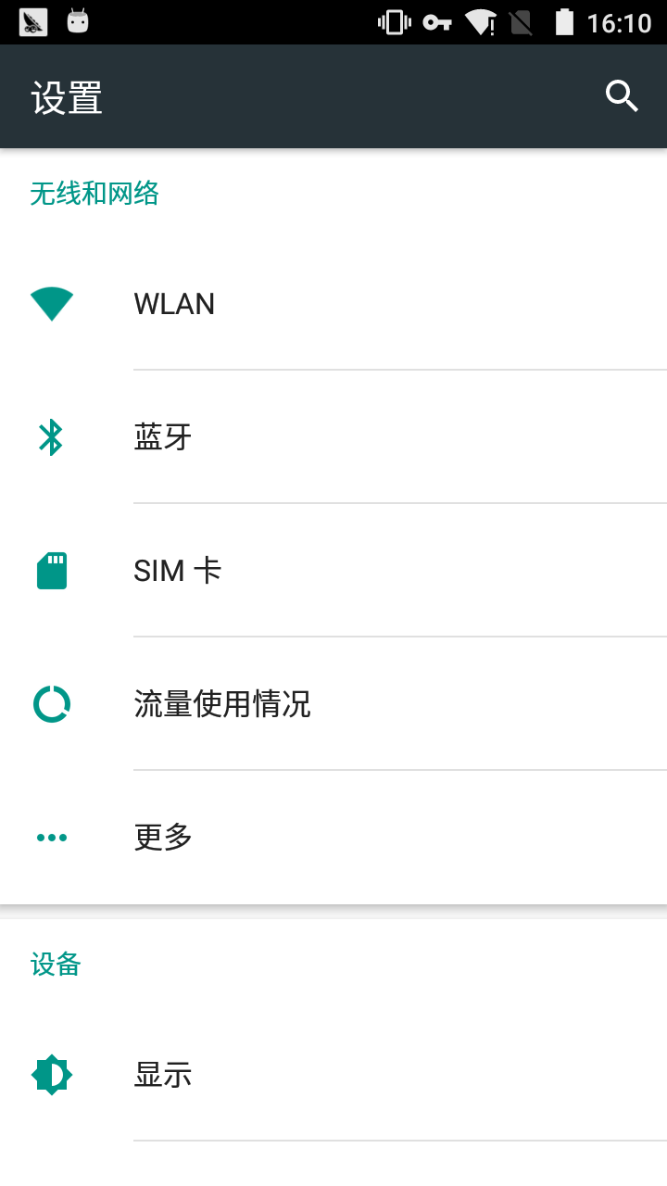

Android M:
packages/apps/Settings/res/xml/dashboard_categories.xml
每个选项的点击事件在上面的ｘｍｌ文件中，可以去看。
Android N:
没有dashboard_categories.xml了。暂时还没研究。

WLAN：WifiSettings.java
蓝牙：BluetoothSettings.java
SIM卡：SimSettings.java
流量使用情况：DataUsageSummary.java
更多：WirelessSettings.java
显示：DisplaySettings.java
智能唤醒：SmartWakeActivity.java
提示音和通知：NotificationSettings.java
应用：ManageApplications.java
存储：StorageSettings.java
电池：PowerUsageSummary.java
内存：ProcessStatsSummary.java
位置信息：LocationSettings.java
安全：SecuritySettings.java
账户：AccountSettings.java
语言和输入法：InputMethodAndLanguageSettings.java
Google：
备份和重置：PrivacySettings.java
日期和时间：DateTimeSettings.java
定时开关机：<intent android:action="com.android.settings.SCHEDULE_POWER_ON_OFF_SETTING" />
无障碍：AccessibilitySettings.java
打印：PrintSettingsFragment.java
开发者选项：DevelopmentSettings.java
关于手机：DeviceInfoSettings.java
2.Settings中部分子页面对应
settings/security/app-permissions：/vendor/mediatek/proprietary/packages/apps/PermissionControl
settings/security/anti-theft：/vendor/mediatek/proprietary/packages/apps/PrivacyProtectionLock
settings/security/data protection：/vendor/mediatek/proprietary/packages/apps/DataProtection
settings/Display/Font size:
packages/apps/Settings/res/values/arrays.xml
<string-array name="entryvalues_font_size" translatable="false">
<item>0.85</item>
<item>0.99</item>
<item>1.0</item>
<item>1.02</item>
</string-array>
分别对应字体小，正常，大，超大。
3.Settings各个子页面的各种选项默认值
存储的默认值有三个位置：
alps/frameworks/base/packages/settingsprovider/res/valuse/Defaults.xml
alps/frameworks/base/core/res/res/values/config.xml
xxx.mk文件中配置的宏控预设了值。
第一次开机读取上述值的代码位置：
alps/frameworks/base/packages/SettingsProvider/src/com/android/providers/settings/DatabaseHelper.java
DatabaseHelper中涉及到的大量常量值定义位置：
alps/frameworks/base/core/java/android/provider/Settings.java
Settings.java定义内部类。内部类定义了很多常量
例如：Settings.System.HAPTIC_FEEDBACK_ENABLED
Settings .Global.CHARGING_SOUNDS_ENABLED
简单的例子：
拨号键盘提示音：<bool name="def_dtmf_tones_enabled">true</bool>
屏幕锁定提示音：<integer name="def_lockscreen_sounds_enabled">1</integer>
触摸提示音： <bool name="def_sound_effects_enabled">true</bool>
点按时振动： <bool name="def_haptic_feedback">true</bool>
现在是默认开启的，如果要改为默认关闭。true改为false,1改为0.

