长按Power键
1.长按power键后的对话框修改：
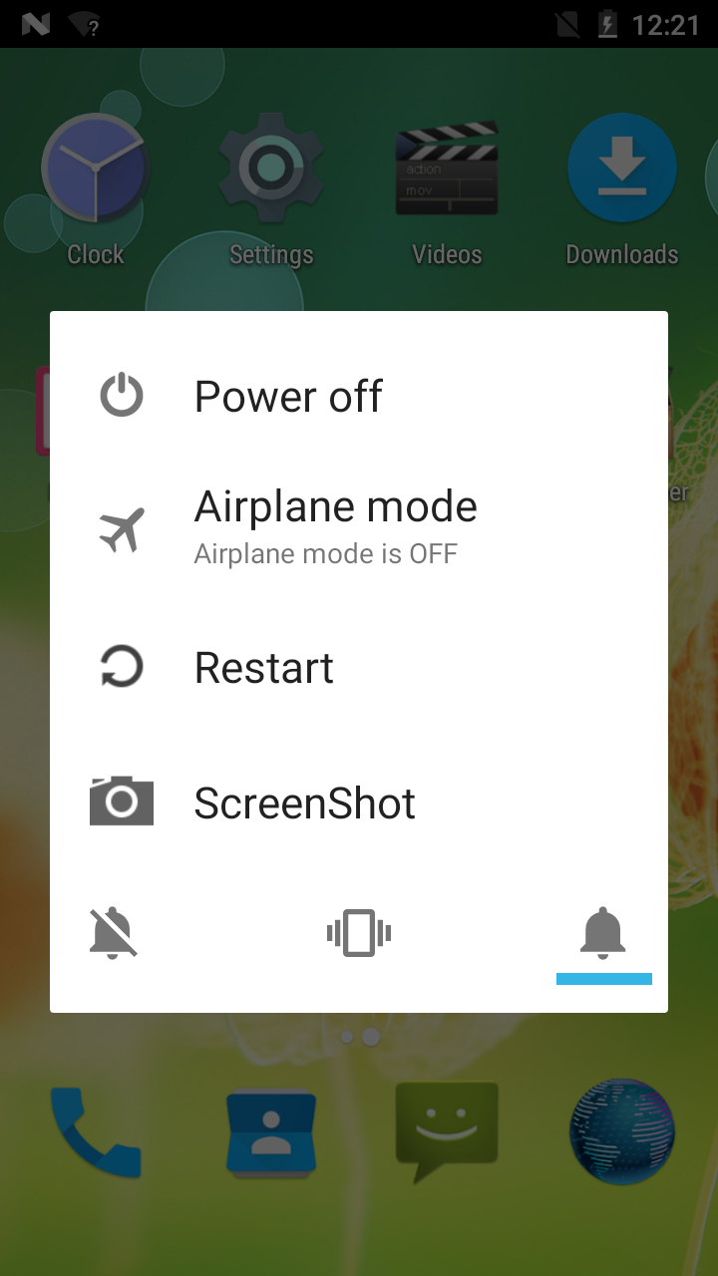
frameworks/base/services/core/java/com/android/server/policy/PhoneWindowManager.java
修改showGlobalActionsInternal();因为长按power键的逻辑在这。
frameworks/base/services/core/java/com/android/server/policy/GlobalActions.java
如果要移除这个对话框的某一项。
注销掉对应的mItems.add(***)即可;
2.长按Power键的对话框新增选项
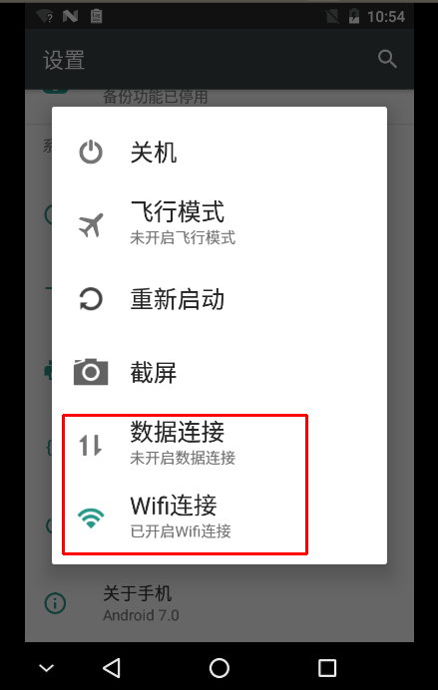

新增图片，string资源:
framework/base/core/res/res/
将资源公开：
framework/base/core/res/values/config.xml
修改代码：
frameworks/base/services/core/java/com/android/server/policy/GlobalActions.java
如果是做类似截屏这种功能(图片不显示状态)
//add by liuqipeng for dataconnection begin BUG #26154
private final class DataConnectionAction extends SinglePressAction{
private DataConnectionAction() {
super(com.android.internal.R.drawable.dataconnection,
R.string.global_action_dataconnection);
}
@Override
public boolean showDuringKeyguard() {
return true;
}

@Override
public boolean showBeforeProvisioning() {
return true;
}

@Override
public void onPress() {
if(telephonyManager.getDataEnabled()){
telephonyManager.setDataEnabled(false);
}else{
telephonyManager.setDataEnabled(true);
}
}

}
private final class WifiConnectionAction extends SinglePressAction{
private WifiConnectionAction() {
super(com.android.internal.R.drawable.wificonnection,
R.string.global_action_wificonnection);
}
@Override
public boolean showDuringKeyguard() {
return true;
}

@Override
public boolean showBeforeProvisioning() {
return true;
}

@Override
public void onPress() {
if(wifiManager.isWifiEnabled()){
wifiManager.setWifiEnabled(false);
}else{
wifiManager.setWifiEnabled(true);
}
}

}
//add by liuqipeng for dataconnection end BUG #26154
如果做类似飞行模式这种的(图片显示开启关闭状态)
创建ToggleAction对象就行了，需要实现下onToggle这个抽象方法。如果对话框是一点就关闭的，就可以不需要用观察者模式去观察对应的值变化了(每次创建对话框的时候读一次值，确保是正确的状态)。不过谷歌的代码飞行模式是用观察者模式处理的了(比如在对话框界面把sim卡拔掉了？或者其他途径飞行模式状态变化了)，更稳。
//liuqipeng add BUG #26154
mDataModeOn = new ToggleAction(
R.drawable.dataconnection,
R.drawable.dataconnection_off,
R.string.global_action_dataconnection,
R.string.global_action_dataconnection_on,
R.string.global_action_dataconnection_off) {

void onToggle(boolean on) {
if(telephonyManager.getDataEnabled()){
telephonyManager.setDataEnabled(false);
}else{
telephonyManager.setDataEnabled(true);
}
}

public boolean showDuringKeyguard() {
return true;
}

public boolean showBeforeProvisioning() {
return false;
}
};
//onDataModeChanged();
boolean dataModeOn = telephonyManager.getDataEnabled();
mDataState = dataModeOn ? ToggleAction.State.On : ToggleAction.State.Off;
mDataModeOn.updateState(mDataState);
mWifiModeOn = new ToggleAction(
R.drawable.wificonnection,
R.drawable.wificonnection_off,
R.string.global_action_wificonnection,
R.string.global_action_wificonnection_on,
R.string.global_action_wificonnection_off) {

void onToggle(boolean on) {
if(wifiManager.isWifiEnabled()){
wifiManager.setWifiEnabled(false);
}else{
wifiManager.setWifiEnabled(true);
}
}

public boolean showDuringKeyguard() {
return true;
}

public boolean showBeforeProvisioning() {
return false;
}
};
//onWifiModeChanged();
boolean wifiModeOn = wifiManager.isWifiEnabled();
mWifiState = wifiModeOn ? ToggleAction.State.On : ToggleAction.State.Off;
mWifiModeOn.updateState(mWifiState);
//liuqipeng end BUG #26154

