GetPrimitivesToGoal → Get expanded collision free primitives
GetALlPrimitives → Get expanded primitivies
GetClosedSet-→ Get points in the close set
GetOpenSet → Get points in the Open Set
GetExpandedNodes-→ Get expanded nodes, for A* should be the same as the closed set
getWs-→ get states on the optimal trajectory
getTraj → get optimal trajectory
getPrimitivesToGoal → Get valid (collision free) primitives connecting to the goal
getValidPrimitives → Get expanded collision free primitives
getAllPrimitives → Get expanded primitives

setW-→ set weight for cost in time
setEpsilon → Set greedy searching param

In A*: The "Open set" is the set of nodes we choose current from - that is, it contains all the nodes we might be interested in looking at next. The "Closed set" is the set of nodes we've already considered. Often, rather than an actual closed-set, we'll just set a flag on each Node, named HasBeenVisited or something similar.
Initially, the Open set contains only start, so in the first iteration we remove start, add its neighbors to the Open set, and add start to the Closed set. Then we take the next node in the Open set, add its neighbors, etc.
Assuming your heuristic is consistent, they do not get readded to the open set once removed.
Es decir
- closedSet →The set of nodes already evaluated
- openSet → The set of currently discovered nodes that are not evaluated yet. Initially, only the start node is known.

The prior trajectory is read from a file.

Waypoint is an struct that has these fields and functions:
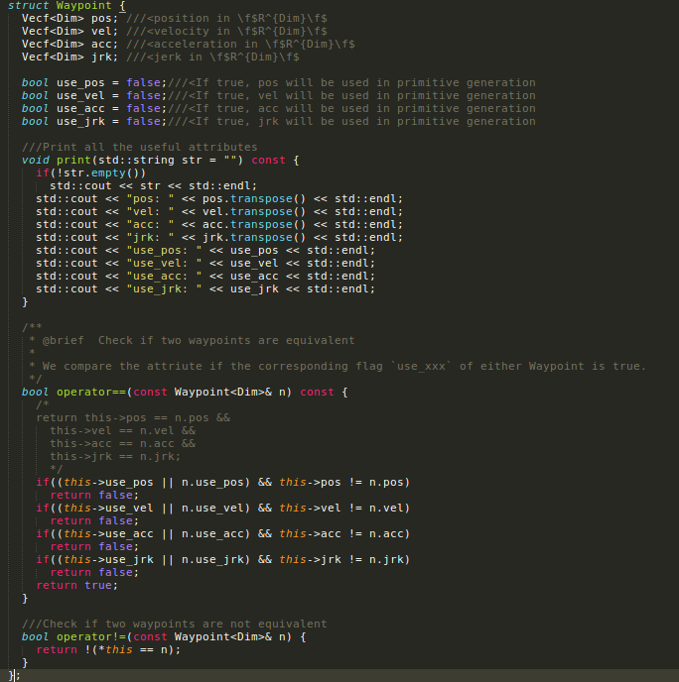

Donde dice Vecf is Eigen::Matrix
