 | Diagnostic Medicare Center Manager  Business Requirements Document  V1.0
 | Prepared By / Last Updated By | Reviewed By | Approved By
Name | Cognizant Academy
Role
Signature
Date

Table of Contents

1.0 Introduction 3
1.1 Purpose of this document 3
1.2 Project Overview 3
1.2.1 Objectives 3
1.3 Intended Audience 3
2.0 Process Architecture 4
3.0 High Level Business Requirements 8
4.0 Detailed Business Requirements 10
4.1 Functional Requirements 10
5.0 References 21
5.1 Table 1.0 22
5.2 Table 2.0 22
5.3 Table 3.0 23
5.4 Table 4.0 23
5.5 Table 5.0 23
5.6 Table 6.0 24
5.7 Table 7.0 25
5.8 Table 8.0 25
6.0 Terms & Conditions 26
7.0 Change Log 26

Introduction

Purpose of this document
This document is aimed at:
- Providing the necessary inputs to the detailed requirements gathering phase and further on for the SDLC processes.
- This document also serves to establish the traceability between the Business Objectives and the requirements identified in the proposed solution and how they satisfy the stated objectives.
- Provide expectation traceability in terms of the requirements and the Customer expectation
- Serves as a formal template for documenting the Business Requirements, which also includes statutory and regulatory requirements.
The purpose of this document is to systematically capture requirements for the project and the system to be developed. Functional requirements are captured in this document. It also serves as the input for the project scoping.

Project Overview

Objectives
Below are the objectives that shall be fulfilled post the execution of this project:
Diagnostic Medicare Center Management system will create and maintain Customer and Doctor Information.
- Create and maintain customer and doctor information.
- Search for the Medicare services.
- Customer applies for the Health Checkup.
- Customer can search for agent.
- Customer/Doctor will view the result.

Intended Audience
- All member of the project.
- Delivery Assurance Group.

Process Architecture
Below is the overall functional flow of the project including the components of interaction
- Create Customer Registration page & Authentication.
- Create Admin Registration page & Authentication.
- Create Doctor Registration page & Authentication.
- Get and manage Doctor Details.
- Update medical service details.
- Get and manage Agent Details.
- Raise Check up request.
- Doctor / Admin to upload the test results.
- Option to view the Test results for Customer / Doctor.
- Update / delete/ maintain Doctor / Customer/ Medical Service info
- Disconnect on log off.

Admin Process flow
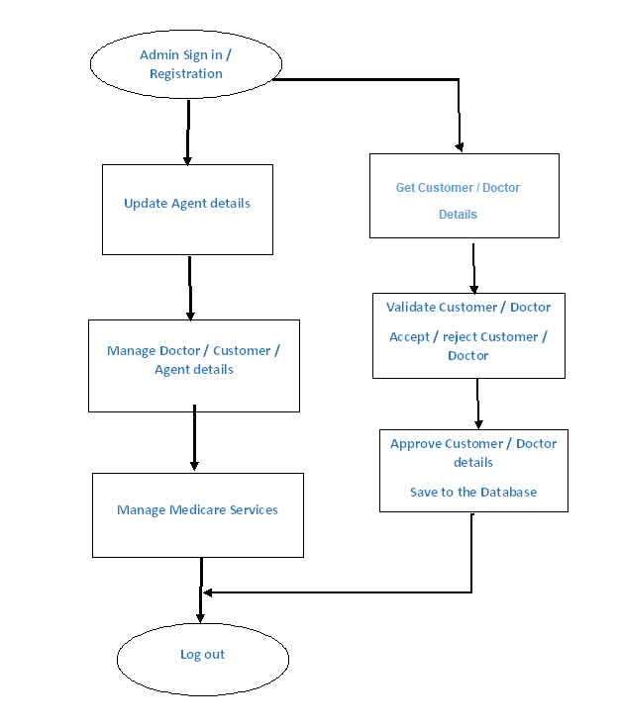

Customer Process Flow
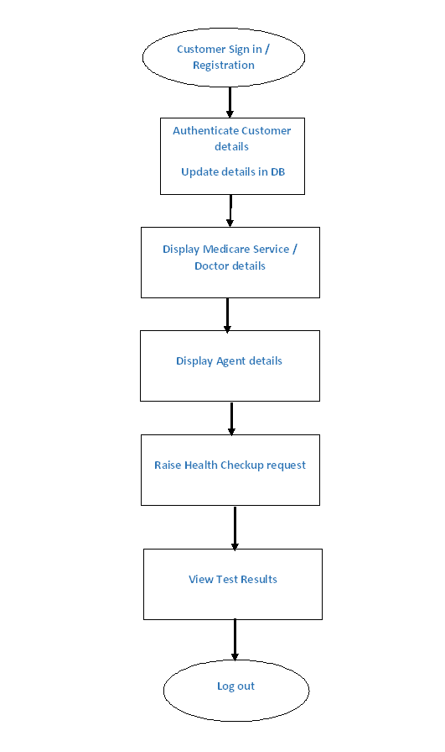
Doctor Process flow
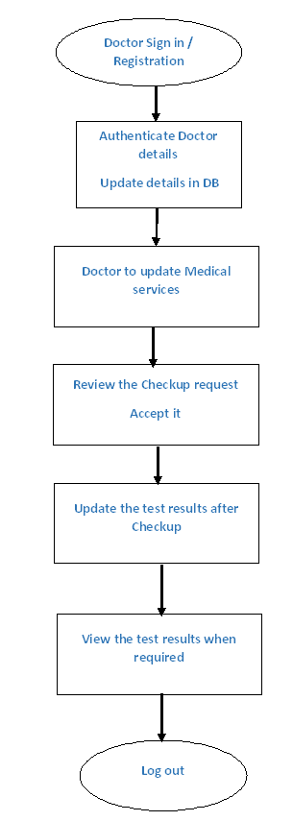

High Level Business Requirements
Note - Primary focus is to complete developing the critical requirements (highlighted in Yellow) and then to proceed with the remaining requirements.
S.No. | Business Requirement ID | Short Description | Description in detail | Interacting Business Processes
1 | Req_1 | Initial Selection | Ability of the system to allow to Customer to choose Admin/Customer/ Doctor Login/Registration
2 | Req_2 | Customer Registration | Ability of the system to procure the fundamental details of the Customer
3 | Req_3 | Customer Authentication | Ability of the system to authenticate the Customer credentials of the registered Customer
4 | Req_4 | Doctor Registration | Ability of the system to procure the fundamental details of the Doctor
5 | Req_5 | Doctor Authentication | Ability of the system to authenticate the Doctor credentials of the registered Doctor
6 | Req_6 | Agent Registration | Ability of the system to procure the fundamental details of the Agent
7 | Req_7 | Agent Authentication | Ability of the system to authenticate the Agent credentials of the registered Agent
8 | Req_8 | Admin Registration | Ability of the system to procure the fundamental details of the Admin
9 | Req_9 | Admin Authentication | Ability of the system to authenticate the credentials of the registered Admin
10 | Req_10 | Add / Update Medicare Service Details | Ability of the system to allow doctor to add / update the Medicare service Details
11 | Req_11 | Update Agent details | Ability of the system to allow Admin to update Agent Details
12 | Req_12 | View Medicare Service/ Doctor details | Ability of the system to list Medicare service / Doctor details to the Customer / Agent.
13 | Req_13 | Book appointment | Ability of the system to allow Customer / agent to book appointment
14 | Req_14 | Approval / Denial for appointment | Ability of the system to allow Doctor / Admin to approve / deny the
15 | Req_15 | View appointment status | Ability of the system to allow Customer / agent to view appointment status.
16 | Req_16 | Send remainders | Ability of the system to send remainder messages to Doctor / Patient upon the Appointment approval.
17 | Req_17 | Update Test results | Ability of the system to allow Admin to update the Test result.
18 | Req_18 | View Test Result | Ability of the system to allow customer / doctor to view the updated test result.
19 | Req_19 | Update Treatment / prescription details | Ability of the system to allow Doctor to update Treatment / prescription details
20 | Req_20 | Maintain treatment history | Ability of the system to allow doctor to maintain the treatment history of the patient
21 | Req_21 | View treatment history | Ability of the system to allow patient to view the treatment history
22 | Req_22 | Chat with Doctors | Ability of the system to allow Patients to chat with Doctors
23 | Req_23 | Help | Page to assist the Customers to report technical issues
24 | Req_24 | Other validations | Ability of the system to allow add on validations like Forget Customer ID, Forget Password
25 | Req_25 | Reviews | Ability of the system to allow the Customer to provide feedback / reviews for Doctor / Service
26 | Req_26 | Review Questionnaire | Ability of the system to allow admin to create review questionnaire for the Doctor / Service
27 | Req_27 | Trigger Review | For an appointment, once the treatment / follow up is completed, on the next log trigger message to the Customer for Review.
28 | Req_28 | Agent commission | Ability of the system to calculate agent commission based on the service
29 | Req_29 | View Commission | Ability of the system to allow Agent to view Commission details.
30 | Req_30 | Update Commission details | Ability of the system to allow admin to update commission details for the services.
31 | Req_31 | Admin reporting | Ability of the system to pull report for any service, agent, doctor.
32 | Req_32 | Customer / Admin logoff | Ability of the system to enable Customer / Admin to logoff

Detailed Business Requirements

Functional Requirements
The Requirements in this document are prioritized as follows:
Value | Rating | Description
1 | Critical | This requirement is critical to the success of the project. The project will not be possible without this requirement.
2 | High | This requirement is high priority, but the project can be implemented at a bare minimum without this requirement.
3 | Medium | This requirement is somewhat important, as it provides some value but the project can proceed without it.
4 | Low | This is a low priority requirement or a “nice to have” feature, if time and cost allow it.
5 | Future | This requirement is out of scope for this project, and has been included here for a possible future release.

Req. # | Rationale Categorization | Business Requirement | Req. Type * | Priority ** | Originator *** | BR Traced to Business Requirement / Use case ID | Impacted Stakeholders
Req_1.1 | Initial selection | Screen should display the option for Admin login / Registration and Patient / User login / Registration  Doctor login / Registration | UI | Critical | NA | Req_1
Req_2.1 | Patient / User Registration | When the Patient / User clicks on the registration link, it should re-direct to registration form. | UI | Critical | NA | Req_2
Req_2.2 | Patient / User Registration | Patient / User needs to fill some of the basic attributes/fields as mentioned below in requirement: First Name, Last Name, Age, Gender, Contact Number, Patient / User Id, Password | UI | Critical | NA | Req_2 | Please refer to Table 1.0 under References
Req_2.3 | Patient / User Registration | Clicking ‘Submit’ should validate the datatype constraints for each field | F | Critical | NA | Req_2
Req_2.4 | Patient / User Registration | Patient / User failing to provide information on the mandatory fields be provided with an alert message – ‘Please update the highlighted mandatory field(s).’ Also, highlight the missed out field in red | E | Medium | NA | Req_2
Req_2.5 | Patient / User Registration | Post-successful field level validation, save the information in the database | F | Critical | NA | Req_2
Req_2.6 | Patient / User Registration | Upon saving the information in the database, display the message, ‘Your details are submitted successfully’. | E | Medium | NA | Req_2
Req_2.7 | Patient / User Registration | Admin should be able to view the New Patient / Users for registration | F | Critical | NA | Req_2
Req_2.8 | Patient / User Registration | Admin should approve / reject the Patient / User Request. | F | Critical | NA | Req_2
Req_2.9 | Patient / User Registration | If rejected, the Patient / User should not be allowed to login with the registered credentials | F | Critical | NA | Req_2
Req_2.10 | Patient / User Registration | Patient / User should get SMS on Approval / Rejection | E | Medium | NA | Req_2
Req_3.1 | Credential Authentication | A registered Patient / User – is able click ‘Login’ link, after keying in ‘Patient / User ID’ & ‘Password’ field and get his credentials authenticated with the existing database entry. | F | Critical | NA | Req_3
Req_4.1 | Doctor Registration | When the Doctor clicks on the registration link, it should re-direct to registration form. | UI | Critical | NA | Req_4
Req_4.2 | Doctor Registration | Doctor needs to fill some of the basic attributes/fields as mentioned below in requirement: First Name, Last Name, Age, Gender, Contact Number, Doctor Id, Password | UI | Critical | NA | Req_4 | Please refer to Table 2.0 under References
Req_4.3 | Doctor Registration | Clicking ‘Submit’ should validate the datatype constraints for each field | F | Critical | NA | Req_4
Req_4.4 | Doctor Registration | Doctor failing to provide information on the mandatory fields be provided with an alert message – ‘Please update the highlighted mandatory field(s).’ Also, highlight the missed out field in red | E | Medium | NA | Req_4
Req_4.5 | Doctor Registration | Post-successful field level validation, save the information in the database | F | Critical | NA | Req_4
Req_4.6 | Doctor Registration | Upon saving the information in the database, display the message, ‘Your details are submitted successfully’. | E | Medium | NA | Req_4
Req_4.7 | Doctor Registration | Admin should be able to view the New Doctors for registration | F | Critical | NA | Req_4
Req_4.8 | Doctor Registration | Admin should approve / reject the Doctor Request. | F | Critical | NA | Req_4
Req_4.9 | Doctor Registration | If rejected, the Doctor should not be allowed to login with the registered credentials | F | Critical | NA | Req_4
Req_4.10 | Doctor Registration | Doctor should get SMS on Approval / Rejection | E | Medium | NA | Req_4
Req_5.1 | Credential Authentication | A registered Customer – is able click ‘Login’ link, after keying in ‘Doctor ID’ & ‘Password’ field and get his credentials authenticated with the existing database entry. | F | Critical | NA | Req_5
Req_6.1 | Agent Registration | When the Agent clicks on the registration link, it should re-direct to registration form. | UI | Critical | NA | Req_6
Req_6.2 | Agent Registration | Agent needs to fill some of the basic attributes/fields as mentioned below in requirement: First Name, Last Name, Age, Gender, Contact Number, Agent Id, Password | UI | Critical | NA | Req_6 | Please refer to Table 3.0 under References
Req_6.3 | Agent Registration | Clicking ‘Submit’ should validate the datatype constraints for each field | F | Critical | NA | Req_6
Req_6.4 | Agent Registration | Agent failing to provide information on the mandatory fields be provided with an alert message – ‘Please update the highlighted mandatory field(s).’ Also, highlight the missed out field in red | E | Medium | NA | Req_6
Req_6.5 | Agent Registration | Post-successful field level validation, save the information in the database | F | Critical | NA | Req_6
Req_6.6 | Agent Registration | Upon saving the information in the database, display the message, ‘Your details are submitted successfully’. | E | Medium | NA | Req_6
Req_7.1 | Credential Authentication | A registered Agent – is able click ‘Login’ link, after keying in ‘Agent ID’ & ‘Password’ field and get his credentials authenticated with the existing database entry. | F | Critical | NA | Req_7
Req_8.1 | Admin Registration | When the Admin clicks on the registration link, it should re-direct to registration form. | UI | Critical | NA | Req_8
Req_8.2 | Admin Registration | Admin needs to fill some of the basic attributes/fields as mentioned below in requirement: First Name, Last Name, Age, Gender, Contact Number, Vendor Id, Password | UI | Critical | NA | Req_8 | Please refer to Table 3.0 under References
Req_8.3 | Admin Registration | Clicking ‘Submit’ should validate the datatype constraints for each field | F | Critical | NA | Req_8
Req_8.4 | Admin Registration | Admin failing to provide information on the mandatory fields be provided with an alert message – ‘Please update the highlighted mandatory field(s).’ Also, highlight the missed out field in red | E | Medium | NA | Req_8
Req_8.5 | Admin Registration | Post-successful field level validation, save the information in the database | F | Critical | NA | Req_8
Req_8.6 | Admin Registration | Upon saving the information in the database, display the message, ‘Your details are submitted successfully’. | E | Medium | NA | Req_8
Req_9.1 | Credential Authentication | A registered Admin – is able click ‘Login’ link, after keying in ‘Admin ID’ & ‘Password’ field and get his credentials authenticated with the existing database entry. | F | Critical | NA | Req_9
Req_10.1 | Add / Update Medicare Service Details | On clicking “Create Medicare Service”, it should redirect to the Medicare Service Details Update Page | UI | Critical | NA | Req_10
Req_10.2 | Add / Update Medicare Service Details | Doctor should be able to update the mandatory fields of the Medicare Service | F | Critical | NA | Req_10 | Please refer to Table 4.0 under References
Req_10.3 | Add / Update Medicare Service Details | Clicking ‘Submit’ should validate the datatype constraints for each field | F | Critical | NA | Req_10
Req_10.4 | Add / Update Medicare Service Details | Doctor failing to provide information on the mandatory fields be provided with an alert message – ‘Please update the highlighted mandatory field(s).’ Also, highlight the missed out field in red | F | Critical | NA | Req_10
Req_10.5 | Add / Update Medicare Service Details | Post-successful field level validation, save the information in the database | F | Critical | NA | Req_10
Req_10.6 | Add / Update Medicare Service Details | Upon saving the information in the database, display the message, ‘Your details are submitted successfully’. | F | Critical | NA | Req_10
Req_11.1 | Update Agent Details | On clicking “Create Agent”, it should redirect to the Agent creation Page | UI | Critical | NA | Req_11
Req_11.2 | Update Agent Details | Admin should be able to update the mandatory fields of the Agent | F | Critical | NA | Req_11 | Please refer to Table 5.0 under References
Req_11.3 | Update Agent Details | Clicking ‘Submit’ should validate the datatype constraints for each field | F | Critical | NA | Req_11
Req_11.4 | Update Agent Details | Admin failing to provide information on the mandatory fields be provided with an alert message – ‘Please update the highlighted mandatory field(s).’ Also, highlight the missed out field in red | F | Critical | NA | Req_11
Req_11.5 | Update Agent Details | Post-successful field level validation, save the information in the database | F | Critical | NA | Req_11
Req_11.6 | Update Agent Details | Upon saving the information in the database, display the message, ‘Your details are submitted successfully’. | F | Critical | NA | Req_11
Req_12.1 | View Medicare Service/ Doctor / Agent details | On clicking View Medicare services, the page should list all the medicare services available | UI | Critical | NA | Req_12
Req_12.2 | View Medicare Service/ Doctor / Agent details | By Clicking the Medicare ID, it should list all the details of the Medicare services | F | Critical | NA | Req_12
Req_12.3 | View Medicare Service/ Doctor / Agent details | On clicking View Doctor, the page should list all the doctors available | F | Critical | NA | Req_12
Req_12.4 | View Medicare Service/ Doctor / Agent details | By Clicking the Doctor Id, it should display all the details of the doctor | F | Critical | NA | Req_12 | Please refer to Table 5.0 under References
Req_12.5 | View Medicare Service/ Doctor / Agent details | On clicking View Agent, the page should list all the Agents available | F | Critical | NA | Req_12
Req_12.6 | View Medicare Service/ Doctor / Agent details | By Clicking the Agent Id, it should display all the details of the Agent | F | Critical | NA | Req_12
Req_13.1 | Book appointment | When Member / Agent Clicks on Book appointment link, it should redirect to the Request creation page | F | Critical | NA | Req_13
Req_13.2 | Book appointment | Customer / Agent should be able to fill in the necessary fields, select date, doctor and Medicare service and submit the request | F | Critical | NA | Req_13 | Please refer to Table 6.0 under References
Req_13.3 | Book appointment | Doctor should be able to view the Checkup request and approve it | UI | Critical | NA | Req_13
Req_13.4 | Book appointment | Appointment will be fixed for the Customer on the selected date on approval and message will be sent to the customer | UI | Critical | NA | Req_13
Req_14.1 | Approve Appointment | Doctor should be able to view the appointment requests for him | F | Critical | NA | Req_14
Req_14.2 | Approve Appointment | Doctor should approve or reject the appointment based on the criticality of the request | F | Critical | NA | Req_14
Req_14.3 | Approve Appointment | Upon approval, user should be able to see the status | F | Critical | NA | Req_14
Req_15.1 | View appointment status | Customer / agent on clicking View Appointment should redirect to the Appointment status page | F | Critical | NA | Req_15
Req_15.2 | View appointment status | The Appointment status page should display the entire Appointment request raised by the Customer / Agent. | F | Critical | NA | Req_15
Req_15.3 | View appointment status | On clicking the Appointment ID, it should display the details and Status | F | Critical | NA | Req_15
Req_16.1 | Send remainders | System should sent the remainder message / mail one day prior to the date of appointment to Patient and Doctor | F | Critical | NA | Req_16
Req_17.1 | Update Test results | Admin on Clicking the Update test result, it should display the entire patient Ids who have raised the Test Request. | F | Critical | NA | Req_17
Req_17.2 | Update Test results | On clicking the Patient Id, it should populate all the details of the Test Request and Admin should be able to update the Results | F | Critical | NA | Req_17
Req_17.3 | Update test Result | Admin should maintain the Basic information on each test and the required values for each test. It should also maintain the Baseline values for each test. | F | Critical | NA | Req_17
Req_18.1 | View Test Result | Doctor on clicking View Test result should list all the patient IDs linked to the doctor | F | Critical | NA | Req_18
Req_18.2 | View Test Result | On clicking the Patient Id, it should list all the Test result Ids and Description of that patient. | F | Critical | NA | Req_18
Req_18.3 | View Test Result | On clicking the Test Id, it should display all the details | F | Critical | NA | Req_18
Req_18.4 | View Test Result | Patient on clicking view test results, it should list all the Test result Ids and Description of that patient. | F | Critical | NA | Req_18
Req_18.5 | View Test Result | On clicking the Test Id, it should display all the details | F | Critical | NA | Req_18
Req_19.1 | Update Treatment / prescription details | Doctor on clicking Patient Record link should redirect to the Medical record page | F | Critical | NA | Req_19
Req_19.2 | Update Treatment / prescription details | Doctor should fill in the necessary details and submit | UI | Critical | NA | Req_19
Req_19.3 | Update Treatment / prescription details | After successful validation the details should be stored to the DB | F | Critical | NA | Req_19
Req_19.4 | Update Treatment / prescription details | In case any field value is missing, error message should pop up | F | Critical | NA | Req_19
Req_19.5 | Update Treatment / prescription details | On saving the data, Data saved successfully message should be displayed | F | Critical | NA | Req_19
Req_19.6 | Update Treatment / prescription details | Doctor on clicking the Update Records, should list all the patient records created by him | F | Critical | NA | Req_19
Req_20.1 | Maintain treatment history | Doctor should be able to update the existing Patient record by clicking the patient ID | F | Critical | NA | Req_20
Req_20.2 | Maintain treatment history | Data validation to be done as in Req_19 | F | Critical | NA | Req_20
Req_21.1 | View treatment history | Patient on clicking Treatment history link should display the Treatment history details of the Patient | F | Critical | NA | Req_21
Req_22.1 | Chat with Doctors | Ability of the portal to allow the users to chat with the Doctors based on their availability to solve any queries | F | Critical | NA | Req_22
Req_23.1 | Help | Portal to display a form that allows user to report the technical issues through Email:  Issue  Description  Send Button | F | Low | NA | Req_23
Req_23.2 | Help | Portal to display the Contact number to report issues | F | Low | NA | Req_23
Req_24.1 | Other validations | During registration, System should pop up three secret questions for Password recovery. | UI | Medium | NA | Req_24
Req_24.2 | Other validations | When the user clicks Forgot User ID, system should ask for the secret questions. On answering the questions correctly, the User ID should be displayed. | UI | Medium | NA | Req_24
Req_24.3 | Other validations | When the user clicks Forgot Password, system should ask for the User ID and secret questions. On answering the questions correctly, the password reset page should be displayed. | UI | Medium | NA | Req_24
Req_24.4 | Other validations | On entering the details in the password reset page, password should be validated | F | Medium | NA | Req_24
Req_24.5 | Other validations | On clicking Submit, the details should be saved to the Database | F | Medium | NA | Req_24
Req_25.1 | Reviews | User should be able to provide feedback / reviews for Doctor / Clinic / facility | F | Medium | NA | Req_25
Req_26.1 | Review Questionnaire | Admin should be able to create review questionnaire for the Doctor, Clinic | F | Medium | NA | Req_26
Req_27.1 | Trigger Review | When the user logs in after the Appointment is marked completed by the doctor, system should trigger message to the User for Review. | F | Medium | NA | Req_27
Req_28.1 | Agent commission | The system should calculate agent commission based on the service for the appointments booked by the agent. | F | Medium | NA | Req_28
Req_28.2 | Agent commission | Once the Test results are updated, batch job should run once a week and it should update the commission for the completed tests. | F | Medium | NA | Req_28
Req_29.1 | View Commission | Agent on clicking View Commission should display all the Test result Ids for which Agent have raised the request. It should display the commission amount for each test. | F | Medium | NA | Req_29
Req_30.1 | Update Commission details | Baseline for Commissions for each service should be updated by the admin | F | Medium | NA | Req_30
Req_31.1 | Admin reporting | Admin on clicking Reports should redirect to the reporting page. | F | Medium | NA | Req_31
Req_31.2 | Admin reporting | It should display drop down Service, Agent, Doctor, Agent | F | Medium | NA | Req_31
Req_31.3 | Admin reporting | On selecting Doctor, it should display the doctors available and their specialty. | F | Medium | NA | Req_31
Req_31.4 | Admin reporting | On clicking Service, should display all the available services and the time and cost. It should mention instructions if any. | F | Medium | NA | Req_31
Req_31.5 | Admin reporting | On clicking the agent, it should display all the agent , number of appointments, commission | F | Medium | NA | Req_31
Req_32.1 | Log off | Option to log off from the system. | UI | Critical | NA | Req_32

References
Note: Table details can be altered as required. Additional tables can be added if needed

Table 1.0

Patient / User
Field Name | Field Type | Data Type | Mandatory | Possible Values
Patient / User ID | Text(10) | Alphabetic | Yes | System Generated
First Name | Text(50) | Alphabetic | Yes
Last Name | Text(50) | Alphabetic | Yes
Age | Numeric(2) | Numeric | Yes
Gender | Drop Down | NA |  | Male, Female
DoB | Text(10) | Alphanumeric | No
Contact Number | Text(10) | Numeric | Yes
Alt Contact Number | Text(10) | Numeric | No
Email ID | Text(50) | Alphanumeric | Yes
Password | Text(15) | Alphanumeric | Yes
Address Line 1 | Text(100) | Alphanumeric | Yes
Address Line 2 | Text(100) | Alphabetic | No
City | Text(50) | Alphabetic | Yes
State | Text(50) | Alphabetic | Yes
Zip Code | Text(10) | Numeric | Yes

Table 2.0

Doctor
Field Name | Field Type | Data Type | Mandatory | Possible Values
Doctor ID | Text(10) | Alphabetic | Yes | System Generated
First Name | Text(50) | Alphabetic | Yes
Last Name | Text(50) | Alphabetic | Yes
Age | Numeric(2) | Numeric | Yes
Gender | Drop Down | NA |  | Male, Female
DoB | Text(10) | Alphanumeric | No
Contact Number | Text(10) | Numeric | Yes
Alt Contact Number | Text(10) | Numeric | No
Email ID | Text(50) | Alphanumeric | Yes
Password | Text(15) | Alphanumeric | Yes
Address Line 1 | Text(100) | Alphanumeric | Yes
Address Line 2 | Text(100) | Alphabetic | No
City | Text(50) | Alphabetic | Yes
State | Text(50) | Alphabetic | Yes
Zip Code | Text(10) | Numeric | Yes
Degree | Text(50) | Alphabetic | Yes
Specialty | Text(50) | Alphabetic | Yes
Work hours | Drop down | NA | Yes
Hospital/Clinic Name | Text(100) | Alphanumeric | Yes
Medicare Service ID | Numeric(10) | Numeric | Yes | System Generated

Table 3.0

Admin
Field Name | Field Type | Data Type | Mandatory | Possible Values
Admin ID | Text(10) | Alphabetic | Yes | System Generated
First Name | Text(50) | Alphabetic | Yes
Last Name | Text(50) | Alphabetic | Yes
Age | Numeric(2) | Numeric | Yes
Gender | Drop Down | NA |  | Male, Female
DoB | Text(10) | Alphanumeric | Yes
Contact Number | Text(10) | Numeric | Yes
Alt Contact Number | Text(10) | Numeric | No
Email ID | Text(50) | Alphanumeric | Yes
Password | Text(15) | Alphanumeric | Yes

Table 4.0

Medicare services
Field Name | Field Type | Data Type | Mandatory | Possible Values
Medicare Service ID | Numeric(10) | Numeric | Yes | System Generated
Medicare Service | Text 50 | Alphabetic | Yes
Service Description | Text(200) | Alphabetic | Yes
Amount | Numeric(10) | Numeric | Yes

Table 5.0

Agent

Field Name | Field Type | Data Type | Mandatory | Possible Values
Agent ID | Text(10) | Alphabetic | Yes | System Generated
First Name | Text(50) | Alphabetic | Yes
Last Name | Text(50) | Alphabetic | Yes
Age | Numeric(2) | Numeric | Yes
Gender | Drop Down | NA |  | Male, Female
DoB | Text(10) | Alphanumeric | No
Contact Number | Text(10) | Numeric | Yes
Alt Contact Number | Text(10) | Numeric | No
Email ID | Text(50) | Alphanumeric | Yes
Password | Text(15) | Alphanumeric | Yes
Address Line 1 | Text(100) | Alphanumeric | Yes
Address Line 1 | Text(100) | Alphabetic | Yes
City | Text(50) | Alphabetic | Yes
State | Text(50) | Alphabetic | Yes
Zip Code | Text(10) | Numeric | Yes

Table 6.0

Medical Test History
Field Name | Field Type | Data Type | Mandatory | Possible Values
Report ID | Numeric(10) | Numeric | Yes | System Generated
Customer ID | Text(10) | Alphabetic | Yes | System Generated
Doctor ID | Text(10) | Alphabetic | Yes | System Generated
Medicare Service ID | Numeric(10) | Numeric | Yes | System Generated
Agent ID | Text(10) | Alphabetic | Yes | System Generated
Service date | Text(10) | Alphanumeric | Yes
Test Result date | Text(10) | Alphanumeric | Yes
Diag 1 – Actual Value | Numeric(10) | Numeric | Yes
Diag 1 – Normal Range | Numeric(10) | Numeric | Yes
Diag 2 – Actual Value | Numeric(10) | Numeric | No
Diag 2 – Normal Range | Numeric(10) | Numeric | No
Diag 3 – Actual Value | Numeric(10) | Numeric | No
Diag 3 – Normal Range | Numeric(10) | Numeric | No
Diag 4 – Actual Value | Numeric(10) | Numeric | No
Diag 4 – Normal Range | Numeric(10) | Numeric | No
Diag 5 – Actual Value | Numeric(10) | Numeric | No
Diag 5 – Normal Range | Numeric(10) | Numeric | No
Diag 6 – Actual Value | Numeric(10) | Numeric | No
Diag 6 – Normal Range | Numeric(10) | Numeric | No
Doctors Comments | Text(300) | Alphabetic | Yes
Other info | Text(300) | Alphabetic | No

Table 7.0

Feedback
Field Name | Field Type | Data Type | Mandatory | Possible Values
Assessment id | number | numeric | Yes
Question 1 | Text(200) | Alphabetic | Yes
Question 2 | Text(200) | Alphabetic | Yes
Question 3 | Text(200) | Alphabetic | Yes
Question 4 | Text(200) | Alphabetic | Yes
Question 5 | Text(200) | Alphabetic | Yes
Question 6 | Text(200) | Alphabetic | Yes
Question 7 | Text(200) | Alphabetic | Yes
Question 8 | Text(200) | Alphabetic | Yes
Question 9 | Text(200) | Alphabetic | Yes
Question 10 | Text(200) | Alphabetic | Yes

Table 8.0

User Feedback
Field Name | Field Type | Data Type | Mandatory | Possible Values
User ID | Text(10) | Alphanumeric | Yes
Assessment id | number | numeric | Yes
Rating Que 1 | Text(200) | Alphabetic | Yes
Rating Que 2 | Text(200) | Alphabetic | Yes
Rating Que 3 | Text(200) | Alphabetic | Yes
Rating Que 4 | Text(200) | Alphabetic | Yes
Rating Que 5 | Text(200) | Alphabetic | Yes
Rating Que 6 | Text(200) | Alphabetic | Yes
Rating Que 7 | Text(200) | Alphabetic | Yes
Rating Que 8 | Text(200) | Alphabetic | Yes
Rating Que 9 | Text(200) | Alphabetic | Yes
Rating Que 10 | Text(200) | Alphabetic | Yes
Assessment date | Date | Date | Yes

Terms & Conditions
GenC shall be solely responsible for all its acts and omissions under this program. GenC will comply at all times with all applicable laws. GenC shall not use Cognizant’s name, logo and trademark in any promotional materials or other communications with third parties without the prior written consent of Cognizant. Any materials used by GenC in relation to program will not infringe the copyrights, trademarks, patents, trade secrets or other intellectual property rights, privacy or similar rights of any person or entity. GenC agrees not to post, draw, make, display any content that is threatening, libelous, obscene, defamatory, abusive, pornographic, or advocates/encourages any conduct that could constitute a criminal offence or give rise to any civil liability. Cognizant its associates’ personal details including but not limited to name, address, contact number shall not be shared or forwarded to any third party, without prior written consent of Cognizant, its associates. All intellectual property provided by Cognizant, as part of program shall be owned exclusively by Cognizant. Intern shall indemnify, defend and indemnify Cognizant its associates, officers, directors from and against any claims, demands, loss, damage, liability, causes of action, judgments, or costs and expenses of every nature (including attorney’s fees and expenses) incurred by Cognizant based on any claim that any breach of terms and conditions of this program.

Change Log
Version Number | Changes Made
V1.0.0 | Initial baseline created on 6/02/2019 by Manonmani Guruswamy
Vx.y.z | <Please refer the configuration control tool / change item status form if the details of changes are maintained separately. If not, the template given below needs to be followed>
Vx.y.z | Section No. | Changed By | Effective Date | Changes Effected

