FPT UNIVERSITY
CAPSTONE PROJECT REPORT
Report 3 – Software Requirement Specification
TechMart – Online Electronics Store
Group: G3 – SE1806

– Ho Chi Minh City, October 2026 –

I. Record of Changes
Date | A*  M, D | In charge | Change Description
01/09/2026 | A | AnhNM | Create the document: Product Overview and context diagram
08/09/2026 | A | BaoTQ | Add Actors, Use Case diagram and descriptions
15/09/2026 | A | HuyPD | Add screens flow, screen descriptions, screen authorization, ERD
26/09/2026 | A | AnhNM | Add feature details 3.2 – 3.4 (account, catalog, checkout)
03/10/2026 | A | BaoTQ | Add feature details 3.5 – 3.7 (orders, returns, administration)
10/10/2026 | M | HuyPD | Change free-shipping threshold to 500,000 ₫ and COD limit to 10,000,000 ₫
14/10/2026 | D | AnhNM | Remove loyalty points feature (moved to release 2)
20/10/2026 | A | BaoTQ | Add Non-Functional Requirements, Business Rules and Messages List

*A - Added M - Modified D - Deleted

II. Software Requirement Specification

1. Product Overview
TechMart is a single-seller online store for laptops, phones and accessories run by TechMart Co., Ltd. with one warehouse in Ho Chi Minh City. Today orders arrive through Facebook messages and phone calls and are tracked in spreadsheets, which causes overselling, slow confirmation and lost return requests. The new system lets customers search the catalogue, buy and pay online, track deliveries and request returns, while sales and warehouse staff process orders and stock in one place and the store admin manages products, vouchers and sales reports.
The context diagram below shows the external entities and interfaces for release 1.0.
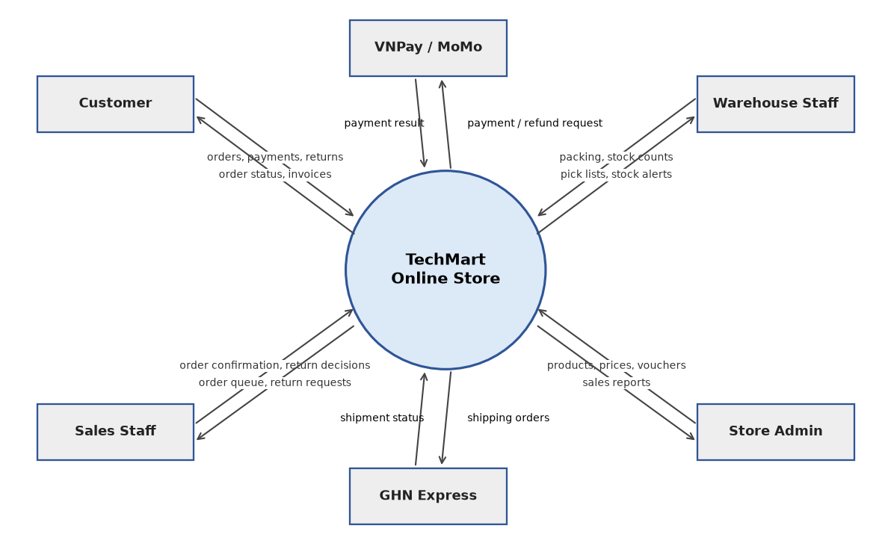
Figure 1 - TechMart context diagram

2. User Requirements

2.1 Actors
# | Actor | Description
1 | Guest | A visitor who is not logged in. Can search and view products, and register an account.
2 | Customer | A registered buyer. Inherits everything a Guest can do, and can manage the cart, place and pay orders, track, cancel and return orders, and review purchased products.
3 | Sales Staff | Employee who confirms or rejects new orders and handles return requests.
4 | Warehouse Staff | Employee who picks and packs orders, creates shipments and keeps stock counts correct.
5 | Store Admin | Store manager who manages products, prices, vouchers and staff accounts and views reports.
6 | Scheduler (System) | Background job runner that syncs shipment status and cancels unpaid orders.

2.2 Use Cases

2.2.1 Diagram(s)
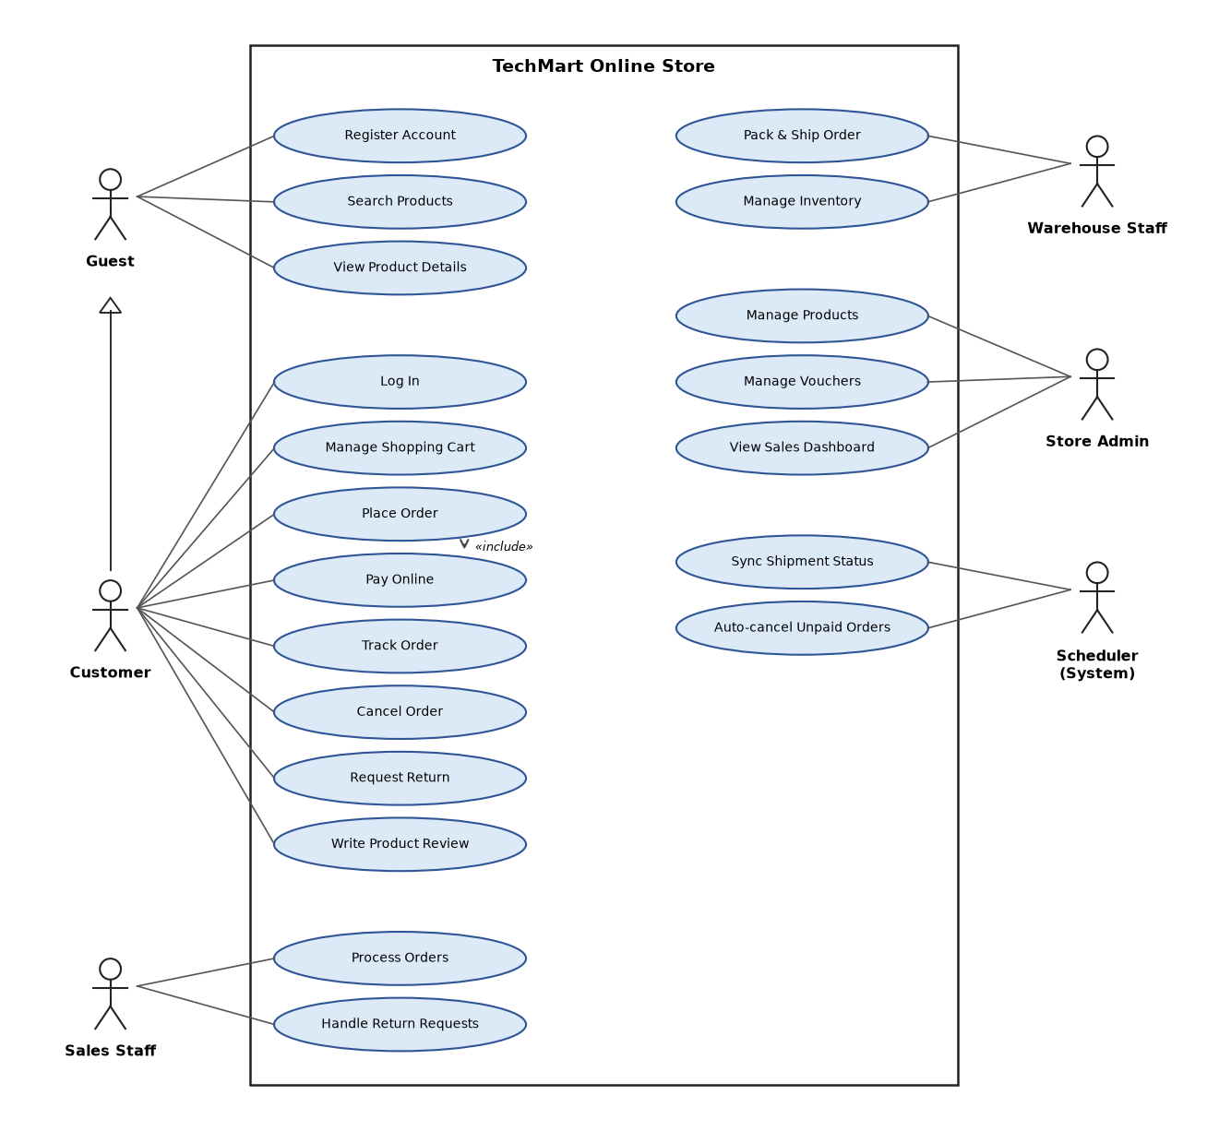
Figure 2 - TechMart use case diagram

2.2.2 Descriptions
ID | Use Case | Actors | Use Case Description
UC-01 | Register Account | Guest | Guest creates an account with e-mail, phone and password and verifies the e-mail.
UC-02 | Log In | Customer, Sales Staff, Warehouse Staff, Store Admin | User logs in with e-mail/phone and password or Google.
UC-03 | Search Products | Guest, Customer | User searches by keyword and filters by category, price and brand.
UC-04 | View Product Details | Guest, Customer | User views images, variants, price, stock, specifications and reviews.
UC-05 | Manage Shopping Cart | Customer | Customer adds, updates and removes cart items.
UC-06 | Place Order | Customer | Customer chooses address, voucher and payment method and places the order.
UC-07 | Pay Online | Customer | Customer pays the order through VNPay or MoMo.
UC-08 | Track Order | Customer | Customer follows the order status and shipment events.
UC-09 | Cancel Order | Customer | Customer cancels an order that has not been packed yet.
UC-10 | Request Return | Customer | Customer asks to return an item within 7 days after delivery.
UC-11 | Write Product Review | Customer | Customer rates and reviews a product they received.
UC-12 | Process Orders | Sales Staff | Sales staff confirm or reject new orders.
UC-13 | Handle Return Requests | Sales Staff | Sales staff approve or reject returns and trigger refunds.
UC-14 | Pack & Ship Order | Warehouse Staff | Warehouse staff scan items, pack the order and create the GHN shipment.
UC-15 | Manage Inventory | Warehouse Staff | Warehouse staff receive stock and adjust stock counts.
UC-16 | Manage Products | Store Admin | Admin creates and edits products, variants, prices and images.
UC-17 | Manage Vouchers | Store Admin | Admin creates and edits discount vouchers.
UC-18 | View Sales Dashboard | Store Admin | Admin views revenue, orders and top products for a period.
UC-19 | Sync Shipment Status | Scheduler (System) | System updates shipment status from GHN webhooks and polling.
UC-20 | Auto-cancel Unpaid Orders | Scheduler (System) | System cancels online-payment orders unpaid after 30 minutes.

3. Functional Requirements

3.1 System Functional Overview
The system has 20 screens for 5 user roles (3 of them are pop-ups) and 4 non-screen functions. Customer screens are responsive for mobile; staff and admin screens are designed for a desktop browser.

3.1.1 Screens Flow
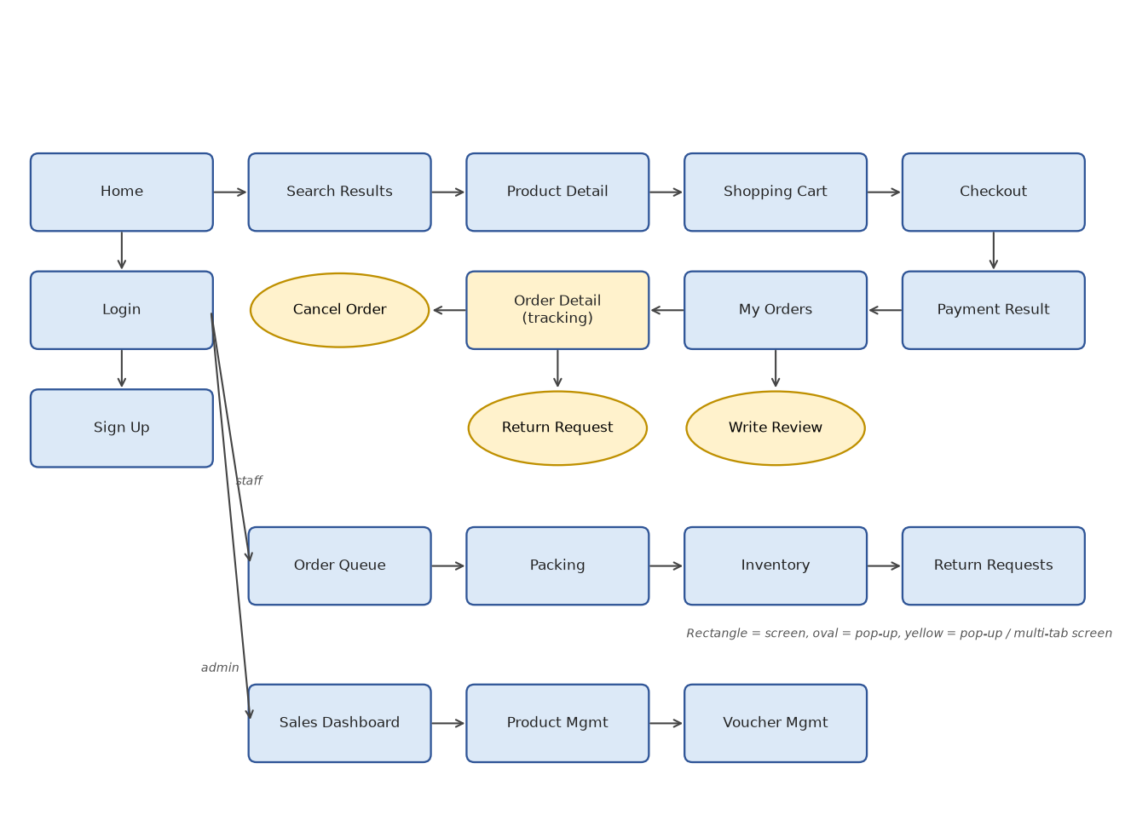
Figure 3 - TechMart screens flow

3.1.2 Screen Descriptions
# | Feature | Screen | Description
1 | Account | Sign Up | Register a customer account
2 | Account | Login | Log in with e-mail/phone and password or Google
3 | Product Catalog | Home | Banners, categories, best sellers and the search bar
4 | Product Catalog | Search Results | Product grid with filters, sorting and paging
5 | Product Catalog | Product Detail | Images, variants, price, stock, specifications and reviews
6 | Product Catalog | Write Review | Pop-up to rate and review a received product
7 | Shopping & Checkout | Shopping Cart | Cart items with quantities and subtotal
8 | Shopping & Checkout | Checkout | Address, items, voucher, payment method and totals
9 | Shopping & Checkout | Payment Result | Result page after returning from VNPay / MoMo
10 | Order Management | My Orders | Customer's orders by status
11 | Order Management | Order Detail | Status timeline, shipment events and items (tracking)
12 | Order Management | Cancel Order | Pop-up to cancel an order with a reason
13 | Order Management | Order Queue | Sales staff list of new orders to confirm or reject
14 | Order Management | Packing | Warehouse screen to scan items and create the shipment
15 | Returns | Return Request | Pop-up to request a return for an item
16 | Returns | Return Requests | Sales staff list and detail of return requests
17 | Store Administration | Inventory | Stock on hand, reserved and available per SKU
18 | Store Administration | Product Management | Products, variants, prices and images
19 | Store Administration | Voucher Management | Discount vouchers
20 | Store Administration | Sales Dashboard | Revenue and order KPIs

3.1.3 Screen Authorization
Screen | Guest | Customer | Sales Staff | Warehouse Staff | Store Admin
Search Results / Product Detail | X | X | X | X | X
Shopping Cart |  | X
Checkout |  | X
My Orders / Order Detail |  | X
Query Own Data |  | X
Cancel Own Order |  | X
Return Request |  | X
Write Review |  | X
Order Queue |  |  | X |  | X
Confirm / Reject Order |  |  | X
Query All Data |  |  | X |  | X
Return Requests |  |  | X |  | X
Approve / Reject / Mark Received |  |  | X
Packing |  |  |  | X
Inventory |  |  |  | X | X
Adjust Stock |  |  |  | X
Product Management |  |  |  |  | X
Add / Update / Hide Data |  |  |  |  | X
Voucher Management |  |  |  |  | X
Sales Dashboard |  |  |  |  | X

3.1.4 Non-Screen Functions
# | Feature | System Function | Description
1 | Order Management | Sync Shipment Status | GHN webhook POST /api/shipping/ghn/callback plus a polling job every 30 minutes (UC-19)
2 | Shopping & Checkout | Auto-cancel Unpaid Orders | Cron job every minute; cancels online-payment orders unpaid for 30 minutes (UC-20)
3 | Shopping & Checkout | Process Payment Callback | Webhook API POST /api/payments/{provider}/ipn from VNPay / MoMo (part of UC-07)
4 | Order Management | Auto-complete Delivered Orders | Cron job daily at 01:00; completes orders delivered 7 days ago without a return request

3.1.5 Entity Relationship Diagram
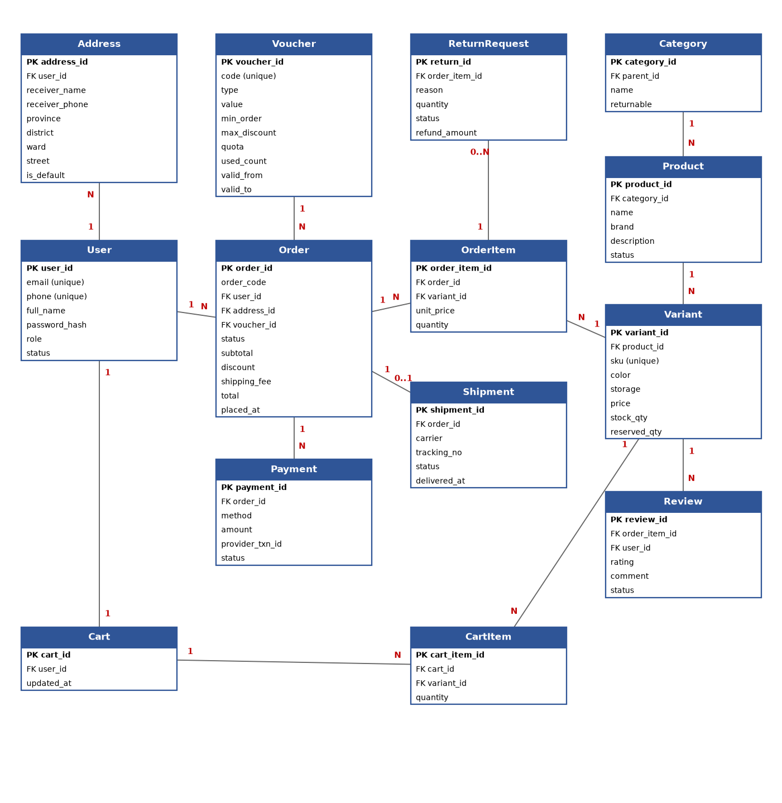
Figure 4 - TechMart entity relationship diagram
Entities Description
# | Entity | Description
1 | User | Customer or staff account with role (Customer, Sales, Warehouse, Admin) and status
2 | Address | A delivery address of a customer; one is the default
3 | Category | Product category tree; marks whether items are returnable
4 | Product | A product shown in the catalogue
5 | Variant | A sellable SKU of a product (colour, storage) with its price and stock
6 | Cart / CartItem | The customer's shopping cart and its lines
7 | Voucher | A discount code with type, value, conditions and quota
8 | Order | A placed order with status and totals
9 | OrderItem | A line of an order with the price snapshot at placing time
10 | Payment | A payment or refund transaction of an order
11 | Shipment | The GHN shipment of an order
12 | ReturnRequest | A customer's request to return an order item
13 | Review | A rating and comment for a purchased variant

3.2 Account

3.2.1 Register Account (UC-01)
Function trigger:
- Navigation path: Header -> “Log in” -> link “Create an account” (/register); or Checkout as a guest -> “Sign up to continue”.
- Timing Frequency: User-initiated only.
Function description:
- Actors / Roles: Guest
- Purpose: Let a visitor create a customer account so that they can buy, track orders and request returns.
- Interface: Sign Up screen:
- “Create your TechMart account”: Label - screen title.
- “Full name”: Text box - required.
- “Email”: Text box - required; used to log in and to receive order e-mails.
- “Phone number”: Text box - required; used by the shipper.
- “Password”: Password box - required.
- “Confirm password”: Password box - must be the same as Password.
- “Date of birth”: Date picker - optional.
- “I agree to the Terms of Use and Privacy Policy”: Check box - must be ticked.
- “Create account”: Button - creates the account.
- “Sign up with Google”: Button - creates the account from a Google profile.
- “Log in”: Link - opens the Login screen (UC-02).
- Data processing: Receive the form -> validate the fields -> check e-mail and phone are not used -> hash the password with bcrypt -> create the User with role Customer and status Unverified -> create an empty Cart -> send a verification e-mail with a link valid for 24 hours -> log the customer in; checkout stays blocked until the e-mail is verified -> when the link is opened set status Active.
Screen layout:
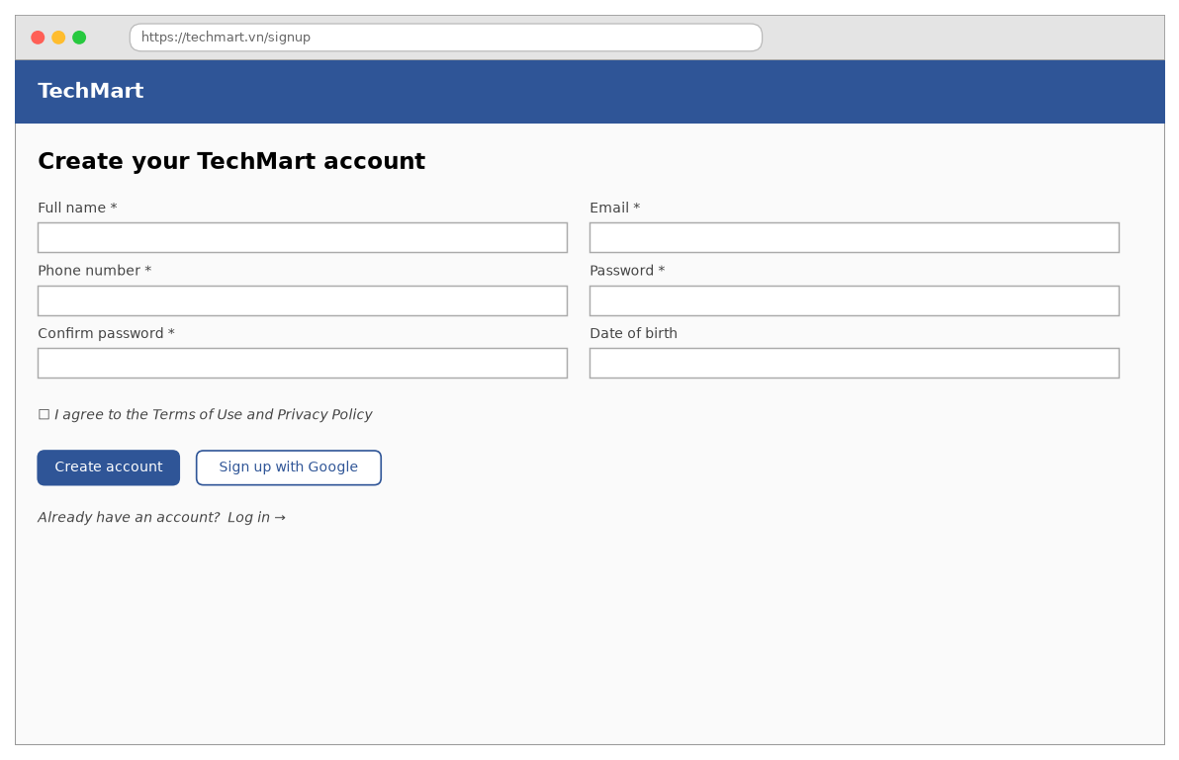
Figure 5 - Register Account — Sign Up screen
Function details:
- Data: Full name, Email, Phone number, Password, Date of birth, Terms accepted, Status (Unverified, Active), Verification token, Token expiry.
- Validation: Full name 2–100 characters. Email valid format, max 254 characters. Phone 10 digits starting with 0. Password 8–64 characters with upper case, lower case and a digit. Confirm password equals Password. Date of birth: customer at least 13 years old. Terms must be accepted.
- Business rules: BR-11: one account per e-mail and per phone number. BR-15: staff accounts are created by the Store Admin and cannot be registered here.
- Normal case: The guest opens “Create an account” -> fills in the form and ticks the terms -> clicks “Create account” -> the system creates the account, shows “Account created. Please check your e-mail to verify it.” -> the guest opens the e-mail link -> the account becomes Active.
- Abnormal case: Required field empty -> “The {field} field is required.” E-mail already used -> “This e-mail is already registered.” Phone already used -> “This phone number is already registered.” Weak password -> “Password must have 8–64 characters with upper case, lower case and a digit.” Terms not ticked -> “Please accept the Terms of Use to continue.” Verification link expired -> “This link has expired. We have sent you a new one.” E-mail service fails -> “Could not send the verification e-mail. Please try again later.”

3.2.2 Log In (UC-02)
Function trigger:
- Navigation path: Header -> “Log in” (/login); or any page that needs login (cart checkout, My Orders); staff use /staff/login.
- Timing Frequency: User-initiated only.
Function description:
- Actors / Roles: Customer, Sales Staff, Warehouse Staff, Store Admin
- Purpose: Authenticate the user and open the right area for the role.
- Interface: Login screen:
- “Log in”: Label - screen title.
- “Email or phone number”: Text box - required.
- “Password”: Password box - required.
- “Remember me”: Check box - keeps the session for 30 days instead of 1 day.
- “Log in”: Button - signs in.
- “Continue with Google”: Button - signs in with Google (customers only).
- “Forgot password?”: Link - sends a reset link by e-mail.
- “Create an account”: Link - opens Sign Up (UC-01).
- Data processing: Receive the credentials -> find the user by e-mail or phone -> check the status is not Locked or Disabled -> compare the bcrypt hash -> on success reset the failed counter, issue an access token (15 minutes) and a refresh token (1 or 30 days) -> merge the guest cart stored in the browser into the customer's cart -> redirect: customers back to the page they came from, Sales Staff to Order Queue, Warehouse Staff to Packing, Store Admin to Sales Dashboard. On failure increase the failed counter.
Screen layout:
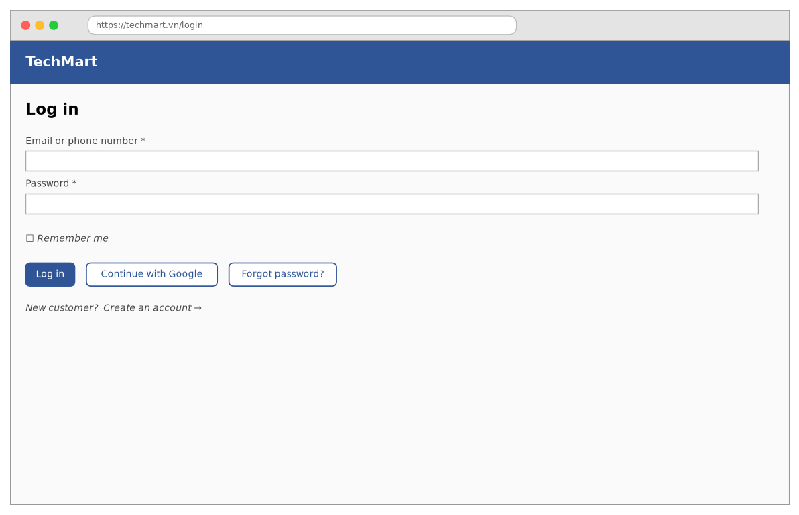
Figure 6 - Log In — Login screen
Function details:
- Data: Email or phone, Password, Remember me, Role, Failed login count, Locked until, Tokens.
- Validation: Both fields required. Email/phone max 254 characters.
- Business rules: BR-12: the account is locked for 15 minutes after 5 consecutive failed logins. BR-15: Google sign-in is for customers only.
- Normal case: The customer enters e-mail and password -> clicks “Log in” -> the system signs them in, merges the guest cart and returns to the previous page.
- Abnormal case: Wrong credentials -> “Incorrect e-mail/phone or password.” 5 failures -> “Your account is locked for 15 minutes.” Disabled account -> “Your account has been disabled. Please contact support.” Staff uses Google -> “Staff accounts must log in with e-mail and password.” Server error -> “Could not log in. Please try again.”

3.3 Product Catalog

3.3.1 Search Products (UC-03)
Function trigger:
- Navigation path: Header search bar -> type a keyword and press Enter (/search?q=…); or Home -> a category tile (/c/{slug}).
- Timing Frequency: User-initiated only; suggestions appear while typing (after 2 characters, 300 ms debounce).
Function description:
- Actors / Roles: Guest, Customer
- Purpose: Help shoppers find products quickly by keyword, category, price and brand.
- Interface: Search Results screen:
- “Search bar”: Text box - keyword with suggestions.
- “Results for “{keyword}” ({count})”: Label - title with the number of results.
- “Category”: Check boxes - filters by category.
- “Price”: Check boxes - price ranges: under 10M, 10M – 20M, over 20M.
- “Brand”: Check boxes - filters by brand.
- “Sort by”: Dropdown - Relevance, Best selling, Newest, Price low–high, Price high–low.
- “Product grid”: Cards - image, name, price, rating and number of reviews; click opens Product Detail.
- “Paging”: Pager - 24 products per page.
- Data processing: Receive keyword, filters, sort and page -> normalise the keyword (lower case, remove Vietnamese accents) -> full-text search on product name, brand and SKU in the search index -> apply filters -> keep only Active products -> sort; out-of-stock products last -> return the page and the filter counts -> log the keyword for search analytics.
Screen layout:
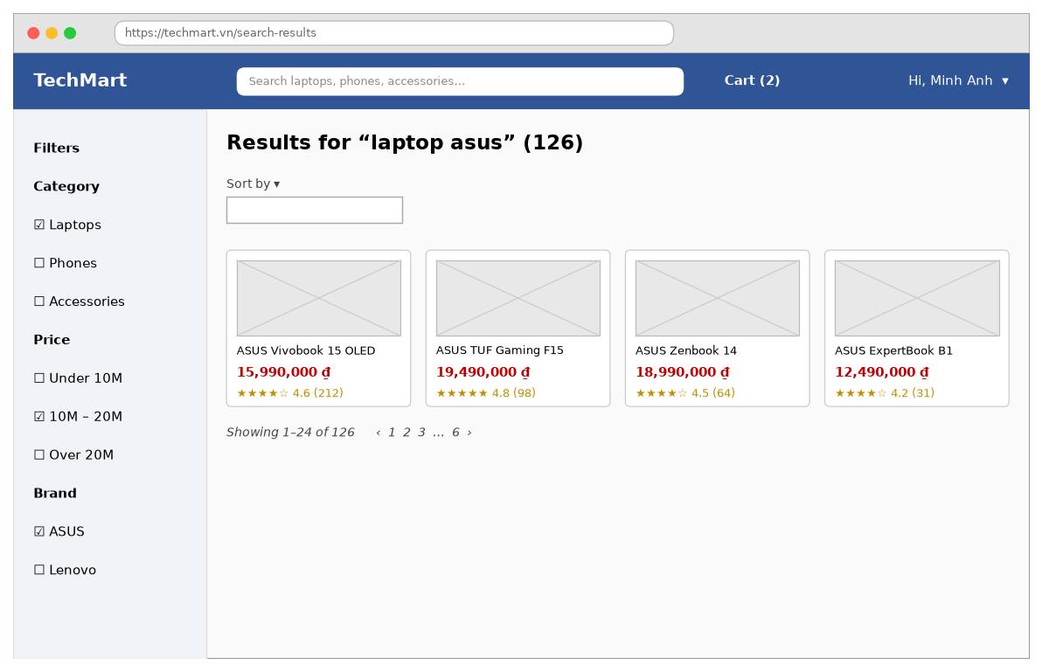
Figure 7 - Search Products — Search Results screen
Function details:
- Data: Keyword, Category, Price range, Brand, Sort, Page, Results (product, min price, rating, review count, in stock), Total count.
- Validation: Keyword max 100 characters; special characters are ignored. Page 1–100.
- Business rules: BR-21: only Active products are shown; out-of-stock products are shown last with the label “Out of stock”.
- Normal case: The customer types “laptop asus” -> presses Enter -> the system shows 126 results -> the customer ticks “10M – 20M” -> the grid is filtered to 38 products.
- Abnormal case: No result -> “No products match your search. Try other keywords.” Search service fails -> “Could not load the products. Please try again.”

3.3.2 View Product Details (UC-04)
Function trigger:
- Navigation path: Search Results / Home / Cart -> click a product (/p/{slug}).
- Timing Frequency: User-initiated only.
Function description:
- Actors / Roles: Guest, Customer
- Purpose: Show everything a shopper needs to decide: images, variants, price, stock, specifications and reviews.
- Interface: Product Detail screen:
- “Product name”: Label - title.
- “Image gallery”: Image + thumbnails - up to 10 images; click to zoom.
- “Price”: Label - current price; compare-at price struck through with the discount %.
- “Rating”: Label - average rating, number of reviews and units sold.
- “Colour / Storage”: Option chips - variant options; unavailable options are greyed out.
- “Quantity”: Number stepper - 1–5.
- “Stock”: Label - “In stock: {n}” or “Out of stock”.
- “Add to cart”: Button - adds the selected variant to the cart (UC-05).
- “Buy now”: Button - adds the variant and opens Checkout (UC-06).
- “Specifications / Description / Reviews”: Tabs - details and customer reviews.
- Data processing: Load the product by slug with its variants, images, specifications and review summary -> select the default variant (first in stock) -> on option change show the price and available stock (stock_qty − reserved_qty) of that variant -> Add to cart: requires login (a guest cart is kept in the browser) -> record a product view for “recently viewed”.
Screen layout:
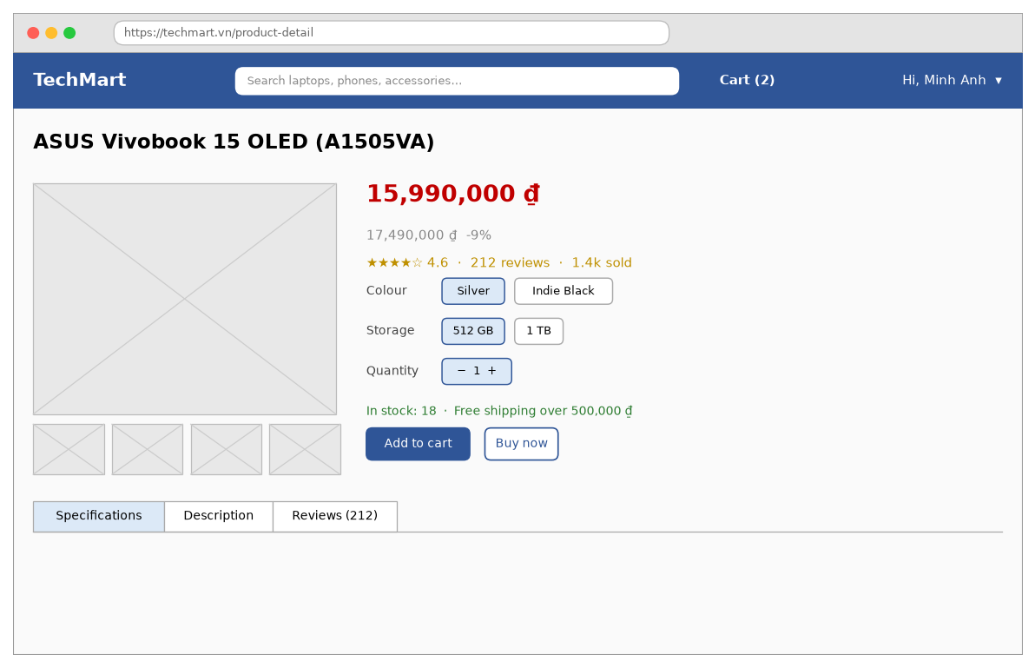
Figure 8 - View Product Details — Product Detail screen
Function details:
- Data: Product (name, brand, description, specifications), Variants (SKU, colour, storage, price, compare-at price, available stock), Images, Rating summary, Reviews (paged).
- Validation: Quantity 1–5 and not more than the available stock.
- Business rules: BR-03: at most 5 units of one variant per order. BR-21: hidden products return the 404 page.
- Normal case: The customer opens “ASUS Vivobook 15 OLED” -> chooses Silver / 512 GB -> the system shows 15,990,000 ₫ and 18 in stock -> clicks “Add to cart” -> the cart counter becomes 2.
- Abnormal case: Variant out of stock -> “This option is out of stock.” Quantity over limit -> “You can buy at most 5 units of this item.” Product hidden or deleted -> “This product is no longer available.” Loading fails -> “Could not load the product. Please try again.”

3.3.3 Write Product Review (UC-11)
Function trigger:
- Navigation path: My Orders -> tab “Completed” -> “Review”; or the review reminder e-mail sent 3 days after delivery.
- Timing Frequency: User-initiated only.
Function description:
- Actors / Roles: Customer
- Purpose: Let customers who received a product share a rating and comment to help other shoppers.
- Interface: Write Review pop-up:
- “Review – {product}”: Label - pop-up title.
- “Rating”: Star picker - 1–5 stars; required.
- “Comment”: Text area - optional.
- “Photos”: File upload - up to 5 images.
- “Post anonymously”: Check box - shows the name as “M*** A***”.
- “Submit review”: Button - sends the review.
- “Cancel”: Button - closes the pop-up.
- Data processing: Check the order item belongs to the customer, is Delivered or Completed, and has no review -> validate -> run the content filter (banned words, phone numbers, links) -> save the Review with status Published, or Pending when the filter flags it -> recompute the product's average rating.
Screen layout:
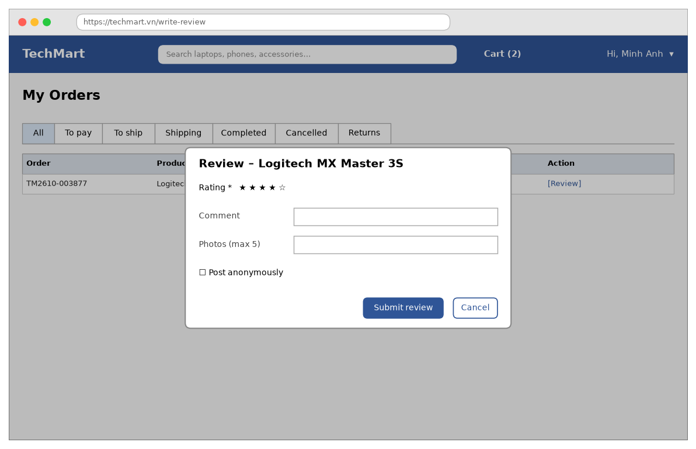
Figure 9 - Write Product Review — Write Review pop-up
Function details:
- Data: Order item, Rating, Comment, Photos, Anonymous, Review status (Published, Pending, Hidden).
- Validation: Rating 1–5 required. Comment max 1,000 characters. Photos JPG/PNG, each max 5 MB, max 5.
- Business rules: BR-10: only customers who received the product can review it, once per order item; flagged reviews wait for moderation.
- Normal case: The customer clicks “Review” on a completed order -> gives 4 stars and a comment -> clicks “Submit review” -> the review appears on the product page.
- Abnormal case: Rating missing -> “Please choose a rating.” Already reviewed -> “You have already reviewed this item.” Not delivered yet -> “You can review this item after it is delivered.” Comment flagged -> “Thanks! Your review will be published after moderation.” Upload fails -> “Could not upload the photo. Please try again.”

3.4 Shopping & Checkout

3.4.1 Manage Shopping Cart (UC-05)
Function trigger:
- Navigation path: Header -> “Cart (n)” (/cart); or Product Detail -> “Add to cart”.
- Timing Frequency: User-initiated only.
Function description:
- Actors / Roles: Customer
- Purpose: Let the customer collect items, change quantities and choose which items to check out.
- Interface: Shopping Cart screen:
- “Shopping Cart ({n} items)”: Label - screen title.
- “Cart table”: Table - columns select box, “Product”, “Variant”, “Unit price”, “Quantity”, “Amount”, “Remove”.
- “Quantity”: Number stepper - changes the quantity of a line.
- “Stock note”: Label - warning when a quantity was reduced or an item is out of stock.
- “Selected items / Subtotal / Shipping”: Summary cards - totals of the selected lines.
- “Check out”: Button - opens Checkout with the selected lines (UC-06).
- “Continue shopping”: Button - returns to the last search.
- Data processing: Load the cart lines with the current variant price and available stock -> if a line's quantity is more than the available stock reduce it and show the note; mark lines of hidden products as unavailable -> on quantity change validate and save -> recompute the subtotal and the estimated shipping fee of the selected lines -> Check out: at least one selected line, e-mail verified.
Screen layout:
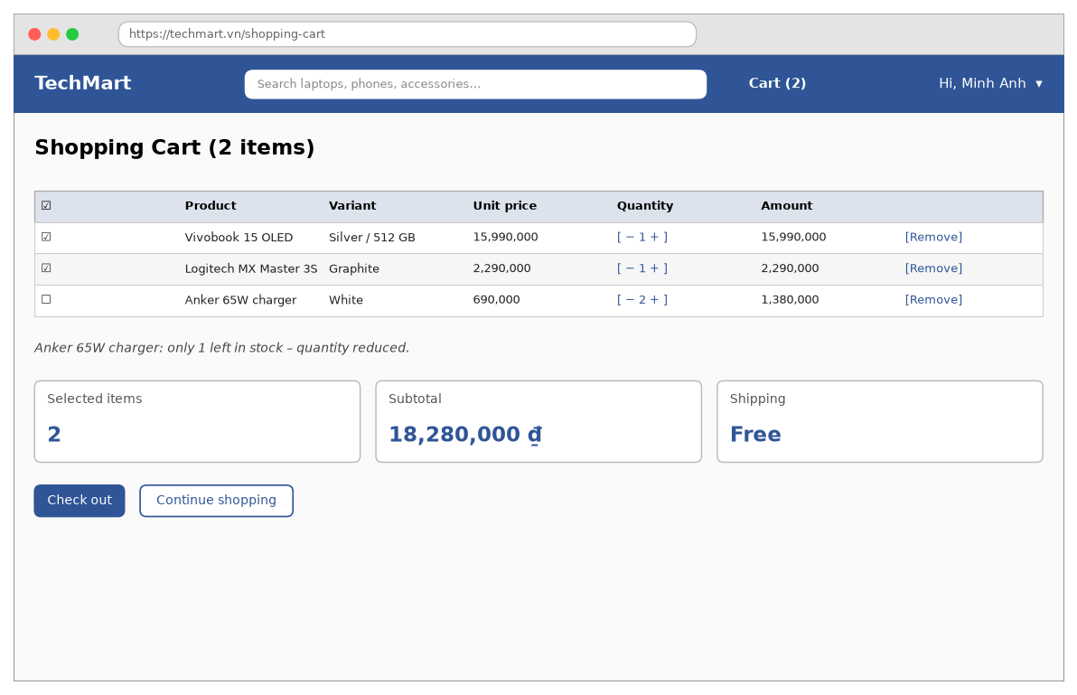
Figure 10 - Manage Shopping Cart — Shopping Cart screen
Function details:
- Data: Cart lines (variant, product name, image, unit price, quantity, amount, selected, available), Subtotal, Estimated shipping fee.
- Validation: Quantity 1–5 per line and not more than the available stock. At most 30 lines per cart.
- Business rules: BR-03: at most 5 units of a variant per order and 30 lines per cart. BR-02: free shipping for orders from 500,000 ₫. BR-22: the price shown is the current price; the order keeps the price at placing time.
- Normal case: The customer opens the cart -> changes the charger quantity to 2 -> unticks it -> the subtotal becomes 18,280,000 ₫ -> clicks “Check out”.
- Abnormal case: Quantity more than stock -> “Only {n} left in stock – quantity reduced.” Item no longer sold -> “This item is no longer available and cannot be checked out.” Cart full -> “Your cart can hold at most 30 items.” No item selected -> “Please select at least one item.” E-mail not verified -> “Please verify your e-mail before checking out.”

3.4.2 Place Order (UC-06)
Function trigger:
- Navigation path: Shopping Cart -> “Check out” (/checkout); or Product Detail -> “Buy now”.
- Timing Frequency: User-initiated only.
Function description:
- Actors / Roles: Customer
- Purpose: Turn the selected cart lines into an order with a delivery address, discount and payment method.
- Interface: Checkout screen:
- “Delivery address”: Panel - default address with “Change” to pick or add another address.
- “Items”: Table - columns “Product”, “Qty”, “Amount”.
- “Voucher code”: Text box + Apply - applies one voucher.
- “Note for the shop”: Text box - optional, max 200 characters.
- “VNPay / MoMo / Cash on delivery (COD)”: Tabs - payment method.
- “Totals”: Label - Subtotal, Voucher, Shipping, Total.
- “Place order”: Button - creates the order.
- “Back to cart”: Button - returns to the cart.
- Data processing: Load the selected lines and the default address -> compute the GHN shipping fee for the address and weight (free from 500,000 ₫) -> Apply voucher: check BR-06 and compute the discount -> Place order: in one transaction re-check prices and stock, reserve stock (reserved_qty + quantity), create the Order with status Pending Payment (online) or Pending (COD), copy prices into OrderItems, increase the voucher's used_count, remove the lines from the cart -> online payment: start UC-07; COD: show the success page and send the order e-mail.
Screen layout:
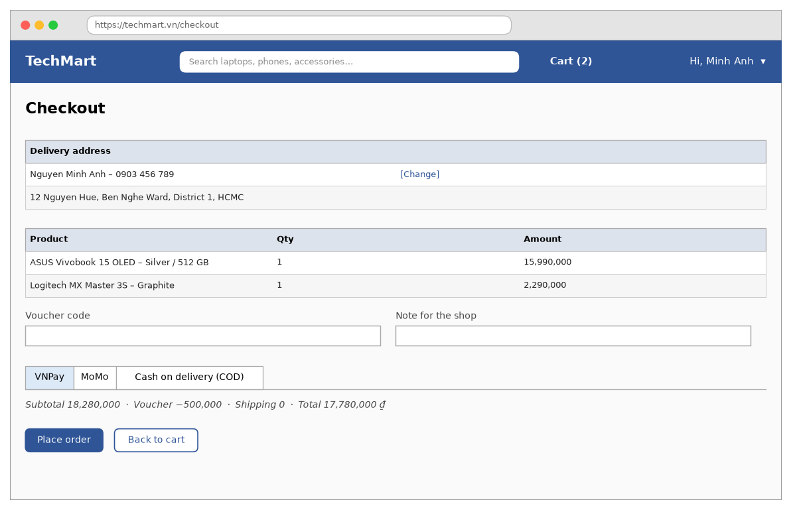
Figure 11 - Place Order — Checkout screen
Function details:
- Data: Address (receiver, phone, province, district, ward, street), Lines, Voucher, Note, Payment method, Subtotal, Discount, Shipping fee, Total, Order code (TMyyMM-nnnnnn).
- Validation: An address is required. Receiver phone 10 digits. Voucher code 4–20 letters or digits. Note max 200 characters. COD only when the total is at most 10,000,000 ₫.
- Business rules: BR-01: Total = Subtotal − Discount + Shipping fee; prices include VAT. BR-02: free shipping from 500,000 ₫. BR-04: stock is reserved when the order is placed. BR-06: one voucher per order within its validity, quota and minimum order. BR-13: COD up to 10,000,000 ₫. BR-22: OrderItem keeps the price at placing time.
- Normal case: The customer checks the address -> types TECH500 and clicks Apply -> the system deducts 500,000 ₫ -> selects VNPay -> clicks “Place order” -> the system creates order TM2610-004512 and redirects to VNPay.
- Abnormal case: No address -> “Please add a delivery address.” Voucher invalid -> “This voucher code is not valid.” Voucher expired or used up -> “This voucher has expired or run out.” Order below the voucher minimum -> “Spend {amount} more to use this voucher.” Price changed since the cart -> “Some prices have changed. Please review your order.” Stock gone at placing time -> “Some items are out of stock. Your cart has been updated.” COD over limit -> “Cash on delivery is available for orders up to 10,000,000 ₫.” Shipping fee service fails -> “Could not calculate the shipping fee. Please try again.”

3.4.3 Pay Online (UC-07)
Function trigger:
- Navigation path: Checkout -> “Place order” with VNPay or MoMo; or Order Detail -> “Pay now” on a Pending Payment order.
- Timing Frequency: User-initiated; the provider result arrives by IPN webhook.
Function description:
- Actors / Roles: Customer; secondary: VNPay / MoMo
- Purpose: Collect the order payment online and confirm it to the customer.
- Interface: Payment Result screen:
- “Payment successful / Payment failed”: Label - result title.
- “Result message”: Label - order code and next step.
- “Payment table”: Table - rows “Order code”, “Amount paid”, “Method”, “Transaction id”, “Paid at”.
- “View order”: Button - opens Order Detail (UC-08).
- “Continue shopping”: Button - opens Home.
- “Try again”: Button - shown on failure; creates a new payment for the same order.
- Data processing: Create a Payment (status Pending, amount = order total) -> build the signed URL (vnp_SecureHash / MoMo signature) with a 15-minute expiry -> redirect -> the provider calls POST /api/payments/{provider}/ipn -> verify the signature and the amount, ignore a transaction id already processed -> success: Payment Success, Order Pending (waiting for sales confirmation), send the e-mail -> failure: Payment Failed, the order stays Pending Payment -> the return URL shows the result read from the database, not from the URL parameters.
Screen layout:
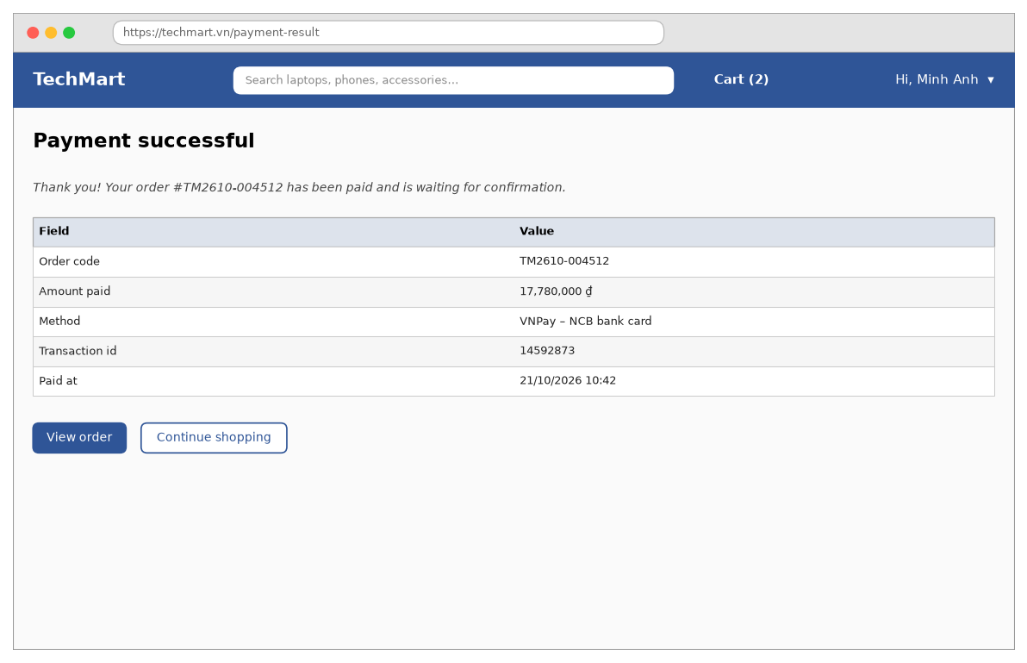
Figure 12 - Pay Online — Payment Result screen
Function details:
- Data: Order, Payment (method, amount, provider transaction id, bank code, status, paid at).
- Validation: IPN signature valid; amount equals the order total; order status Pending Payment.
- Business rules: BR-05: online-payment orders unpaid for 30 minutes are cancelled. BR-09: refunds go back to the original method. Card data is entered only on the provider's page.
- Normal case: The customer pays on VNPay -> VNPay sends the IPN -> the system marks the order paid -> the customer returns and sees “Payment successful” with the order code.
- Abnormal case: Payment cancelled or failed -> “Payment was not completed. You can try again within 30 minutes.” Order already cancelled -> “This order was cancelled because it was not paid in time.” Amount mismatch or invalid signature -> IPN rejected with the provider error code, logged for review. Provider not available -> “The payment service is busy. Please try another method.”

3.4.4 Auto-cancel Unpaid Orders (UC-20)
Function trigger:
- Navigation path: None – system function without a screen.
- Timing Frequency: Cron job every minute.
Function description:
- Actors / Roles: Scheduler (System)
- Purpose: Release reserved stock and vouchers of online-payment orders that were never paid.
- Interface: No screen:
- Data processing: Select orders with status Pending Payment and placed_at < now − 30 minutes -> for each order, query the provider once to make sure it is not paid (avoids cancelling a paid order whose IPN was late) -> if unpaid: set status Cancelled (reason “Payment timeout”), release reserved stock, decrease the voucher's used_count, send the e-mail “Your order was cancelled” -> if paid: process it like a successful IPN.
Function details:
- Data: Order (status, placed at), Variant reserved quantity, Voucher used count, Payment status.
- Validation: No user input.
- Business rules: BR-05: online-payment orders unpaid for 30 minutes are cancelled. BR-04: reserved stock is released when an order is cancelled.
- Normal case: At 11:13 the job finds order TM2610-004530 placed at 10:42 and still unpaid -> the provider confirms it is unpaid -> the order is cancelled and its stock released.
- Abnormal case: Provider query fails -> the order is skipped and retried in the next run (max 10 tries, then flagged to sales staff). Two job runs overlap -> a database lock lets only one process the order.

3.5 Order Management

3.5.1 Track Order (UC-08)
Function trigger:
- Navigation path: Header -> account menu -> “My Orders” -> an order (/orders/{code}); or the link in an order e-mail.
- Timing Frequency: User-initiated; the page refreshes the status every 60 seconds while open.
Function description:
- Actors / Roles: Customer
- Purpose: Let the customer see where the order is and when it will arrive.
- Interface: Order Detail screen:
- “Order #{code}”: Label - screen title.
- “Status timeline”: Stepper - Placed, Paid, Confirmed, Packed, Shipping, Delivered with times.
- “Shipment events”: Table - time and GHN event with the tracking number.
- “Items”: Table - columns “Product”, “Qty”, “Amount”, “Action” (“Return”, “Review”).
- “Cancel order”: Button - shown while the order can be cancelled (UC-09).
- “Contact support”: Button - opens the support chat with the order code.
- Data processing: Load the order by code -> check it belongs to the logged-in customer -> load items, payments, shipment and status history -> build the timeline -> show the actions allowed for the current status (Cancel before packing, Return within 7 days after delivery, Review after delivery).
Screen layout:
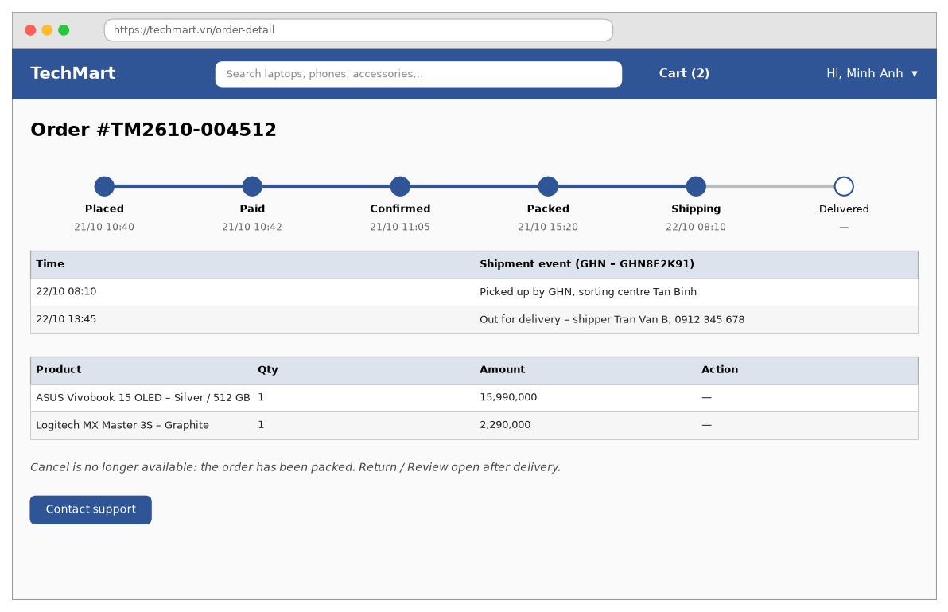
Figure 13 - Track Order — Order Detail screen
Function details:
- Data: Order (code, status, totals, address), Status history (status, time), Shipment (carrier, tracking number, events, expected delivery), Items.
- Validation: Order code format TMyyMM-nnnnnn.
- Business rules: BR-14: order status flow Pending Payment -> Pending -> Confirmed -> Packed -> Shipping -> Delivered -> Completed, or Cancelled / Returned.
- Normal case: The customer opens My Orders -> clicks TM2610-004512 -> the system shows the timeline up to “Shipping” and the latest GHN event “Out for delivery”.
- Abnormal case: Order of another customer -> “Order not found.” Shipment events not available -> “Shipping updates are temporarily unavailable.” Loading fails -> “Could not load the order. Please try again.”

3.5.2 Cancel Order (UC-09)
Function trigger:
- Navigation path: Order Detail -> “Cancel order”; or My Orders -> “Cancel” on an order in tab “To ship”.
- Timing Frequency: User-initiated only.
Function description:
- Actors / Roles: Customer
- Purpose: Let the customer cancel an order before it is packed and get the money back if it was paid.
- Interface: Cancel Order pop-up:
- “Cancel order #{code}?”: Label - pop-up title.
- “Reason”: Dropdown - Changed my mind, Found a better price, Wrong address, Ordered by mistake, Other; required.
- “Note”: Text box - required when the reason is Other.
- “Refund note”: Label - “{amount} will be refunded to {method} within 5 working days.” for paid orders.
- “Confirm cancel”: Button - cancels the order.
- “Keep order”: Button - closes the pop-up.
- Data processing: Check the order belongs to the customer and its status is Pending Payment, Pending or Confirmed -> on confirm, lock the order and re-check the status -> set Cancelled with the reason -> release reserved stock -> decrease the voucher used_count -> paid orders: create a Refund payment through the provider API -> notify sales staff if the order was already Confirmed -> send the cancellation e-mail.
Screen layout:
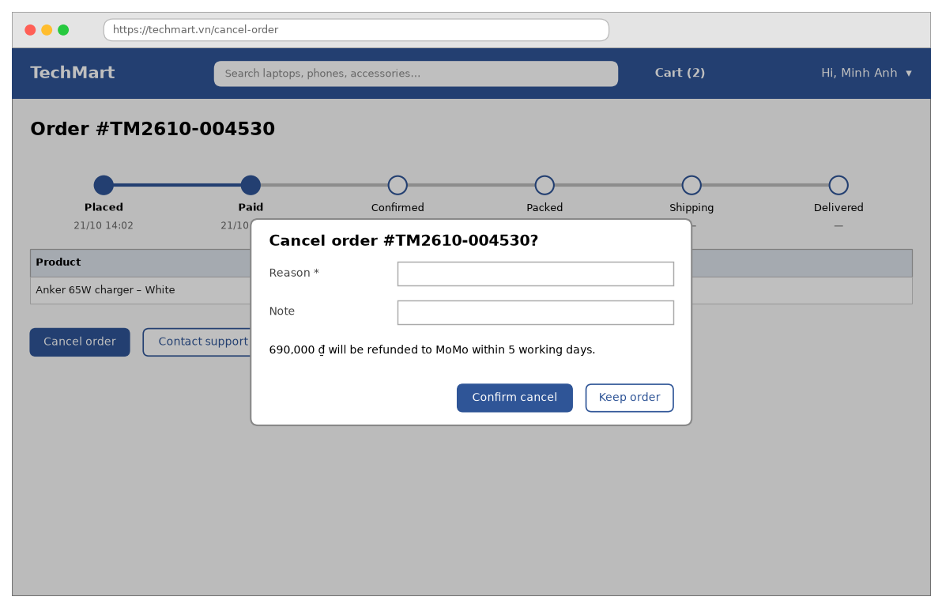
Figure 14 - Cancel Order — Cancel Order pop-up
Function details:
- Data: Order (code, status), Reason, Note, Refund (amount, method, status).
- Validation: Reason required; Note required for Other, max 200 characters.
- Business rules: BR-07: customers can cancel only before the order is Packed. BR-09: refunds go to the original payment method within 5 working days. BR-04: reserved stock is released.
- Normal case: The customer opens order TM2610-004530 -> clicks “Cancel order” -> selects “Changed my mind” -> clicks “Confirm cancel” -> the order becomes Cancelled and the refund is started.
- Abnormal case: Order already packed -> “This order is being packed and can no longer be cancelled. Please request a return after delivery.” Reason missing -> “The Reason field is required.” Refund API fails -> “Your order is cancelled. The refund is being processed and may take up to 7 working days.”

3.5.3 Process Orders (UC-12)
Function trigger:
- Navigation path: Staff portal -> sidebar “Order Queue” (/staff/orders); default screen after a sales staff login.
- Timing Frequency: User-initiated; the queue updates in real time when new orders arrive.
Function description:
- Actors / Roles: Sales Staff; Store Admin (read only)
- Purpose: Check every new order (stock, address, COD risk) and confirm or reject it within the service time.
- Interface: Order Queue screen:
- “Order Queue”: Label - screen title.
- “Waiting confirm / Confirmed / Overdue / All”: Tabs - filters with counters.
- “Search order code / phone”: Text box - search.
- “Payment”: Dropdown - All, Paid online, COD.
- “Placed from”: Date picker - start date.
- “Order table”: Table - columns “Order”, “Customer”, “Items”, “Total”, “Payment”, “Placed”, “Action” (“Confirm”, “Reject”, “Call”).
- “Confirm selected”: Button - confirms all ticked orders.
- “Export”: Button - downloads the list as Excel.
- Data processing: List orders with status Pending sorted by placed time -> mark orders older than 24 hours as Overdue -> Confirm: check stock is still reserved and the address is valid in GHN -> set Confirmed, add the order to the warehouse packing list, e-mail the customer -> Reject: require a reason -> set Cancelled, release stock and voucher, refund paid orders, e-mail the customer.
Screen layout:
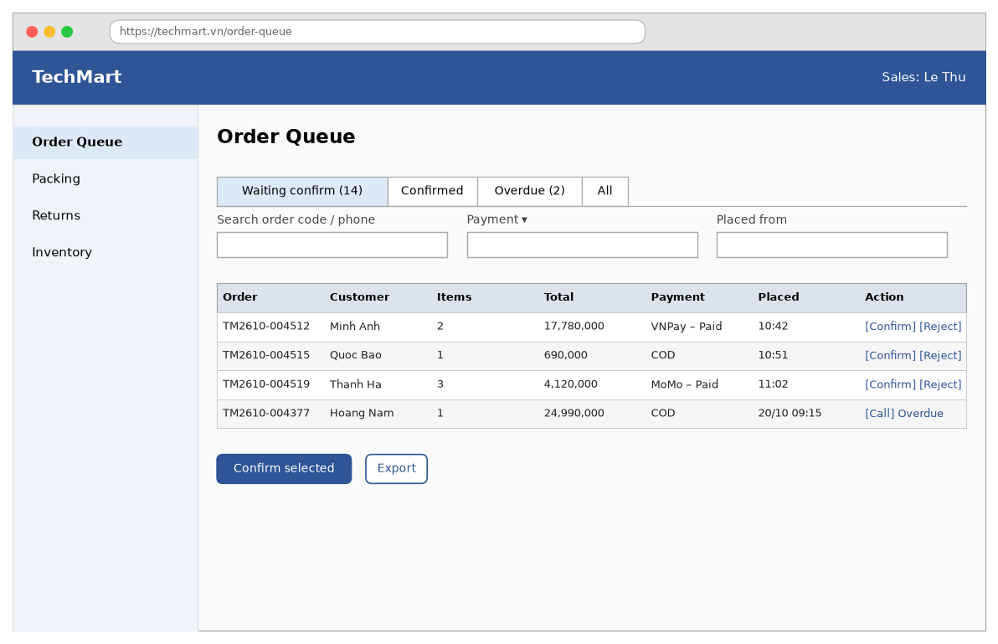
Figure 15 - Process Orders — Order Queue screen
Function details:
- Data: Orders (code, customer, phone, items, total, payment method and status, placed at, overdue), Reject reason.
- Validation: Reject reason required, max 200 characters. Only Pending orders can be confirmed or rejected.
- Business rules: BR-16: orders must be confirmed or rejected within 24 hours. BR-14: status flow. BR-09: refunds of rejected paid orders.
- Normal case: The sales staff opens the queue -> checks TM2610-004512 -> clicks “Confirm” -> the order moves to the Confirmed tab and appears in the warehouse Packing list.
- Abnormal case: Order changed by someone else -> “This order was updated by another user. The list has been refreshed.” Address not supported by GHN -> “GHN does not deliver to this address. Please call the customer.” Reject without a reason -> “The Reject reason field is required.” Loading fails -> “Could not load the orders. Please try again.”

3.5.4 Pack & Ship Order (UC-14)
Function trigger:
- Navigation path: Staff portal -> sidebar “Packing” (/staff/packing) -> select a Confirmed order.
- Timing Frequency: User-initiated only.
Function description:
- Actors / Roles: Warehouse Staff
- Purpose: Make sure the right items are packed and hand the parcel over to GHN with a shipping label.
- Interface: Packing screen:
- “Packing – {order code}”: Label - screen title.
- “Scan SKU / barcode”: Text box - barcode scanner input.
- “Pick list”: Table - columns “SKU”, “Product”, “Bin”, “Qty”, “Scanned”.
- “Package weight (g)”: Number box - required.
- “Length / Width / Height (cm)”: Number boxes - optional.
- “Create GHN shipment”: Button - creates the shipping order at GHN.
- “Print label”: Button - prints the GHN label.
- “Report missing item”: Button - reports a stock problem to sales staff.
- Data processing: Load the Confirmed order with its pick list -> every scan matches a line and increases its scanned count -> when all lines are fully scanned enable “Create GHN shipment” -> call the GHN create-order API with address, weight, COD amount and insurance value -> save the Shipment with tracking number -> decrease stock_qty and reserved_qty -> set the order Packed -> print the label -> when GHN picks it up (UC-19) the order becomes Shipping.
Screen layout:
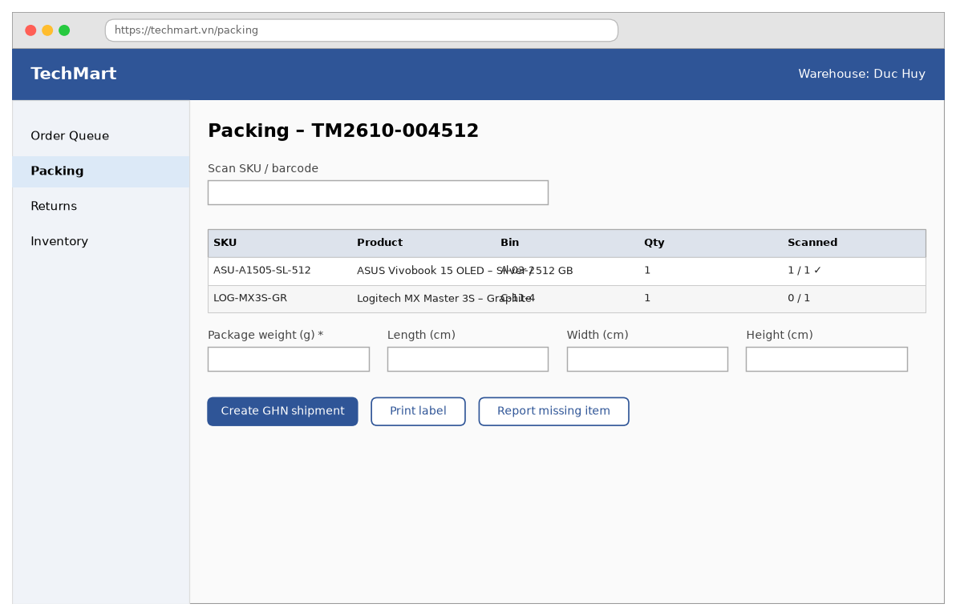
Figure 16 - Pack & Ship Order — Packing screen
Function details:
- Data: Order, Pick list (SKU, product, bin, quantity, scanned), Package weight and size, Shipment (carrier, tracking number, label URL, COD amount).
- Validation: Scanned SKU must belong to the order. Scanned quantity cannot exceed the ordered quantity. Weight 1–30,000 g. Dimensions 1–150 cm.
- Business rules: BR-04: stock is deducted when the order is packed. BR-13: the COD amount is the order total for COD orders.
- Normal case: The warehouse staff opens TM2610-004512 -> scans both items -> types 2,300 g -> clicks “Create GHN shipment” -> the system shows tracking number GHN8F2K91 and prints the label.
- Abnormal case: Wrong item scanned -> “This item is not in the order.” Scanned too many -> “All units of this item have already been scanned.” Not all items scanned -> “Please scan all items before creating the shipment.” GHN API fails -> “Could not create the GHN shipment. Please try again.” Item missing in the bin -> “Report missing item” notifies sales staff and the order stays Confirmed.

3.5.5 Sync Shipment Status (UC-19)
Function trigger:
- Navigation path: None – system function without a screen (webhook POST /api/shipping/ghn/callback).
- Timing Frequency: On every GHN webhook; plus a polling job every 30 minutes for shipments not updated in the last 2 hours.
Function description:
- Actors / Roles: Scheduler (System); secondary: GHN Express
- Purpose: Keep the order status and tracking events in line with the carrier.
- Interface: No screen:
- Data processing: Receive the webhook -> verify the GHN token -> find the Shipment by tracking number -> append the event -> map the GHN status: picked -> order Shipping; delivered -> order Delivered, delivered_at = event time, COD orders get a Payment (COD, Success); return / cancel -> order Delivery Failed and sales staff are notified -> send a push / e-mail to the customer for Shipping and Delivered -> polling job: call the GHN order-detail API for stale shipments and apply the same mapping.
Function details:
- Data: Shipment (tracking number, status, events), Order status, COD payment.
- Validation: Webhook token valid; tracking number exists; events older than the last event are stored but do not change the status.
- Business rules: BR-14: order status flow. BR-20: an order becomes Completed 7 days after delivery if no return is requested.
- Normal case: GHN sends “delivered” for GHN8F2K91 at 15:10 -> the system sets the order Delivered and e-mails the customer “Your order has been delivered”.
- Abnormal case: Invalid token -> HTTP 401, logged. Unknown tracking number -> HTTP 200 with “ignored”, logged for review. GHN API down during polling -> retried in the next run.

3.6 Returns

3.6.1 Request Return (UC-10)
Function trigger:
- Navigation path: Order Detail -> “Return” on an item of a Delivered order.
- Timing Frequency: User-initiated only.
Function description:
- Actors / Roles: Customer
- Purpose: Let the customer return a faulty or wrong item and get a refund.
- Interface: Return Request pop-up:
- “Return request – {product}”: Label - pop-up title.
- “Reason”: Dropdown - Defective, Wrong item, Not as described, Missing parts, Changed my mind; required.
- “Quantity”: Number box - 1 to the ordered quantity.
- “Description”: Text area - required.
- “Photos”: File upload - 1–5 photos or a video up to 30 s; required.
- “Return window note”: Label - “Return window ends {date}. Refund to the original payment method.”
- “Submit request”: Button - sends the request.
- “Cancel”: Button - closes the pop-up.
- Data processing: Check the order belongs to the customer, is Delivered, delivered_at is within 7 days and the category is returnable -> check the quantity not already returned -> save the ReturnRequest with status New and the refund amount (unit price × quantity, minus a proportional share of the voucher discount) -> stop the auto-complete of the order -> notify sales staff -> e-mail the customer the request code.
Screen layout:
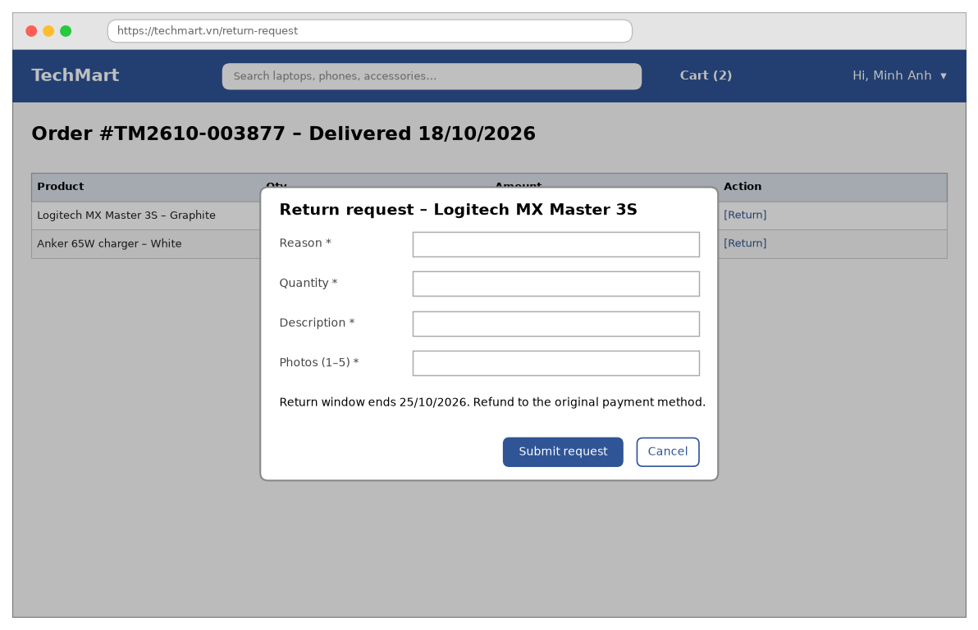
Figure 17 - Request Return — Return Request pop-up
Function details:
- Data: Order item, Reason, Quantity, Description, Photos, Refund amount, Return status (New, Approved, Received, Refunded, Rejected).
- Validation: Reason required. Quantity 1 to (ordered − already returned). Description 10–1,000 characters. 1–5 photos JPG/PNG max 5 MB each, or one MP4 up to 30 s.
- Business rules: BR-08: returns within 7 days after delivery, items in original packaging, not for non-returnable categories. BR-09: refund to the original payment method within 5 working days after the item is received.
- Normal case: The customer opens the delivered order -> clicks “Return” on the mouse -> selects “Defective”, describes the problem and adds 3 photos -> clicks “Submit request” -> the system shows request RT-0391.
- Abnormal case: Return window passed -> “The return period for this order has ended.” Category not returnable -> “This item cannot be returned.” No photo -> “Please add at least one photo.” Quantity too high -> “You can return at most {n} units of this item.” Upload fails -> “Could not upload the photo. Please try again.”

3.6.2 Handle Return Requests (UC-13)
Function trigger:
- Navigation path: Staff portal -> sidebar “Returns” (/staff/returns) -> a request.
- Timing Frequency: User-initiated only.
Function description:
- Actors / Roles: Sales Staff; Store Admin (read only)
- Purpose: Decide on each return, receive the item back and refund the customer.
- Interface: Return Requests screen:
- “Return Requests”: Label - screen title.
- “New / Approved / Received / Refunded / Rejected”: Tabs - filters with counters.
- “Request table”: Table - columns “Request”, “Order”, “Product”, “Reason”, “Requested”, “Action”.
- “Request detail”: Table - description, photos, refund amount and method.
- “Decision note”: Text box - required for Reject.
- “Approve”: Button - approves and creates a GHN return pick-up.
- “Reject”: Button - rejects with the note.
- “Mark as received”: Button - confirms the item arrived and starts the refund.
- Data processing: List requests by status -> Approve: set Approved, create a GHN return shipment for pick-up, e-mail the customer -> Reject: set Rejected with the note, resume auto-complete of the order -> Mark as received: set Received, add the item back to stock if the condition is New, otherwise to the faulty stock -> create the Refund payment through VNPay / MoMo, or a bank-transfer task for COD -> when the refund succeeds set Refunded and the order item Returned.
Screen layout:
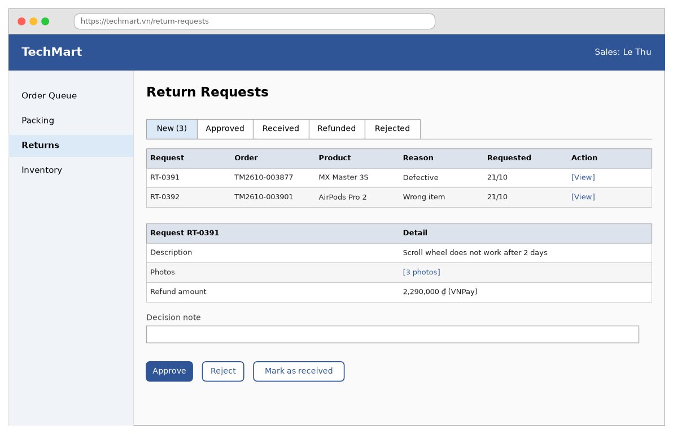
Figure 18 - Handle Return Requests — Return Requests screen
Function details:
- Data: Return request (code, order item, reason, description, photos, refund amount, status, decision note), Refund payment, Return shipment.
- Validation: Decision note required for Reject, max 500 characters. Only New requests can be approved or rejected; only Approved requests can be marked as received.
- Business rules: BR-08: return conditions. BR-09: refund within 5 working days after receiving the item; COD refunds by bank transfer. BR-17: stock adjustments are logged with a reason.
- Normal case: The sales staff opens RT-0391 -> checks the photos -> clicks “Approve” -> GHN picks the mouse up -> when it arrives the staff clicks “Mark as received” -> the system refunds 2,290,000 ₫ to VNPay.
- Abnormal case: Reject without a note -> “The Decision note field is required.” Request already handled by someone else -> “This request was updated by another user. The page has been refreshed.” Refund API fails -> “The refund could not be sent. It will be retried automatically.” GHN return pick-up fails -> “Could not create the return pick-up. Please try again.”

3.7 Store Administration

3.7.1 Manage Inventory (UC-15)
Function trigger:
- Navigation path: Staff portal -> sidebar “Inventory” (/staff/inventory).
- Timing Frequency: User-initiated only; low-stock alerts are e-mailed daily at 08:00.
Function description:
- Actors / Roles: Warehouse Staff; Store Admin (read only)
- Purpose: Keep stock counts correct so that the store never oversells.
- Interface: Inventory screen:
- “Inventory”: Label - screen title.
- “Search SKU / product”: Text box - search.
- “Category”: Dropdown - filter.
- “Stock status”: Dropdown - All, Low, Out of stock.
- “Stock table”: Table - columns “SKU”, “Product”, “On hand”, “Reserved”, “Available”, “Min”, “Action” (“Adjust”).
- “Receive stock”: Button - adds received quantities from a supplier delivery.
- “Import CSV”: Button - imports stock counts.
- “Export”: Button - downloads the stock list.
- Data processing: List variants with stock_qty, reserved_qty, available = stock_qty − reserved_qty and the minimum level -> mark Low when available < min -> Receive stock: add the quantity and record a stock movement (type Receive, supplier, document number) -> Adjust: set the new on-hand quantity with a reason and record a movement (type Adjust) -> Import CSV: validate rows and apply them as adjustments.
Screen layout:
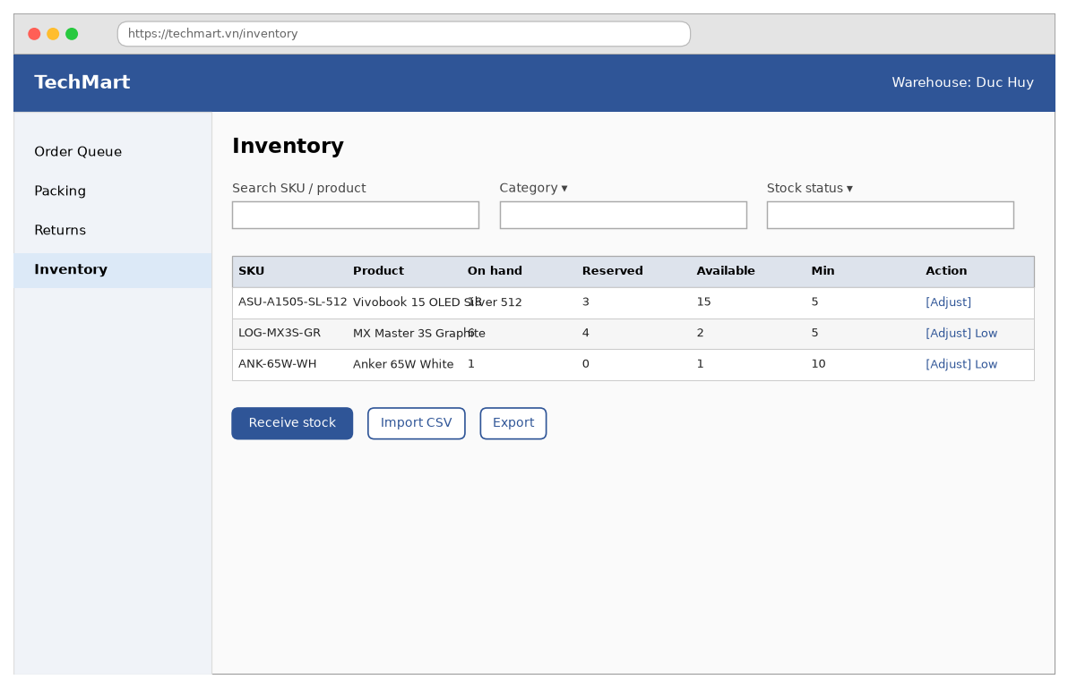
Figure 19 - Manage Inventory — Inventory screen
Function details:
- Data: Variant (SKU, on hand, reserved, available, minimum level), Stock movement (type, quantity, reason, document, user, time).
- Validation: Quantities are whole numbers 0–100,000. New on-hand cannot be less than the reserved quantity. Reason required for Adjust (max 200 characters). CSV max 2,000 rows.
- Business rules: BR-17: every stock change needs a reason and is logged; stock can never be negative. BR-04: reserved stock belongs to placed orders and cannot be adjusted away.
- Normal case: The warehouse staff clicks “Receive stock” -> scans 20 units of LOG-MX3S-GR with delivery note DN-1021 -> the available stock becomes 22 and the Low label disappears.
- Abnormal case: On hand less than reserved -> “On-hand quantity cannot be less than the reserved quantity ({n}).” Reason missing -> “The Reason field is required.” Unknown SKU in CSV -> “{n} rows could not be imported. Download the error report.” Saving fails -> “Could not save the stock change. Please try again.”

3.7.2 Manage Products (UC-16)
Function trigger:
- Navigation path: Admin portal -> sidebar “Products” (/admin/products).
- Timing Frequency: User-initiated only.
Function description:
- Actors / Roles: Store Admin
- Purpose: Keep the catalogue, variants, prices and images correct.
- Interface: Product Management screen:
- “Products”: Label - screen title.
- “+ Add product”: Button - opens an empty product form.
- “Import CSV”: Button - imports products and variants.
- “Product table”: Table - columns “Product”, “Category”, “Brand”, “Variants”, “Price from”, “Status”, “Action” (“Edit”, “Hide”).
- “General / Variants / Images / Specifications / SEO”: Tabs - product form sections.
- “Product name”: Text box - required.
- “Category”: Dropdown - required.
- “Brand”: Text box - required.
- “Status”: Dropdown - Draft, Active, Hidden.
- “Variant table”: Table - columns “SKU”, “Colour”, “Storage”, “Price”, “Compare-at”, “Stock”.
- “Save”: Button - saves the product.
- “Cancel”: Button - discards the changes.
- Data processing: Permission check: role Store Admin -> on Save validate the product and every variant -> create or update Product and Variants in one transaction; images are uploaded to storage and converted to WebP -> a price change is saved in the price history and applies to new carts immediately -> Hide sets status Hidden (products with orders cannot be deleted) -> update the search index -> write the audit log.
Screen layout:
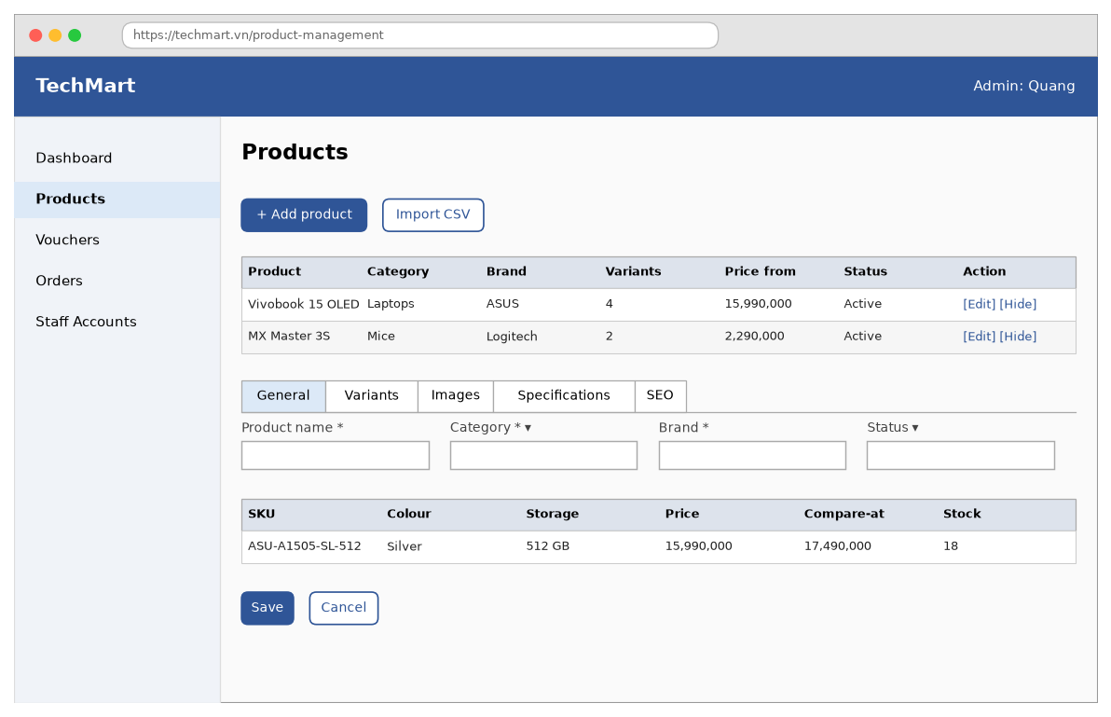
Figure 20 - Manage Products — Product Management screen
Function details:
- Data: Product (name, slug, category, brand, description, specifications, status), Variants (SKU, colour, storage, price, compare-at price, weight), Images, Price history.
- Validation: Name 3–150 characters. At least one variant and one image. SKU unique, 3–40 characters (A–Z, 0–9, -). Price 1,000–200,000,000 ₫. Compare-at price, when given, greater than Price. Image JPG/PNG/WebP up to 5 MB, max 10.
- Business rules: BR-18: products with orders cannot be deleted, only hidden. BR-22: price changes do not affect placed orders. BR-21: only Active products are shown in the store.
- Normal case: The admin clicks “+ Add product” -> fills in the general data -> adds 2 variants and 4 images -> sets status Active -> clicks “Save” -> the product appears in search within 1 minute.
- Abnormal case: Duplicate SKU -> “SKU {sku} is already used.” No variant -> “Please add at least one variant.” Compare-at not higher than price -> “Compare-at price must be higher than the price.” Delete a product with orders -> “This product has orders and can only be hidden.” Image upload fails -> “Could not upload the image. Please try again.”

3.7.3 Manage Vouchers (UC-17)
Function trigger:
- Navigation path: Admin portal -> sidebar “Vouchers” (/admin/vouchers).
- Timing Frequency: User-initiated only.
Function description:
- Actors / Roles: Store Admin
- Purpose: Create and control discount campaigns.
- Interface: Voucher Management screen:
- “Vouchers”: Label - screen title.
- “+ Create voucher”: Button - opens an empty voucher form.
- “Voucher table”: Table - columns “Code”, “Type”, “Value”, “Min order”, “Used / Quota”, “Valid”, “Status”.
- “Code”: Text box - required.
- “Type”: Dropdown - Fixed amount, Percent, Free shipping; required.
- “Value”: Number box - amount or percent; required.
- “Max discount”: Number box - required for Percent.
- “Min order value”: Number box - required.
- “Quota”: Number box - total number of uses; required.
- “Valid from / Valid to”: Date-time pickers - required.
- “Save”: Button - saves the voucher.
- “Cancel”: Button - discards the changes.
- Data processing: Validate -> create or update the Voucher -> a voucher already used can only change its quota (not lower than used_count), end date and status -> status is computed: Scheduled before valid_from, Active, Expired after valid_to, Used up when used_count = quota -> write the audit log.
Screen layout:
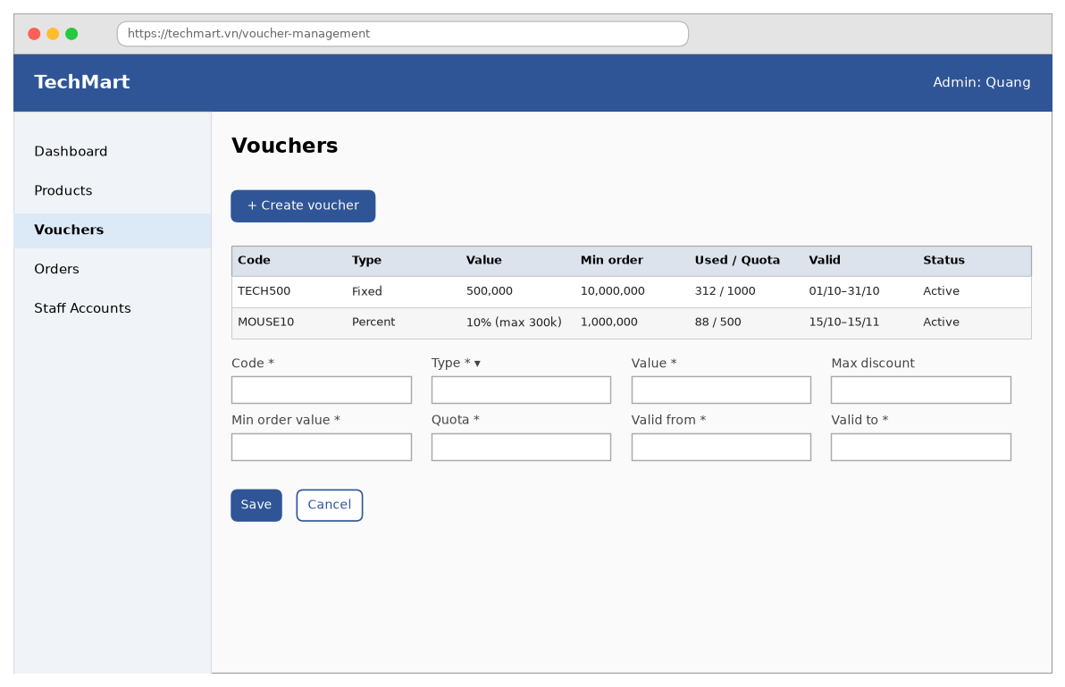
Figure 21 - Manage Vouchers — Voucher Management screen
Function details:
- Data: Voucher (code, type, value, max discount, min order value, quota, used count, valid from, valid to, status).
- Validation: Code unique, 4–20 upper-case letters or digits. Percent 1–90; fixed amount 1,000–5,000,000 ₫. Min order 0–100,000,000 ₫. Quota 1–100,000. Valid to after Valid from, at most 180 days.
- Business rules: BR-06: one voucher per order within its validity, quota and minimum order value.
- Normal case: The admin creates MOUSE10, Percent 10%, max 300,000, min order 1,000,000, quota 500 from 15/10 to 15/11 -> clicks “Save” -> customers can apply it at checkout.
- Abnormal case: Duplicate code -> “This voucher code already exists.” Dates wrong -> “The end time must be after the start time.” Quota below used -> “Quota cannot be lower than the number of uses ({n}).” Edit value of a used voucher -> “This voucher has been used. Only quota, end time and status can be changed.”

3.7.4 View Sales Dashboard (UC-18)
Function trigger:
- Navigation path: Admin portal -> sidebar “Dashboard” (/admin/dashboard); default screen after an admin login.
- Timing Frequency: User-initiated only; the numbers are cached for 5 minutes.
Function description:
- Actors / Roles: Store Admin
- Purpose: Let the Store Admin follow revenue, orders and best-selling products over a period.
- Interface: Sales Dashboard screen:
- “Sales Dashboard – {period}”: Label - screen title.
- “From / To”: Date pickers - period; default this month.
- “Category”: Dropdown - all or one category.
- “KPI cards”: Cards - “Revenue”, “Orders”, “Avg order”, “Return rate”.
- “Revenue per day”: Bar chart - daily revenue.
- “Top products”: Table - columns “Top product”, “Units”, “Revenue”.
- Data processing: Permission check: role Store Admin -> resolve the period in Asia/Ho_Chi_Minh -> revenue = totals of orders Delivered or Completed in the period minus refunds -> orders = orders placed, excluding Cancelled -> average order = revenue / delivered orders -> return rate = returned items / delivered items -> top 10 products by revenue -> render.
Screen layout:
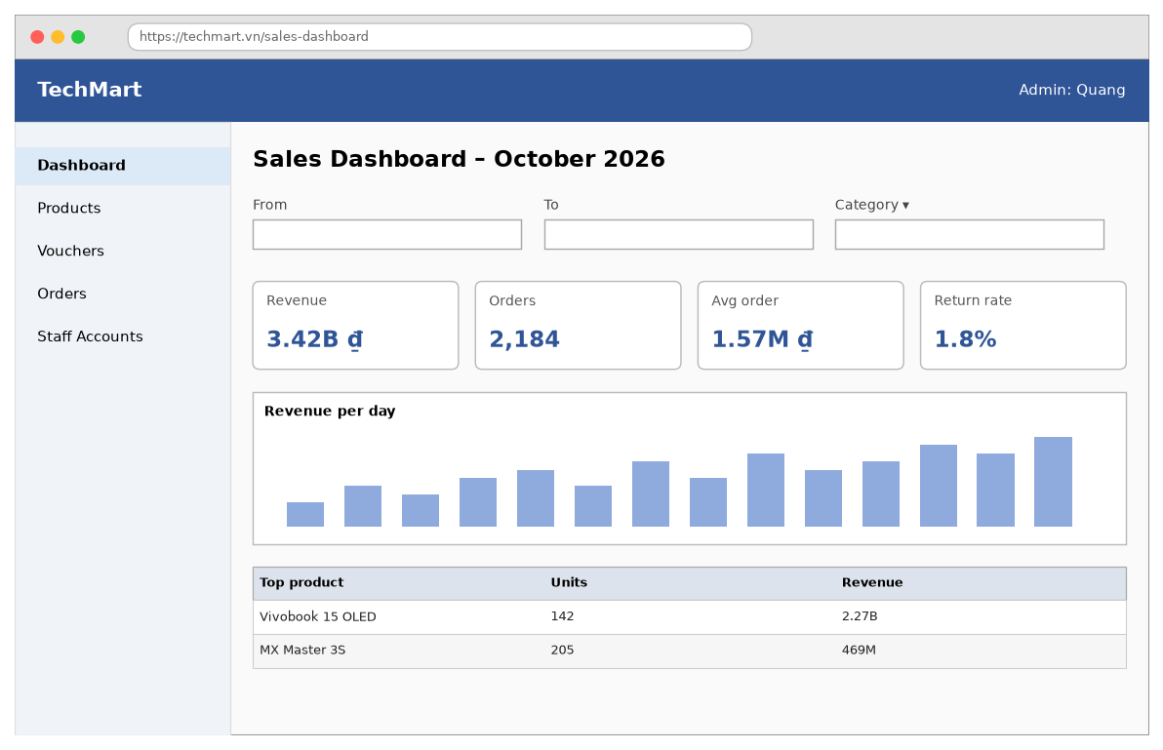
Figure 22 - View Sales Dashboard — Sales Dashboard screen
Function details:
- Data: From, To, Category, Revenue, Orders, Average order value, Return rate, Revenue per day, Top products (name, units, revenue).
- Validation: Dates dd/MM/yyyy. From before To. Period at most 12 months.
- Business rules: BR-19: revenue counts Delivered and Completed orders minus refunds.
- Normal case: The admin opens the dashboard -> sees October numbers -> selects category Laptops -> the cards, chart and top products are recomputed.
- Abnormal case: From not before To -> “The start date must be before the end date.” Period too long -> “The period can be at most 12 months.” No order in the period -> “No data in this period.” Loading fails -> “Could not load the dashboard. Please try again.”

4. Non-Functional Requirements

4.1 External Interfaces
# | Interface | Description | Protocol
1 | User interface | Responsive web for customers; desktop web for staff and admin; Vietnamese and English | HTTPS
2 | VNPay / MoMo | Payment URL, IPN callback, refund and transaction query | REST + webhook
3 | GHN Express | Shipping fee, create shipping order, label, webhook status | REST + webhook
4 | SendGrid | Transactional e-mails (verification, order, refund) | REST
5 | Google Identity | Social login for customers | OAuth 2.0 / OpenID Connect
6 | Barcode scanner | USB scanner on the Packing screen, works as keyboard input | HID

4.2 Quality Attributes

4.2.1 Usability
- A first-time customer can find a product and place an order in under 4 minutes (90% success in usability test).
- All customer screens work on screens from 360 px wide.
- The UI meets WCAG 2.1 AA for contrast and keyboard navigation.

4.2.2 Reliability
- Availability 99.9% per month for the store front; 99.5% for staff screens.
- No overselling: stock is reserved inside the same database transaction that creates the order.
- Payment and shipping webhooks are idempotent and stored before processing.
- Daily database backup kept 30 days; RPO 1 hour, RTO 4 hours.

4.2.3 Performance
- Search results return in p95 < 800 ms with 1,000 concurrent users.
- Product Detail loads in < 2.5 s LCP on 4G.
- Checkout supports 50 orders per second during flash sales.

4.2.4 Security
- Passwords hashed with bcrypt (cost 12); tokens in http-only, secure cookies.
- Card data never touches TechMart servers (PCI-DSS SAQ-A).
- Role-based access control as in 3.1.3; staff actions on orders, stock and refunds are audited.
- Rate limiting: 10 login attempts per minute per IP; 60 search requests per minute per IP.

5. Requirement Appendix

5.1 Business Rules
ID | Rule Definition
BR-01 | Order total = subtotal − voucher discount + shipping fee. All prices include VAT.
BR-02 | Shipping is free for orders whose subtotal after discount is at least 500,000 ₫.
BR-03 | At most 5 units of one variant per order and at most 30 lines in a cart.
BR-04 | Stock is reserved when an order is placed, deducted when it is packed and released when it is cancelled.
BR-05 | Online-payment orders not paid within 30 minutes are cancelled automatically.
BR-06 | One voucher per order; the voucher must be within its validity, quota and minimum order value.
BR-07 | A customer can cancel an order only before it is packed (status Pending Payment, Pending or Confirmed).
BR-08 | Returns are accepted within 7 days after delivery for returnable categories, with the original packaging.
BR-09 | Refunds go to the original payment method within 5 working days; COD orders are refunded by bank transfer.
BR-10 | Only customers who received a product can review it, once per order item; flagged reviews are moderated.
BR-11 | One account per e-mail address and per phone number.
BR-12 | An account is locked for 15 minutes after 5 consecutive failed logins.
BR-13 | Cash on delivery is available only for orders up to 10,000,000 ₫.
BR-14 | Order status flow: Pending Payment -> Pending -> Confirmed -> Packed -> Shipping -> Delivered -> Completed; or Cancelled, Delivery Failed, Returned.
BR-15 | Staff accounts are created by the Store Admin; Google sign-in is for customers only.
BR-16 | Sales staff must confirm or reject an order within 24 hours after it becomes Pending.
BR-17 | Every stock change needs a reason and is logged; stock can never be negative.
BR-18 | A product with orders cannot be deleted, only hidden.
BR-19 | Revenue counts Delivered and Completed orders minus refunds.
BR-20 | An order becomes Completed 7 days after delivery if no return is requested.
BR-21 | Only Active products are shown in the store; out-of-stock products are listed last.
BR-22 | Price changes do not affect placed orders; each order item keeps the price at placing time.

5.2 Common Requirements
- Money is shown in VND with thousands separators, e.g. 15,990,000 ₫.
- Dates use dd/MM/yyyy and the time zone Asia/Ho_Chi_Minh.
- Lists show 20 rows per page (24 products per page in the store).
- Every create, update and delete by staff is written to the audit log with user, time, old and new values.

5.3 Application Messages List
# | Message code | Message Type | Context | Content
1 | MSG01 | In red, under the input | Required field empty | The {field} field is required.
2 | MSG02 | Pop-up | E-mail already used | This e-mail is already registered.
3 | MSG03 | Pop-up | Phone already used | This phone number is already registered.
4 | MSG04 | Pop-up | Weak password | Password must have 8–64 characters with upper case, lower case and a digit.
5 | MSG05 | Pop-up | Terms not ticked | Please accept the Terms of Use to continue.
6 | MSG06 | Pop-up | Verification link expired | This link has expired. We have sent you a new one.
7 | MSG07 | Error banner | E-mail service fails | Could not send the verification e-mail. Please try again later.
8 | MSG08 | Pop-up | Wrong credentials | Incorrect e-mail/phone or password.
9 | MSG09 | Error banner | 5 failures | Your account is locked for 15 minutes.
10 | MSG10 | Pop-up | Disabled account | Your account has been disabled. Please contact support.
11 | MSG11 | Pop-up | Staff uses Google | Staff accounts must log in with e-mail and password.
12 | MSG12 | Error banner | Server error | Could not log in. Please try again.
13 | MSG13 | Pop-up | No result | No products match your search. Try other keywords.
14 | MSG14 | Error banner | Search service fails | Could not load the products. Please try again.
15 | MSG15 | Pop-up | Variant out of stock | This option is out of stock.
16 | MSG16 | Pop-up | Quantity over limit | You can buy at most 5 units of this item.
17 | MSG17 | Pop-up | Product hidden or deleted | This product is no longer available.
18 | MSG18 | Error banner | Loading fails | Could not load the product. Please try again.
19 | MSG19 | Pop-up | Rating missing | Please choose a rating.
20 | MSG20 | Pop-up | Already reviewed | You have already reviewed this item.
21 | MSG21 | Pop-up | Not delivered yet | You can review this item after it is delivered.
22 | MSG22 | Pop-up | Comment flagged | Thanks! Your review will be published after moderation.
23 | MSG23 | Error banner | Upload fails | Could not upload the photo. Please try again.
24 | MSG24 | Pop-up | Quantity more than stock | Only {n} left in stock – quantity reduced.
25 | MSG25 | Pop-up | Item no longer sold | This item is no longer available and cannot be checked out.
26 | MSG26 | Pop-up | Cart full | Your cart can hold at most 30 items.
27 | MSG27 | Pop-up | No item selected | Please select at least one item.
28 | MSG28 | Pop-up | E-mail not verified | Please verify your e-mail before checking out.
29 | MSG29 | Pop-up | No address | Please add a delivery address.
30 | MSG30 | In red, under the input | Voucher invalid | This voucher code is not valid.
31 | MSG31 | Pop-up | Voucher expired or used up | This voucher has expired or run out.
32 | MSG32 | Pop-up | Order below the voucher minimum | Spend {amount} more to use this voucher.
33 | MSG33 | Pop-up | Price changed since the cart | Some prices have changed. Please review your order.
34 | MSG34 | Pop-up | Stock gone at placing time | Some items are out of stock. Your cart has been updated.
35 | MSG35 | Pop-up | COD over limit | Cash on delivery is available for orders up to 10,000,000 ₫.
36 | MSG36 | Error banner | Shipping fee service fails | Could not calculate the shipping fee. Please try again.
37 | MSG37 | Error banner | Payment cancelled or failed | Payment was not completed. You can try again within 30 minutes.
38 | MSG38 | Pop-up | Order already cancelled | This order was cancelled because it was not paid in time.
39 | MSG39 | Pop-up | Provider not available | The payment service is busy. Please try another method.
40 | MSG40 | Pop-up | Order of another customer | Order not found.
41 | MSG41 | Pop-up | Shipment events not available | Shipping updates are temporarily unavailable.
42 | MSG42 | Error banner | Loading fails | Could not load the order. Please try again.
43 | MSG43 | Pop-up | Order already packed | This order is being packed and can no longer be cancelled. Please request a return after delivery.
44 | MSG44 | In red, under the input | Reason missing | The Reason field is required.
45 | MSG45 | Error banner | Refund API fails | Your order is cancelled. The refund is being processed and may take up to 7 working days.
46 | MSG46 | Pop-up | Order changed by someone else | This order was updated by another user. The list has been refreshed.
47 | MSG47 | Pop-up | Address not supported by GHN | GHN does not deliver to this address. Please call the customer.
48 | MSG48 | In red, under the input | Reject without a reason | The Reject reason field is required.
49 | MSG49 | Error banner | Loading fails | Could not load the orders. Please try again.
50 | MSG50 | Pop-up | Wrong item scanned | This item is not in the order.
51 | MSG51 | Pop-up | Scanned too many | All units of this item have already been scanned.
52 | MSG52 | Pop-up | Not all items scanned | Please scan all items before creating the shipment.
53 | MSG53 | Error banner | GHN API fails | Could not create the GHN shipment. Please try again.
54 | MSG54 | Pop-up | Item missing in the bin | Report missing item
55 | MSG55 | Pop-up | Return window passed | The return period for this order has ended.
56 | MSG56 | Pop-up | Category not returnable | This item cannot be returned.
57 | MSG57 | Pop-up | No photo | Please add at least one photo.
58 | MSG58 | Pop-up | Quantity too high | You can return at most {n} units of this item.
59 | MSG59 | In red, under the input | Reject without a note | The Decision note field is required.
60 | MSG60 | Pop-up | Request already handled by someone else | This request was updated by another user. The page has been refreshed.
61 | MSG61 | Error banner | Refund API fails | The refund could not be sent. It will be retried automatically.
62 | MSG62 | Error banner | GHN return pick-up fails | Could not create the return pick-up. Please try again.
63 | MSG63 | Pop-up | On hand less than reserved | On-hand quantity cannot be less than the reserved quantity ({n}).
64 | MSG64 | Error banner | Unknown SKU in CSV | {n} rows could not be imported. Download the error report.
65 | MSG65 | Error banner | Saving fails | Could not save the stock change. Please try again.
66 | MSG66 | Pop-up | Duplicate SKU | SKU {sku} is already used.
67 | MSG67 | Pop-up | No variant | Please add at least one variant.
68 | MSG68 | Pop-up | Compare-at not higher than price | Compare-at price must be higher than the price.
69 | MSG69 | Pop-up | Delete a product with orders | This product has orders and can only be hidden.
70 | MSG70 | Error banner | Image upload fails | Could not upload the image. Please try again.
71 | MSG71 | Pop-up | Duplicate code | This voucher code already exists.
72 | MSG72 | Pop-up | Dates wrong | The end time must be after the start time.
73 | MSG73 | Pop-up | Quota below used | Quota cannot be lower than the number of uses ({n}).
74 | MSG74 | Pop-up | Edit value of a used voucher | This voucher has been used. Only quota, end time and status can be changed.
75 | MSG75 | Pop-up | From not before To | The start date must be before the end date.
76 | MSG76 | Pop-up | Period too long | The period can be at most 12 months.
77 | MSG77 | Pop-up | No order in the period | No data in this period.
78 | MSG78 | Error banner | Loading fails | Could not load the dashboard. Please try again.

5.4 Other Requirements
- Release 1.0 must go live before the 11/11 sale (01/11/2026).
- The system runs on AWS ap-southeast-1 with PostgreSQL and OpenSearch.

