Minh An Booking
Software Requirement Specification
Version: v0.142
Date: 2026-09-22
WORKING DRAFT - NOT BASELINED

Table of Contents

I. Record of Changes
*A - Added, M - Modified, D - Deleted
Date | Version | A*, M, D | In charge | Change Description
2026-09-22 | v0.2 | A | Hiep Tester | step-runner: init step
2026-09-22 | v0.3 | M | Hiep Tester | step-runner: elicit turn
2026-09-22 | v0.4 | A | Hiep Tester | B-0.1 brain dump: product overview; B-0.1 brain dump: booking rules; B-0.1 brain dump: deposit policy; B-0.1 brain dump: roles; B-0.1 brain dump: notifications; B-0.1 brain dump: goals; B-0.1 brain dump: constraints; B-0.1 brain dump: platform and integrations; B-0.1 brain dump: scale; B-0.1 brain dump: reports; B-0.1 brain dump: data migration
2026-09-22 | v0.5 | A | Hiep Tester | Mở cờ section_empty; Mở cờ array_empty; Mở cờ nfr_missing_number; Mở cờ non_english_content
2026-09-22 | v0.6 | M | Hiep Tester | step-runner: cập nhật dải seq
2026-09-22 | v0.7 | M | Hiep Tester | gate: revision requested
2026-09-22 | v0.8 | M | Hiep Tester | gate: revision applied
2026-09-22 | v0.9 | M | Hiep Tester | step-runner: elicit turn
2026-09-22 | v0.10 | M | Hiep Tester | B-0.1 tên tiếng Anh do người dùng chọn; B-0.1 tầm nhìn từ câu trả lời Q2; B-0.1 mục tiêu kinh doanh (AD06); B-0.1 hệ thống nội bộ phục vụ vận hành phòng khám; B-0.1 lĩnh vực; B-0.1 quy mô nhỏ-vừa, 1 tích hợp ngoài, nhiều vai trò; B-0.2 chỉ web responsive, không app native; B-0.3 hệ thống chạy thật với bệnh nhân, xử lý thanh toán; B-0.4 chế độ coaching theo luồng hội thoại; B-0.1 phạm vi giai đoạn đầu; B-0.1 ngoài phạm vi (AD08, AD11); B-0.1 yêu cầu bảo mật từ Q3; B-0.3 stakes suy luận, cần xác nhận; B-0.1 loại sản phẩm suy luận
2026-09-22 | v0.11 | M | Hiep Tester | Đóng cờ section_empty: điều kiện không còn
2026-09-22 | v0.12 | M | Hiep Tester | step-runner: cập nhật dải seq
2026-09-22 | v0.13 | M | Hiep Tester | gate: accept
2026-09-22 | v0.14 | M | Hiep Tester | step-runner: init step
2026-09-22 | v0.15 | M | Hiep Tester | step-runner: elicit turn
2026-09-22 | v0.16 | M | Hiep Tester | step-runner: cập nhật dải seq
2026-09-22 | v0.17 | M | Hiep Tester | gate: accept
2026-09-22 | v0.18 | M | Hiep Tester | step-runner: init step
2026-09-22 | v0.19 | M | Hiep Tester | step-runner: elicit turn
2026-09-22 | v0.20 | M | Hiep Tester | AS01 được người dùng xác nhận ở B-0.3; thời điểm xác nhận AS01
2026-09-22 | v0.21 | M | Hiep Tester | step-runner: cập nhật dải seq
2026-09-22 | v0.22 | M | Hiep Tester | gate: accept
2026-09-22 | v0.23 | M | Hiep Tester | step-runner: init step
2026-09-22 | v0.24 | M | Hiep Tester | step-runner: elicit turn
2026-09-22 | v0.25 | M | Hiep Tester | step-runner: cập nhật dải seq
2026-09-22 | v0.26 | M | Hiep Tester | gate: accept
2026-09-22 | v0.27 | M | Hiep Tester | step-runner: init step
2026-09-22 | v0.28 | M | Hiep Tester | step-runner: elicit turn
2026-09-22 | v0.29 | A | Hiep Tester | B-1.1: yêu cầu sẵn sàng hệ thống từ người dùng, ghi vào Other Requirements; B-1.1: xác nhận mô hình phân quyền theo vai trò, phục vụ B-1.2 personas
2026-09-22 | v0.30 | M | Hiep Tester | step-runner: cập nhật dải seq
2026-09-22 | v0.31 | M | Hiep Tester | gate: accept
2026-09-22 | v0.32 | M | Hiep Tester | step-runner: init step
2026-09-22 | v0.33 | M | Hiep Tester | step-runner: elicit turn
2026-09-22 | v0.34 | A | Hiep Tester | B-1.2 persona bệnh nhân; B-1.2 persona lễ tân; B-1.2 persona bác sĩ; B-1.2 persona quản trị viên; Trả lời Q1 của người dùng; Trả lời Q2 của người dùng
2026-09-22 | v0.35 | M | Hiep Tester | step-runner: cập nhật dải seq
2026-09-22 | v0.36 | M | Hiep Tester | gate: accept
2026-09-22 | v0.37 | M | Hiep Tester | step-runner: init step
2026-09-22 | v0.38 | M | Hiep Tester | step-runner: elicit turn
2026-09-22 | v0.39 | M | Hiep Tester | B-1.3 giá trị cốt lõi từ câu trả lời Q1; Q3 xác nhận: chỉ dùng nội bộ
2026-09-22 | v0.40 | M | Hiep Tester | step-runner: cập nhật dải seq
2026-09-22 | v0.41 | M | Hiep Tester | gate: accept
2026-09-22 | v0.42 | M | Hiep Tester | step-runner: init step
2026-09-22 | v0.43 | M | Hiep Tester | step-runner: elicit turn
2026-09-22 | v0.44 | A | Hiep Tester | B-1.4 MVP capability hypothesis; B-1.4 not-now list; B-1.4 user answer Q1 — NFR, aimed at Other Requirements; B-1.4 user answer Q2 — confirms automated refund capability
2026-09-22 | v0.45 | M | Hiep Tester | step-runner: cập nhật dải seq
2026-09-22 | v0.46 | M | Hiep Tester | gate: accept
2026-09-22 | v0.47 | M | Hiep Tester | step-runner: init step
2026-09-22 | v0.48 | M | Hiep Tester | step-runner: elicit turn
2026-09-22 | v0.49 | A | Hiep Tester | B-1.5 chỉ số thành công với baseline do người dùng chọn; B-1.5 chỉ số thành công cuộc gọi đặt lịch; B-1.5 mục tiêu học tập về việc bệnh nhân chấp nhận cọc online; B-1.5 baseline no-show là ước lượng của người dùng
2026-09-22 | v0.50 | M | Hiep Tester | step-runner: cập nhật dải seq
2026-09-22 | v0.51 | M | Hiep Tester | gate: accept
2026-09-22 | v0.52 | M | Hiep Tester | step-runner: init step
2026-09-22 | v0.53 | M | Hiep Tester | step-runner: elicit turn
2026-09-22 | v0.54 | A | Hiep Tester | B-1.6 rủi ro chính người dùng nêu: bệnh nhân chưa chắc chấp nhận đặt cọc online; B-1.6 rủi ro từ thiếu dữ liệu lịch sử về tỷ lệ no-show; B-1.6 giả định cần xác nhận về tích hợp VNPay; B-1.6 giả định về nhà cung cấp SMS chưa được chốt
2026-09-22 | v0.55 | M | Hiep Tester | Đóng cờ section_empty: điều kiện không còn
2026-09-22 | v0.56 | M | Hiep Tester | step-runner: cập nhật dải seq
2026-09-22 | v0.57 | M | Hiep Tester | gate: accept
2026-09-22 | v0.58 | M | Hiep Tester | step-runner: init step
2026-09-22 | v0.59 | M | Hiep Tester | step-runner: elicit turn
2026-09-22 | v0.60 | M | Hiep Tester | B-2.1 người dùng xác nhận mức cơ sở 15%; B-2.1 ghi nhận thời điểm xác nhận
2026-09-22 | v0.61 | M | Hiep Tester | step-runner: cập nhật dải seq
2026-09-22 | v0.62 | M | Hiep Tester | gate: accept
2026-09-22 | v0.63 | M | Hiep Tester | step-runner: init step
2026-09-22 | v0.64 | M | Hiep Tester | step-runner: elicit turn
2026-09-22 | v0.65 | M | Hiep Tester | B-2.2 triage: data security is a non-functional requirement, park to fixed:5.4 for S-7.4; B-2.2 triage: VNPay automatic refund is a deposit-rule detail, belongs with the MVP payment capability
2026-09-22 | v0.66 | M | Hiep Tester | step-runner: cập nhật dải seq
2026-09-22 | v0.67 | M | Hiep Tester | gate: accept
2026-09-22 | v0.68 | M | Hiep Tester | step-runner: init step
2026-09-22 | v0.69 | M | Hiep Tester | step-runner: elicit turn
2026-09-22 | v0.70 | M | Hiep Tester | Người dùng xác nhận sẽ kiểm tra API VNPay trước go-live; Người dùng xác nhận sẽ lấy báo giá SMS trước khi phát triển; Lens Skeptic: OTP phụ thuộc cùng kênh SMS, chưa được nói rõ; Lens Opportunity: reminder có thể thành hành động, brief đang under-claim; Lens Contextual: domain y tế + stakes production nhưng retention dữ liệu cá nhân chưa được nói tới
2026-09-22 | v0.71 | M | Hiep Tester | step-runner: cập nhật dải seq
2026-09-22 | v0.72 | M | Hiep Tester | gate: accept
2026-09-22 | v0.73 | M | Hiep Tester | step-runner: init step
2026-09-22 | v0.74 | M | Hiep Tester | step-runner: elicit turn
2026-09-22 | v0.75 | M | Hiep Tester | User confirmed VNPay API refund support (Q1); User confirmed SMS provider reliability (Q2); Q2 resolves the OTP/SMS delivery concern; Q3 gives evidence on patient payment habits; monitoring stays
2026-09-22 | v0.76 | M | Hiep Tester | step-runner: cập nhật dải seq
2026-09-22 | v0.77 | M | Hiep Tester | gate: accept
2026-09-22 | v0.78 | M | Hiep Tester | step-runner: init step
2026-09-22 | v0.79 | M | Hiep Tester | step-runner: elicit turn
2026-09-22 | v0.80 | M | Hiep Tester | step-runner: cập nhật dải seq
2026-09-22 | v0.81 | M | Hiep Tester | gate: accept
2026-09-22 | v0.82 | M | Hiep Tester | step-runner: init step
2026-09-22 | v0.83 | M | Hiep Tester | step-runner: elicit turn
2026-09-22 | v0.84 | A | Hiep Tester | User confirmed registration is phone + OTP only; User confirmed shift entry by admin and 30-minute slots; User confirmed cloud hosting; S-1.4 gap: availability has no figure; S-1.4 gap: OTP validity and retries unspecified
2026-09-22 | v0.85 | M | Hiep Tester | step-runner: cập nhật dải seq
2026-09-22 | v0.86 | M | Hiep Tester | gate: accept
2026-09-22 | v0.87 | M | Hiep Tester | step-runner: init step
2026-09-22 | v0.88 | M | Hiep Tester | step-runner: elicit turn
2026-09-22 | v0.89 | M | Hiep Tester | User accepted the 15% baseline with later re-measurement; Retention question answered by user; User decided: retain indefinitely, no deletion requests; Availability question answered by user; User decided: 99% monthly, night maintenance excluded; OTP policy question answered by user; User decided: OTP valid 5 minutes, max 3 resends
2026-09-22 | v0.90 | M | Hiep Tester | step-runner: cập nhật dải seq
2026-09-22 | v0.91 | M | Hiep Tester | gate: accept
2026-09-22 | v0.92 | M | Hiep Tester | step-runner: init step
2026-09-22 | v0.93 | M | Hiep Tester | step-runner: elicit turn
2026-09-22 | v0.94 | M | Hiep Tester | step-runner: cập nhật dải seq
2026-09-22 | v0.95 | M | Hiep Tester | gate: accept
2026-09-22 | v0.96 | M | Hiep Tester | step-runner: init step
2026-09-22 | v0.97 | M | Hiep Tester | step-runner: elicit turn
2026-09-22 | v0.98 | M | Hiep Tester | step-runner: cập nhật dải seq
2026-09-22 | v0.99 | M | Hiep Tester | gate: accept
2026-09-22 | v0.100 | M | Hiep Tester | step-runner: init step
2026-09-22 | v0.101 | M | Hiep Tester | step-runner: elicit turn
2026-09-22 | v0.102 | A | Hiep Tester | S-2.3 external system named in release scope and deposit rules; S-2.3 external system from notification scope (AD05)
2026-09-22 | v0.103 | M | Hiep Tester | Mở cờ orphan_actor; Đóng cờ section_empty: điều kiện không còn; Đóng cờ array_empty: điều kiện không còn
2026-09-22 | v0.104 | M | Hiep Tester | step-runner: cập nhật dải seq
2026-09-22 | v0.105 | M | Hiep Tester | gate: accept
2026-09-22 | v0.106 | M | Hiep Tester | step-runner: init step
2026-09-22 | v0.107 | M | Hiep Tester | step-runner: elicit turn
2026-09-22 | v0.108 | A | Hiep Tester | S-2.4 from AD02 booking rules; S-2.4 from AD03 deposit policy; S-2.4 from AD03 plus user answers Q2-Q3; S-2.4 from user answer Q1 and AD04 shifts; S-2.4 from AD04 roles; S-2.4 from AD05 notifications
2026-09-22 | v0.109 | M | Hiep Tester | step-runner: cập nhật dải seq
2026-09-22 | v0.110 | M | Hiep Tester | gate: accept
2026-09-22 | v0.111 | M | Hiep Tester | step-runner: init step
2026-09-22 | v0.112 | A | Hiep Tester | render
2026-09-22 | v0.113 | M | Hiep Tester | step-runner: cập nhật dải seq
2026-09-22 | v0.114 | M | Hiep Tester | gate: accept
2026-09-22 | v0.115 | M | Hiep Tester | step-runner: init step
2026-09-22 | v0.116 | M | Hiep Tester | step-runner: elicit turn
2026-09-22 | v0.117 | A | Hiep Tester | AD15 persona; self-registers with OTP per AD20; AD16 persona; invited account per AD18; AD17 persona; invited account per AD18; AD18 persona; RBAC per AD14; S-3.1 role for patient self-service; S-3.1 role per AD14 RBAC; S-3.2 account use case: patient self-registers (AD20); S-3.2 account use case for all signed-in actors; S-3.2 account use case for self-registers/invited actors; S-3.2 core patient goal; deposit runs every booking; S-3.2 patient goal from release scope; S-3.2 patient goal; VNPay refund on timely cancellation; Included behaviour of Book Appointment; runs every time; AD16 receptionist job; AD16 booking on behalf of callers; AD17 doctor job; AD17 short notes only; AD18 admin entity management; AD18 staff accounts created by admin; AD18 reports; covers project goal on no-show rate; S-3.1 combined access assumption for unresolved actor onboarding
2026-09-22 | v0.118 | M | Hiep Tester | Mở cờ usecase_no_function; Mở cờ usecase_name_style; Mở cờ usecase_name_semantic; Đóng cờ section_empty: điều kiện không còn; Đóng cờ array_empty: điều kiện không còn; Đóng cờ orphan_actor: điều kiện không còn
2026-09-22 | v0.119 | M | Hiep Tester | step-runner: cập nhật dải seq
2026-09-22 | v0.120 | M | Hiep Tester | gate: accept
2026-09-22 | v0.121 | M | Hiep Tester | step-runner: init step
2026-09-22 | v0.122 | M | Hiep Tester | step-runner: elicit turn
2026-09-22 | v0.123 | M | Hiep Tester | step-runner: cập nhật dải seq
2026-09-22 | v0.124 | M | Hiep Tester | gate: accept
2026-09-22 | v0.125 | M | Hiep Tester | step-runner: init step
2026-09-22 | v0.126 | M | Hiep Tester | step-runner: elicit turn
2026-09-22 | v0.127 | A | Hiep Tester | S-3.3 theme 1: appointments are the entity end users create; admin lacks view/cancel over them; S-3.3 theme 5: destructive/high-trust actions exist (staff accounts, refunds) so admin needs an audit review path
2026-09-22 | v0.128 | A | Hiep Tester | Mở cờ usecase_no_function; Mở cờ usecase_name_semantic
2026-09-22 | v0.129 | M | Hiep Tester | step-runner: cập nhật dải seq
2026-09-22 | v0.130 | M | Hiep Tester | gate: accept
2026-09-22 | v0.131 | M | Hiep Tester | step-runner: init step
2026-09-22 | v0.132 | M | Hiep Tester | step-runner: elicit turn
2026-09-22 | v0.133 | M | Hiep Tester | step-runner: cập nhật dải seq
2026-09-22 | v0.134 | M | Hiep Tester | gate: accept
2026-09-22 | v0.135 | M | Hiep Tester | step-runner: init step
2026-09-22 | v0.136 | M | Hiep Tester | step-runner: elicit turn
2026-09-22 | v0.137 | M | Hiep Tester | step-runner: cập nhật dải seq
2026-09-22 | v0.138 | M | Hiep Tester | gate: accept
2026-09-22 | v0.139 | M | Hiep Tester | step-runner: init step
2026-09-22 | v0.140 | A | Hiep Tester | render
2026-09-22 | v0.141 | M | Hiep Tester | Đóng cờ section_empty: điều kiện không còn
2026-09-22 | v0.142 | M | Hiep Tester | step-runner: cập nhật dải seq

Working Draft Status
Open red flags: 20 · Stale sections: 0 · Waived flags: 0

Open Red Flags
ID | Rule | Section | Message
FL005 | section_empty | 3.1.1 Screens Flow | Section bắt buộc fixed:3.1.1 chưa có dữ liệu
FL006 | section_empty | 3.1.2 Screen Descriptions | Section bắt buộc fixed:3.1.2 chưa có dữ liệu
FL008 | section_empty | 3.1.4 Non-Screen Functions | Section bắt buộc fixed:3.1.4 chưa có dữ liệu
FL009 | section_empty | 3.1.5 Entity Relationship Diagram | Section bắt buộc fixed:3.1.5 chưa có dữ liệu
FL010 | section_empty | 4.1 External Interfaces | Section bắt buộc fixed:4.1 chưa có dữ liệu
FL011 | section_empty | 4.2.1 Usability | Section bắt buộc fixed:4.2.1 chưa có dữ liệu
FL012 | section_empty | 4.2.2 Reliability | Section bắt buộc fixed:4.2.2 chưa có dữ liệu
FL013 | section_empty | 4.2.3 Performance | Section bắt buộc fixed:4.2.3 chưa có dữ liệu
FL014 | section_empty | 5.1 Business Rules | Section bắt buộc fixed:5.1 chưa có dữ liệu
FL015 | section_empty | 5.2 Common Requirements | Section bắt buộc fixed:5.2 chưa có dữ liệu
FL016 | section_empty | 5.3 Application Messages List | Section bắt buộc fixed:5.3 chưa có dữ liệu
FL020 | array_empty | 3.1.2 Screen Descriptions | screens đang rỗng
FL021 | array_empty | 3.1.5 Entity Relationship Diagram | entities đang rỗng
FL023 | array_empty | 3.1.2 Screen Descriptions | features đang rỗng
FL024 | array_empty | 3.1.2 Screen Descriptions | functions đang rỗng
FL026 | array_empty | 4.2.2 Reliability | nfrs[category=reliability] đang rỗng
FL027 | array_empty | 4.2.3 Performance | nfrs[category=performance] đang rỗng
FL028 | array_empty | 5.2 Common Requirements | common_requirements đang rỗng
FL029 | nfr_missing_number | 4.2.2 Reliability | Chưa có NFR reliability nào
FL030 | nfr_missing_number | 4.2.3 Performance | Chưa có NFR performance nào

1 Product Overview
Help patients at Minh An general clinic book appointments easily online, reducing no-shows and front-desk overload across 3 branches in Da Nang.

Goals
- Cut the no-show rate by 30% (from an estimated 10–20%)
- Reduce queue waiting at the front desk
- Let patients self-book, reschedule and cancel without calling the clinic

Release 1.0 Scope

In Scope
- Patient self-service booking (branch, specialty, doctor, time slot)
- Reschedule/cancel up to 2 hours before with deposit rules
- 50,000 VND deposit via VNPay
- Receptionist check-in and booking on behalf of phone callers
- Doctor day schedule and short visit notes
- Admin management of branches, doctors, shifts and staff accounts
- SMS reminder 24h before, booking confirmation email
- Basic reports (no-show rate, visits per branch/doctor)

Out of Scope
- Native mobile apps (responsive web only)
- Full electronic medical records (short visit notes only)
- Migration of existing patient and appointment data
- Integrations other than VNPay

High-Level Business Rules
- A patient may reschedule or cancel an appointment up to 2 hours before the scheduled time; later changes are not allowed through the system.
- A patient may book appointments up to 30 days ahead, one appointment per booking, and holds at most one pending appointment at a time.
- Every self-service booking requires a 50,000 VND deposit paid via VNPay; receptionist-assisted bookings require no deposit and are paid at check-in.
- Cancelling more than 2 hours ahead triggers an automatic VNPay refund within 1-3 business days; a no-show forfeits the deposit; rescheduling more than 2 hours ahead carries the deposit to the new slot.
- A doctor's schedule consists of continuous 15-minute slots within their assigned shifts, and a slot is closed once full.
- Staff accounts are created only by administrators; patients self-register, and staff cannot self-register.
- The system sends a confirmation email on successful booking and an SMS reminder 24 hours before every appointment.

External Systems
- VNPay (system) — External payment gateway that processes the 50,000 VND booking deposit, refunds on timely cancellation, and carries the deposit over on reschedule.
- SMS/Email Notification Service (system) — External messaging service that delivers the booking confirmation email and the SMS reminder sent 24 hours before each appointment.
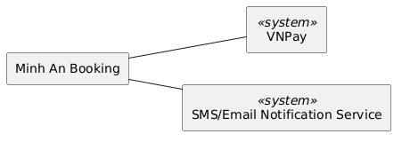
Figure — System Context Diagram

2 User Requirements

2.1 Actors
ID | Name | Kind | Description
A01 | VNPay | system | External payment gateway that processes the 50,000 VND booking deposit, refunds on timely cancellation, and carries the deposit over on reschedule.
A02 | SMS/Email Notification Service | system | External messaging service that delivers the booking confirmation email and the SMS reminder sent 24 hours before each appointment.
A03 | Patient | human | A clinic patient who self-registers with SMS OTP verification, books, reschedules and cancels appointments online, and pays the 50,000 VND deposit via VNPay to get a confirmed slot without phoning the clinic.
A04 | Receptionist | human | A front-desk staff member with a clinic-created account who checks patients in on arrival and books appointments on behalf of phone callers without a deposit, to keep the day's arrivals organized.
A05 | Doctor | human | A clinic doctor with a clinic-created account who views the day's schedule and writes short visit notes for each appointment with minimal effort.
A06 | Administrator | human | A clinic administrator with a provisioned account who manages branches, doctors, shifts and staff accounts, and views reports to track whether the no-show rate is improving.

2.2 Use Cases

2.2.1 Use Case Diagram
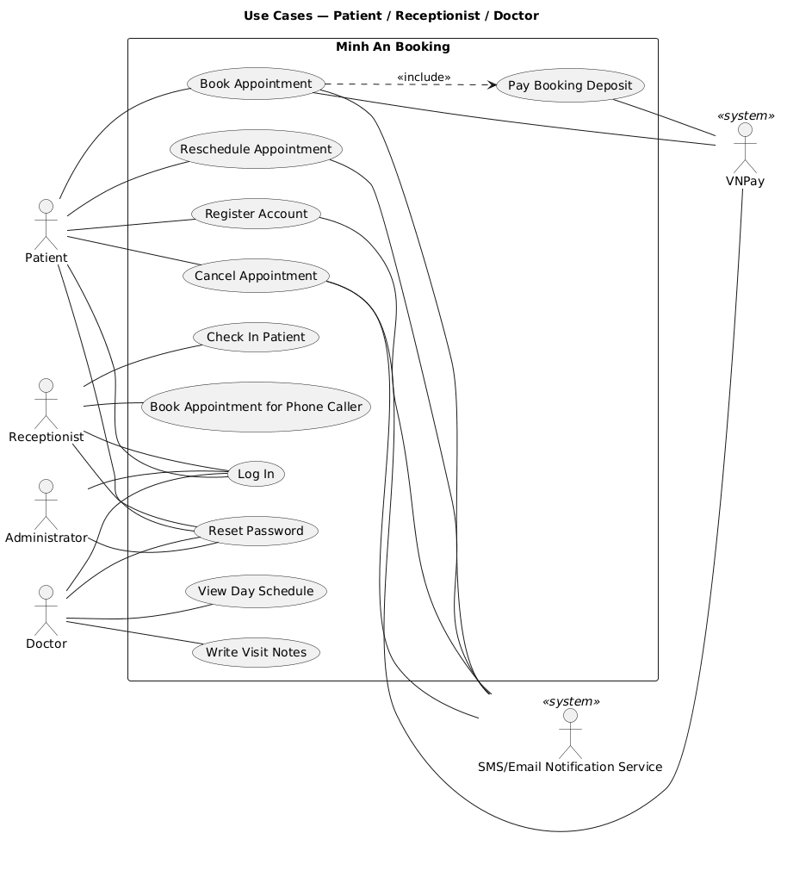
Use Case Diagram (1/2)
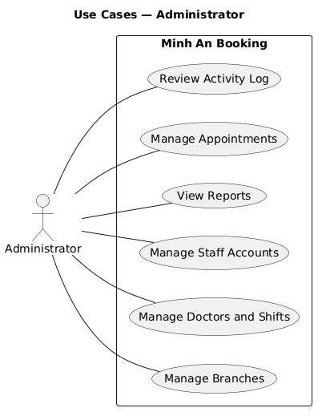
Use Case Diagram (2/2)

2.2.2 Use Case Descriptions
ID | Use Case | Actors | Use Case Description | Includes | Extends
UC01 | Register Account | Patient, SMS/Email Notification Service | A patient registers with phone number and verifies via an OTP sent by SMS to create a booking account.
UC02 | Log In | Patient, Receptionist, Doctor, Administrator | A patient or staff member signs in with their account credentials to access the booking system.
UC03 | Reset Password | Patient, Receptionist, Doctor, Administrator | A user who cannot sign in resets their password via a verification code to regain access to their account.
UC04 | Book Appointment | Patient, VNPay, SMS/Email Notification Service | A patient books an appointment by choosing branch, specialty, doctor and time slot, pays the 50,000 VND deposit via VNPay, and receives a confirmation email. | Pay Booking Deposit
UC05 | Reschedule Appointment | Patient, SMS/Email Notification Service | A patient changes an existing appointment to another time slot up to 2 hours before, carrying the deposit over, and receives an updated confirmation.
UC06 | Cancel Appointment | Patient, VNPay, SMS/Email Notification Service | A patient cancels an appointment up to 2 hours before and the deposit is refunded via VNPay according to the deposit rules.
UC07 | Pay Booking Deposit | Patient, VNPay | The patient pays the 50,000 VND deposit through the VNPay gateway as part of completing a self-service booking.
UC08 | Check In Patient | Receptionist | A receptionist marks an arriving patient's appointment as checked in to keep the day's arrivals organized.
UC09 | Book Appointment for Phone Caller | Receptionist | A receptionist books an appointment on behalf of a phone caller without a deposit, with payment collected at check-in.
UC10 | View Day Schedule | Doctor | A doctor views the day's appointment schedule for their clinic to see who is coming.
UC11 | Write Visit Notes | Doctor | A doctor records short visit notes for a completed appointment to capture what happened in the visit.
UC12 | Manage Branches | Administrator | An administrator creates and updates clinic branch records to keep the scheduling setup current across the 3 branches.
UC13 | Manage Doctors and Shifts | Administrator | An administrator manages doctor records and work shifts so that bookable slots reflect actual clinic staffing.
UC14 | Manage Staff Accounts | Administrator | An administrator creates and manages receptionist and doctor accounts, since staff cannot self-register.
UC15 | View Reports | Administrator | An administrator views basic reports on no-show rate and visits per branch and doctor to see whether the no-show problem is improving.
UC16 | Manage Appointments | Administrator | An administrator views and cancels patient appointments across branches to handle complaints and remove invalid bookings.
UC17 | Review Activity Log | Administrator | An administrator reviews a log of high-trust actions such as staff account changes and deposit refunds to detect misuse.

3 Functional Requirements

3.1 System Functional Overview

3.1.1 Screens Flow

3.1.2 Screen Descriptions

3.1.3 Screen Authorization

3.1.4 Non-Screen Functions

3.1.5 Entity Relationship Diagram

4 Non-Functional Requirements

4.1 External Interfaces

4.2 Quality Attributes

4.2.1 Usability

4.2.2 Reliability

4.2.3 Performance

4.2.4 Domain-Specific Attributes

5 Requirement Appendix

5.1 Business Rules

5.2 Common Requirements

5.3 Application Messages List

5.4 Other Requirements
Kind | Statement
risk | Risk partially mitigated by user input: most patients use smartphones and are familiar with online payment, so online deposit acceptance is expected to be high. Residual action: still track drop-off at the VNPay payment step after launch (see learning goal on online deposit acceptance) and be ready to adjust the deposit policy if completion is low.
risk | RESOLVED by user: the 15% no-show baseline is accepted as the working baseline despite being an estimate; the 30% reduction target stands. Re-baseline from the basic reports after a few months of real data.
assumption | CONFIRMED by user: VNPay has verified that automatic deposit refunds via API are supported. Refunds on cancellation are processed automatically; no manual fallback needed.
assumption | CONFIRMED by user: a known local SMS provider with good reliability is available for reminders and OTP at 50-150 bookings per day. No further provider quotes needed before development.
risk | Risk reduced by user input: the SMS provider for reminders and OTP is a known vendor with good delivery reliability. Residual action: monitor OTP failure rates after launch as a routine check.
open_question | Should the 24h SMS reminder include a confirm/cancel link so patients can act directly from the message? This could further cut no-shows beyond the reminder alone, but adds scope to the notification capability. Decide before S-3 scoping.
assumption | CONFIRMED by user: patient personal data (names, phone numbers, booking history) is kept indefinitely; no deletion-on-request requirement applies. No retention limit or deletion workflow is in scope.
assumption | CONFIRMED by user: availability target is 99% per month; scheduled maintenance performed at night does not count against the uptime figure.
assumption | CONFIRMED by user: an SMS OTP is valid for 5 minutes, with a maximum of 3 resend attempts before the registration must restart.

5.5 Glossary

