**PROJECT REPORT**

**Project Title:** Time in Gujarati keyword detection

**Project Tools:**  yacc **,** flex , c lang.

**Group details:** IT020- Miten Chauhan

**Rules of Language:**

* **Keyword:**
* savar, bapor, sanj, raat
* na
* **Operation:**
* sava, sada, pona
* dodh, adhi

**FA:**

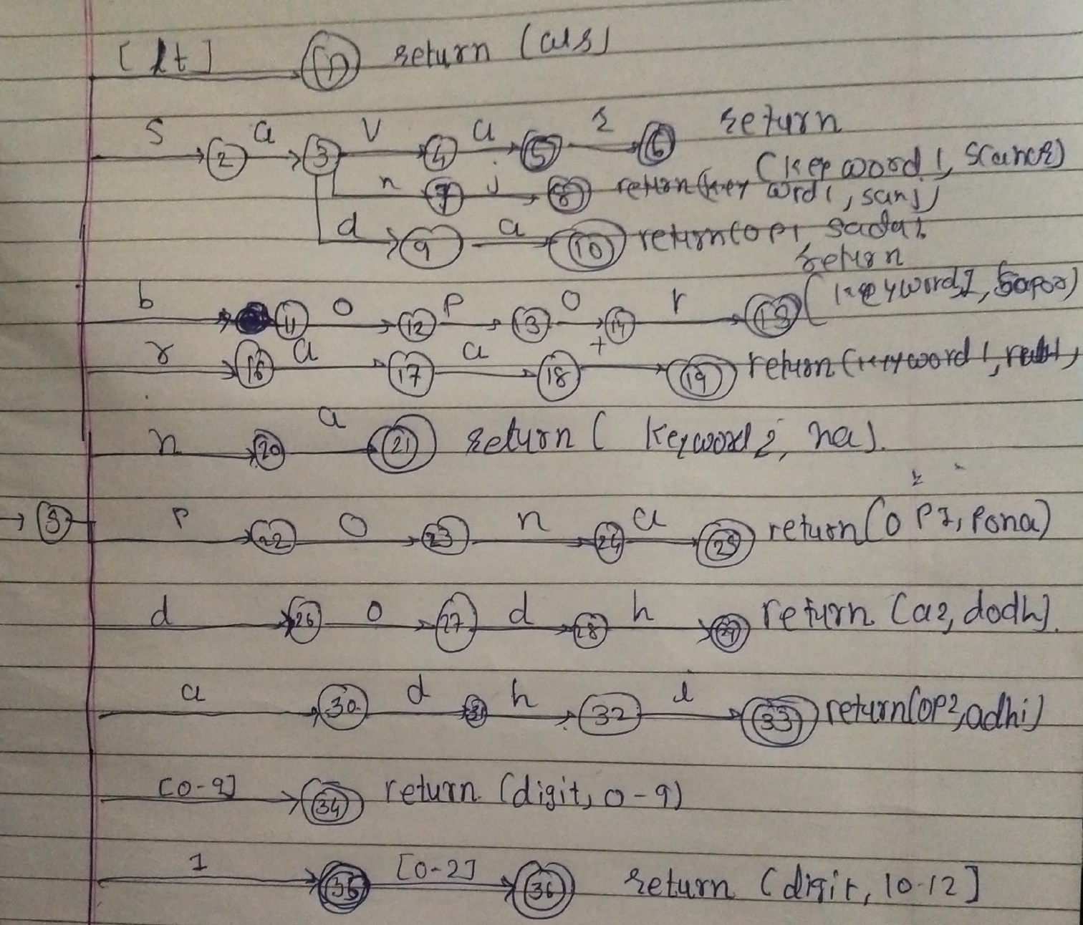

**Code:**

**C FILE:**

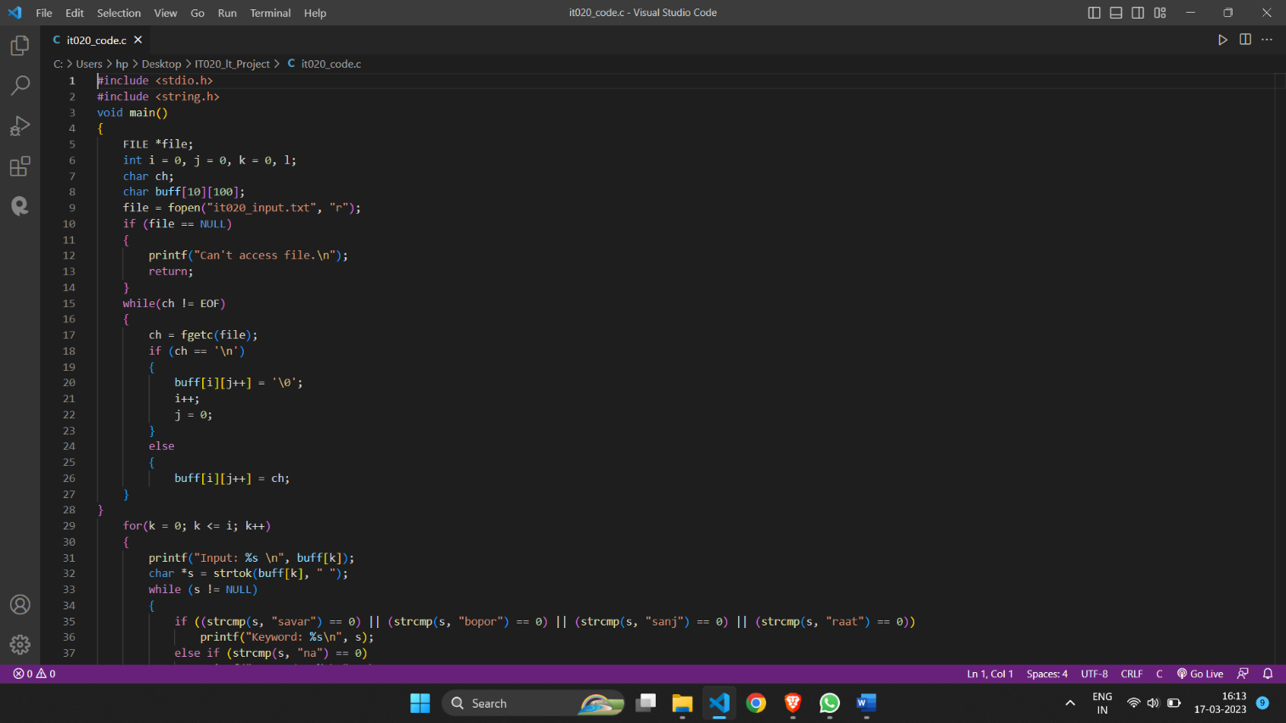

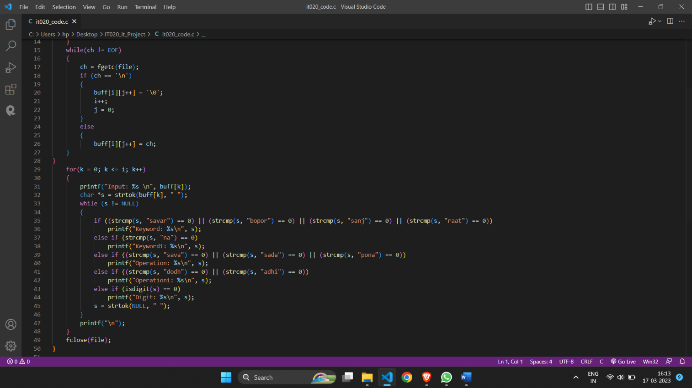

**Lex file:**

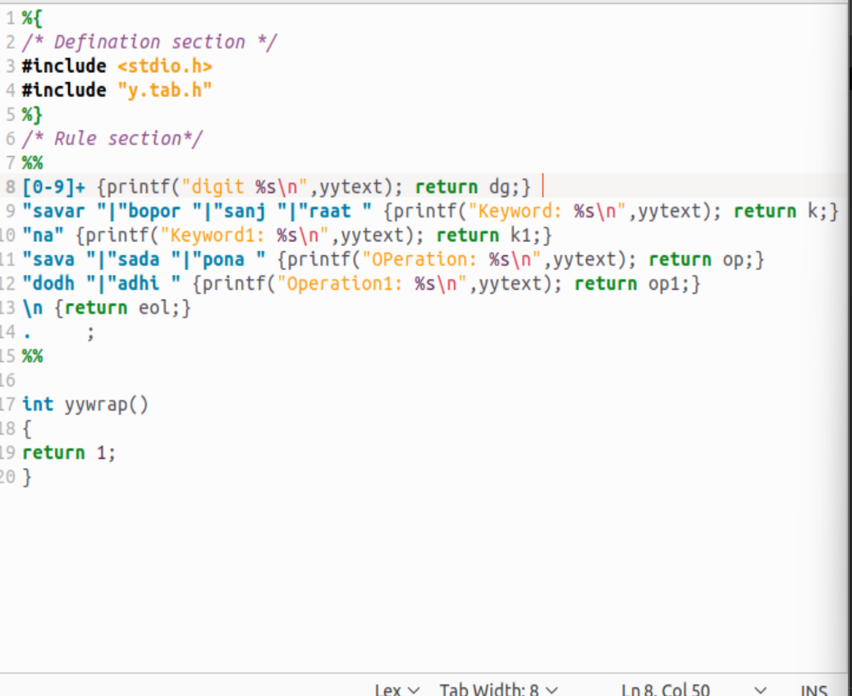

**YACC FILE:**

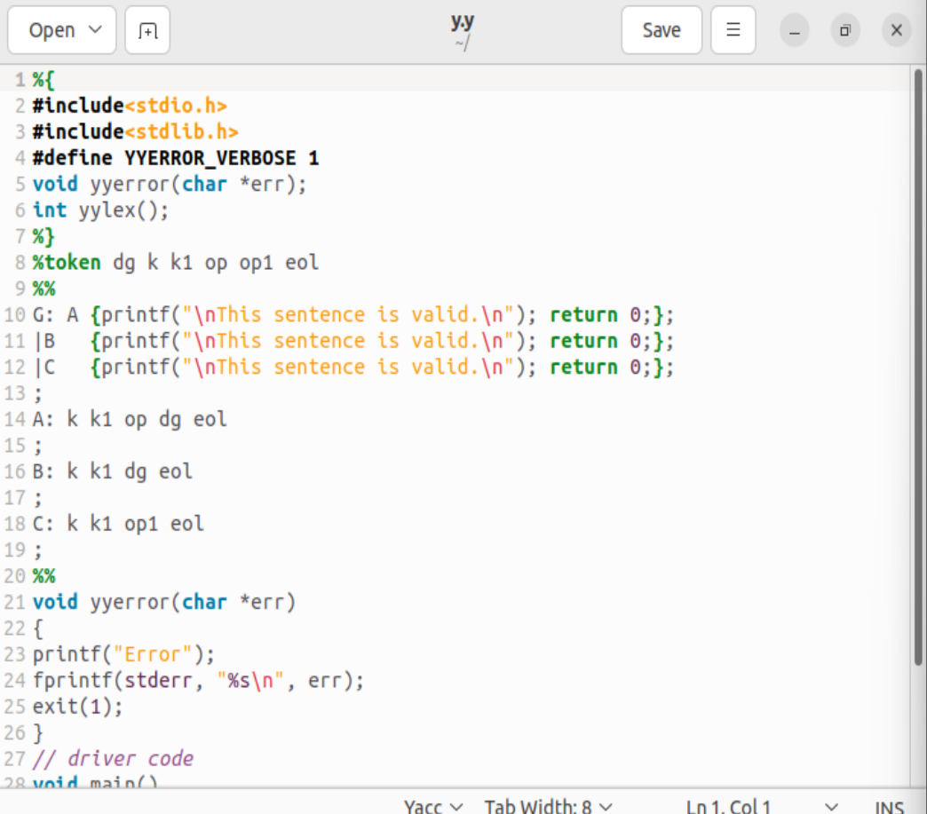

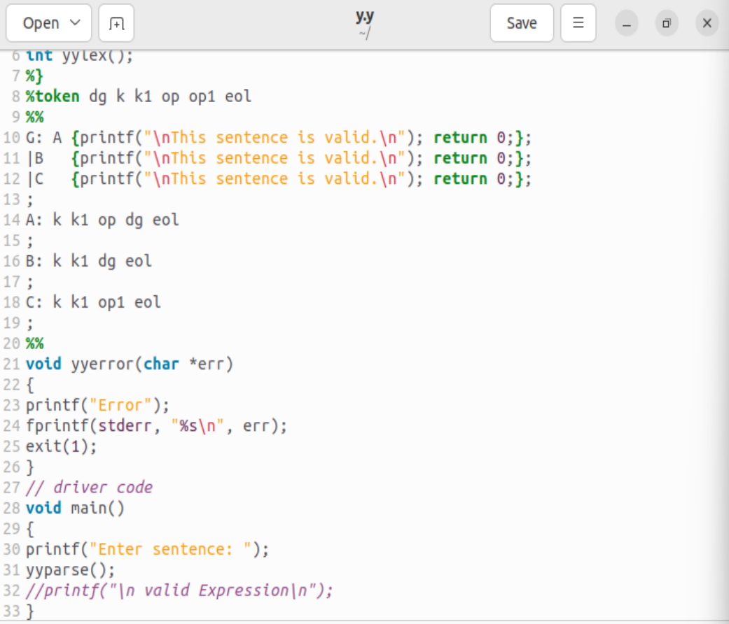

**STEPS TO EXECUTE FILE:**

**Flex y.l**

**Yacc y.y**

**Gcc lex.yy.c y.tab.c**

**./a.out**

**Output:**

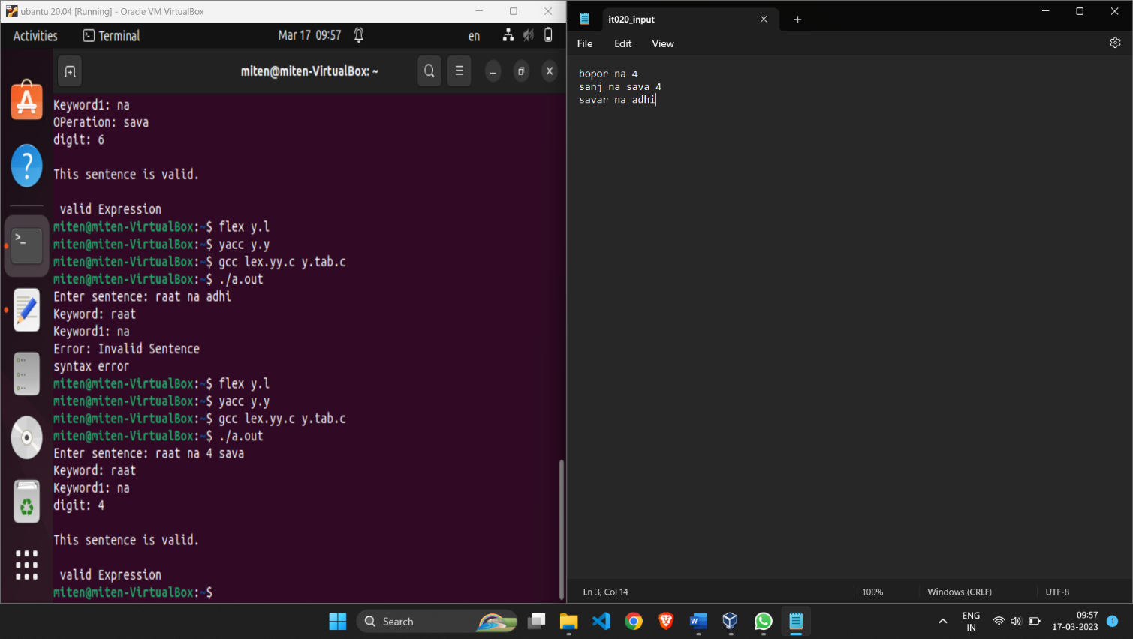

LINK OF PROJECT: