Treehouse — Phase 1 Detailed Workflow (2-Person Split)
This document breaks Phase 1 down task-by-task across the two-person team. It
defines who owns what, what depends on what, and where the two members hand work
off to each other.
Phase 1 goal: Upload a sketch → generate a live layout → circle a region to
edit it → see UX audit flags.
________________________________________

The Two Roles
 | Role | Owns
Member 1 | Frontend / Canvas Engineer | The canvas, the UI, image upload, selection tools, live preview, the copilot sidebar UI. Everything the user sees and touches.
Member 2 | Full-Stack / AI Engineer | The API routes, the OpenAI integration, prompt engineering, turning images + coordinates into code, the copilot analysis logic. Everything behind the scenes.

Rule of thumb: Member 1 builds *the interface*. Member 2 builds *the intelligence*.
They meet at the API — Member 1 calls it, Member 2 builds it.
________________________________________

Shared Setup (Do Together, Day 1)
Before splitting off, both members do this together so everyone has the same base:
- Initialize the Next.js + TypeScript + Tailwind project.
- Install shared dependencies (Konva.js, OpenAI SDK).
- Agree on the shared TypeScript types — the "contract" between frontend and
backend. Specifically, agree on the shape of:
- What the frontend sends to /api/generate (image data, optional
selection box, optional prompt).
- What the backend returns (generated HTML string, list of UX flags).
- Set up .env.local with the OpenAI key.
- Confirm the dev server runs and a blank page loads.
- Push the base project to GitHub.
This shared "contract" is the most important step. Once both members agree on
what the API sends and returns, they can work in parallel without blocking
each other.
________________________________________

Feature-by-Feature Breakdown

Feature 1 — Canvas + Image Upload
Primary: Member 1
Member 1 tasks:
- Build the main app layout (header + split view: canvas left, output right).
- Add the Konva.js canvas to the left panel.
- Implement drag-and-drop and click-to-upload for images (PNG, JPG, SVG).
- Render the uploaded image onto the canvas, scaled to fit.
- Store the uploaded image in component state (as a base64 data URL) so it can
later be sent to the API.
Member 2 tasks (in parallel):
- Scaffold the empty /api/generate API route so it exists and returns a
placeholder response. This unblocks Member 1's testing later.
Handoff: None yet — they work independently.
Done when: An image can be dropped and appears on the canvas.
________________________________________

Feature 2 — Sketch → Code Generation
Primary: Member 2 (with a UI assist from Member 1)
Member 2 tasks:
- Build the real /api/generate route logic.
- Take the incoming base64 image and send it to OpenAI's vision model.
- Write the system prompt: "Convert this wireframe into clean, semantic HTML with
Tailwind CSS. Return only the HTML."
- Parse the model's response and return clean HTML to the frontend.
- Handle errors (bad image, API failure, empty response).
Member 1 tasks:
- Add a "Generate" button to the UI.
- Wire the button to send the canvas image to /api/generate.
- Add a loading state (spinner / disabled button) while waiting.
- Store the returned HTML in state.
Handoff: Member 1 sends the image → Member 2's route processes it → Member 1
receives the HTML. This is the first real integration point. **They should test
this together.**
Done when: Clicking Generate returns real HTML from the sketch.
________________________________________

Feature 3 — Live Preview
Primary: Member 1
Member 1 tasks:
- Add a preview panel on the right side.
- Render the returned HTML inside a sandboxed iframe.
- Inject the Tailwind CDN into the iframe so styles render correctly.
- Add a "Copy HTML" button.
- Handle the empty state ("upload a sketch to begin") and the loading state.
Member 2 tasks (in parallel):
- Refine the generation prompt based on what the preview reveals (e.g. if output
is messy, tighten the prompt). This is prompt-tuning based on real results.
Handoff: Light — Member 2 improves output quality, Member 1 improves how it's
displayed.
Done when: The generated layout appears as a live, styled webpage.
________________________________________

Feature 4 — Spatial Prompting (the standout feature)
Shared — this is the biggest joint effort in Phase 1
Member 1 tasks (the selection interface):
- Add a selection tool to the canvas — let the user draw a box/lasso over a region.
- Draw the selection visually (highlighted rectangle) on the canvas.
- Capture the selection's coordinates relative to the image (not the screen),
so they're meaningful to the backend.
- Add a prompt input that appears when a region is selected.
- Send the coordinates + prompt to the API alongside the image.
Member 2 tasks (the targeted edit logic):
- Extend /api/generate to accept an optional selection box + prompt.
- Convert the pixel coordinates into a description the model understands (e.g.
"focus only on the region at roughly x%, y%, width%, height% of the image").
- Adjust the prompt so the model edits only that region and returns the
updated result.
- Return the updated HTML.
Handoff: Heavy. The coordinate format is a shared contract — Member 1 decides
how coordinates are captured, Member 2 decides how they're interpreted. **They
must agree on the exact coordinate format before building.**
Done when: Circling one part of the sketch and prompting a change updates only
that part.
________________________________________

Feature 5 — UX Copilot
Primary: Member 2 (with sidebar UI from Member 1)
Member 2 tasks (the analysis):
- Add copilot analysis logic (either a new /api/analyze route or an extension
of /api/generate).
- Send the generated HTML to the model and ask: "What critical UX elements are
missing? Return a structured list."
- Define the flag structure: each flag has a severity (error / warning / tip), a
message, and a suggestion.
- Return the flags to the frontend as structured data.
Member 1 tasks (the sidebar):
- Build the UX Copilot sidebar / tab in the UI.
- Display each flag with its severity color, message, and suggestion.
- Handle empty state ("no issues found") and loading state ("analyzing…").
- (Stretch) Add an "Add it for me" button that sends the fix back to the API.
Handoff: Member 2 defines the flag data shape → Member 1 displays it. Agree on
the flag structure up front (it's part of the shared contract from setup).
Done when: After generating a layout, a sidebar lists concrete missing UX items.
________________________________________

Visual Flowchart
The full task-and-dependency flowchart is below. Member 1 tasks are blue,
Member 2 tasks are green, integration checkpoints are orange, and shared work is
purple. Arrows show what must finish before the next task can start.
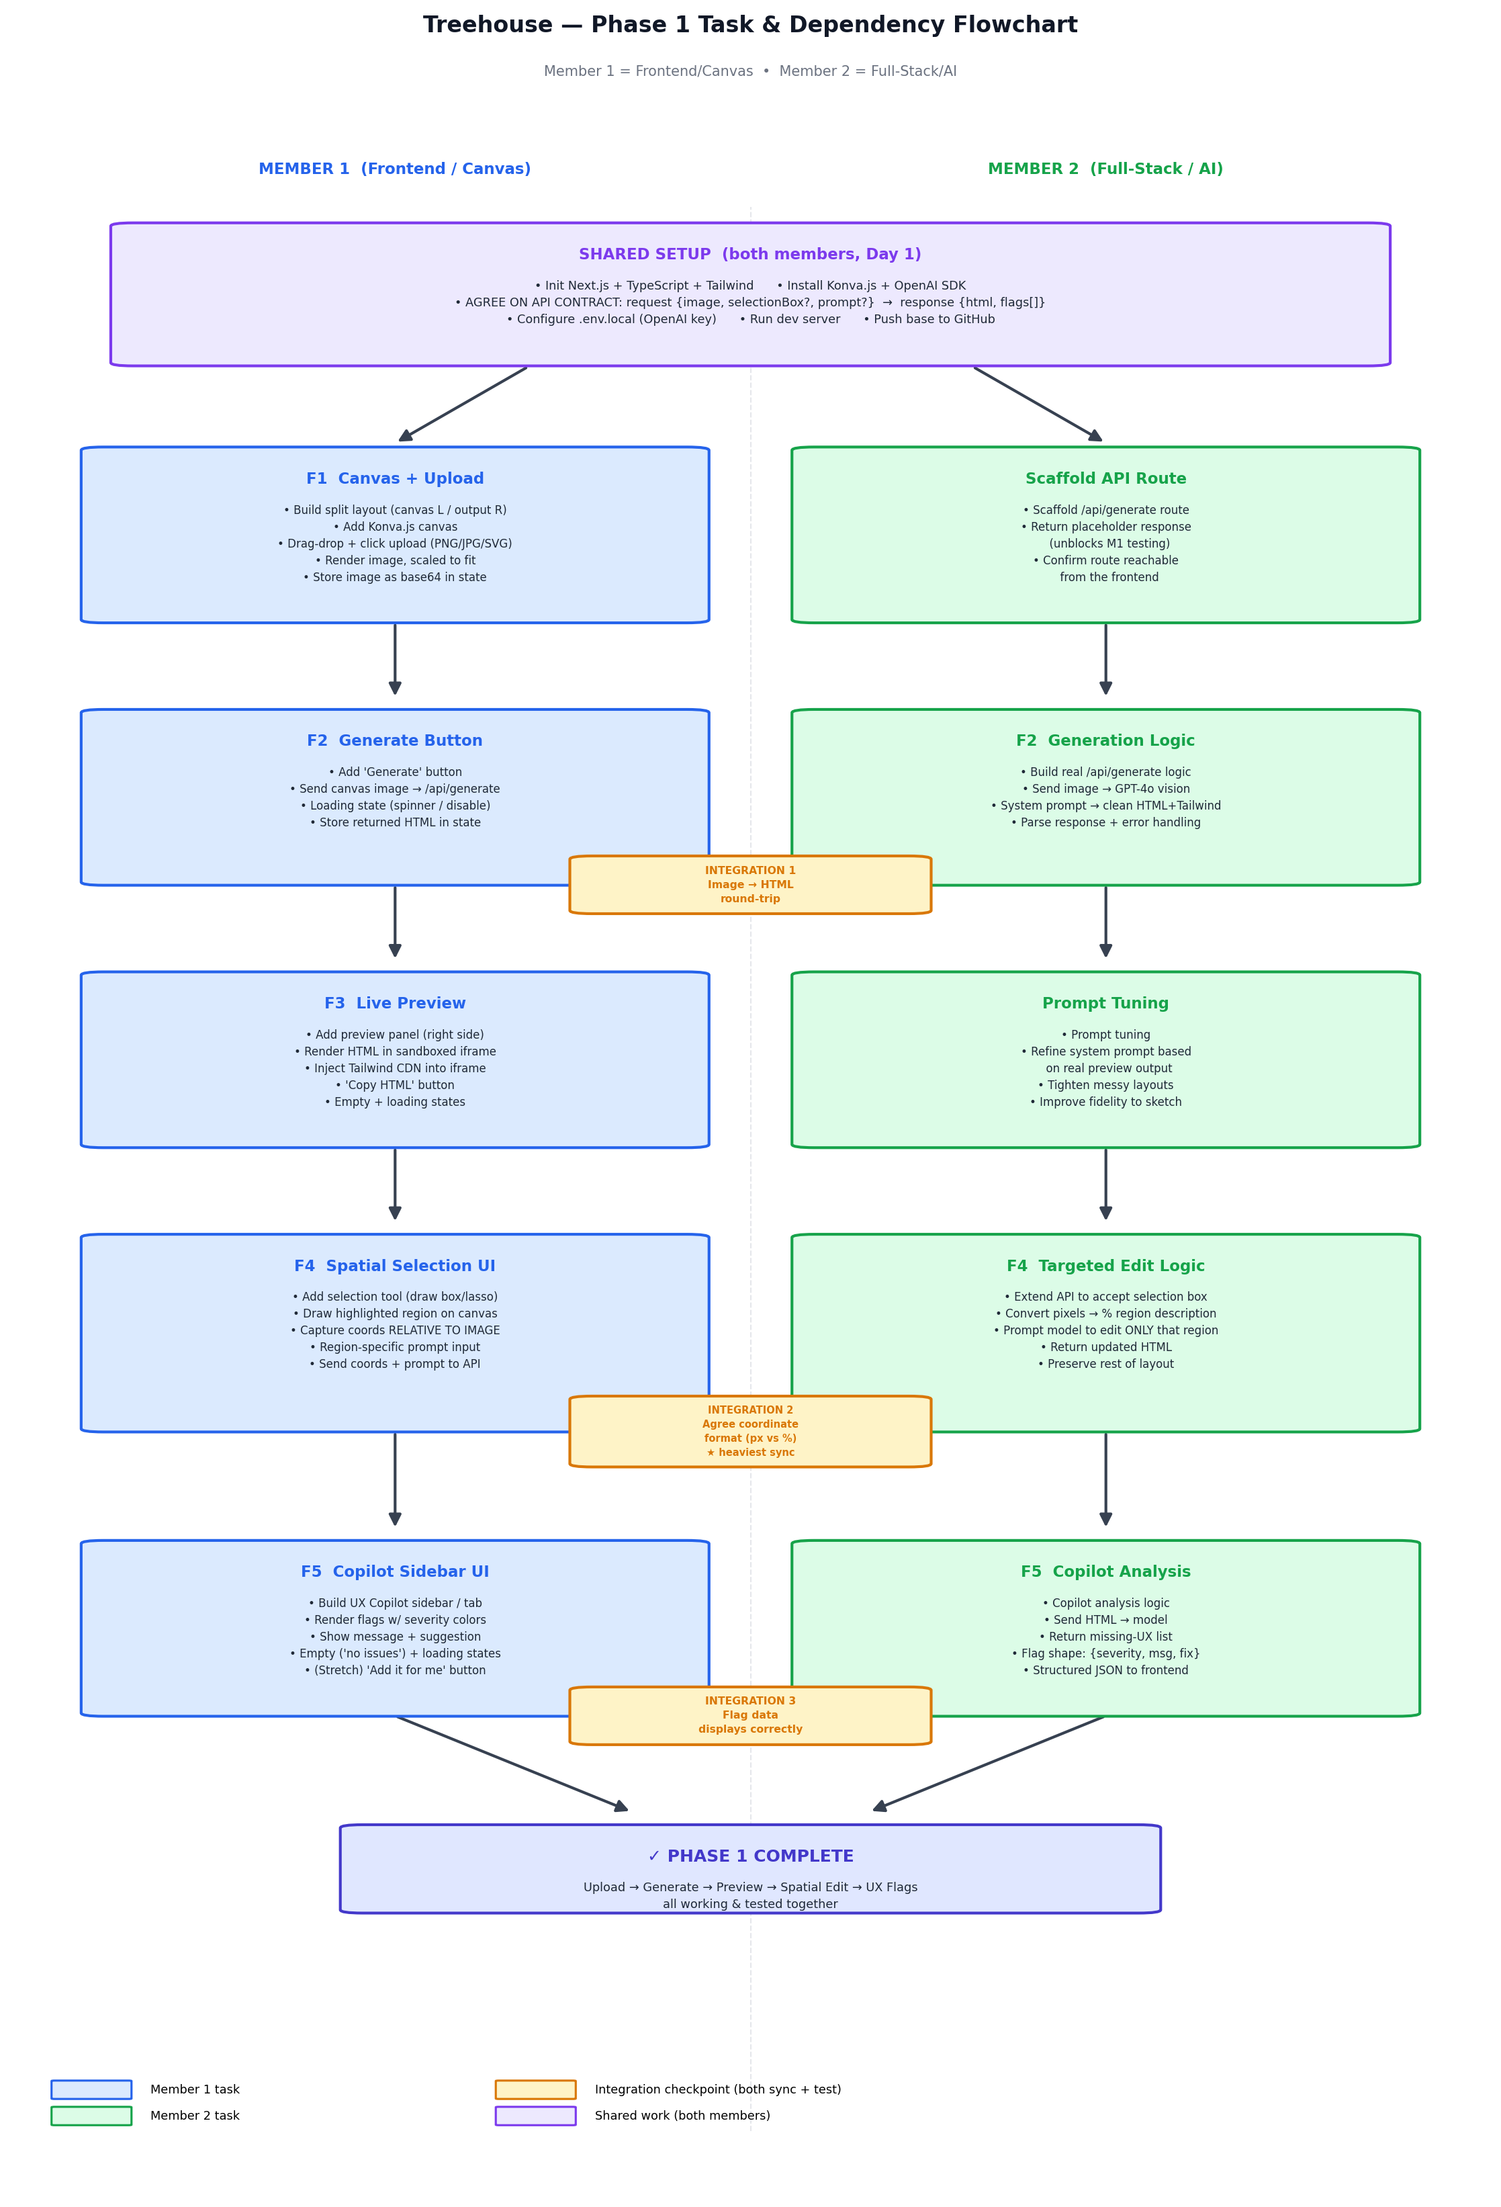
________________________________________

Dependency Map (What Blocks What)
Shared Setup (both)
│
├──────────────┬───────────────────────────┐
▼ ▼ ▼
M1: Canvas + M2: /api/generate (agree on the
Upload scaffold API contract)
│ │
└──────┬───────┘
▼
Feature 2: Sketch → Code
(M2 builds route, M1 wires button) ◄── first integration
│
▼
Feature 3: Live Preview (M1)
+ prompt tuning (M2)
│
▼
Feature 4: Spatial Prompting (SHARED) ◄── heaviest collaboration
(M1 selection UI + M2 targeted edit)
│
▼
Feature 5: UX Copilot
(M2 analysis + M1 sidebar)
________________________________________

Suggested Parallel Schedule (Part-Time)
Because you're both part-time, the key is minimizing blocking. This order lets
each person always have something to do:
Stage | Member 1 | Member 2
1 | Canvas + image upload | Scaffold API route + agree on contract
2 | Generate button + loading UI | Build real generation logic
3 | Live preview panel | Tune generation prompt
4 | Selection tool + coordinate capture | Targeted-edit API logic
5 | Copilot sidebar UI | Copilot analysis logic

At each stage they work in parallel, then sync at the end of the stage to
integrate and test before moving on.
________________________________________

Integration Checkpoints
These are the moments both members must sync and test together:
- After Feature 2 — first time frontend and backend talk. Confirm an image
round-trips into HTML.
- During Feature 4 — confirm the coordinate format matches on both sides.
- After Feature 5 — confirm the flag data displays correctly.
________________________________________

Phase 1 Exit Checklist (Both Members Confirm)
- ☐ Upload a sketch to the canvas — *M1*
- ☐ Generate a live HTML/CSS layout from it — *M1 + M2*
- ☐ See the result rendered in a live preview — *M1*
- ☐ Circle a region and make a targeted edit — *M1 + M2*
- ☐ See UX Copilot flags for the generated design — *M1 + M2*
When all five are checked and tested together, Phase 1 is complete.

