1. | Develop a Laravel Web Application Based on the Following Instructions:
A. | Project Setup
- Create a folder for your Laravel project.

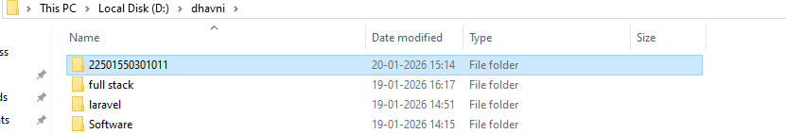

- Open the terminal in that folder.
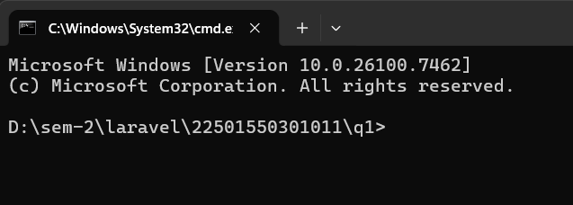

B. | Create a Laravel Project
- Create a Laravel project using the terminal with a project name (e.g., blog).
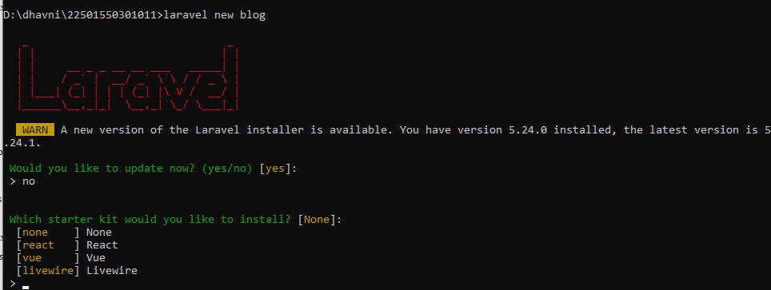

- Choose “None” for the starter kit and press enter for default options.

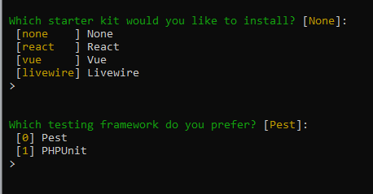

- Select MySQL as the database.
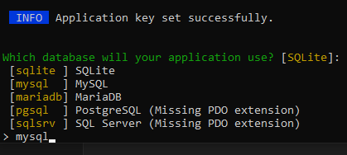

C. | Build and Serve the Application
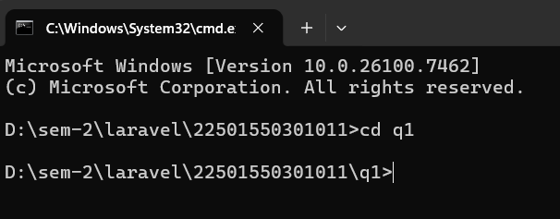
- Move into the project directory

- Run the necessary NPM and Artisan commands to serve the application.

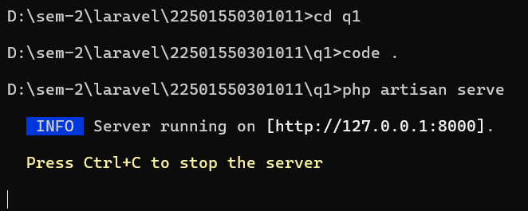
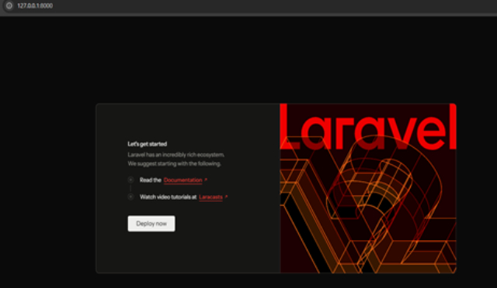

D. | Modify the Welcome Page
- Open welcome.blade.php and display your full name.
- Welcome.blade.php

<h1>Dhavni Patel</h1>

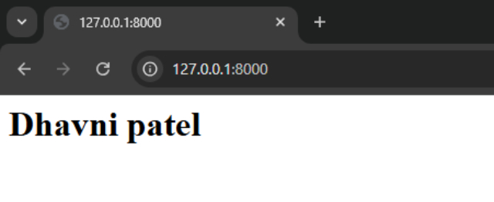

E. | Create a New Blade View
- Create a new Blade file named home.blade.php.
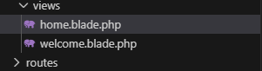

- Home.blade.php

<h1>Dhavni Patel - 22501550301011</h1>

F. | Update Routes
- Define a route in web.php to load the new view when /home is accessed.
- Web.php

<?php

use Illuminate\Support\Facades\Route;

Route::get('/home', function () {
return view(home);
});

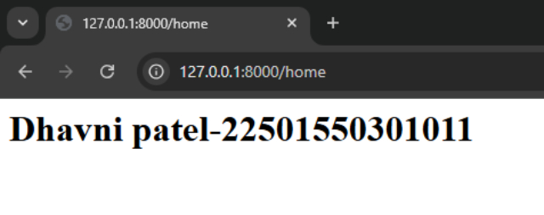

2. | Perform the Following Tasks Related to Laravel Routing:  - What is routing?  - How to make route?  - Open view with routing & pass data with routing?  - Anchor tag  - Redirect with routing  - Routing method.
A. | Routing Basics
- Create a Blade view file and display content via a defined route.
- Create one file -> welcome.blade.php
- resources > view > welcome.blade.php

<h1> welcome – Dhavni Patel<h1>

- routes > web.php

<?php

use Illuminate\Support\Facades\Route;

Route::get('/demo1', function () {
return view('welcome');
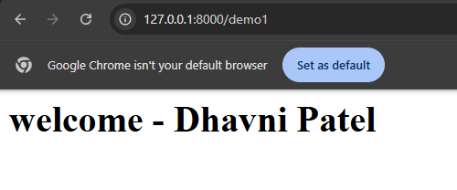
});

- routes > web.php

<?php

use Illuminate\Support\Facades\Route;

Route::get('/demo', function () {
return view('home');
});

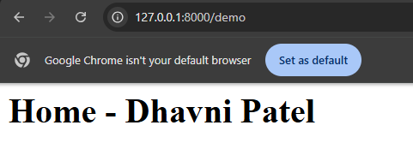

B. | Define Routes
- Define a basic route using Route::get() method.
- routes > Web.php

<?php

use Illuminate\Support\Facades\Route;

Route::get('/demo1', function () {
return view('home');
});
Route::get('/demo',function(){
return view('welcome');
});

- Change the route path and access it via a browser.
- routes > Web.php

<?php

use Illuminate\Support\Facades\Route;

Route::get('/demo1', function () {
return view('home');
});
//Route::get('/demo',function(){
//return view('welcome');
//});
Route::view('/abc','welcome');

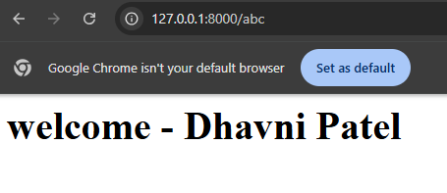

C. | Pass Data via Routes
- Create a route that accepts a parameter (e.g., /about/{name}).
- Resources > view > About.blade.php

<h1> about – Dhavni Patel</h1>

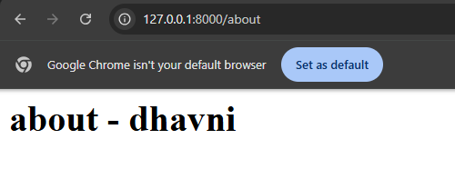
- Pass and display this parameter in a Blade view using Blade syntax.
- Routes > Web.php

<?php

use Illuminate\Support\Facades\Route;

Route::get('/demo1', function () {
return view('home');
});
//Route::get('/demo',function(){
// return view('welcome');
//});
Route::view('/abc','welcome');
Route::get('/about/{name}',function($name){
echo $name;
return view('about');
});
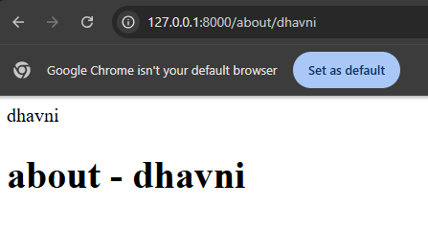

- Routes > web.php

<?php

use Illuminate\Support\Facades\Route;

// Route::get('/demo1', function () {
// return view('home');
// });

Route::get('/demo',function(){
return view('welcome');
});

// Route::view('/abc','welcome');

// Route::get('/about',function(){
// return view('about');
// });

Route::get('/about/{name}',function($name){
// echo $name;
return view('about',['name'=>$name]);
});

- Resources > views > about.blade.php

<h1>about - dhavni patel</h1>
<h1>{{$name}}</h1>
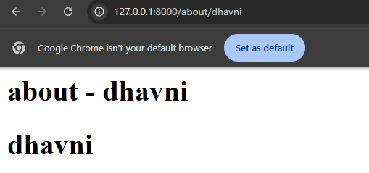

D. | Anchor Tag with Routing.
- Add anchor () tags inside a Blade view to link to other defined routes.
- Resources > views > Home.blade.php

<h1>Home - Dhavni patel</h1>
<a href="/demo">welcome page</a><br>
<a href="/about/dhavni">About page</a>
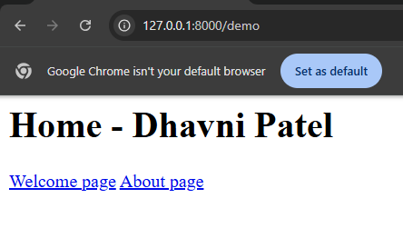

E | Redirection
- Create a route that redirects from one path to another using redirect().
- If are mentioned url of home page but page redirect would be welcome page.
- Routes > Web.php

<?php

use Illuminate\Support\Facades\Route;

// Route::get('/demo1', function () {
// return view('home');
// });

Route::get('/demo',function(){
return view('welcome');
});

// Route::view('/abc','welcome');

Route::get('/about/{name}',function($name){
//echo $name;
return view('about',['name'=>$name]);
});

Route::redirect('/demo1','/abc');

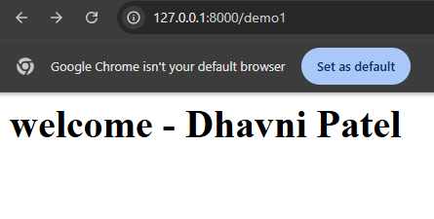

F. | Routing Methods :  - Explore the methods;  - Route::get($uri,$callback);  - Route::post($uri,$callback);  - Route::put($uri,$callback);  - Route::patch($uri,$callback);  - Route::delete($uri,$callback);  - Route::options($uri,$callback);  - Route::view($uri,$callback);
3. | Perform the Following Tasks and Implement Each One Practically:  - What is controller?  - How to make controller?  - Call controller with routes?  - Pass data from router to controller  - Call view with controller
A. | Create a Controller.
- Create a controller using the command line (php artisan make:controller)
- Note : Stop the server in cmd(ctrl+c) and then the clear the screen(ctrl+s)
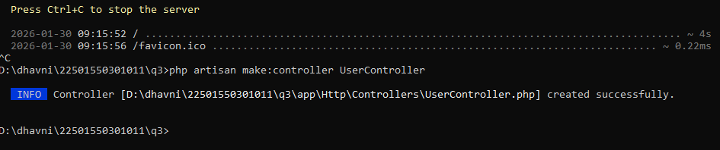

- App > http > controller > UserController.php

<?php

namespace App\Http\Controllers;

use Illuminate\Http\Request;

class UserController extends Controller
{
//
}

B. | Call controller with routes.
- Call Controller Methods Using Routes .
- Define a method inside the controller (e.g., getUser()).
- UserController.php

<?php

namespace App\Http\Controllers;

use Illuminate\Http\Request;

class UserController extends Controller
{
//
function getUSer()
{
return "Istar college - Dhavni Patel";
}
}

- Connect the method to a route in web.php.
- Web.php

<?php

use Illuminate\Support\Facades\Route;
use App\Http\Controllers\UserController;

Route::get('/', function () {
return view('welcome');
});

Route::get('user',[UserController::class,'getUser']);

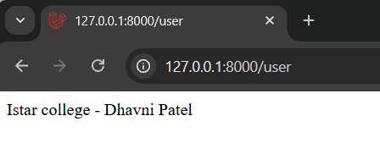

- Create another function .
- UserController.php

<?php

namespace App\Http\Controllers;

use Illuminate\Http\Request;

class UserController extends Controller
{
//
function getUser()
{
return "Istar college - Dhavni Patel";
}
function getData()
{
return "Welcome in MCA - Dhavni Patel";
}
}

- Web.php

<?php

use Illuminate\Support\Facades\Route;
use App\Http\Controllers\UserController;

Route::get('/', function () {
return view('welcome');
});

Route::get('user', [UserController::class, 'getUser']);
Route::get('about',[UserController::class,'getData']);

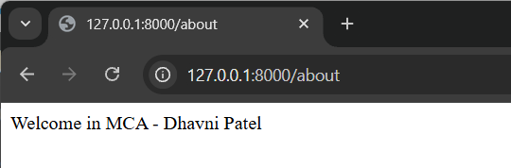

C | pass data from route to controller
- Create a route that accepts a parameter (e.g., /user/{name}).
- Web.php

<?php

use Illuminate\Support\Facades\Route;
use App\Http\Controllers\UserController;

Route::get('/', function () {
return view('welcome');
});

Route::get('user', [UserController::class, 'getUser']);
Route::get('about',[UserController::class,'getData']);
Route:get('user1/{name}',[UserController::class,'getName']);

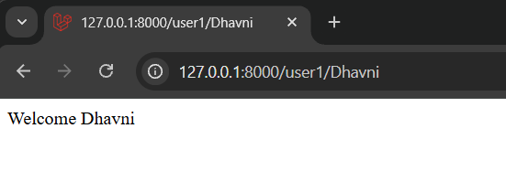

- Access and use the parameter inside the controller method.
- UserController.php

<?php

namespace App\Http\Controllers;

use Illuminate\Http\Request;

class UserController extends Controller
{
//
function getUser()
{
return "Istar college - Dhavni Patel";
}
function getData()
{
return "Welcome in MCA - Dhavni Patel";
}
function getName($name)
{
return "Welcome ".$name;
}
}

D. | Call a View from a Controller .
- Create a Blade view (e.g., user.blade.php).
- User.blade.php

<h1> view page – Dhavni Patel<h1>

- Return the view from a controller method using return view('user').
- UserController.php

<?php

namespace App\Http\Controllers;

use Illuminate\Http\Request;

class UserController extends Controller
{
//
function getUser()
{
return "Istar college - Dhavni Patel";
}
function getData()
{
return "Welcome in MCA - Dhavni Patel";
}
function getName($name)
{
return "Welcome ".$name;
}
function getUser1()
{
return view('user');
}
}

- Web.php

<?php

use Illuminate\Support\Facades\Route;
use App\Http\Controllers\UserController;

Route::get('/', function () {
return view('welcome');
});

Route::get('user', [UserController::class, 'getUser']);
Route::get('about',[UserController::class,'getData']);
Route::get('user1/{name}',[UserController::class,'getName']);
Route::get('user1', [UserController::class, 'getUser1']);

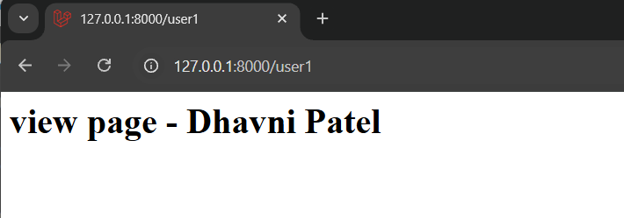

E. | Pass Data from Controller to View.
- Return the view with data using an associative array.
- getUser.blade.php

<h1>User name is: {{$name}}</h1>

- UserController.php

<?php

namespace App\Http\Controllers;

use Illuminate\Http\Request;

class UserController extends Controller
{
//

function getUser()
{
return "Istar college - Dhavni Patel";
}
function getData()
{
return "Welcome in MCA - Dhavni Patel";
}
function getName($name)
{
//return "Welcome ".$name;
return view('getUser',['name'=>$name]);
}
function getUser1()
{
return view('user');
}
}

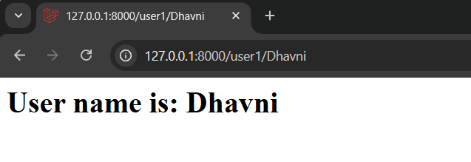

4. | Perform the Following Tasks and Implement Each One Practically:  - What is view?  - How to make view?  - How to make view with command line?  - Call view from route and controller.  - Pass data in view.  - How to know view exists or not?
A. | Create and Implement a View .  - Through structure.  - Via cmd(php artisan make:view about)
- Create a Blade view file manually inside the resources/views folder.

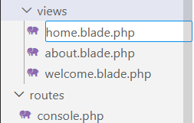

- Alternatively, use the command: php artisan make:view about.

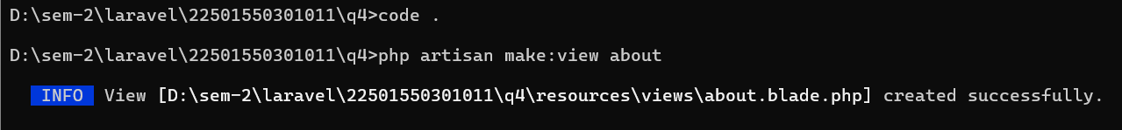

- Implement: Ensure the view renders text correctly when loaded.
- Call view from routes. - about.blade.php

<div>
<h1> About- Dhavni Patel<h1>
</div>

B. | Call and Implement a View from Route and Controller.
- Create a route in web.php that directly returns a view.
- About.blade.php

<div>
<h1> About- Dhavni Patel<h1>
</div>

- Create a controller method that returns a view.
- Web.php

<?php

use Illuminate\Support\Facades\Route;

Route::get('/', function () {
return view('welcome');
});
Route::view('/about','about');

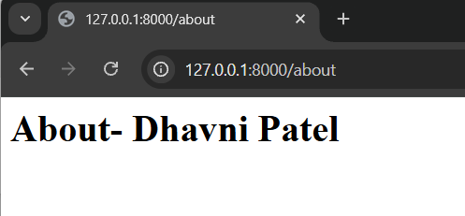

- Create a controller method that return a view.
- Call view from controller.

- Implement: Test both route-based and controller-based view rendering.
- UserController.php

<?php

namespace App\Http\Controllers;

use Illuminate\Http\Request;

class UserController extends Controller
{
//
function userHome(){
return view('about');
}
function userAbout(){
return view('home');
}
}

- Web.php

<?php

use Illuminate\Support\Facades\Route;
use App\Http\Controllers\UserController;

Route::get('/', function () {
return view('welcome');
});
Route::view('/about','about');
Route::get('user-about',[UserController::class,'userHome']);
Route::get('user-home',[UserController::class,'userAbout']);

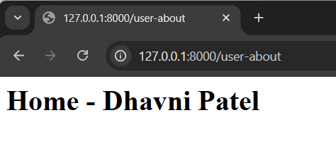

C. | Create and Implement a Nested View
- Create a view file in a subfolder (e.g., admin/login.blade.php).

- Login.blade.php

<div>
<h1>Nested view - Dhavni </h1>
</div>

- Call the nested view using view('admin.login').
- Admin > login.blade.php

<?php

namespace App\Http\Controllers;

use Illuminate\Http\Request;

class UserController extends Controller
{
//
function userHome(){
return view('about');
}
function userAbout(){
return view('home');
}
function userLogin(){
return view('admin.login');
}
}

- Direct call :

<?php

use Illuminate\Support\Facades\Route;
use App\Http\Controllers\UserController;

Route::get('/', function () {
return view('welcome');
});
Route::view('/about','about');
Route::get('user-about',[UserController::class,'userAbout']);
Route::get('user-home',[UserController::class,'userHome']);
Route::view('/login','admin.login');

- Calling :

<?php

use Illuminate\Support\Facades\Route;
use App\Http\Controllers\UserController;

Route::get('/', function () {
return view('welcome');
});
Route::view('/about','about');
Route::get('user-about',[UserController::class,'userAbout']);
Route::get('user-home',[UserController::class,'userHome']);
Route::view('/login','admin.login');
Route::get('user-login',[UserController::class,'userLogin']);

- Implement: Access it via browser to confirm nested view loading.

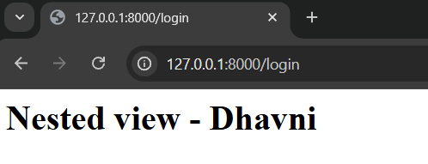

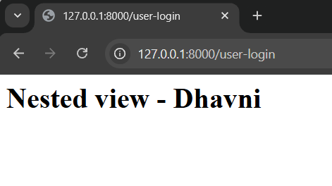
D. | Pass and Implement Data in a View.
- Pass a parameter from the route to the controller and then to the view.
- UserController.php

<?php

namespace App\Http\Controllers;

use Illuminate\Http\Request;

class UserController extends Controller
{
//
function userHome(){
return view('about');
}
function userAbout(){
return view('home');
}
function userLogin(){
return view('admin.login');
}
function getName($name)
{
//return "welcome ".$name;
return view('getUser',['name'=>$name]);
}
}

- Web.php

<?php

use Illuminate\Support\Facades\Route;
use App\Http\Controllers\UserController;

Route::get('/', function () {
return view('welcome');
});
Route::view('/about','about');
Route::get('user-about',[UserController::class,'userAbout']);
Route::get('user-home',[UserController::class,'userHome']);
Route::view('/login','admin.login');
Route::get('user-login',[UserController::class,'userLogin']);
Route::get('user-login/{name}',[UserController::class,'getName']);

- Use Blade syntax {{ $variable }} to display the data.
- getUser.blade.php

<h1>User name: {$name}</h1>

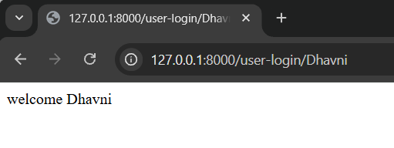
- Implement: Confirm the data is received and shown on the view.

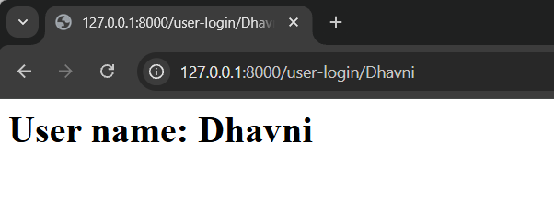
E. | Verify and Implement View Existence Check.
- Use View::exists('viewname') inside the controller.
- Web.php

<?php

use Illuminate\Support\Facades\Route;
use App\Http\Controllers\UserController;

Route::get('/', function () {
return view('welcome');
});
Route::view('/about','about');
Route::get('user-about',[UserController::class,'userAbout']);
Route::get('user-home',[UserController::class,'userHome']);
Route::view('/login','admin.login');
Route::get('user-login',[UserController::class,'userLogin']);
Route::get('user-login/{name}',[UserController::class,'getName']);
Route::get('istar',[UserController::class,'getUser']);

- Write this in UserController file= use Illuminate\Support\Facades\View;

<?php

namespace App\Http\Controllers;
use Illuminate\Support\Facades\View;

use Illuminate\Http\Request;

class UserController extends Controller
{
//
function userHome(){
return view('about');
}
function userAbout(){
return view('home');
}
function userLogin(){
return view('admin.login');
}
function getName($name)
{
//return "welcome ".$name;
return view('getUser',['name'=>$name]);
}
function getUser()
{
if(View::exists('user1'))
{
return view('user1');
}
else
{
echo "No view found";
}
}
}

- Show fallback message if view is not found.
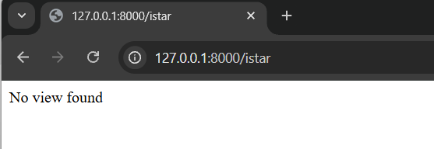

- User1.blade.php

<h1>User 1 -Dhavni </h1>

- Implement: Test with both existing and non-existing views
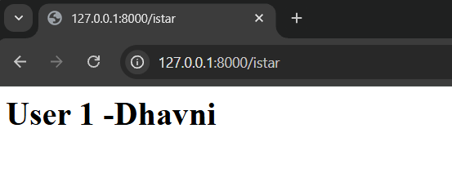
5. | Perform the following tasks and impletement each one practically.  - What is blade template.  Blade is a simple, yet powerful templating engine for executing php code. This is included in the laravel framework. The template engine is a module or toll for executing code. We can write php tags also in blade template. To use blade template view should end with the .blade.php extension.  - Expression of blade template.  - Display variables.  - Executes function.  - If else  - For loop  - Foreach
A. | Understand and Implement Blade Template.  - Identify the file extension used for Blade (.blade.php).  - Web.php  <?php  use Illuminate\Support\Facades\Route;  use App\Http\Controllers\UserController;  Route::get('/', function () {  return view('welcome');  });  Route::get('/test1',[UserController::class,'getUser1']);  - UserController.php  <?php  namespace App\Http\Controllers;  use Illuminate\Http\Request;  class UserController extends Controller  {  //  function getUser1()  {  $name="Dhavni";  return view('user1',["user"=>$name]);  }  }  - User1.blade.php  <div>  <h1>User1</h1>  <h1>{{$user}}</h1>  </div>  - Implement: Create a simple Blade file and verify output in the browser.  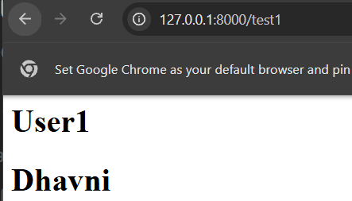
B. | Use and Implement Blade Expressions.
- Use {{ }} syntax to display dynamic values.
- User1.blade.php

<div>
<h1>User1</h1>
<h1>{{$user}}</h1>
<h3><?php echo $Suser ?></h3>
</div>

- Implement: Pass a variable from controller to view and display it using Blade syntax.

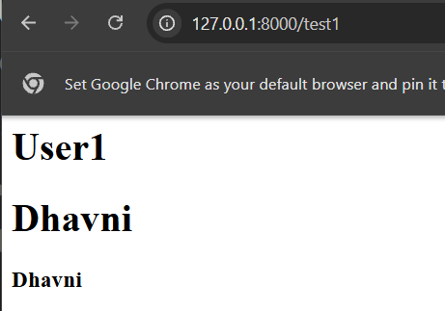

C. | Execute and Implement PHP Functions.
- Use Blade to call PHP functions like rand(), date(), etc.
- User1.blade.php

<div>
<h1>User1</h1>
<h1>{{$user}}</h1>
<h3><?php echo $user ?></h3>
<h3>{{rand()}}</h3>
</div>

- Implement: Display the output of a function in your Blade view.

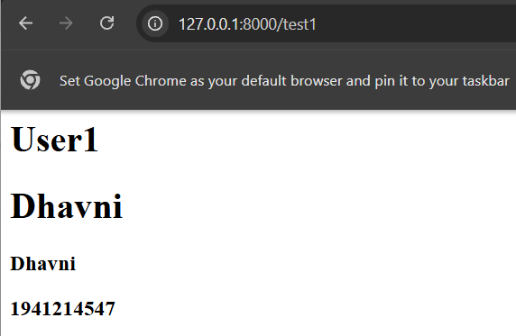

D. | Implement Conditional Logic (if-else) in Blade.
- Use @if, @elseif, and @else directives.
- UserController.php

<?php

namespace App\Http\Controllers;

use Illuminate\Http\Request;

class UserController extends Controller
{
//
function getUser1()
{
$name="Dhavni";
//return view('user1',["user"=>$name]);
$name="ISTAR";
$users=['ISTAR','NVPAS','SEMCOM'];
return view('user1',["user"=>$name,"users"=>$users]);
}
}

- User1.blade.php

<div>
<h1>User1</h1>
<h1>{{$user}}</h1>
<h3><?php echo $user ?></h3>
<h3>{{rand()}}</h3>'

<h3>{{$users[1]}}</h3>
@if($user=='ISTAR')
<h3>This is ISTAR college</h3>
@elseif($user=='NVPAS')
<h3>This is NVPAS college</h3>
@else
<h3>other college</h3>
@endif

</div>

- Implement: Display a custom message based on a passed variable value.

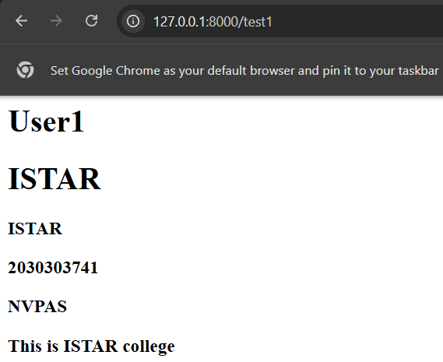

E. | Implement For Loop in Blade.
- Use @for directive to loop through numeric values.
- User1.blade.php

<div>
<h1>User1</h1>
<h1>{{$user}}</h1>
<h3><?php echo $user ?></h3>
<h3>{{rand()}}</h3>

<h3>{{$users[1]}}</h3>
@if($user=='ISTAR')
<h3>This is ISTAR college</h3>
@elseif($user=='NVPAS')
<h3>This is NVPAS college</h3>
@else
<h3>other college</h3>
@endif

@for($i=0;$i<=10;$i++)
<h3>{{$i}}</h3>
@endfor

</div>

- Implement: Display a list of numbers using a Blade for-loop.

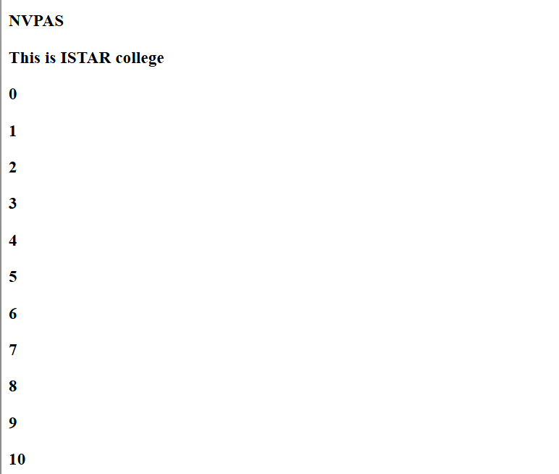

F. | Implement Foreach Loop in Blade.
- Use @foreach to iterate over an array passed from the controller.
- User1.blade.php

<div>
<h1>User1</h1>
<h1>{{$user}}</h1>
<h3><?php echo $user ?></h3>
<h3>{{rand()}}</h3>

<h3>{{$users[1]}}</h3>
@if($user=='ISTAR')
<h3>This is ISTAR college</h3>
@elseif($user=='NVPAS')
<h3>This is NVPAS college</h3>
@else
<h3>other college</h3>
@endif

@for($i=0;$i<=10;$i++)
<h3>{{$i}}</h3>
@endfor

@foreach($users as $user)
<h3>{{$user}}</h3>
@endforeach

</div>

- Implement: Display each value of the array in your view.

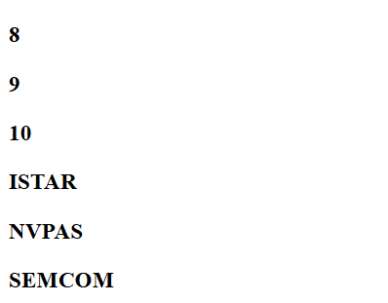

6. | Execute the Following Tasks and Demonstrate Each One Practically:  - What is subview?  - Make subview.  - Use subview  - Pass data from view to subview  - Check if sub view exists(student side)
A. | Understand and Implement Subviews
- Create a subview using a folder structure inside resources/views.

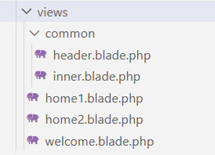

- Implement: Create a subview like common.header and verify its structure.
- Header.blade.php

<div style="background-color:green">
<h3> Dhavni - This is Header</h3>
</div>

B | Include and Implement Subviews in Main View
- Use @include() directive to include a subview inside a main view (e.g., home1.blade.php).

- Home.blade.php

<div style="background-color:green">
<h3> Dhavni - This is Header</h3>
</div>

- Web.php

<?php

use Illuminate\Support\Facades\Route;
use App\Http\Controllers\UserController1;

Route::get('/', function () {
return view('welcome');
});
Route::get('/demo1',function()
{
return view('home1');
});

- Implement: Verify both views render together correctly in the browser.

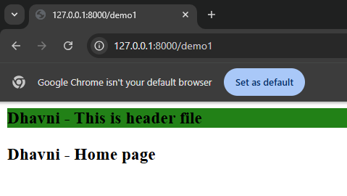

C. | Create and Implement Multiple Subviews
- Create additional subviews like common.inner.blade.php.

- Inner.blade.php

<div>
<h3 style="color:red">Dhavni -This is inner file</h3>
</div>

- Include multiple subviews inside a main Blade file.
- Home1.blade.php

@include('common.header')
@include('common.inner')
<h3>Dhavni - Home Page</h3>

- Implement: Load them together and ensure they render properly.

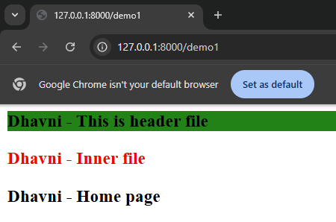

- UserController1.php

<?php

namespace App\Http\Controllers;

use Illuminate\Http\Request;

class UserController1 extends Controller
{
//
function userHome2()
{
return view('home2');
}
}

- Web.php

<?php

use Illuminate\Support\Facades\Route;
use App\Http\Controllers\UserController1;

Route::get('/', function () {
return view('welcome');
});
Route::get('/demo1',function()
{
return view('home1');
});
route::get('/user-home',[UserController1::class,'userHom2']);

- Home2.blade.php

@include('common.header')
<h3>Dhavni - Home 2</h3>

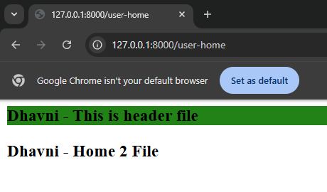

D. | Pass and Implement Data from Main View to Subview
- Use @include('viewname', ['key' => 'value']) to pass data.
- Hom1.blade.php

@include('common.header')
@include('common.inner',['page'=>"Dhavni Patel"])
<h3>Dhavni - Home Page</h3>

- Access and display the variable in the subview using {{ $variable }}.

- Inner.blade.php

<div>
<h3 style="color:red">{{$page}}</h3>
</div>

- Implement: Confirm the passed data renders correctly.

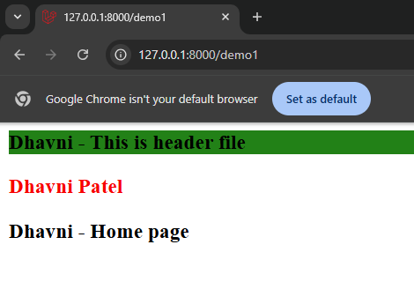

- Check if sub view exists
- Home1.blade.php

@includeIf('common.header')
@include('common.inner',['page'=>"Dhavni Patel"])
<h3>Dhavni - Home Page</h3>



7. | Execute the Following Tasks and Demonstrate Each One Practically:
A. | Execute the Following Tasks and Demonstrate Each One Practically:
- Define a route using ->name('routeName').

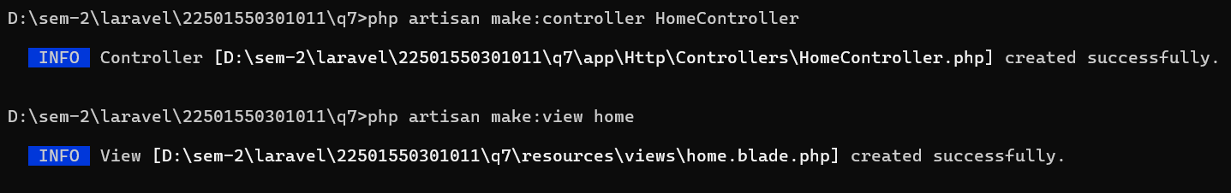

- Home.blade.php

<div>
<h3>Home - Dhavni</h3>
</div>

- Web.php

<?php

use Illuminate\Support\Facades\Route;

Route::get('/', function () {
return view('welcome');
});
Route::view('home/profile/user','home');

- Implement: Create a named route for a view and verify its output.

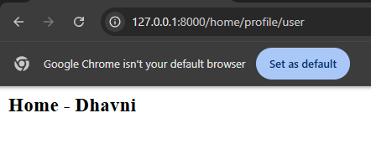

B. | Use Named Route in View
- Use route('routeName') within a Blade file for navigation.
- Welcome.blade.php

<h1><a href='home/profile/user'>Go to home page</h1>

- Implement: Add an anchor tag that navigates using the named route.

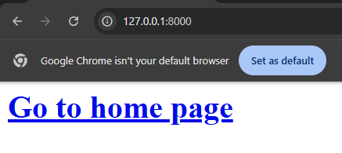

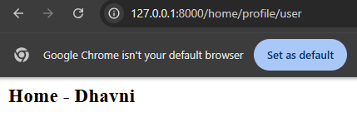

- Provide nick name:
- Welcome.blade.php

<h3>Welcome page</h3>
<h1><a href="{{route('hm')}}">Go to home page</h1>

- Web.php

<?php

use Illuminate\Support\Facades\Route;

Route::get('/', function () {
return view('welcome');
});
Route::view('home/profile/user','home');
Route::view('home/profile/user','home')->name('hm');

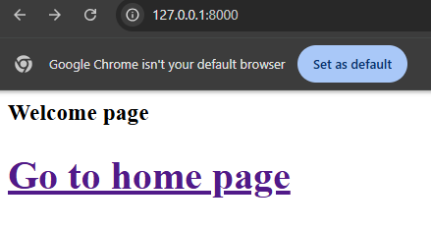



C. | Use Named Route in Controller
- Redirect to a named route from a controller using redirect() >route('name') or to_route('name').
- HomeController.php

<?php

namespace App\Http\Controllers;

use Illuminate\Http\Request;

class HomeController extends Controller
{
//
function show()
{
return view('home');
}
}

- Web.php

<?php

use Illuminate\Support\Facades\Route;

Route::get('/', function () {
return view('welcome');
});
Route::view('home/profile/user','home');
Route::view('home/profile/user','home')->name('hm');
Route::get('show',[HomeController::class,'show']);

- Implement: Call a controller method that redirects to a named route.

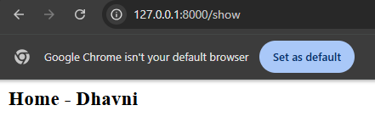

- Redirect
- HomeController.php

<?php

namespace App\Http\Controllers;

use Illuminate\Http\Request;

class HomeController extends Controller
{
//
function show()
{
// return view('home');
return redirect()->to('home/profile/user');
}
}

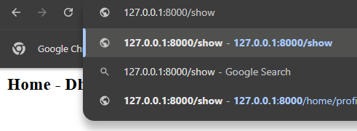

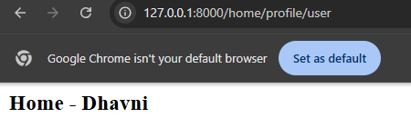

- Nick name
- HomeController.php

<?php

namespace App\Http\Controllers;

use Illuminate\Http\Request;

class HomeController extends Controller
{
//
function show()
{
// return view('home');
//return redirect()->to('home/profile/user');
return to_route('hm');
}
}

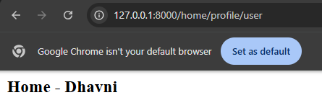

D. | Pass Parameters in a Named Route
- Define a named route that accepts a parameter (e.g., {name}).
- Web.php

<?php

use Illuminate\Support\Facades\Route;

Route::get('/', function () {
return view('welcome');
});
Route::view('home/profile/user','home');
Route::view('home/profile/user','home')->name('hm');
Route::get('show',[HomeController::class,'show']);
Route::view('home/profile/{name}','home')->name('user');

- Use route('routeName', ['name' => 'value']) in the controller or view.
- Welcome.php

<h3>Welcome page</h3>
<h1><a href="{{route('hm')}}">Go to home page</h1>
<a href="home/profile/dhavni">Go to ISTAR page</h1>

- Implement: Access the dynamic parameter in the Blade view.

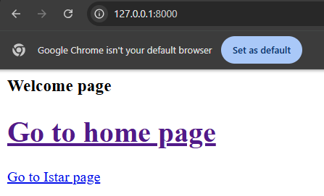

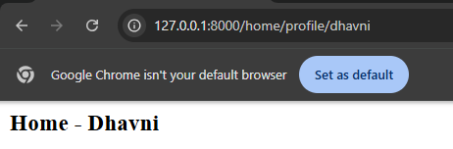

E. | Pass Dynamic Data from Controller Using Named Routes
- Use to_route('routeName', ['key' => 'value']) from a controller.
- HomeController.php

<?php

namespace App\Http\Controllers;

use Illuminate\Http\Request;

class HomeController extends Controller
{
//
function show()
{
// return view('home');
//return redirect()->to('home/profile/user');
return to_route('hm');
}
function user()
{
return to_route('user',["name"=>'dhavni']);
}
}

- Web.php

<?php

use Illuminate\Support\Facades\Route;

Route::get('/', function () {
return view('welcome');
});
Route::view('home/profile/user','home');
Route::view('home/profile/user','home')->name('hm');
Route::get('show',[HomeController::class,'show']);
Route::view('home/profile/{name}','home')->name('user');
Route::view('home/profile/{name}','home')->name('user');

- Implement: Redirect from a controller to a named route with parameter and display it in view.

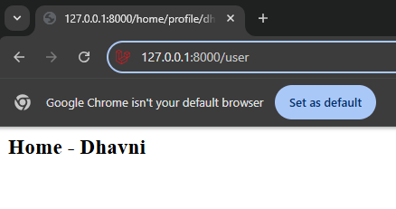

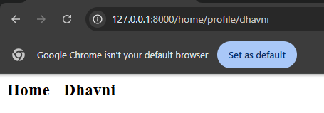

8. | Execute the Following Tasks and Demonstrate Each One Practically:
A. | Understand and Define Route Grouping with Prefix
- Implement: Use Route::prefix('student') to define grouped routes.

- Web.php

<?php

use Illuminate\Support\Facades\Route;
use App\Http\Controllers\HomeController;

Route::get('/', function () {
return view('welcome');
});
//Route::view('student/home','home1');
//Route::get('student/show',[HomeController::class,'show1']);
//Route::get('student/add',[HomeController::class,'add']);
Route::prefix('student')->group(function(){
Route::view('/home','home1');
Route::get('/show',[HomeController::class,'show1']);
Route::get('/add',[HomeController::class,'add']);
});

- HomeController.php

<?php

namespace App\Http\Controllers;

use Illuminate\Http\Request;

class HomeController extends Controller
{
//
function show1()
{
return "Student list Dhavni";
}
function add()
{
return "add new student";
}
}

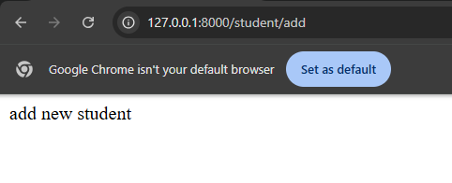

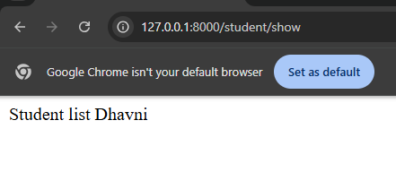



B. | Create Routes for View and Controller
- Create a Blade view file (e.g., home1.blade.php) and a controller (e.g., HomeController).
- Home1.blade.php

<div>
<h1>Home page - Dhavni</h1>
</div>

- Define individual routes like /student/home, /student/show, and /student/add.
- Web.php

Route::prefix('student')->group(function(){
Route::view('/home','home1');
Route::get('/show',[HomeController::class,'show1']);
Route::get('/add',[HomeController::class,'add']);
});

- Implement: Return views and simple text responses from controller methods.



C. | Group the Routes Under a Common Prefix
- Use Route::prefix('student')->group(function(){ ... });
- Web.php

<?php

use Illuminate\Support\Facades\Route;
use App\Http\Controllers\HomeController;

Route::get('/', function () {
return view('welcome');
});

//Route::view('student/home','home1');
//Route::get('student/show',[HomeController::class,'show1']);
//Route::get('student/add',[HomeController::class,'add']);

Route::prefix('student')->group(function(){

});

- Include multiple routes inside the group (both view and controller-based).
- Web.php

<?php

use Illuminate\Support\Facades\Route;
use App\Http\Controllers\HomeController;

Route::get('/', function () {
return view('welcome');
});

//Route::view('student/home','home1');
//Route::get('student/show',[HomeController::class,'show1']);
//Route::get('student/add',[HomeController::class,'add']);

Route::prefix('student')->group(function(){
Route::view('/home','home1');
Route::get('/show',[HomeController::class,'show1']);
Route::get('/add',[HomeController::class,'add']);
});

- Implement: Access and verify all grouped URLs in the browser.





9. | Execute the Following Tasks and Demonstrate Each One Practically:  - What is route grouping with controller?  - Make some routes for controller?  - Make route groups of controller?  - Interview question
A. | Understand and Implement Route Grouping with Controller
- Implement: Use Route::controller(ControllerName::class)->group(...) syntax.

Route::controller(Controller_name :: class)->group(function()
{
//
});

B. | Create Routes for Controller Methods
- Create a controller (e.g., StudentController).

- Add methods like show(), add(), and delete() inside the controller.
- StudentController.php

<?php

namespace App\Http\Controllers;

use Illuminate\Http\Request;

class StudentController extends Controller
{
//
function show()
{
return "list of students";
}
function add()
{
return "list of students added.";
}
function delete()
{
return "list of student deleted.";
}
}

- Implement: Define corresponding routes in web.php and check the output.
- Web.php

<?php

use Illuminate\Support\Facades\Route;
use App\Http\Controllers\StudentController;

Route::get('/', function () {
return view('welcome');
});
Route::get('show',[StudentController::class,'show']);
Route::get('add',[StudentController::class,'add']);
Route::get('delete',[StudentController::class,'delete']);

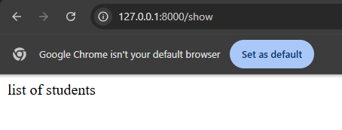

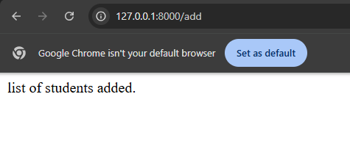

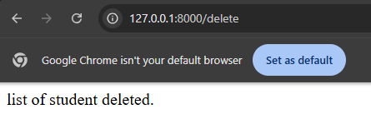

C. | Group Controller Routes Using Route::controller
- Define a grouped route structure using Route::controller(...)->group(...).
- Web.php

<?php

use Illuminate\Support\Facades\Route;
use App\Http\Controllers\StudentController;

Route::get('/', function () {
return view('welcome');
});
//Route::get('show',[StudentController::class,'show']);
//Route::get('add',[StudentController::class,'add']);
//Route::get('delete',[StudentController::class,'delete']);
Route::controller(StudentController::class)->group(function()
{
Route::get('show','show');
Route::get('add','add');
Route::get('delete','delete');
});

- Inside the group, define paths that call methods directly without repeating the controller.
- Web.php

Route::controller(StudentController::class)->group(function()
{
Route::get('show','show');
Route::get('add','add');
Route::get('delete','delete');
});

- Implement: Access routes like /show, /add, /delete and confirm functionality.







D. | Pass Parameters with Controller-Based Routes
- Add a route with a dynamic parameter (e.g., /about/{name}) in the controller group.
- Web.php

<?php

use Illuminate\Support\Facades\Route;
use App\Http\Controllers\StudentController;

Route::get('/', function () {
return view('welcome');
});
//Route::get('show',[StudentController::class,'show']);
//Route::get('add',[StudentController::class,'add']);
//Route::get('delete',[StudentController::class,'delete']);
Route::controller(StudentController::class)->group(function()
{
Route::get('show','show');
Route::get('add','add');
Route::get('delete','delete');
});
Route::get('about/{name}',[StudentController::class,'about']);

- Create a method (e.g., about($name)) in the controller to receive it.
- Web.php

Route::controller(StudentController::class)->group(function()
{
Route::get('show','show');
Route::get('add','add');
Route::get('delete','delete');
Route::get('about/{name}','about');
});
//Route::get('about/{name}',[StudentController::class,'about']);

- Implement: Pass and display the parameter in the browser.

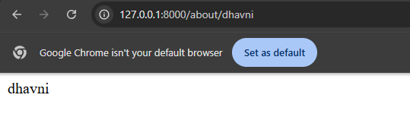

10. | Execute the Following Tasks and Demonstrate Each One Practically:  - What is middleware?  - Types of middleware? ( global, Route, group)  - Make middleware.  - Apply middleware.  - Filter request with middleware.
A. | Understand and Describe Middleware
B. | Create Middleware
- Use Artisan to create middleware using the command:

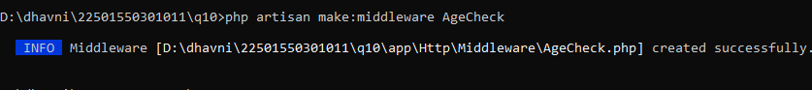

- Implement: Verify that AgeCheck.php is created inside the Http/Middleware folder.

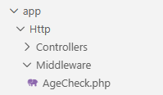

C. | Apply Middleware Globally
- Open bootstrap/app.php.
- App.php

<?php

use Illuminate\Foundation\Application;
use Illuminate\Foundation\Configuration\Exceptions;
use Illuminate\Foundation\Configuration\Middleware;
use App\Http\Middleware\AgeCheck;

return Application::configure(basePath: dirname(__DIR__))
->withRouting(
web: __DIR__.'/../routes/web.php',
commands: __DIR__.'/../routes/console.php',
health: '/up',
)
->withMiddleware(function (Middleware $middleware): void {
//
$middleware->append(AgeCheck::class);
})
->withExceptions(function (Exceptions $exceptions): void {
//
})->create();

- Add the middleware class inside the withMiddleware block.
- AgeCheck.php

<?php

namespace App\Http\Middleware;

use Closure;
use Illuminate\Http\Request;
use Symfony\Component\HttpFoundation\Response;

class AgeCheck
{
/**
* Handle an incoming request.
*
* @param \Closure(\Illuminate\Http\Request): (\Symfony\Component\HttpFoundation\Response) $next
*/
public function handle(Request $request, Closure $next): Response
{
echo "Dhavni";
return $next($request);
}
}

- Implement: Confirm it executes for every incoming request.

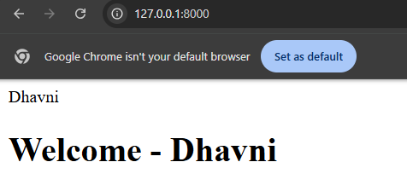

D. | Filter Requests Using Middleware Logic
- Modify the handle() method to include a custom condition using request parameters.
- AgeCheck.php

<?php

namespace App\Http\Middleware;

use Closure;
use Illuminate\Http\Request;
use Symfony\Component\HttpFoundation\Response;

class AgeCheck
{
/**
* Handle an incoming request.
*
* @param \Closure(\Illuminate\Http\Request): (\Symfony\Component\HttpFoundation\Response) $next
*/
public function handle(Request $request, Closure $next): Response
{
//echo "Dhavni";
if($request->age<18)
{
die ("You can not visit this site.");
}
return $next($request);
}
}

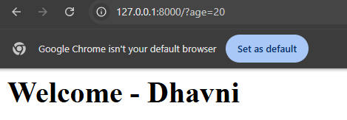

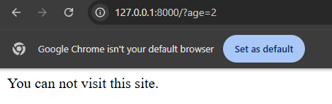

E. | Create Additional View and Test Middleware
- Create a view file named about.blade.php.

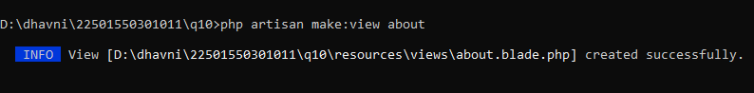

- Define a route for the view (e.g., /about).
- About.blade.php

<div>
<h1>About - Dhavni</h1>
</div>

- Implement: Apply middleware and test how it filters access based on the
given request.

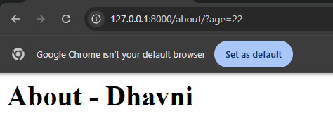

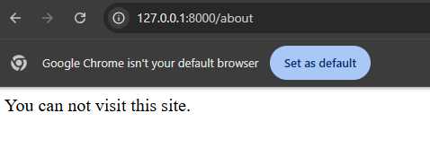

11. | Execute the Following Tasks and Demonstrate Each One Practically:  - What is the middleware group?  - How to register middleware in a group?  - Apply a group of middleware to route group?  - Apply group of middleware to single route.
A. | Understand and Describe Middleware Group  - Middleware apply on single route.  - Middleware apply on route group.  - Middleware apply on all route.
B. | Create Middleware Files
- Use Artisan commands to create multiple middleware:

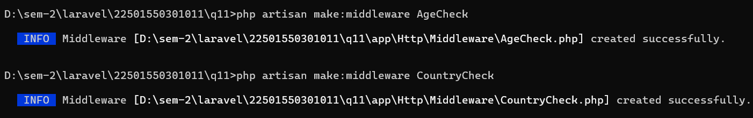

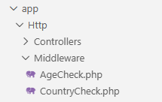

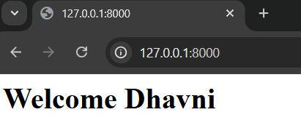

- Implement: Add simple logic inside each middleware’s handle() method.
- AgeCheck.php

<?php

namespace App\Http\Middleware;

use Closure;
use Illuminate\Http\Request;
use Symfony\Component\HttpFoundation\Response;

class AgeCheck
{
public function handle(Request $request, Closure $next): Response
{
echo "Age Check";
return $next($request);
}
}

- CountryCheck.php

<?php

namespace App\Http\Middleware;

use Closure;
use Illuminate\Http\Request;
use Symfony\Component\HttpFoundation\Response;

class CountryCheck
{
public function handle(Request $request, Closure $next): Response
{
echo "Country Check";
return $next($request);
}
}

- Bootstrap -> app.php

<?php

use Illuminate\Foundation\Application;
use Illuminate\Foundation\Configuration\Exceptions;
use Illuminate\Foundation\Configuration\Middleware;
use App\Http\Middleware\AgeCheck;
use App\Http\Middleware\CountryCheck;

return Application::configure(basePath: dirname(__DIR__))
->withRouting(
web: __DIR__.'/../routes/web.php',
commands: __DIR__.'/../routes/console.php',
health: '/up',
)
->withMiddleware(function (Middleware $middleware): void {
//
$middleware->appendToGroup('check1',[
AgeCheck::class,
CountryCheck::class,
]);
})
->withExceptions(function (Exceptions $exceptions): void {
//
})->create();

C. | Register Middleware Group  - Web.php  <?php  use Illuminate\Support\Facades\Route;  Route::get('/', function () {  return view('welcome');  });  Route::view('home','home')->middleware('check1');  Route::view('about','about')->middleware('check1');  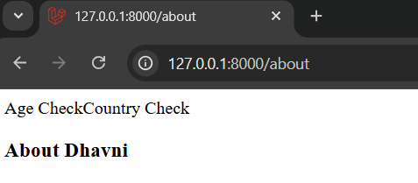  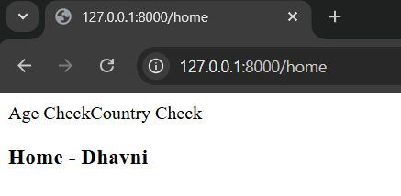  - CountryCheck.php  <?php  namespace App\Http\Middleware;  use Closure;  use Illuminate\Http\Request;  use Symfony\Component\HttpFoundation\Response;  class CountryCheck  {  public function handle(Request $request, Closure $next): Response  {  if($request->country!="india")  {  die("you can not visit this site");  }  return $next($request);  }  }  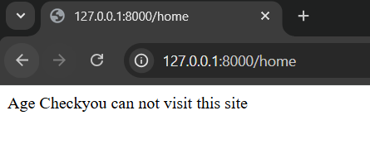  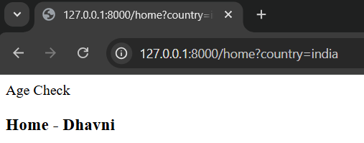  - AgeCheck.php  <?php  namespace App\Http\Middleware;  use Closure;  use Illuminate\Http\Request;  use Symfony\Component\HttpFoundation\Response;  class AgeCheck  {  public function handle(Request $request, Closure $next): Response  {  if($request->age<18)  {  die("you are under 18 and can not visit this site.");  }  return $next($request);  }  }  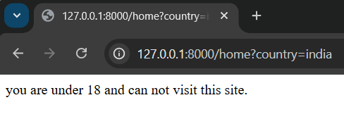  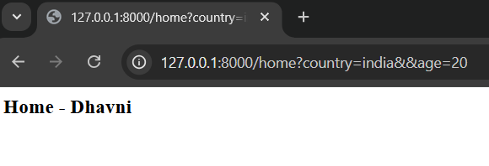
D. | Apply Middleware Group to Single Route  - Web.php  <?php  use Illuminate\Support\Facades\Route;  Route::get('/', function () {  return view('welcome');  });  Route::view('home','home')->middleware('check1');  Route::view('about','about')->middleware('check1');  Route::view('about','about');  Route::view('contact','contact');  Route::view('list','list');  Route::view('home','home');  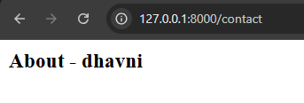
E. | Apply Middleware Group to Route Group  - Web.php  <?php  use Illuminate\Support\Facades\Route;  Route::get('/', function () {  return view('welcome');  });  Route::view('home','home')->middleware('check1');  Route::view('about','about')->middleware('check1');  Route::middleware('check1')->group(function(){  Route::view('about','about');  Route::view('contact','contact');  Route::view('list','list');  Route::view('home','home');  });  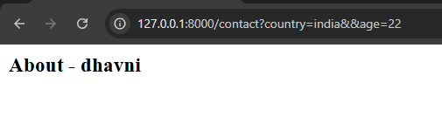  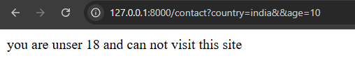  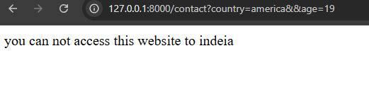
12. | Execute the Following Tasks and Demonstrate Each One Practically:  - Make middleware  - Make route  - Apply middleware on the route  - Apply multiple middleware on route
A. | Create and Implement Middleware
- Use the following command to create middleware:
php artisan make:middleware AgeCheck

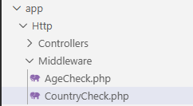

- Implement: Add basic logic to print a message or block underaged users.
- AgeCheck.php

<?php

namespace App\Http\Middleware;

use Closure;
use Illuminate\Http\Request;
use Symfony\Component\HttpFoundation\Response;

class AgeCheck
{
public function handle(Request $request, Closure $next): Response
{
echo "Middleware";
return $next($request);
}
}

- We do not required register of this middleware (route middleware ) like global middleware and group middleware in app file. Directly we import this middleware like below code.
- Web.php

<?php

use Illuminate\Support\Facades\Route;
use App\Http\Middleware\AgeCheck;
use App\Http\Middleware\CountryCheck;

B. | Create View Files
- Create two Blade view files:
- php artisan make:view home
- php artisan make:view about

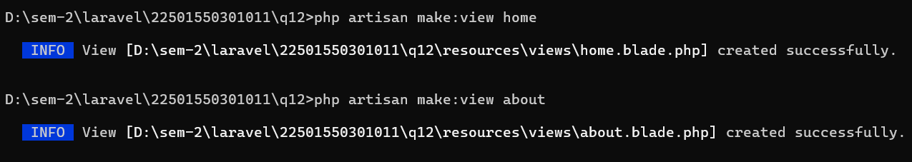

- home.blade.php

<div>
<h3>Home - Dhavni </h3>
</div>

- About.blade.php

<div>
<h3>About - Dhavni </h3>
</div>

- Implement: Load these views using Route::view() in web.php.
- Web.php

<?php

use Illuminate\Support\Facades\Route;
use App\Http\Middleware\AgeCheck;
use App\Http\Middleware\CountryCheck;

Route::get('/', function () {
return view('welcome');
});
Route::view('home','home');
Route::view('about','about');

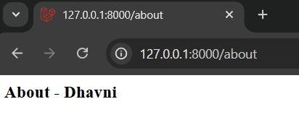

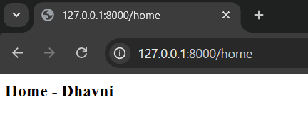

C. | Assign Middleware to a Specific Route
- Import the middleware class directly in web.php.
- Web.php

<?php

use Illuminate\Support\Facades\Route;
use App\Http\Middleware\AgeCheck;
use App\Http\Middleware\CountryCheck;

- Apply middleware to a single route like so:
- Route::view('home1', 'home')->middleware(AgeCheck::class);
- Web.php

<?php

use Illuminate\Support\Facades\Route;
use App\Http\Middleware\AgeCheck;
use App\Http\Middleware\CountryCheck;

Route::get('/', function () {
return view('welcome');
});
Route::view('home','home')->middleware(AgeCheck::class);
Route::view('about','about');

- Implement: Add validation in the middleware (e.g., restrict if age < 18) and test using ?age= parameter.
- Bootstrap -> app.php

<?php

namespace App\Http\Middleware;

use Closure;
use Illuminate\Http\Request;
use Symfony\Component\HttpFoundation\Response;

class AgeCheck
{
public function handle(Request $request, Closure $next): Response
{
if($request->age<18)
{
die("you are underaged");
}
return $next($request);
}
}

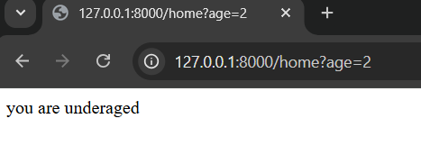

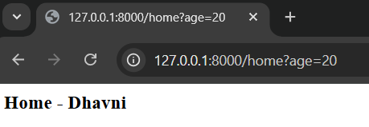

D. | Create and Apply Multiple Middleware
- Create another middleware named CountryCheck:
- php artisan make:middleware CountryCheck

- Add logic to block access if country != 'india'.
- CountryCheck.php

<?php

namespace App\Http\Middleware;

use Closure;
use Illuminate\Http\Request;
use Symfony\Component\HttpFoundation\Response;

class CountryCheck
{
public function handle(Request $request, Closure $next): Response
{
if($request->country!="india")
{
die("You are not access this website.");
}
return $next($request);
}
}

- Apply both middleware to a single route:
- Web.php

<?php

use Illuminate\Support\Facades\Route;
use App\Http\Middleware\AgeCheck;
use App\Http\Middleware\CountryCheck;

Route::get('/', function () {
return view('welcome');
});
Route::view('home','home')->middleware(AgeCheck::class,CountryCheck::class);
Route::view('about','about');

- Route::view('home1', 'home')->middleware([AgeCheck::class, CountryCheck::class]);

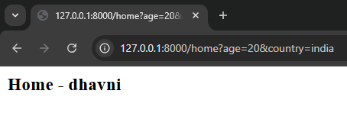

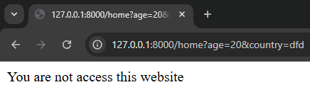

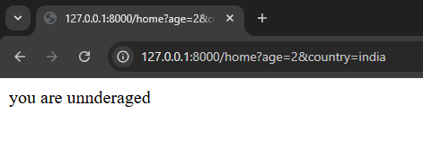

13. | Execute the Following Tasks and Demonstrate Each One Practically:  - Make view and route for view.  - Make form and input field.  - Make controller.  - Make form submit route.  - Get form input field data.
A. | Create View and Define Route for the Form
- Create a Blade view named user-form.blade.php using Artisan.

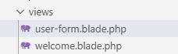

- User-from.blade.php

<div>
<h3>Add New User</h3>
</div>

- Define a route using Route::view('user-form', 'user-form');
- Web.php

<?php

use Illuminate\Support\Facades\Route;

Route::get('/', function () {
return view('welcome');
});
Route::view('user-form','user-form');

- Implement: Load the form in the browser at /user-form.

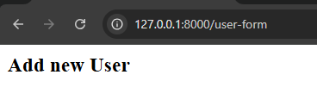

B. | Design the Form with Input Fields
- Create an HTML form in the Blade file with fields:
- Name (name="username")
- Email (name="email")
- City (name="city")
- User-form.blade.php

<div>
<h3>Add New User</h3>
<form action=" " method="post">
@csrf
<div class="input-wrapper">
<input type="text" placeholder="Enter Username" name="username">
</div>
<div class="input-wrapper">
<input type="text" placeholder="Enter User Email" name="email">
</div>
<div class="input-wrapper">
<input type="text" placeholder="Enter User City" name="city">
</div>
<div class="input-wrapper">
<button>Add New User</button>
</div>
</form>
</div>
<style>
input{
border:red 2px solid;
width:200px;
height:35px;
border-radius:2px;
color:orange;
}
.input-wrapper{
margin:10px;
}
button{
border:red 2px solid;
width:200px;
height:35px;
border-radius:2px;
color:orange;
cursor:pointer;
}
</style>

- Implement: Use the POST method and add @csrf inside the form

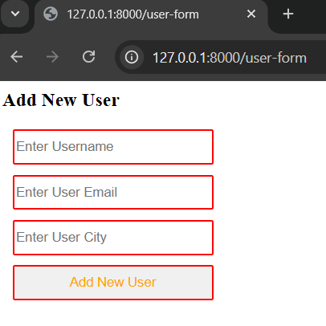

C. | Create the Controller
- php artisan make:controller UserController

- Implement: Create a method named adduser to handle the form data.
- UserController.php

<?php

namespace App\Http\Controllers;

use Illuminate\Http\Request;

class UserController extends Controller
{
//
function addUser(Request $request)
{

}
}

D. | Create the Form Submission Route
- Route::post('adduser', [UserController::class, 'adduser'])
- Web.php

<?php

use Illuminate\Support\Facades\Route;
use App\Http\Controllers\UserController;

Route::get('/', function () {
return view('welcome');
});
Route::view('user-form','user-form');
Route::post('addUser',[UserController::class,'addUser']);

- Implement: Ensure this matches the action="adduser" in the form.
- User-form.blade.php

<div>
<h3>Add New User</h3>
<form action="addUser" method="post">
@csrf
<div class="input-wrapper">
<input type="text" placeholder="Enter Username" name="username">
</div>

E. | Retrieve and Display Form Data in Controller
- In the adduser() method of the controller, use the $request object.
- UserController.php

<?php

namespace App\Http\Controllers;

use Illuminate\Http\Request;

class UserController extends Controller
{
//
function addUser(Request $request)
{
echo "Username is $request->username";
echo "<br>";
echo "User Email is $request->email";
echo "<br>";
echo "User City is $request->city";
echo "<br>";
}
}

- Implement: Submit the form and verify that the values appear correctly in the browser.
- Without write @csrf in user-form.blade.php



- Write after @csrf

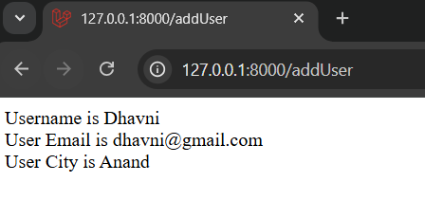

14. | Execute the Following Tasks and Demonstrate Each One Practically:  - Make view and its routes  - Make checkbox  - Make radio button  - Make range  - Make dropdown  - Make controller and get value.
A. | Create a View and Define Its Route  - php artisan make:view user-form
- Define the route using:
- Route::view('user-form', 'user-form');

- User-form.blade.php

<div>
<h3>Add User</h3>
</div>

- Web.php

<?php

use Illuminate\Support\Facades\Route;
use App\Http\Controllers\UserController;

Route::get('/', function () {
return view('welcome');
});
Route::view('/user-form','user-form');

- Implement: Access /user-form and verify the page loads.

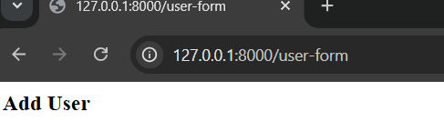

B. | Add and Implement Form Elements
- Inside user-form.blade.php, create a form with the following elements.
- Checkboxes for skills (e.g., PHP, Node, Java)
- Radio buttons for gender
- Dropdown (select) for city options (e.g., Delhi, Anand, Mumbai)
- Range input for age (min=18, max=100)
- A submit button and @csrf token for security

- User-form.blade.php

<div>
<h3>Add User</h3>
<form action="addUser" method="post">
@csrf
<div>
<h5>User Skill</h5>
<input type="Checkbox" name="skill[]" value="PHP" id="php">
<lable for="php">PHP</lable>
<input type="checkbox" name="skill[]" value="Node" id="node">
<lable for="node">Node</lable>
<input type="checkbox" name="skill[]" value="Java" id="java">
<lable for="java">Java</lable>
</div>
<div>
<h5>Gender</h5>
<input type="radio" name="gender" value="male" id="male">
<lable for="male">Male</lable>
<input type="radio" name="gender" value="female" id="female">
<lable for="female">Female</lable>
</div>
<div>
<h5>City</h5>
<select name="city">
<option value="Delhi">Delhi</option>
<option value="Anand">Anand</option>
<option value="Mumbai">Mumbai</option>
</select>
</div>
<div>
<h5>Age</h5>
<input type="range" name="age" min="18" max="100">
</div>
<button>Add New User</button>
</form>

</div>

C. | Create the Controller
- Generate a controller using:
- php artisan make:controller UserController
- Add a method addUser() to handle form submissions.
- UserController.php

<?php

namespace App\Http\Controllers;

use Illuminate\Http\Request;

class UserController extends Controller
{
//
function addUser(Request $request)
{
echo $request->city;
echo "<br>";
echo $request->gender;
echo "<br>";
echo $request->age;
echo "<br>";
print_r($request->skill);
echo "<br>";

}
}

D. | Set Up the Route for Form Submission  - Route::post('adduser', [UserController::class, 'addUser']);
- Web.php

<?php

use Illuminate\Support\Facades\Route;
use App\Http\Controllers\UserController;

Route::get('/', function () {
return view('welcome');
});
Route::view('/user-form','user-form');
Route::post('addUser',[UserController::class,'addUser']);

E. | Retrieve and Display Input Values
- Implement: Submit the form with different input combinations and verify the output.

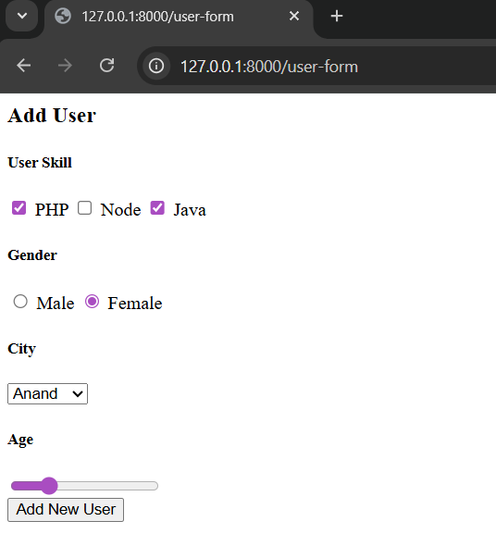

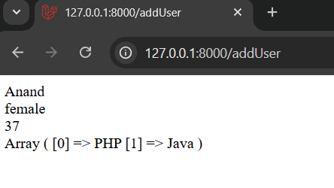

15. | Execute the Following Tasks and Demonstrate Each One Practically:  - Connect to MySQl database  - Make database  - Update Env file  - Run migration  - Make controller and route  - Get data from the database  - Connect to DB without migration  - Display DB data on UI  - Make view  - Call view from controller  - Pass DB data from the controller to view  - User for each loop display data
A. | Connect to MySQL Database Using .env and Migration
- Create a database in phpMyAdmin with the name laravel.

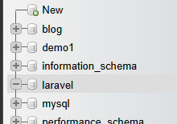

- Update your .env file with the following credentials:
DB_CONNECTION=mysql
DB_HOST=127.0.0.1
DB_PORT=3306
DB_DATABASE=Laravel
DB_USERNAME=root
DB_PASSWORD=

- .env file

DB_CONNECTION=mysql
DB_HOST=127.0.0.1
DB_PORT=3306
DB_DATABASE=laravel
DB_USERNAME=root
DB_PASSWORD=

- Run the migration using the command

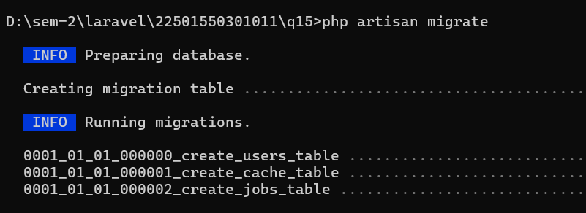

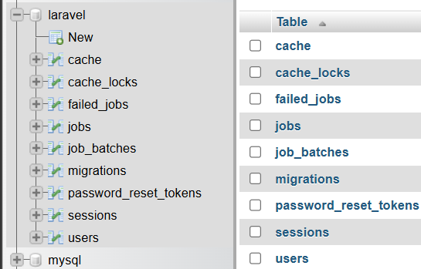

B. | Retrieve and Display Data from the Database
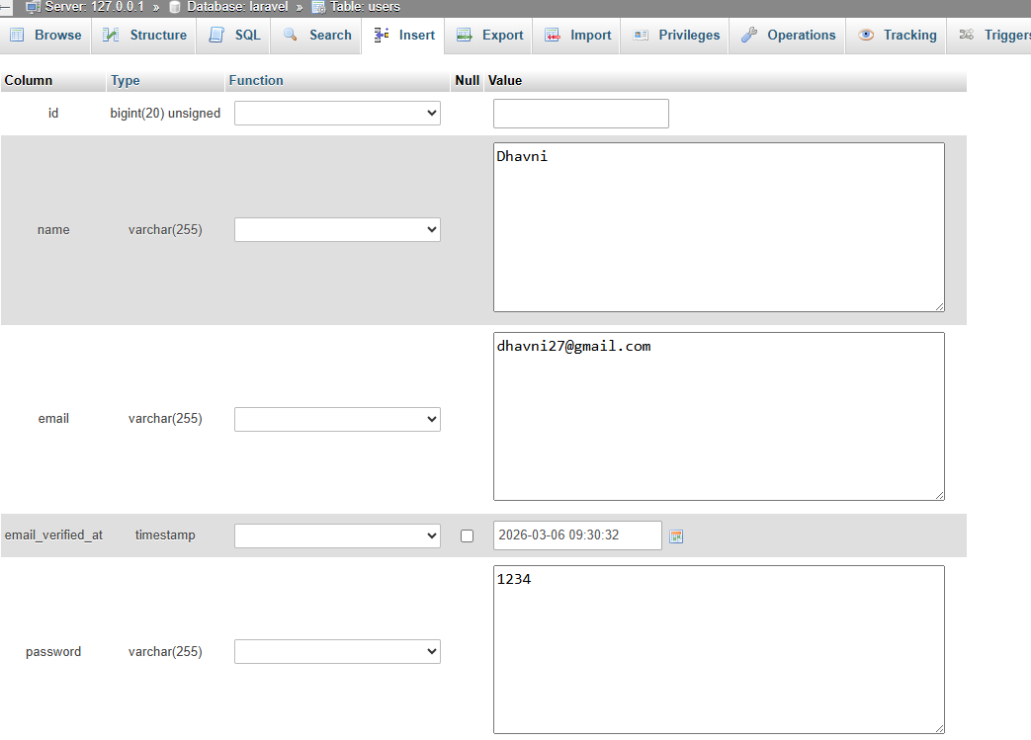

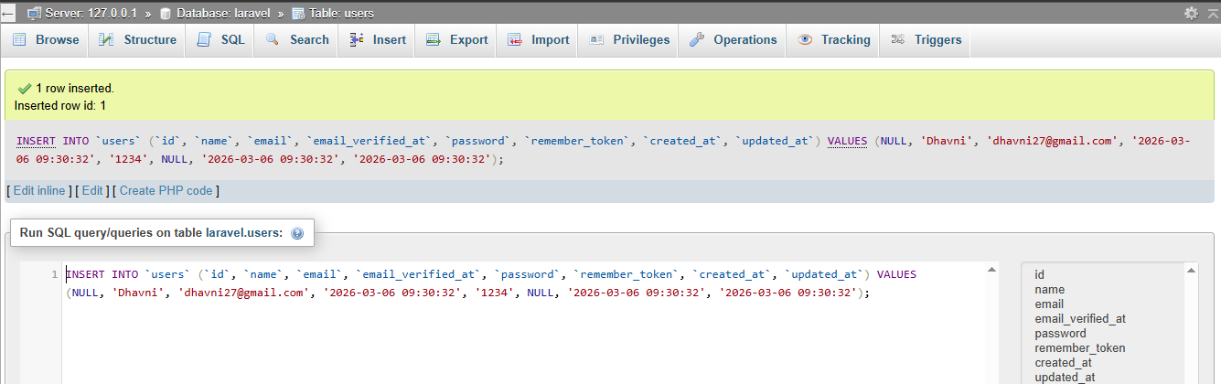

- UserController.php

<?php

namespace App\Http\Controllers;

use Illuminate\Http\Request;
use Illuminate\Support\Facades\DB;

class UserController extends Controller
{
//
function users()
{
return DB::select('select * from users');
}
}

- Web.php

<?php

use Illuminate\Support\Facades\Route;
use App\Http\Controllers\UserController;

Route::get('/', function () {
return view('welcome');
});
Route::get('users',[UserController::class,'users']);

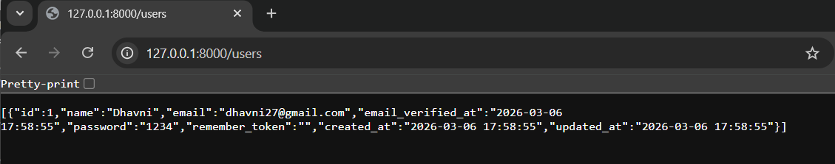

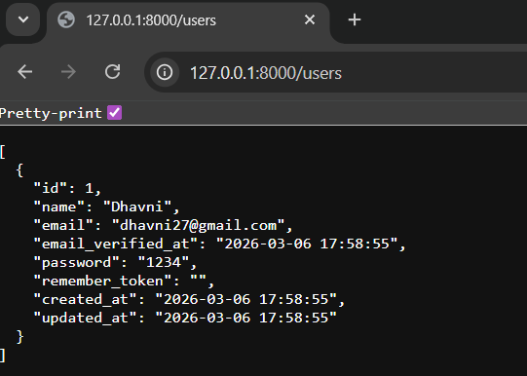

C. | Connect to a Database Without Migration
- Create database name = demo and table name = users1

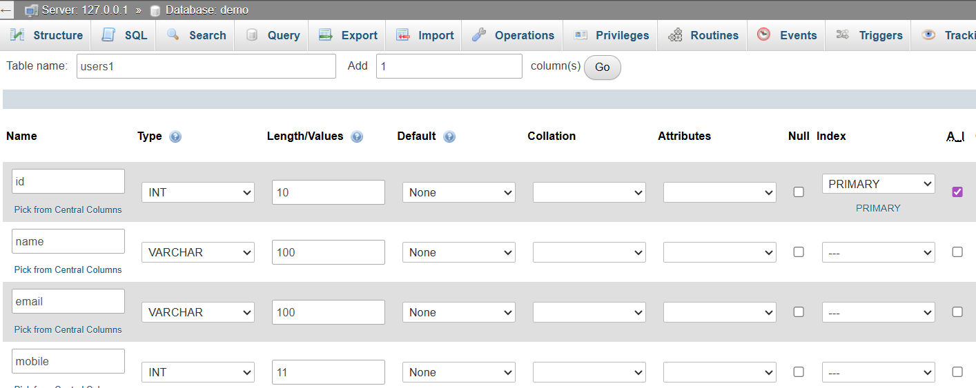

- UserController.php

<?php

namespace App\Http\Controllers;

use Illuminate\Http\Request;
use Illuminate\Support\Facades\DB;

class UserController extends Controller
{
//
function users()
{
return DB::select('select * from users1');
}
}

- .env file

DB_CONNECTION=mysql
DB_HOST=127.0.0.1
DB_PORT=3306
DB_DATABASE=demo
DB_USERNAME=root
DB_PASSWORD=

SESSION_DRIVER=file
SESSION_LIFETIME=120
SESSION_ENCRYPT=false
SESSION_PATH=/
SESSION_DOMAIN=null

- Web.php

<?php

use Illuminate\Support\Facades\Route;
use App\Http\Controllers\UserController;

Route::get('/', function () {
return view('welcome');
});
Route::get('users',[UserController::class,'users']);

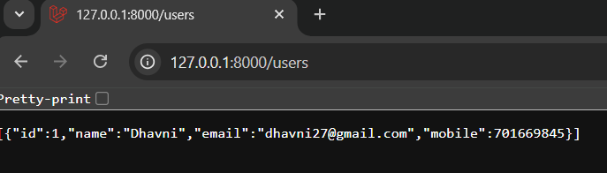

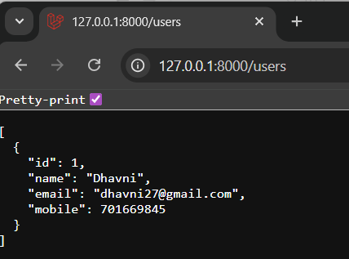

D. | Display DB Data on UI
- Make a view.

- Call Controller
- UserController.php

<?php

namespace App\Http\Controllers;

use Illuminate\Http\Request;
use Illuminate\Support\Facades\DB;

class UserController extends Controller
{
//
function users()
{
$users= DB::select('select * from users1');
return view('users');
}
}

- Users.blade.php

<div>
<h3>User List</h3>
</div>

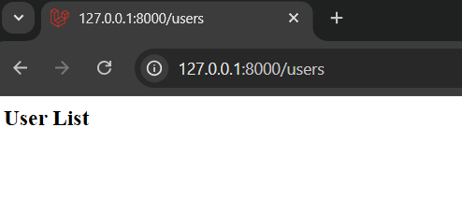

- Pass DB from controller to view
- UserConbtroller.php

<?php

namespace App\Http\Controllers;

use Illuminate\Http\Request;
use Illuminate\Support\Facades\DB;

class UserController extends Controller
{
//
function users()
{
$users= DB::select('select * from users1');
return view('users',['users'=>$users]);
}
}

- Users.blade.php

<div>
<h3>User List</h3>
{{print_r($users)}}
</div>

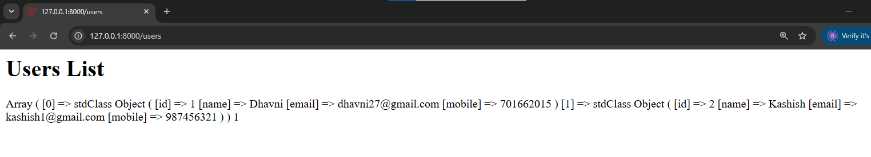

- User for each loop display data
- Users.blade.php

<div>
<h3>User List</h3>
<table border = "1">
<tr>
<td>ID</td>
<td>NAME</td>
<td>EMAIL</td>
<td>MOBILE</td>
</tr>
<tr>
@foreach($users as $user)
<tr>
<td>{{$user->id}}</td>
<td>{{$user->name}}</td>
<td>{{$user->email}}</td>
<td>{{$user->mobile}}</td>
</tr>
@endforeach
</table>

</div>

