11 | Execute the Following Tasks and Demonstrate Each One Practically:
A. Understand and Describe Middleware Group

B. Create Middleware Files
- Use Artisan commands to create multiple middleware:

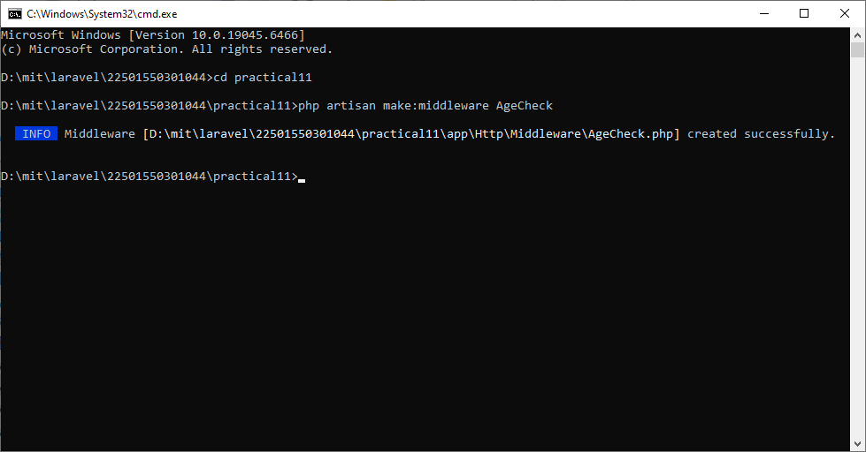

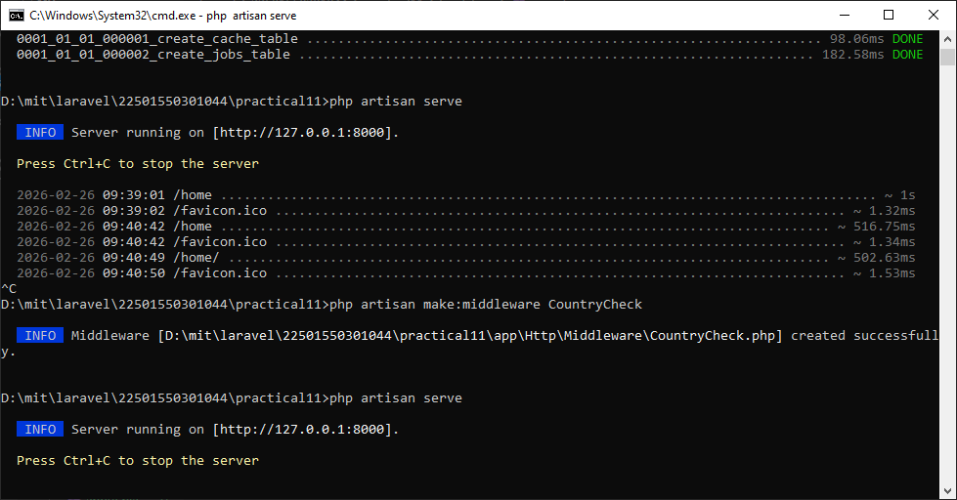

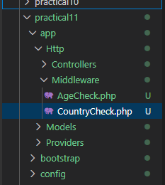
- Implement:Add simple Logic inside each middleware’s handle() method
AgeCheck.php
public function handle(Request $request, Closure $next): Response
{
if($request->age<18){
die("you are underage");
}
return $next($request);
}
CountryCheck.php
public function handle(Request $request, Closure $next): Response
{
if($request->country!='india'){
die('you are not allow to this website');
}
return $next($request);
}
C. Register Middleware Group
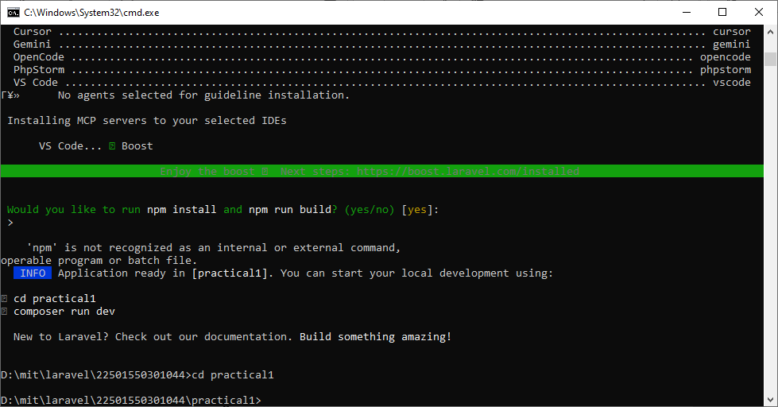
- Run the necessary NPM and Artisan commands to serve the application.
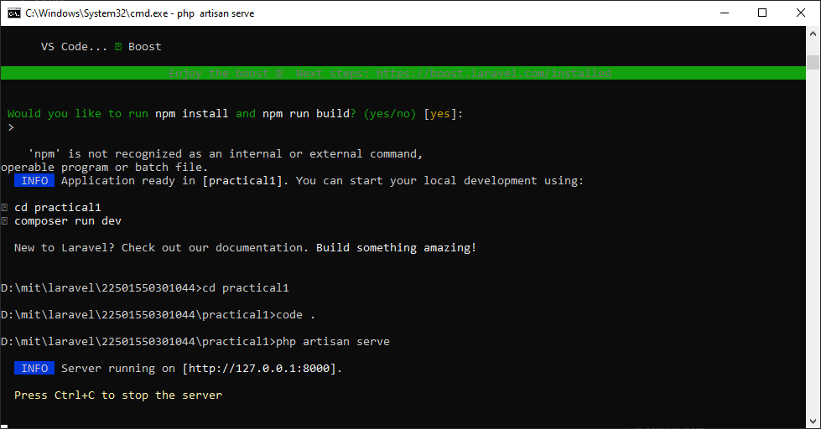
D. Modify the Welcome Page
- Open welcome.blade.php and display your full name.
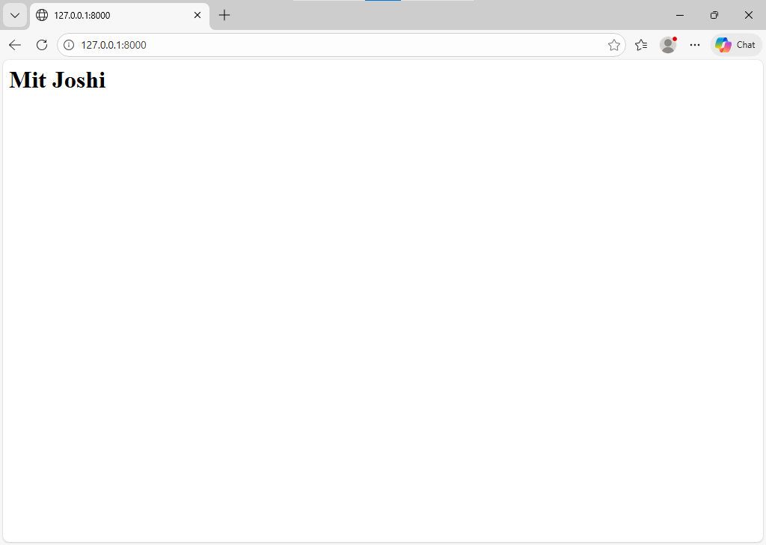
E. Create a New Blade View
Create a new Blade file named home.blade.php.
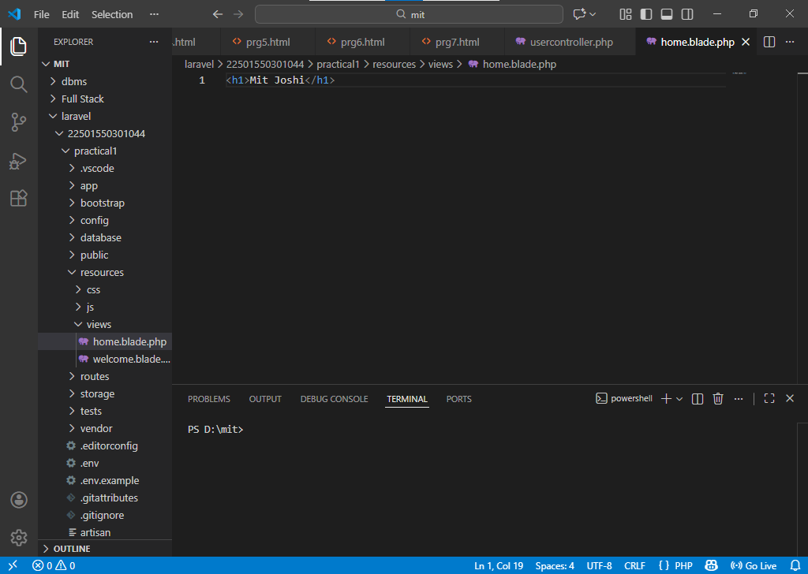
- Display any custom heading in it.
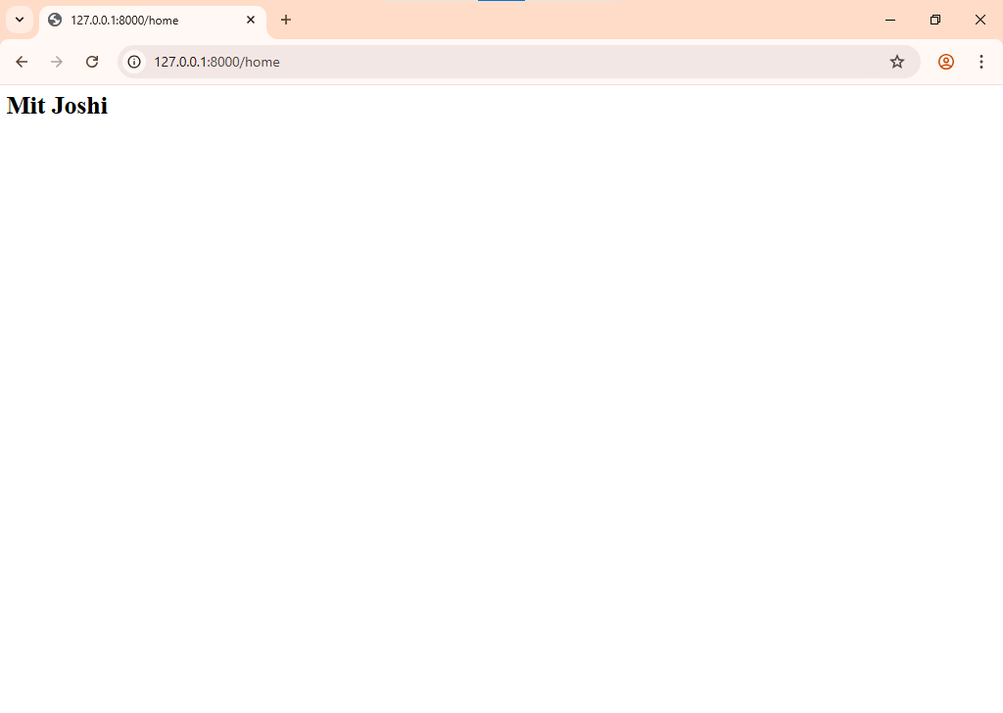
F. Update Routes
- Define a route in web.php to load the new view when /home is accessed.

Route::get('/home', function () {
return view('home');
- Set this route to replace the default / route if needed. 