1. | Exercise:1 Basic SQL Syntax  1. Create a database named university.  2. Switch to the university database.  3. Create a table named students with the following columns.  Id(integer,primary key)  Name(varchar(100),not null)  Age(Integer,check age>16)  Email(varchar(255),unique)  4. Retrive the structure of the students table.  5 Insert at least 20 records.
CODE | create database university;  \c university  create table students(  Id INTEGER PRIMARY KEY,  Name VARCHAR(100) NOT NULL,  Age INTEGER CHECK (Age > 16),  Email VARCHAR(255) UNIQUE  );  \d students  insert into students (Id, Name, Age, Email) VALUES  (1, 'Alice Johnson', 20, 'alice.johnson@example.com'),  (2, 'Bob Smith', 22, 'bob.smith@example.com'),  (3, 'Charlie Brown', 19, 'charlie.brown@example.com'),  (4, 'Diana Prince', 21, 'diana.prince@example.com'),  (5, 'Ethan Hunt', 23, 'ethan.hunt@example.com'),  (6, 'Fiona Davis', 24, 'fiona.davis@example.com'),  (7, 'George Miller', 25, 'george.miller@example.com'),  (8, 'Hannah Lee', 20, 'hannah.lee@example.com'),  (9, 'Ian Clark', 22, 'ian.clark@example.com'),  (10, 'Julia Roberts', 23, 'julia.roberts@example.com'),  (11, 'Kevin Adams', 21, 'kevin.adams@example.com'),  (12, 'Laura Scott', 19, 'laura.scott@example.com'),  (13, 'Michael Jordan', 24, 'michael.jordan@example.com'),  (14, 'Nina Taylor', 22, 'nina.taylor@example.com'),  (15, 'Oscar White', 23, 'oscar.white@example.com'),  (16, 'Paula Green', 25, 'paula.green@example.com'),  (17, 'Quentin Blake', 21, 'quentin.blake@example.com'),  (18, 'Rachel Moore', 20, 'rachel.moore@example.com'),  (19, 'Steven King', 22, 'steven.king@example.com'),  (20, 'Tina Turner', 23, 'tina.turner@example.com');
OUTPUT | 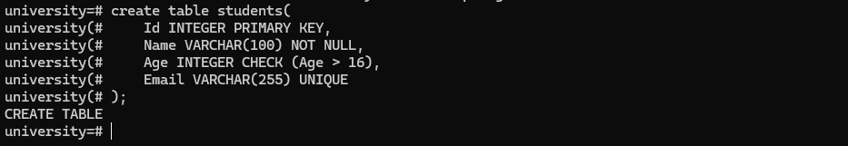  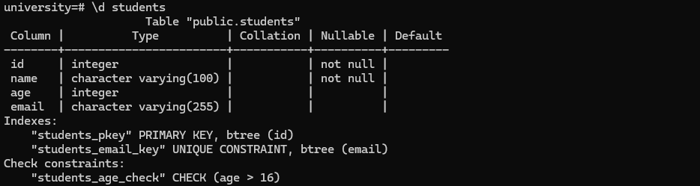  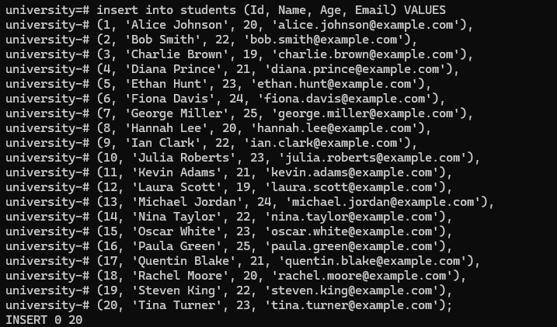
2 | Exercise:2 Working with different data types:  1. Create a table named product with columns:  Product_id(integer,primary key)  Name(varchar(100)not null)  Price(numeric(10,2),check price>0)  Create_at(timestamp default current_timestamp)  Is_avilable(Boolean default true)  2. Insert sample data into products(20 data)  3. Retrive all products where is_availble is true  4. Update the price of a specific product.  5. Delete a product based on product_id.
CODE | CREATE TABLE product (  product_id INT PRIMARY KEY,  name VARCHAR(100) NOT NULL,  price NUMERIC(10,2) CHECK (price > 0),  created_at TIMESTAMP DEFAULT CURRENT_TIMESTAMP,  is_available BOOLEAN DEFAULT TRUE  );  INSERT INTO product (product_id, name, price, is_available) VALUES  (1, 'Laptop', 75000.00, TRUE),  (2, 'Smartphone', 30000.00, FALSE),  (3, 'Tablet', 20000.00, TRUE),  (4, 'Headphones', 2500.00, TRUE),  (5, 'Keyboard', 1500.00, FALSE),  (6, 'Mouse', 800.00, TRUE),  (7, 'Monitor', 12000.00, TRUE),  (8, 'Printer', 8500.00, TRUE),  (9, 'Camera', 45000.00, FALSE),  (10, 'Speaker', 3500.00, TRUE),  (11, 'Smartwatch', 15000.00, TRUE),  (12, 'Router', 5000.00, FALSE),  (13, 'External HDD', 6000.00, TRUE),  (14, 'SSD', 7000.00, TRUE),  (15, 'Microphone', 4000.00, FALSE),  (16, 'Projector', 25000.00, TRUE),  (17, 'TV', 55000.00, TRUE),  (18, 'Gaming Console', 45000.00, TRUE),  (19, 'Drone', 65000.00, FALSE),  (20, 'VR Headset', 30000.00, TRUE);  SELECT *  FROM product  WHERE is_available = TRUE;  UPDATE product  SET price = 1800.00  WHERE product_id = 5  RETURNING *;  DELETE FROM product  WHERE product_id = 10  RETURNING *;
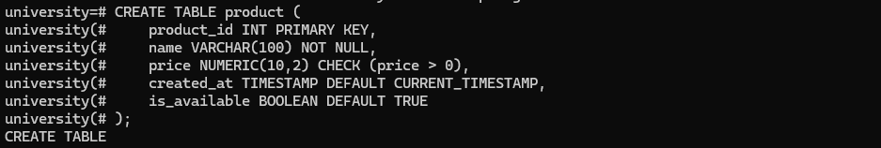

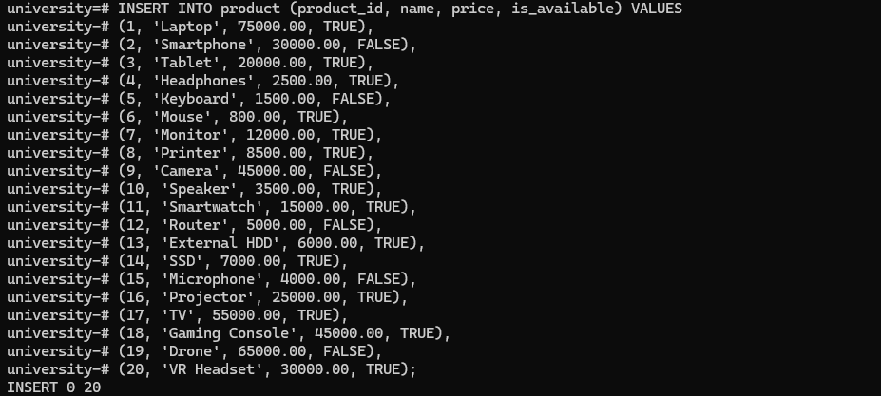

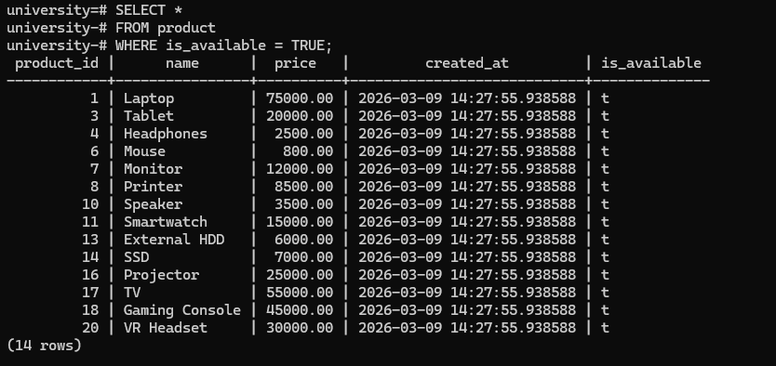

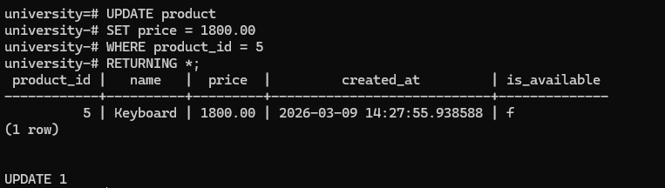

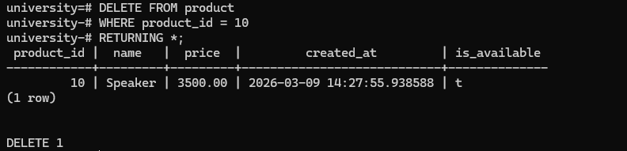
3. | Exercise:3 Modifying Tables and Constraints  - Alter the students table to add a new column  phone_number(numeric(11)unique)  - Rename the students table to university_students.  - Drop the email column from university_students.  - Add a not null constraint to the phone_number columns.
ALTER TABLE students
ADD COLUMN phone_number NUMERIC(11) UNIQUE;

ALTER TABLE students
RENAME TO university_students;

ALTER TABLE university_students
DROP COLUMN email;

ALTER TABLE university_students
ALTER COLUMN phone_number SET NOT NULL;

 | 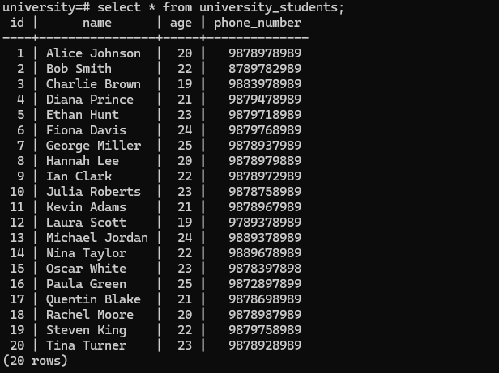
4. | Exercise :4 Inserting,Updating and Deleting Data.  1. Insert three student into university_students.  2. Update the age of a student where id=1.  3. Delete a student where id=3.  4. Return data from modified rows.  5. Insert multiple students in a single query.  6. Remove all students who are younger than 18.
INSERT INTO university_students (id, name, age, phone_number)
VALUES
(21, 'Alice', 20, 98765432101),
(22, 'Bob', 22, 98765432102),
(23, 'Charlie', 19, 98765432103);

UPDATE university_students
SET age = 21
WHERE id = 1
RETURNING *;

DELETE FROM university_students
WHERE id = 3
RETURNING *;

INSERT INTO university_students (id, name, age, phone_number)
VALUES
(24, 'David', 23, 98765432104),
(25, 'Emma', 18, 98765432105),
(26, 'Frank', 25, 98765432106);

DELETE FROM university_students
WHERE age < 18;

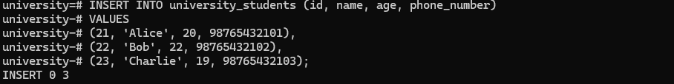

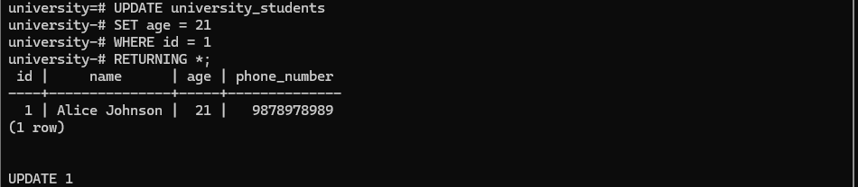

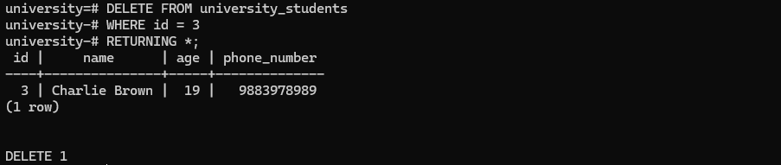

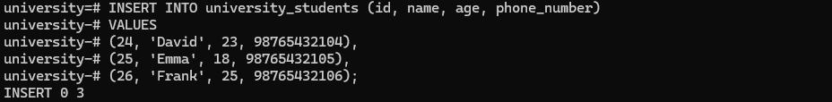

5. | Exercise:5 Retrieving Data  1 Select all columns from university_students.  2 Select only name and age where age > 20.  3 Order results by name in descending order.  4 Limit the number of results to 2.  5 Select students whose names start with 'A'.  6 Retrieve distinct ages from the university_students table.  7 Find students who have NULL values in the phone_number  column.
SELECT *
FROM university_students;

SELECT name, age
FROM university_students
WHERE age > 20;

SELECT *
FROM university_students
ORDER BY name DESC;

SELECT *
FROM university_students
LIMIT 2;

SELECT *
FROM university_students
WHERE name LIKE 'A%';

SELECT DISTINCT age
FROM university_students;

SELECT *
FROM university_students
WHERE phone_number IS NULL;

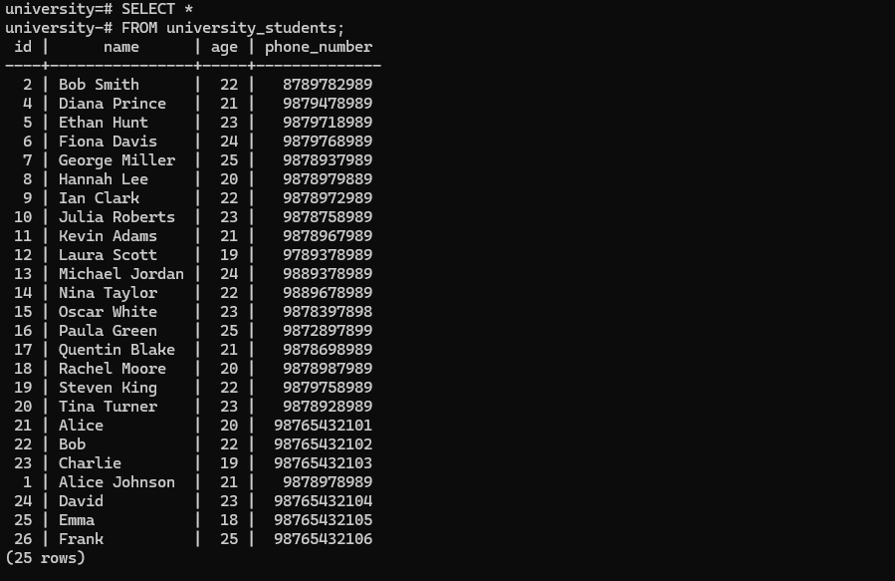

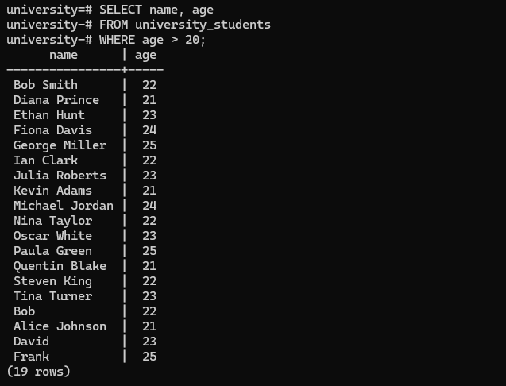

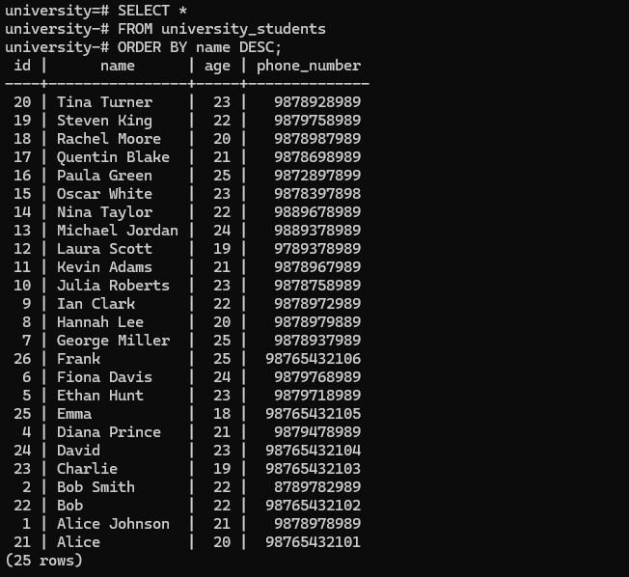

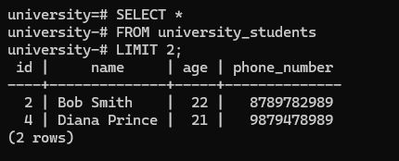

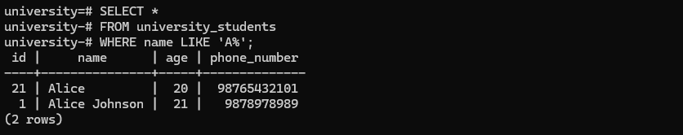

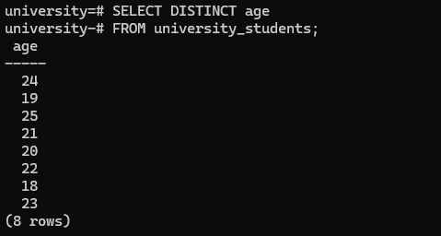

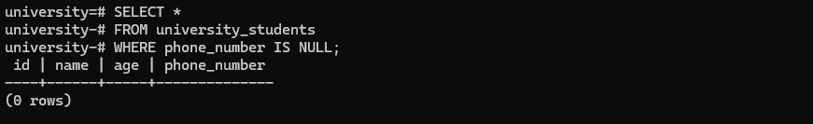

6. | Exercise:6 Using Operators and Functions  1.Create a new table orders with columns:  order_id (int, primary key) student_id (integer, foreign key referencing  university_students(id))  total_price (numeric(10,2))  order_date (timestamp default current_timestamp)  2 Retrieve all students along with their orders using a JOIN.  3 Find the total orders placed by each student.  4 Retrieve students who have not placed any orders.  5 Retrieve students who have placed orders with a total price  above 500.  6 Use a WITH query to find the average order price for each  student.
CREATE TABLE orders (
order_id INT PRIMARY KEY,
student_id INT REFERENCES university_students(id),
total_price NUMERIC(10,2),
order_date TIMESTAMP DEFAULT CURRENT_TIMESTAMP
);

SELECT u.*, o.order_id, o.total_price, o.order_date
FROM university_students u
JOIN orders o ON u.id = o.student_id;

SELECT u.id, u.name, COUNT(o.order_id) AS total_orders
FROM university_students u
LEFT JOIN orders o ON u.id = o.student_id
GROUP BY u.id, u.name;

SELECT u.*
FROM university_students u
LEFT JOIN orders o ON u.id = o.student_id
WHERE o.order_id IS NULL;

SELECT DISTINCT u.*
FROM university_students u
JOIN orders o ON u.id = o.student_id
WHERE o.total_price > 500;

WITH avg_orders AS (
SELECT student_id, AVG(total_price) AS avg_price
FROM orders
GROUP BY student_id
)
SELECT u.id, u.name, avg_orders.avg_price
FROM university_students u
JOIN avg_orders ON u.id = avg_orders.student_id;
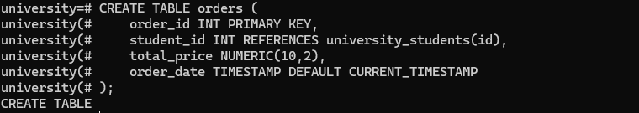

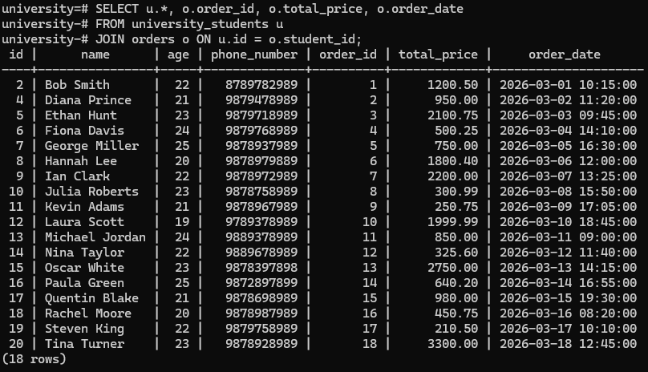

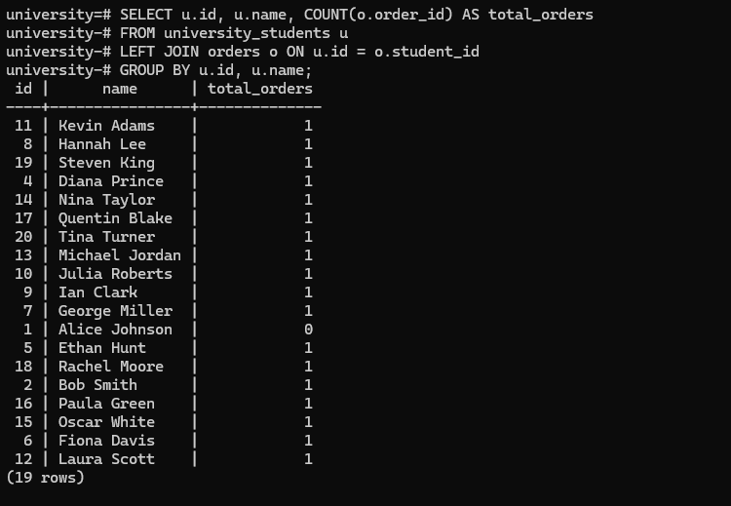

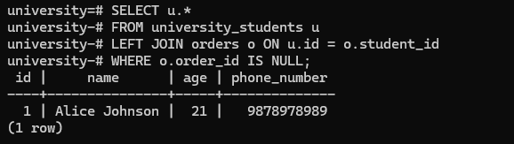

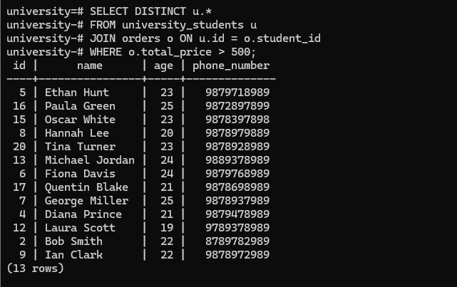

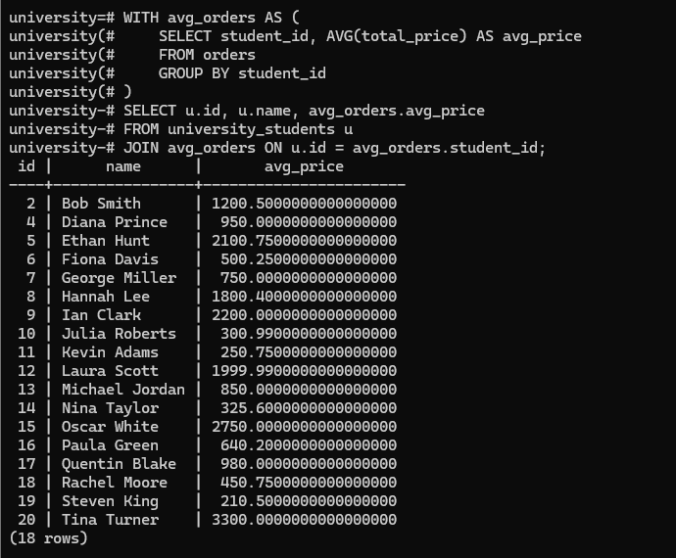

1 | Mini Project:Library Management System using PostgreSQL
Objective: Develop a system to manage books, students, and
borrowing records.
Step:1:DataBase Setup
1. Create a database named 'library_db'.
2. Switch to the database.
Step 2: Creating Tables
1. Create a 'students' table with fields: student_id (primary
key), name, age (must be >= 16), and phone_number (unique,
not null).
2. Create a 'books' table with fields: book_id (primary key),
title, author, and availability status.
3. Create a 'borrow_records' table with fields: record_id
(primary key), student_id (foreign key), book_id (foreign key),
borrow_date, and return_date.
Step 3: Insert Sample Data
1. Insert at least 20 students records into the 'students' table.
2. Insert at least 10 books records into the 'books' table.
3.
Insert at least 10 borrowing records into the
'borrow_records' table.
Step 4: Queries and Data Retrieval
1. Retrieve the details of students who have borrowed books.
2. Find all available books.
3. Update the availability status of a book after it is borrowed.
4. Identify students who have not borrowed any books.
5. Record the return of a book and update availability.
6. Display first 5 students only.
7. Display next 5 students and skip first 5
8. Show only students who borrowed more than 1 book.
9. Find students who borrowed at least 3 books.
CREATE DATABASE library_db;

\c library_db;

CREATE TABLE students (
student_id SERIAL PRIMARY KEY,
name VARCHAR(100) NOT NULL,
age INT CHECK (age >= 16),
phone_number VARCHAR(15) UNIQUE NOT NULL
);

CREATE TABLE books (
book_id SERIAL PRIMARY KEY,
title VARCHAR(200) NOT NULL,
author VARCHAR(100) NOT NULL,
availability BOOLEAN DEFAULT TRUE
);

CREATE TABLE borrow_records (
record_id SERIAL PRIMARY KEY,
student_id INT REFERENCES students(student_id),
book_id INT REFERENCES books(book_id),
borrow_date TIMESTAMP DEFAULT CURRENT_TIMESTAMP,
return_date TIMESTAMP
);

INSERT INTO students (name, age, phone_number) VALUES
('Amit', 18, '9876543210'),
('Priya', 20, '9876543211'),
('Ravi', 19, '9876543212'),
('Sneha', 21, '9876543213'),
('Karan', 22, '9876543214'),
('Meera', 23, '9876543215'),
('Vikas', 24, '9876543216'),
('Anjali', 25, '9876543217'),
('Suresh', 26, '9876543218'),
('Pooja', 27, '9876543219'),
('Raj', 28, '9876543220'),
('Neha', 29, '9876543221'),
('Arjun', 30, '9876543222'),
('Divya', 31, '9876543223'),
('Manish', 32, '9876543224'),
('Komal', 33, '9876543225'),
('Deepak', 34, '9876543226'),
('Shreya', 35, '9876543227'),
('Nikhil', 36, '9876543228'),
('Ritika', 37, '9876543229');

INSERT INTO books (title, author, availability) VALUES
('Database Systems', 'Elmasri', TRUE),
('Operating Systems', 'Silberschatz', TRUE),
('Computer Networks', 'Tanenbaum', TRUE),
('Data Structures', 'Cormen', TRUE),
('Artificial Intelligence', 'Russell', TRUE),
('Machine Learning', 'Goodfellow', TRUE),
('Web Development', 'Flanagan', TRUE),
('Python Programming', 'Mark Lutz', TRUE),
('Java Programming', 'Horstmann', TRUE),
('Cloud Computing', 'Rajkumar Buyya', TRUE);

INSERT INTO borrow_records (student_id, book_id, borrow_date) VALUES
(1, 1, CURRENT_TIMESTAMP),
(1, 2, CURRENT_TIMESTAMP),
(1, 3, CURRENT_TIMESTAMP),
(2, 2, CURRENT_TIMESTAMP),
(2, 4, CURRENT_TIMESTAMP),
(2, 5, CURRENT_TIMESTAMP),
(3, 3, CURRENT_TIMESTAMP),
(3, 6, CURRENT_TIMESTAMP),
(3, 7, CURRENT_TIMESTAMP),
(3, 8, CURRENT_TIMESTAMP),
(3, 9, CURRENT_TIMESTAMP),
(4, 4, CURRENT_TIMESTAMP),
(4, 10, CURRENT_TIMESTAMP),
(4, 1, CURRENT_TIMESTAMP),
(5, 5, CURRENT_TIMESTAMP),
(6, 6, CURRENT_TIMESTAMP),
(7, 7, CURRENT_TIMESTAMP),
(8, 8, CURRENT_TIMESTAMP),
(9, 9, CURRENT_TIMESTAMP),
(10, 10, CURRENT_TIMESTAMP);

SELECT DISTINCT s.*
FROM students s
JOIN borrow_records br ON s.student_id = br.student_id;

SELECT * FROM books WHERE availability = TRUE;

UPDATE books SET availability = FALSE WHERE book_id = 1;

SELECT * FROM students
WHERE student_id NOT IN (SELECT student_id FROM borrow_records);

UPDATE borrow_records SET return_date = CURRENT_TIMESTAMP WHERE record_id = 1;
UPDATE books SET availability = TRUE WHERE book_id = 1;

SELECT * FROM students LIMIT 5;

SELECT * FROM students OFFSET 5 LIMIT 5;

SELECT s.name, COUNT(br.book_id) AS books_borrowed
FROM students s
JOIN borrow_records br ON s.student_id = br.student_id
GROUP BY s.name
HAVING COUNT(br.book_id) > 1;

SELECT s.name, COUNT(br.book_id) AS books_borrowed
FROM students s
JOIN borrow_records br ON s.student_id = br.student_id
GROUP BY s.name
HAVING COUNT(br.book_id) >= 3;

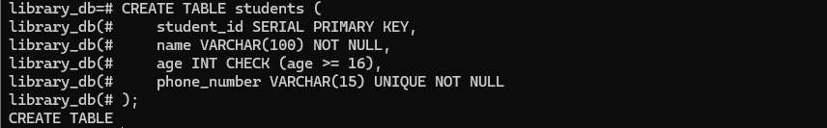

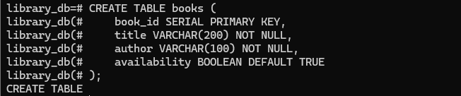

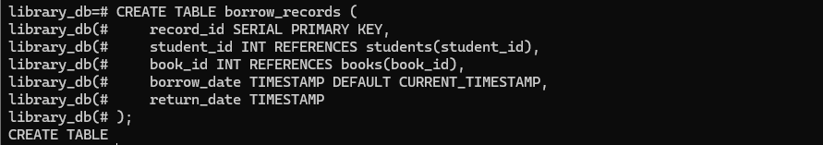

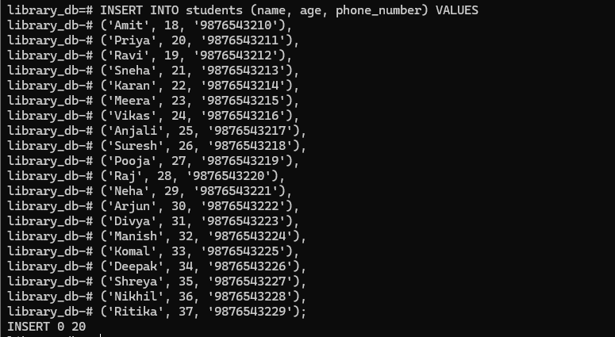

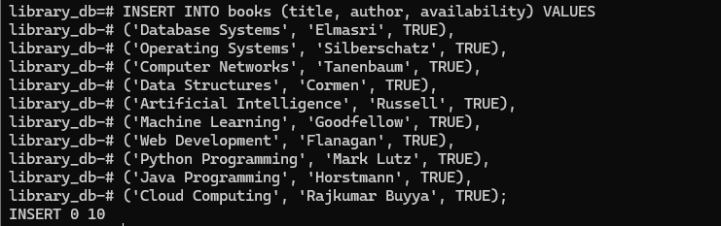

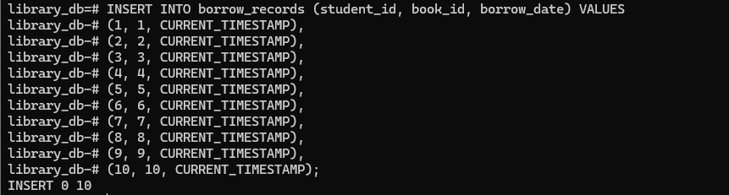

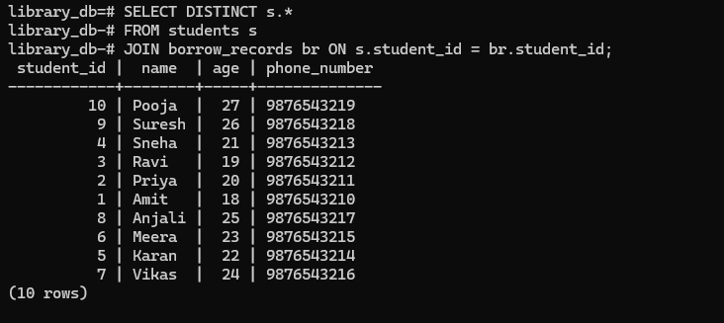

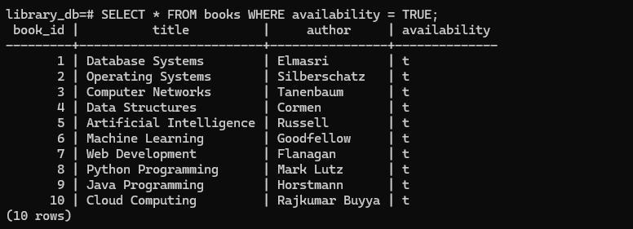

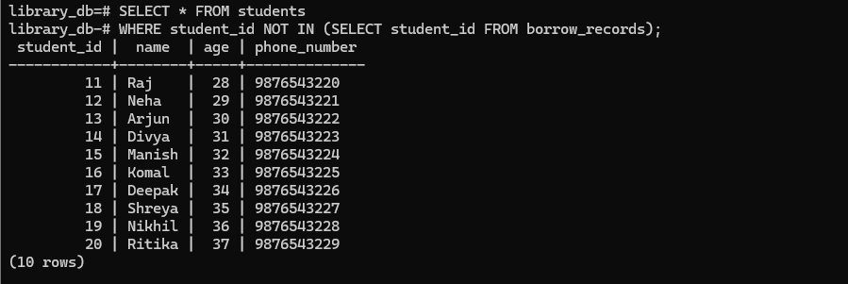

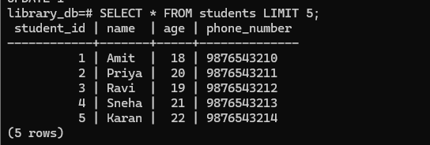

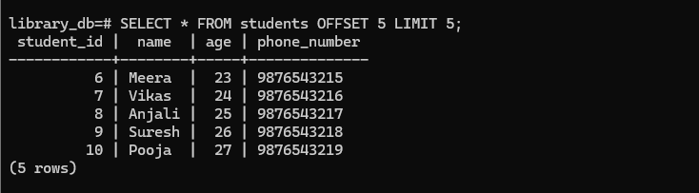

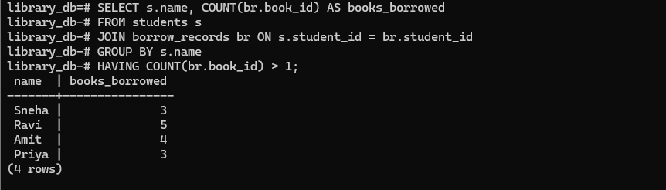

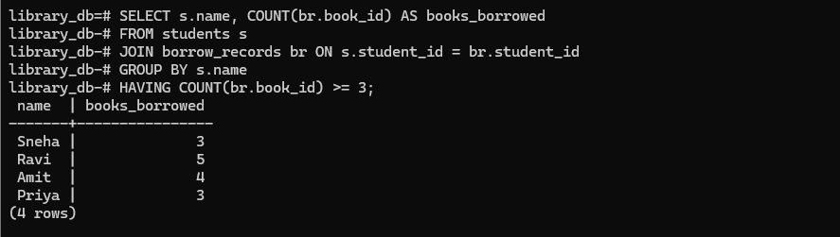

2. | Project- 2 Employee Attendance Management System using PostgreSQL
Step 1: Database Setup
1. Create a database named 'attendance_db'.
2. Switch to the database.

Step 2: Creating Tables
1. Create an 'employees' table with fields: employee_id
(primary key), name, department, and phone_number (unique,
not null).
2. Create an 'attendance' table with fields: record_id (primary
key), employee_id (foreign key), date, check_in_time, and
check_out_time.

Step 3: Insert Sample Data
1. Insert at least 20 employees records into the 'employees'
table.
2. Insert at least 20 attendance records records into the
'attendance' table.

Step 4: Queries and Data Retrieval
1. Retrieve the attendance records for a specific employee.
2. Find employees who have not checked in today.
3. Update the check-out time for a specific employee.
4. Identify employees who were present for more than 8 hours.
5. Retrieve a summary of total working hours for each
employee.
CREATE DATABASE attendance_db;
\c attendance_db;

CREATE TABLE employees (
employee_id SERIAL PRIMARY KEY,
name VARCHAR(100) NOT NULL,
department VARCHAR(50),
phone_number VARCHAR(15) UNIQUE NOT NULL
);

CREATE TABLE attendance (
record_id SERIAL PRIMARY KEY,
employee_id INT REFERENCES employees(employee_id),
date DATE NOT NULL,
check_in_time TIMESTAMP,
check_out_time TIMESTAMP
);

INSERT INTO employees (name, department, phone_number) VALUES
('Amit','HR','9786758761'),('Priya','Finance','9235467832'),
('Ravi','IT','9865768573'),('Sneha','Sales','9854683574'),
('Karan','HR','9765876585'),('Meera','Finance','9685753476'),
('Vikas','IT','9634736747'),('Anjali','Sales','9758365748'),
('Suresh','HR','9869568599'),('Pooja','Finance','9937548390'),
('Raj','IT','9976859831'),('Neha','Sales','9725874812'),
('Arjun','HR','9012836473'),('Divya','Finance','9796875684'),
('Manish','IT','9865768575'),('Komal','Sales','9976879866'),
('Deepak','HR','93674859617'),('Shreya','Finance','9975984398'),
('Nikhil','IT',’9878787859’),('Ritika','Sales','9834926470'),
('Yash','IT','9000000031'),('Zara','Sales','9000000032'),
('Omkar','HR','9000000033'),('Pallavi','Finance','9000000034'),
('Rohan','IT','9000000035');

INSERT INTO attendance (employee_id,date,check_in_time,check_out_time) VALUES
(1,CURRENT_DATE,'2026-03-10 09:00','2026-03-10 17:30'),
(2,CURRENT_DATE,'2026-03-10 09:15','2026-03-10 18:00'),
(3,CURRENT_DATE,'2026-03-10 08:45','2026-03-10 17:00'),
(4,CURRENT_DATE,'2026-03-10 09:30','2026-03-10 18:15'),
(5,CURRENT_DATE,'2026-03-10 09:00','2026-03-10 17:00'),
(6,CURRENT_DATE,'2026-03-10 09:10','2026-03-10 17:20'),
(7,CURRENT_DATE,'2026-03-10 09:05','2026-03-10 18:00'),
(8,CURRENT_DATE,'2026-03-10 09:20','2026-03-10 17:45'),
(9,CURRENT_DATE,'2026-03-10 09:00','2026-03-10 17:10'),
(10,CURRENT_DATE,'2026-03-10 09:25','2026-03-10 18:30'),
(11,CURRENT_DATE,'2026-03-10 09:00','2026-03-10 17:00'),
(12,CURRENT_DATE,'2026-03-10 09:15','2026-03-10 17:45'),
(13,CURRENT_DATE,'2026-03-10 08:55','2026-03-10 17:20'),
(14,CURRENT_DATE,'2026-03-10 09:05','2026-03-10 18:10'),
(15,CURRENT_DATE,'2026-03-10 09:00','2026-03-10 17:30'),
(16,CURRENT_DATE,'2026-03-10 09:10','2026-03-10 18:00'),
(17,CURRENT_DATE,'2026-03-10 09:00','2026-03-10 17:00'),
(18,CURRENT_DATE,'2026-03-10 09:20','2026-03-10 18:00'),
(19,CURRENT_DATE,'2026-03-10 09:00','2026-03-10 17:15'),
(20,CURRENT_DATE,'2026-03-10 09:30','2026-03-10 18:30');

SELECT * FROM attendance WHERE employee_id=1;

SELECT * FROM employees WHERE employee_id NOT IN
(SELECT employee_id FROM attendance WHERE date=CURRENT_DATE);

UPDATE attendance SET check_out_time='2026-03-10 18:00' WHERE employee_id=1 AND date=CURRENT_DATE;

SELECT e.name,(a.check_out_time-a.check_in_time) AS duration
FROM employees e JOIN attendance a ON e.employee_id=a.employee_id
WHERE (a.check_out_time-a.check_in_time)>'08:00:00';

SELECT e.name,SUM(a.check_out_time-a.check_in_time) AS total_hours
FROM employees e JOIN attendance a ON e.employee_id=a.employee_id
GROUP BY e.name;

