Prg20
Task 1 Insert data in db
1.set .env file
2. make controller,model,view
3. make html form
4.create table in mysql db
5.store data in db table

1.
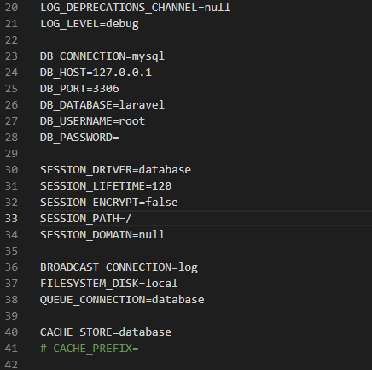
2.
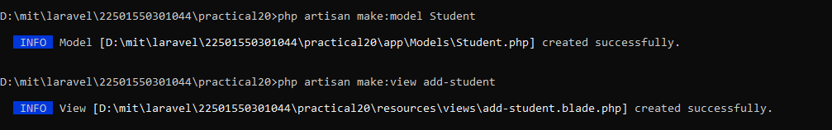
3.
<div>
<form action='add' method='POST'>
@csrf
Name:
<input type="text" id="name" name="name"><br><br>
Email:
<input type="email" id="email" name="email"><br><br>
Phone:
<input type="text" id="phone" name="phone"><br><br>
<button>Add Student</button>
</form>
</div>
4.
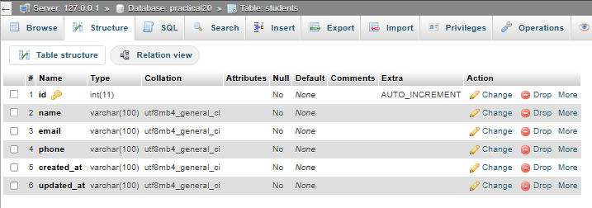
5.
<?php

namespace App\Http\Controllers;

use Illuminate\Http\Request;
use App\Models\Student;

class StudentController extends Controller
{
function add(Request $request){
$student = new Student;
$student->name = $request->name;
$student->email = $request->email;
$student->save();
return "Student record inserted successfully";
}
}

