Eloquent Model in Laravel
- What is Model
- Make a table in database
- Check .env file configuration
- Make Controller
- Make Model.
- Make View.
- Get Data from the database
- Pass data to view and display data
- Make Function in Model and Use it.
2. Make a table in database.
Create the table name is students in Laravel Database.
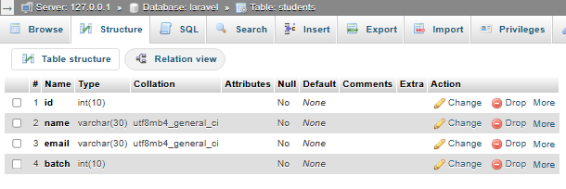

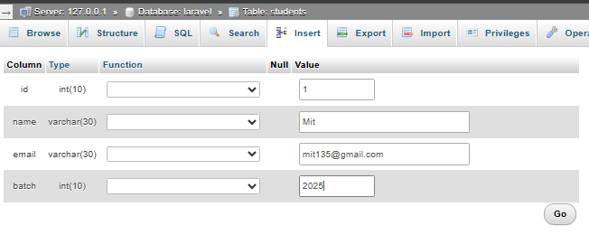

3. Check .env file configuration.
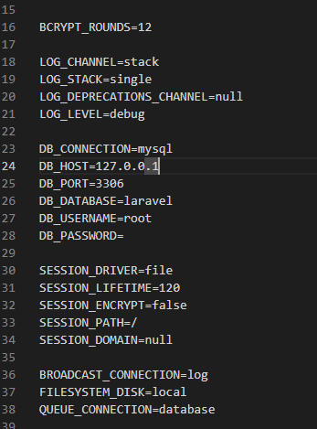

4. Make Controller

php artisan make:controller StudentController

5. Make Model
6. Get Data from the database
Php artisan make:model Student
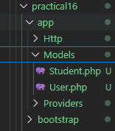

Note: Model name always depends on table name and table name have always plural and Model name have always singular. Here our table name is students so Model name is Student(It is a class, so first character would be capital).

StudentController.php
<?php
namespace App\Http\Controllers;
use Illuminate\Http\Request;
class StudentController extends Controller
{
//
function getStudents(){
$students = \App\Models\Student::all();
return $students;
}
}

Web.php

Output:

7. Make View
php artisan make:view students

8. Pass data to view and display data

Student view file:

9 . Make function in model and use it

StudentController

