1.what is Query Builder?
2.get data from
3.make queries like where ,get first etc.
4.insert data
5.update data.
6.delete data.

1.
Database query builder provides a convinent way to creating and running database queries

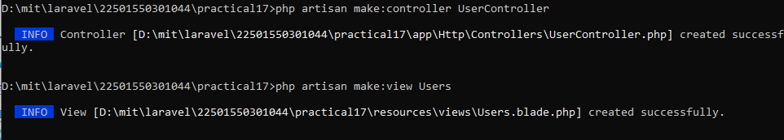
2. get data from db with query builder
<?php

namespace App\Http\Controllers;

use Illuminate\Http\Request;
use Illuminate\Support\Facades\DB;

class UserController extends Controller
{
//
function queries(){
$result=DB::table('users')->get();
return $result;
}
}

<?php

use Illuminate\Support\Facades\Route;
use App\Http\Controller\StudentController;
use App\Http\Controller\UserController;

Route::get('/', function () {
return view('welcome');
});
Route::get('users',[UserController::class,'queries']);

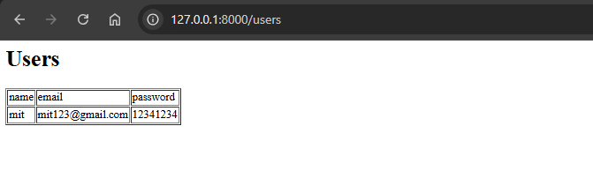

$result=DB::table('users')->insert([
'name'=>'demo1',
'email'=>'demo@gmail.com',
'password'=>'12121212'
]);
if($result){
return "data inserted";
}else{
return "data not inserted";
}

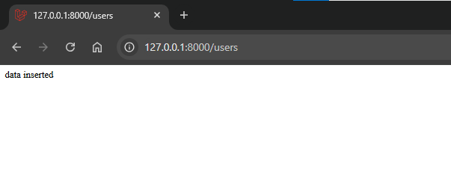

$result=DB::table('Users')->get();
return view('Users',['Users'=>$result]);

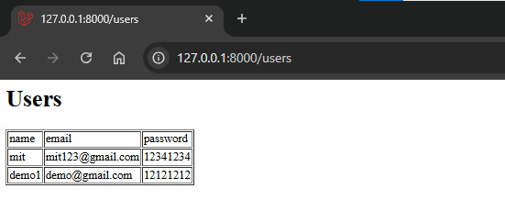
Update data
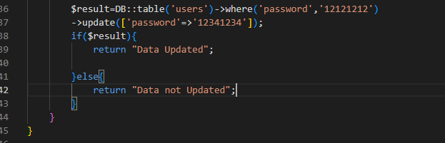
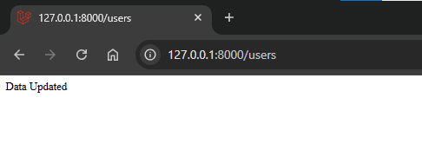
Delete data
