1.create a registration form
User-form.blade.php

Controller

Advanced validation –custom validation
1.make a custom error message
2. get old value
3. change input color if valid
4. publish validation message

1.make a custom error message
<?php

namespace App\Http\Controllers;

use Illuminate\Http\Request;

class userController extends Controller
{
//
function adduser(Request $request){
$request->validate([
'firstname'=>'required |min:3 |max:10',
'lastname'=>'required |min:3 |max:10',
'email'=>'required |email',
'password'=>'required|min:6 |max:12',
'gender'=>'required',

],[
'firstname.required'=>'First Name is required',
'firstname.min'=>'First Name must be at least 3 characters',
'firstname.max'=>'First Name must be less than 10 characters',
'email.required'=>'Email is required',

]);
return $request;
}
}

2. get old value

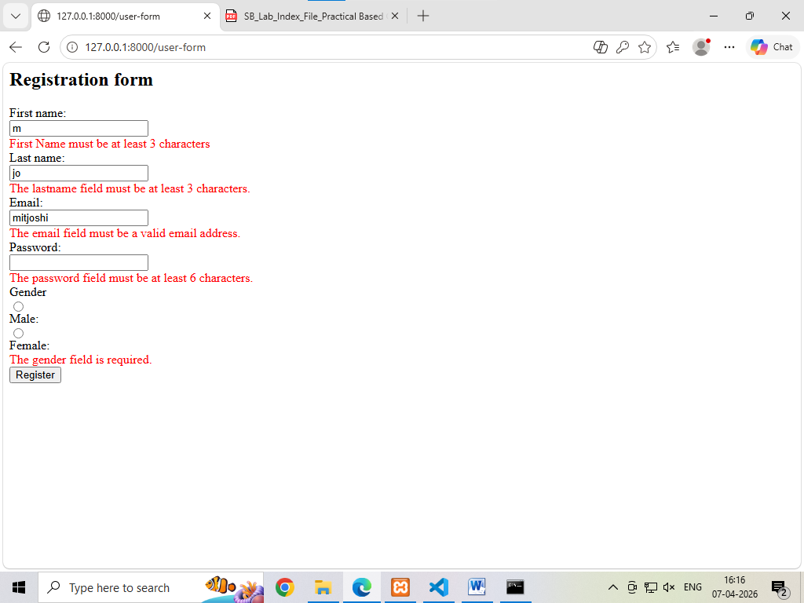

Get old value
<div>
<form method="POST" action="adduser">
@csrf
<h2>Registration form</h2>
First name:<br>
<input type="text" id="firstname" name="firstname"
value="{{old('firstname')}}"><br>
<span style="color:red">@error('firstname'){{$message}}@enderror</span><br>
Last name:<br>
<input type="text" id="lastname" name="lastname"
value="{{old('lastname')}}"><br>
<span style="color:red">@error('lastname'){{$message}}@enderror</span><br>
Email:<br>
<input type="text" id="email" name="email"
value="{{old('email')}}"><br>
<span style="color:red">@error('email'){{$message}}@enderror</span><br>
Password:<br>
<input type="password" id="password" name="password"
value="{{old('password')}}"><br>
<span style="color:red">@error('password'){{$message}}@enderror</span><br>
Gender<br>

<input type="radio" id="male" name="gender" value="male"
{{old('gender')=='male' ? 'checked' : ''}}><br>
Male:<br>
<input type="radio" id="female" name="gender" value="female"
{{old('gender')=='female' ? 'checked' : ''}}><br>
Female:<br>
<span style="color:red">@error('gender'){{$message}}@enderror</span><br>
<input type="submit" value="Register">
</form>

</div>

