1 | Develop a Laravel Web Application Based on the Following Instructions:
A. Project Setup
- Create a folder for your Laravel project.
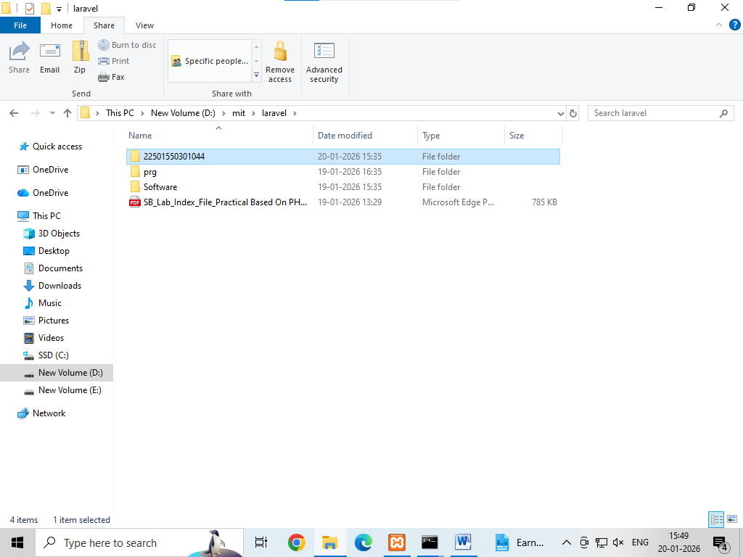
- Open the terminal in that folder.
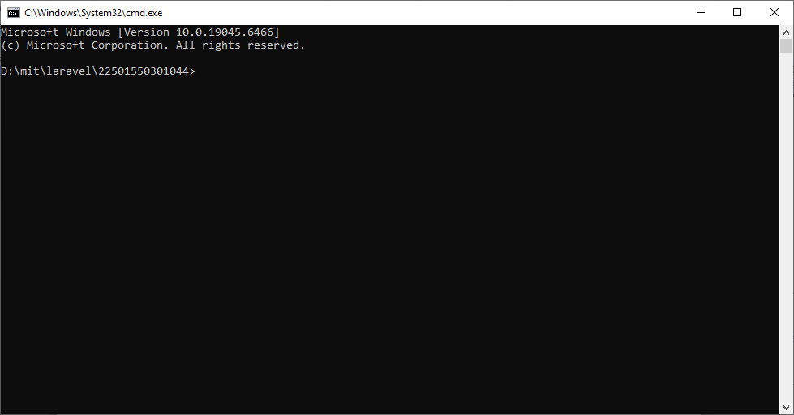
B. Create a Laravel Project
- Create a Laravel project using the terminal with a project name (e.g., blog).
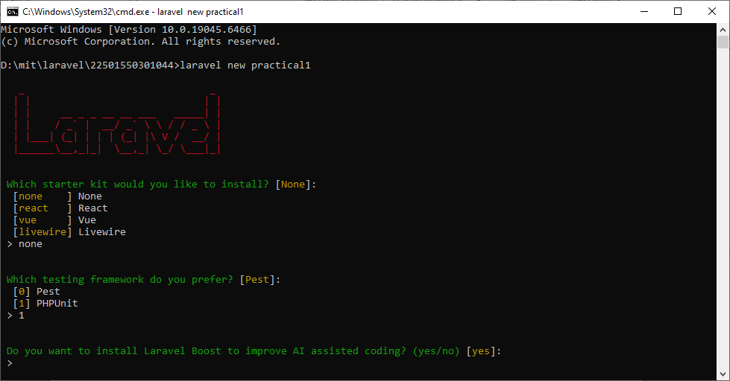
- Choose “None” for the starter kit and press enter for default options.
- Select MySQL as the database.
C. Build and Serve the Application
- Move into the project directory.
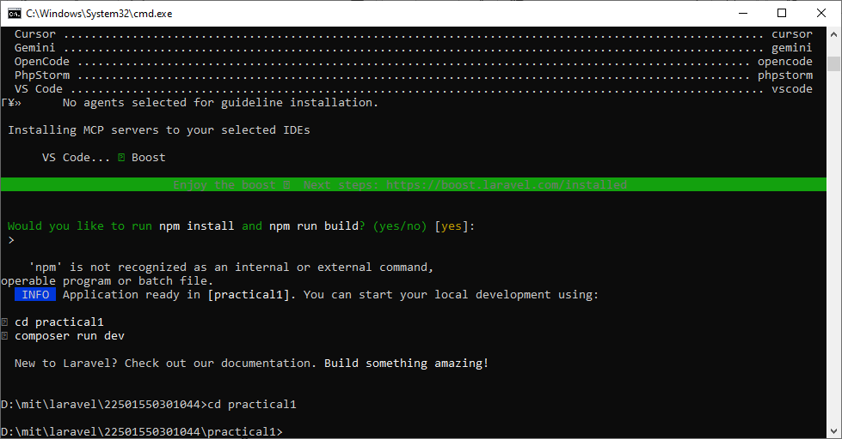
- Run the necessary NPM and Artisan commands to serve the application.
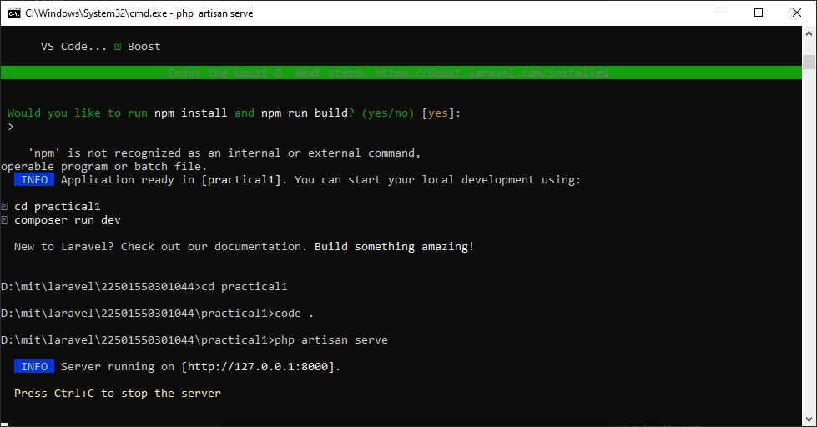
D. Modify the Welcome Page
- Open welcome.blade.php and display your full name.
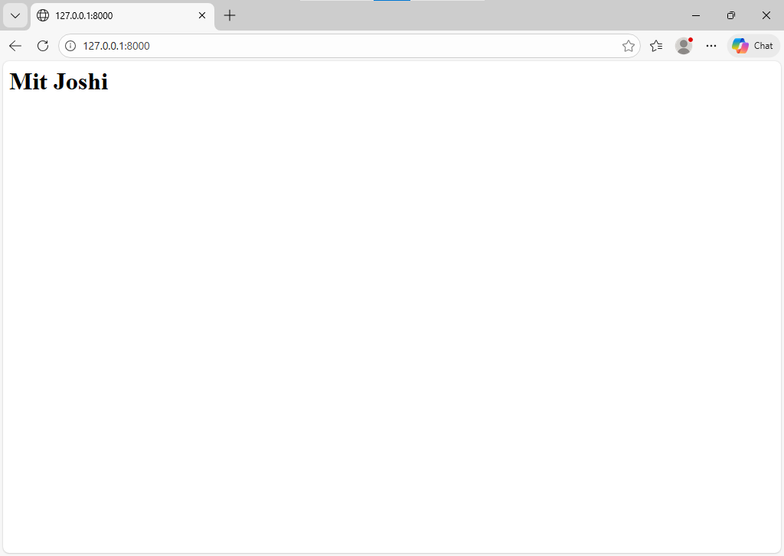
E. Create a New Blade View
Create a new Blade file named home.blade.php.
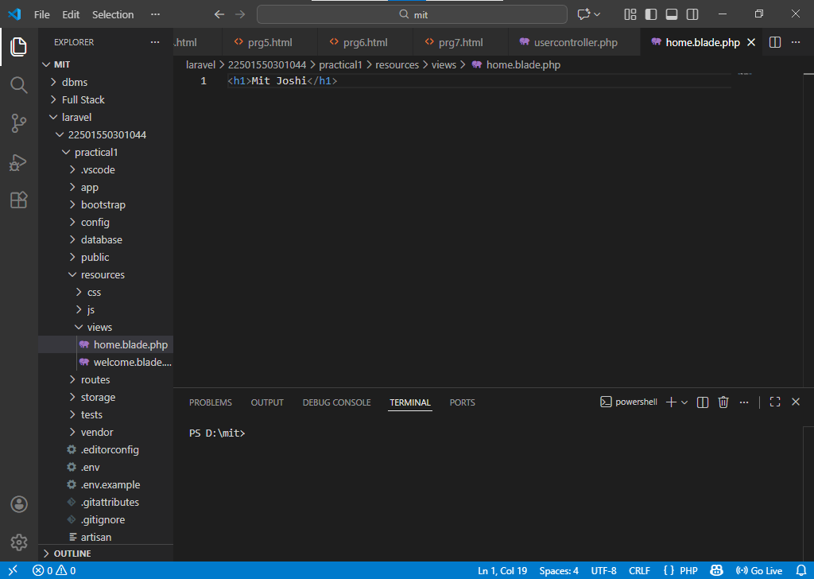
- Display any custom heading in it.
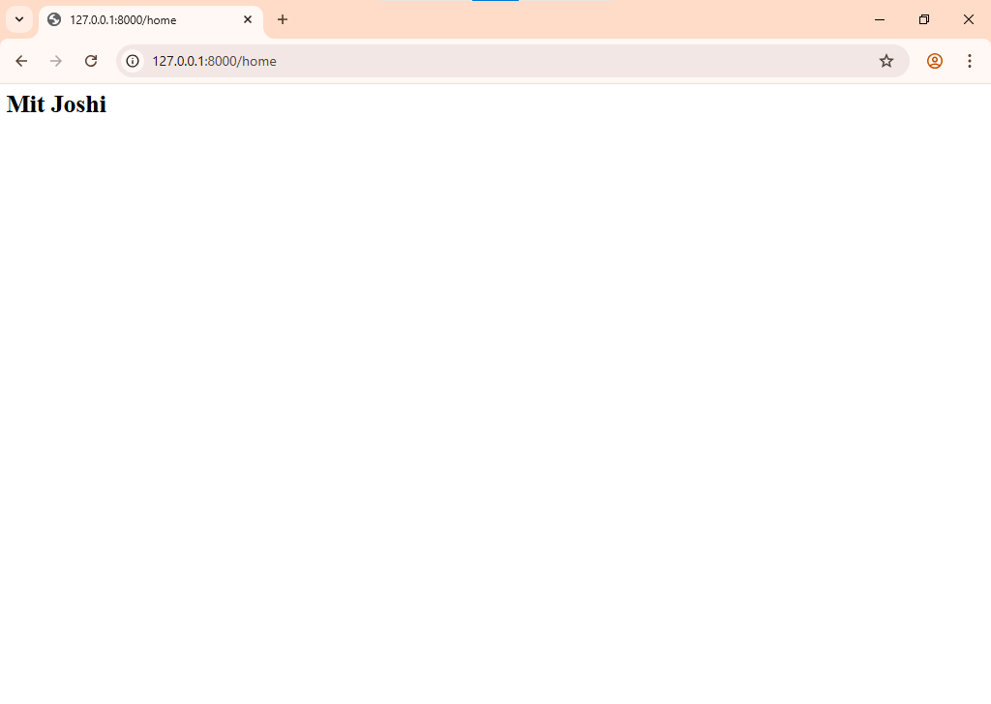
F. Update Routes
- Define a route in web.php to load the new view when /home is accessed.

Route::get('/home', function () {
return view('home');
- Set this route to replace the default / route if needed. 