2 | Perform the Following Tasks Related to Laravel Routing:
A. Routing Basics
- Create a Blade view file and display content via a defined route.

Web.php:
Route::get('/demo', function () {
return view('home');
});

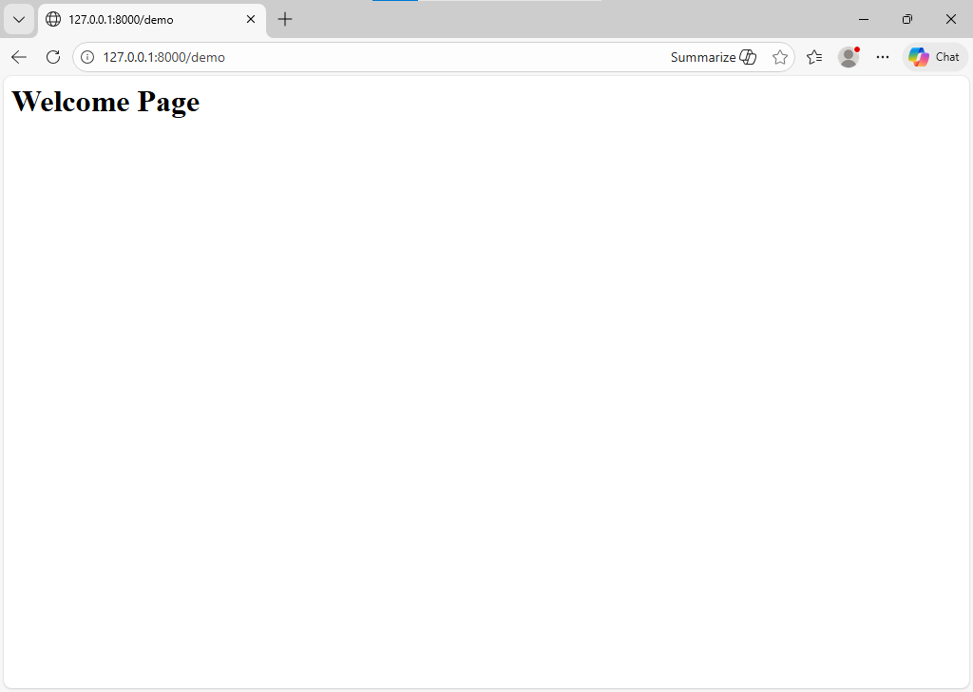
B. Define Routes
- Define a basic route using Route::get() method.
web.php:
Route::get('/about/{name}'){
return view('about');
}

- Change the route path and access it via a browser.

