1.what is sub view.
2.make subview.
3.use subview.
4.pass data from view to subview.
5.check if subview exists.

2.
Php artisan make:view common.header
Php artisan make:view common.inner
Php artisan make:view home1
Php artisan make:view home2
Php artisan make:controller UserController1
3.
Header.blade.php
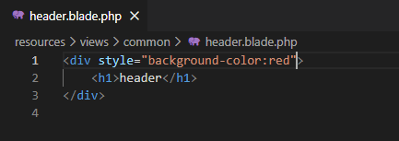
Home1.blade.php
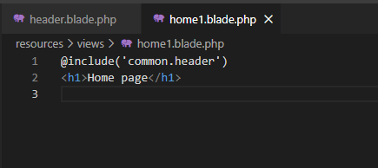
Web.php
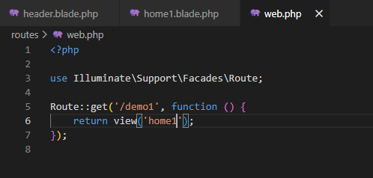

127.0.0.1:8000/demo1
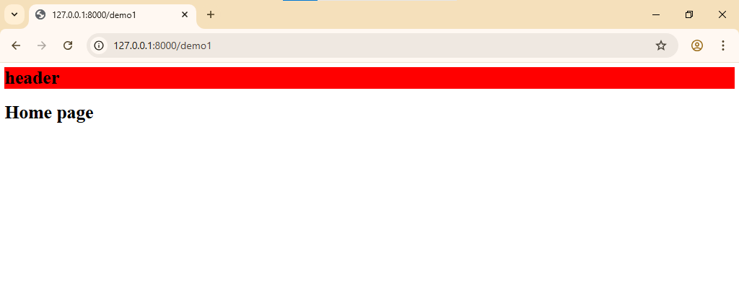

4.pass data from view to subview
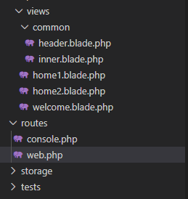
UserController1.php

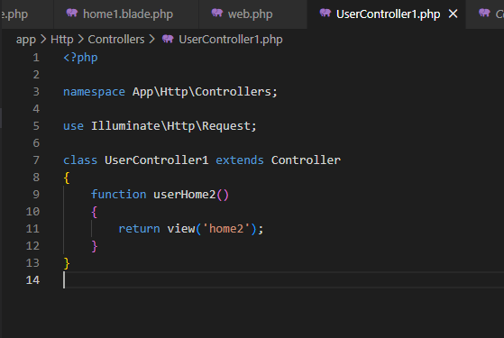
Web.php
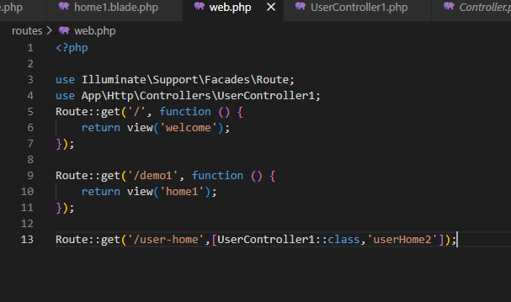
Home2.blade.php
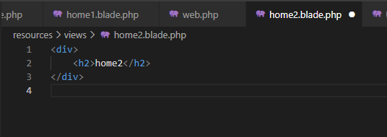

127.0.0.1:8000/User-home
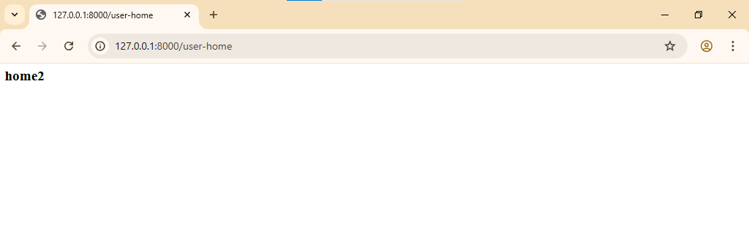
Home2.blade.php
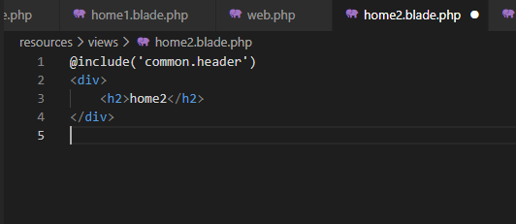
User-home
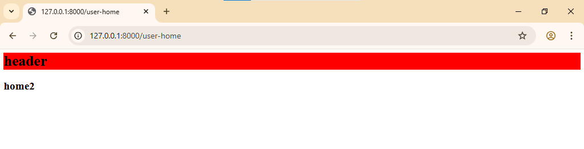
Inner.blade.php
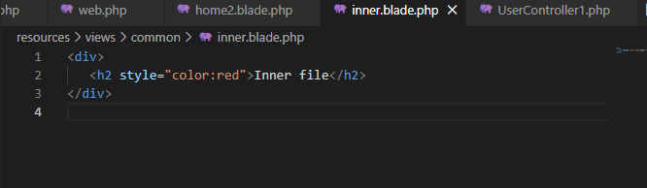

Home1.blade.php
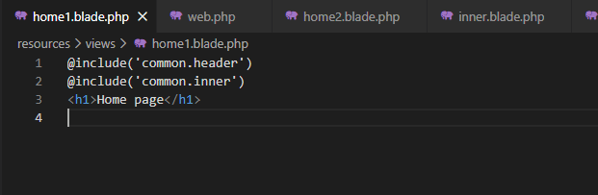

Demo1
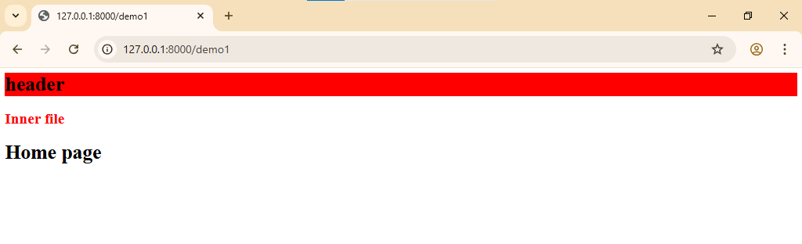
Pass data from mainview to subview
Home1.blade.php
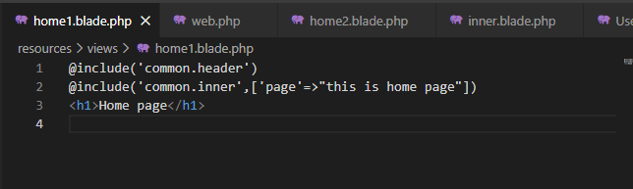

Inner.blade.php
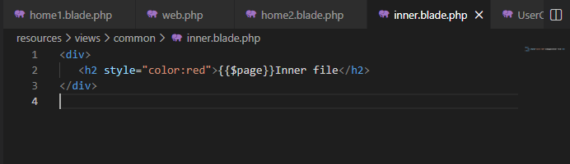
Demo1

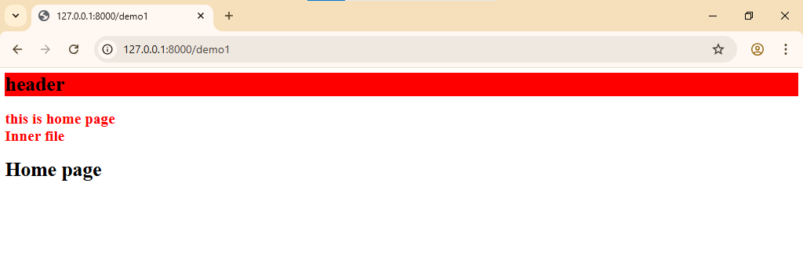
Home1.blade.php
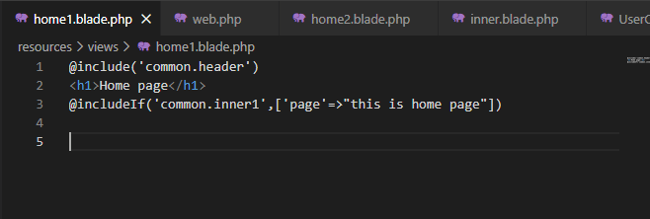
Demo1 without inner
