**ITU SWE 610 Ruby on Rails MidTerm Exam 04/21/2016**

This exam is open book, open notes, open internet. Please do not collaborate with other students as I have tools to identify plagiarism specially in programming questions. You are suppose to complete this exam on your own. This Exam is timed at 4 hours. You should be able to complete this exam in 4 hours. You can take 30 minutes extra if needed. So after 4.5 hours I will start deducting points at the rate of 1 point per hour late.  Your time will start as soon as you download this exam from EMS. If you use the textbook, the internet, or other external sources, give references.

**Name: Mitalee Save ITU Student ID:89803**

**Start Time: 2:05PM End Time:**

1. This Question involves writing scripts in ruby in order to get a feel for the Ruby programming language.

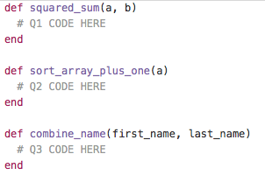

1. In above Ruby Code there is a function called check_squared_sum. This function takes two integers, a and b, and calculates the sum of a and b, then returns the square of the sum.
2. The second method you have to fill in is sort_array_plus_one. This method takes in an array of integers, sorts it, then increments every element by 1, and returns it. It does not matter if this method is destructive or not.
3. The third method takes in two strings, a first_name and last_name. It will return the first_name concatenated with the last_name, along with a space in between.

Example:

combine_name 'Howard', 'Chen'

* + 'Howard Chen'

1. Following exercises reinforces your knowledge into Ruby Programming. Please review attached Ruby code for Number Guessing Game we discussed in the class. Ruby Code can be found at following location: <https://www.dropbox.com/s/k3agw2ie3unbt3r/NumberGuess.rb?dl=0>

Run the above code as shown in the class and experience the Number Guessing Game. Based on the questions below make improvements to number guessing game, the Ruby Number Guessing Game.

1. Currently, the game allows players to play as many times as they wish. It does not provide any feedback on how the players are doing, however. Modify the game so that it keeps track of the number of games played as well as the average number of guesses made per game.
2. The game challenges the player to guess a randomly generated number between 1 and 100 in as few guesses as possible. Make the game more challenging by increasing the range of numbers to between 1 and 1000.
3. The game lets players know whether their guesses are too high or too low. It also rejects any guesses outside of its supported range of numbers, such as negative numbers, numbers greater than 1000, or alphabetic or special characters. Modify the game so that it notifies players when invalid guesses have been made and reminds players of what constitutes valid input.
4. Currently, the game allows players to make an unlimited number of guesses. Therefore, players cannot lose the game. Modify it so that players are allowed a maximum of 10 guesses, after which the game is declared lost.
5. You should thoroughly test all your Ruby scripts to make sure they are running as expected. With the Number Guessing game, that means playing the game repeatedly. To make this easier on you, add a hidden “cheat” to the game that allows you to display the game’s number.

Solve each questions above and submit your answers by pushing it to github repository as SolutionA, SolutionB etc. Post your github link. Please explain how you went about making the change and what data structures, programming concepts you used to solve the problems.

1. Consider the following Ruby code:

def method1

x = 11

method2 do |x|

puts x

end end

def method2

x = 22

yield 33 end

def method3

x = 11

method2 do |y|

puts x

end end

(a) What output (if any) is generated when method1 is called?

Ans: 33

(b) What output (if any) is generated when method3 is called?

Ans: 11

(c) Give 2 examples of how Rails takes advantage of meta-programming facilities in the Ruby language.

Ans: 1) Rails introspect the database and creates methods such as “find_all_by_name”.

2) “validates_format_of” causes new validations to be added to a model.

3) The “has_many” method automatically generates methods such as “students”.

(d) In your opinion, which programming language is better, Ruby or Javascript? List 2 specific reasons to justify your choice.

Ans: In my opinion, Ruby language is better than Javascript because of following reasons

* + 1. Ruby metaprogramming is more powerful than anything in Javascript.
    2. Ruby has more features.
    3. Javascript is simpler.

**3.** Label each of the tasks below with “Model”, “View”, or “Controller” to indicate where that task would typically be implemented in a Web application using an MVC architecture.

(a)  Validate form data- Model

(b)  Make sure a user is logged in - Controller

(c)  Invoke the link_to method - View

(d)  Return a “redirect” to the browser - Controller

(e)  Define an event handler for a custom form element- View

(f)  Generate a new session token - Controller

(g)  Invoke the find_all_by_name method - Controller

(h)  Create a “salt” for a password - Model

1. **Write a Ruby class definition that meets the following criteria:**
   1. class is called Troll
   2. class has publicly accessible attributes ugliness, smelliness, and strength
   3. upon instantiation, an object of this class has a member variable, a String, called grunt, whose initial value is "UNGAH" (that's pronounce "oon-guh").
   4. class has an instance method called speak() that prints the value of the instance variable grunt 42 times
   5. class has an instance method called reverse() that prints the value of the instance variable grunt backwards
   6. class has a static/class method called propagate(), which returns a Troll instance whose grunt attribute is "eegah"
   7. Imagine a Troll instance fred, which, when the following method is called:
   8. fred.respond_to?("fight")  returns true. What is missing from your class definition in order for this example to be accurate?
2. **Short Answer Questions:**
3. Does the respond_to?() method illustrate object-oriented polymorphism? If so, in what manner?

Ans: Yes, the respond_to?() method illustrate object-oriented polymorphism. It returns true if object responds to the given method.

1. According to Ruby conventions, what kind of value would you expect to receive from a method that ends in a question mark (?) ?

Ans: According to Ruby code style convention; it indicates that a method returns a Boolean value.

1. According to Ruby conventions, what is the difference between pairs of methods like do_this and do_this! (notice the bang) ?

Ans: According to Ruby conventions, curly braces only for short one-line blocks and the do..end syntax for longer one-liners and for multi-line blocks.

1. Briefly explain Ruby's type system. What is it (by name)? What does it mean?

Ans: Ruby is dynamically and strongly typed.

A dynamically typed language is a language where the type of a variable can be altered at any time. (It is a string, now it is a Fixnum, now it is a Time object, etc.)

A strongly typed language is a language that is being strict about what you can do with your typed variables. (Don’t mix them… or I will throw you an error in the face!)

1. What type of Ruby object does the following expression yield? %w( master rails and then try another framework you'll never go back)

Ans: %w- Used for single-quoted array elements.

1. Given an array of strings called @happy_places, would these two snippets of code do the same thing?
2. @happy_places.each do |happy_place|
   1. puts happy_place end
3. @happy_places.each {|hp| puts hp}

Ans: Yes, these two snippets of code do the same thing.

1. Given a function that needs to return a value to its caller, does the function need an explicit return statement? If so, explain why. If not, then what can you always expect a Ruby function to return?

Ans: No need of an explicit return statement, because Ruby always expect to return the last statement value.

**6.** The Hash class supports 50 methods, which is many more than can be covered in this chapter. To round out your understanding of arrays, visit *http://ruby-doc.org/core/classes/Hash.html* and view the documentation for the various methods. Then complete the following exercises using IRB:

1. Create a hash named Accounts and add the following items to it:
   1. 10001, AFord
   2. 20001, JAlex
   3. 30001, AJolie

Ans: irb(main):001:0> Accounts={10001=>" AFord ",20001=>"JAlex",30001=>"AJolie"}

=> {10001=>" AFord ", 20001=>"JAlex", 30001=>"AJolie"}

1. Use the Hash class’s delete method to remove the key-value pair with a key of 30001 from the Accounts hash.

Ans: irb(main):002:0> Accounts.delete(30001)

=> "AJolie"

1. Use the Hash class’s inspect method to verify the contents of the hash.

Ans: irb(main):003:0> Accounts.to_s

=> "{10001=>\" AFord \", 20001=>\"JAlex\"}"

1. Use the Hash class’s invert method to convert the Accounts hash’s keys to values and convert its value to keys.

Ans: irb(main):004:0> Accounts.invert

=> {" AFord "=>10001, "JAlex"=>20001}

1. Use the Hash class’s has_key? method to determine if any of the following keys are stored in the Accounts hash: JAlex, 10001.

Ans: irb(main):005:0> Accounts.has_key?("JAlex")

=> false

irb(main):006:0> Accounts.has_key?("10001")

=> false

1. Use the Hash class’s size method to display a count of the number of key-value pairs stored in the Accounts hash.

Ans: irb(main):007:0> Accounts.length

=> 2

1. Use the Hash class’s clear method to remove all items from the Accounts hash and then display the contents of the hash.

Ans: irb(main):008:0> Accounts.clear

=> {}

1. Use the Hash class’s inspect method to verify that the array is now empty.

Ans: irb(main):009:0> Accounts.to_s

=> "{}"

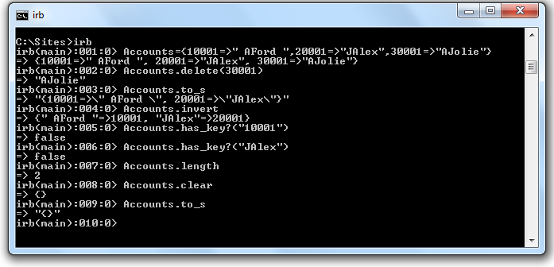

1. String substitution is an important feature of regular expressions. The following exercises are designed to give you the opportunity to demonstrate your knowledge and understanding of how to perform string substitutions using the sub and gsub methods. Solve each of these exercises using IRB and the sub and gsub methods. Capture and turn in your results using screen prints.

Ans: irb(main):001:0> st= "Jack and Jill went up the hill to fetch a pail of water."

=> "Jack and Jill went up the hill to fetch a pail of water."

1. Enter the following statement into IRB, then use the sub method to replace the first vowel found in the string with an asterisk character:

"Jack and Jill went up the hill to fetch a pail of water."

Ans: irb(main):002:0> st.sub(/[aeiou]/, '*')

=> "J*ck and Jill went up the hill to fetch a pail of water."

1. Enter the following statement into IRB. then use the gsub method to replace each vowel found in the string with an asterisk character.

"Jack and Jill went up the hill to fetch a pail of water."

Ans: irb(main):003:0> st.gsub(/[aeiou]/, '*')

=> "J*ck *nd J*ll w*nt *p th* h*ll t* f*tch * p**l *f w*t*r."

1. Enter the following statement into IRB, then use the gsub method to replace the string may be more than with the string can only be.

"In the end there may be more than one."

Ans: irb(main):004:0> “In the end there may be more than one.".gsub('may be more than ', 'can only be ')

=> "In the end there can only be one."

1. Enter the following statement into IRB, then use the gsub method to replace the word bob with the word Bob throughout the string.

"Big bob told little bob to take baby bob home."

Ans: irb(main):005:0> “Big bob told little bob to take baby bob home.".gsub('bob','Bob')

=> "Big Bob told little Bob to take baby Bob home."

1. Enter the following statement into IRB, then use the gsub method to replace a comma for each blank space in the string.

"Bob Sue Sam Dick Jane Peter Paul John"

Ans: irb(main):006:0> "Bob Sue Sam Dick Jane Peter Paul John".gsub(' ',',')

=> "Bob,Sue,Sam,Dick,Jane,Peter,Paul,John"

1. Enter the following statement into IRB, then use the sub method to remove the pound sign and all the characters that follow it.

"804-991-3434 #Client phone number"

Ans: irb(main):007:0> "804-991-3434 #Client phone number".sub(/#.*/,'')

=> "804-991-3434 "

1. Modify your solution to the above exercise to include a second regular expression that removes any blank space and hyphens from the string.

Ans: irb(main):008:0>"804-991-3434 #Client phone number".sub(/#.*/,'').gsub(/[-\s]/,'')

=> "8049913434"

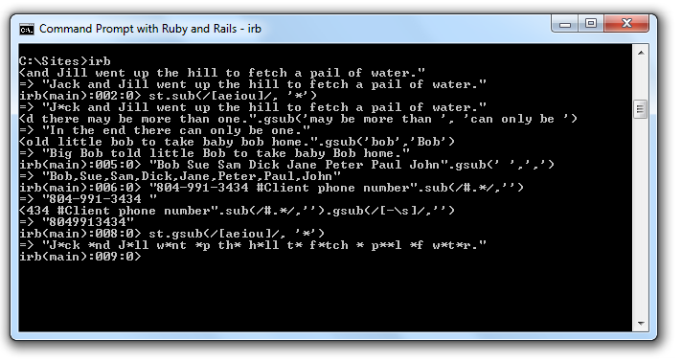

**8. Rails related questions**

1. Name four ActiveRecord callbacks that you can bind methods to.

Ans: 1) after_create

2) after_save

3) after_commit

4) before_validation

5) after_validation

6) before_save

7) before_create

1. The Rails convention maps HTTP methods to certain controller methods, and those methods usually involve specific CRUD operations on models. Given the following CRUD database methods:

create, read, update, and delete

and the following HTTP methods:

GET, PUT, POST, DELETE

and the following controller actions: index, new, create, edit, update, destroy

Complete the following table.

|  |  |  |
| --- | --- | --- |
| **HTTP method** | **controller action** | **CRUD operation** |
| GET | index | READ |
| GET | new | CREATE |
| POST | create | CREATE |
| GET | edit | READ |
| PATCH | update | UPDATE |
| DELETE | destroy | DELETE |

1. Rails "simulates" PUT and DELETE requests. Why?

Ans: Rails uses some "trickery" in HTML forms to act as though a PUT or DELETE request was sent, even though Rails is still using GET or POST for these methods.

1. What is the difference between the two Rails environments 'production' and 'development' ?

Ans: By default, the development environment is without all cache and activate the auto-reloading. The production environment is with all cache.

1. Usually, Rails controllers incorporate plural nouns, such as ProtestsController and RevolutionsController. In what case should a controller have a singular name like GeocodingController?

Ans: Using plural names for controllers is just a convention. How you name your controllers doesn't matter at all.

1. What is a Rails "helper method" and when should they be defined and used by you, the developer?

Ans: A helper method is a method written for the view, it’s designed to be reusable anywhere within the website, and it cleans up the view code by separating out some logic.

**9.** Textbook: Ruby S., Thomas D., Heinemeier Hansson D. - Agile Web Development with Rails, 4th Edition. Skim through Chapter 5 and Chapter 6 and discuss the “Canonical Depot Application” explained and built in these chapters with respect to Rails Framework, Steps followed and potential pain points you may observe in this process. (no more than 1-2 page or flowchart) This book can be downloaded at: [https://www.dropbox.com/s/1hm9itzdaztsr1n/Agile Web Development with Rails.pdf?dl=0](https://www.dropbox.com/s/1hm9itzdaztsr1n/Agile%20Web%20Development%20with%20Rails.pdf?dl=0)

Ans: The Depot Application

1 Incremental Development-

We’ll work out enough of a specification to let us start and then immediately create some functionality. We’ll try ideas, gather feedback, and continue with another cycle of mini-design

and development.

2 What Depot Does-

We’ll also try working out what data the application needs

2.1. Use Cases- A use case is simply a statement about how some entity uses a system

2.2.Page Flow- Page Flow help us to focus on what needs doing and know how actions are sequenced.

2.3.Data- we need to think about the data we’re going to be working with.

3 Code-

Creating a Rails Application

Step1: work> rails new depot

Step2: work> cd depot

Step3: depot> ls -p

Creating the Database- SQLite 3 is the default database for Rails development and was installed along with Rails

Generating the Scaffold

Step4: depot> rails generate scaffold Product \ title:string description:text image_url:string price:decimal

Applying the Migration

Step5: depot> rake db:migrate

Seeing the List of Products

Step6: depot> rails server

rolling back the migration

Step7: depot> rake db:rollback

initialize a repository

Step8: depot> git init

add all the files

Step9: depot> git add .

commit

Step10: depot> git commit -m "Depot Scaffold"

overwrite or delete a file that you didn’t mean to, you can always get back to this point by issuing a single command:

Step11: depot> git checkout .

**10. Project Based Questions:**

A. Explain what REST means and how it relates to Rails. (About 1/4 to 1/2 page.) Include CRUD and HTTP in your discussion. If you use the textbook, the internet, or other external sources, give references.

Ans: REST means Representational State Transfer. REST relies on a stateless, client-server, cacheable communications protocol and in virtually all cases, the HTTP protocol is used

REST is an architecture style for designing networked applications simple HTTP is used to make calls between machines.

RESTful applications use HTTP requests to post data (create and/or update), read data (e.g., make queries), and delete data. Therefore, REST uses HTTP for all four CRUD (Create/Read/Update/Delete) operations. Although, in Rails, REST and CRUD are best buddies, the two can work fine on their own. In fact, every time you have written a backend system that allows you to add, edit and delete items from the database, and a frontend that allows you to view those items, you have been working with CRUD.

B. Create Scaffold Project. Give commands, screenshots, code where applicable. Exam submitted without explanation, steps, commands and code won’t be graded.

1. Create a Rails scaffold-based project named MidtermPartC that keeps track of medal winners in the 2012 London Olympics. Use a scaffold with the model name Olympic medals with the fields athlete_name, event, country, medal_type (gold, silver, bronze), event_date.
2. Change the dropdown menu for event_date so that only 2012 is displayed.
3. Use validations to insure that athlete, and country are non empty.
4. Use a validation with the :inclusion argument to insure that medal_type is "gold", "silver", or "bronze".
5. validates :medal_type, :inclusion => { :in => ["gold", "silver", "bronze"] }
6. Use the layout page to display this image of olympic rings on all pages of the project.
   1. In the CSS file scaffolds.css.scss:
   2. Change the text color to white.
   3. Change the background color to black.
   4. Set the color of all hyperlinks to white.
   5. Set the font size to 110% of the default.
   6. Set the width of the olympic rings image in Part d to be 150 pixels.
7. Start the server and view your project in a browser. Use the new view of your project to enter the following olympic medal information in your project's database:

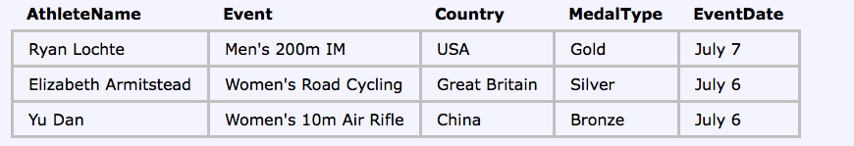

Ans:

Step 1: create repository

Step2:bundle install

Step3: rails generate scaffold Olympicmedles athlete_name:string event:text country:string medal_type:string eventdate:date

Step4: rake db:migrate

Step5: in routes.rb file add root 'olympicmedles#index'

Step6: add below code in olympicmedle.rb in model

validates :athlete_name, presence: true

validates :country, presence: true

validates :medal_type, :inclusion => { :in => ["gold", "silver", "bronze"] }

Step7: In the CSS file scaffolds.css.scss: change body css

background-color: #333;

color: #fff;

font-size: 110%;

line-height: 150%;

step8: and in a css change{

color: #fff;

&:visited {

color:#fff

}

step9: add below code in application.html.erb

<img alt="Rails logo" src="/assets/olymipicring.jpeg" />"

step10: add below code in application css

img {

width: 150px;

}

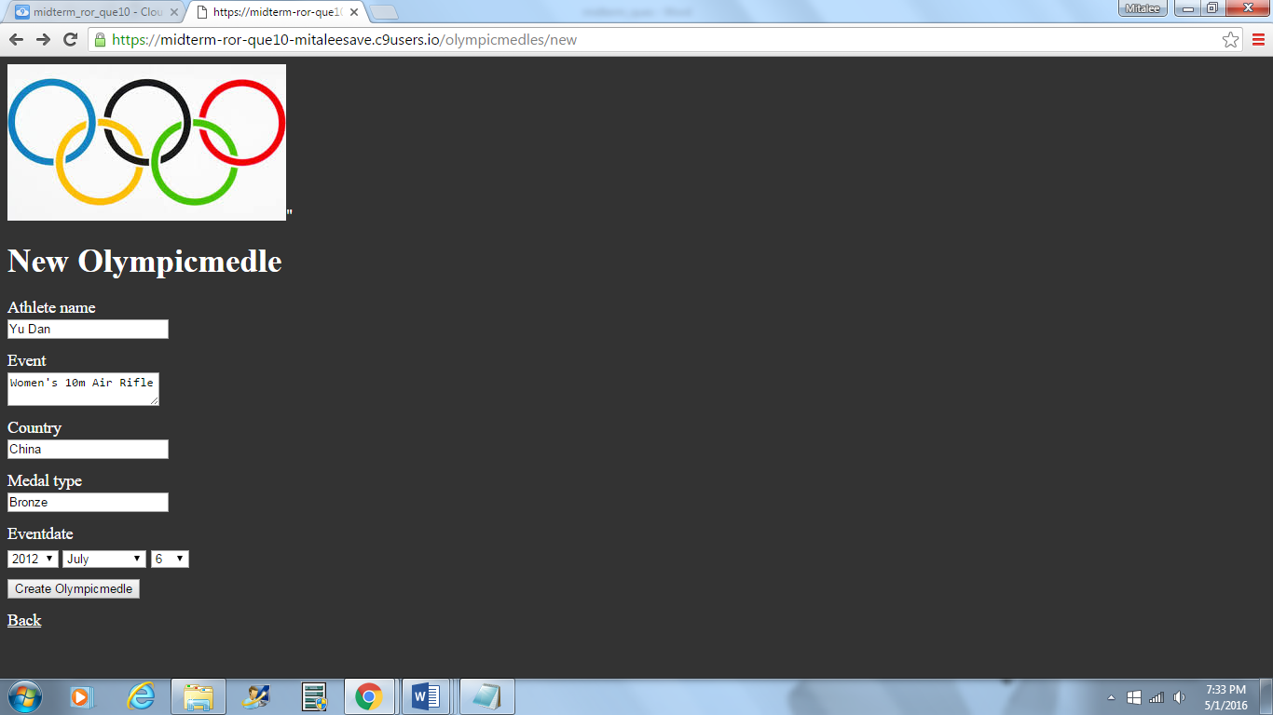

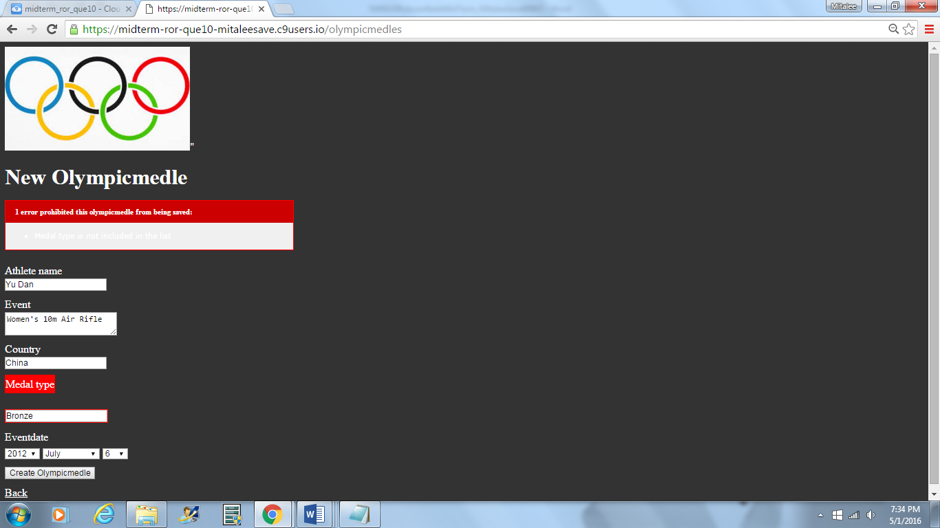

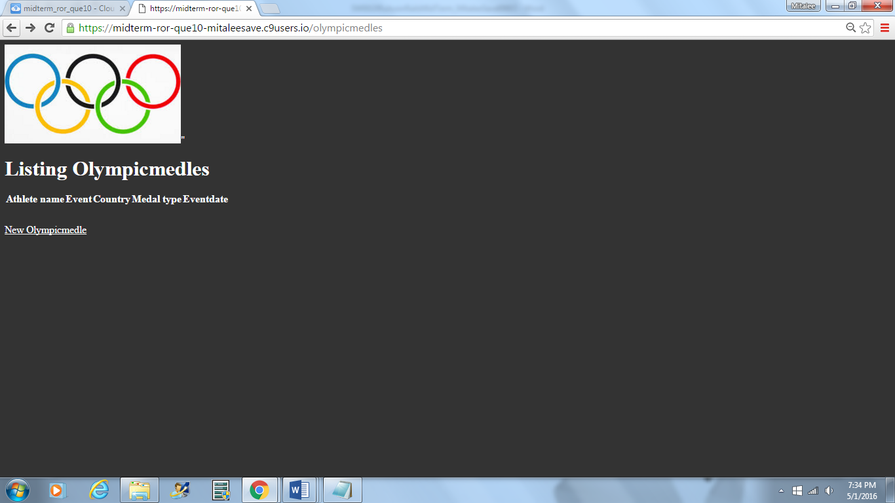

C. Find the Errors.

Fix the errors in the following source code. All your code should be XHTML complient. To check your answer, you can build a Rails project named MidtermPartC using the corrected source code. Generate a controller named ShowDateTime with a view named display. Copy these images to the assets/images folder before viewing the project.

jan.jpg feb.jpg mar.jpg apr.jpg may.jpg jun.jpg

jul.jpg aug.jpg sep.jpg oct.jpg nov.jpg dec.jpg

sun.png moon.jpg

Images can be downloaded from: <https://www.dropbox.com/s/v7fyrsefs84pu5i/images.zip?dl=0>

**There are about 20 intentional mistakes. Complete these layout elements and push the static page RoR app to github print your repo link here. Deploy this to Heroku and print your Heroku link after fixing the above 20 mistakes and noting them here.**

----- View code in app/views/show_date_time/display.html.erb -----------------------

<p>Date and Time: <%= @datetime %><br>

<%= image_tag @timeimg, :class => "img" %>

<p>Month: <%= @monthname %><br />

<% image-tag @monthimg, :class = "img" %></p>

----- Layout code in app/views/layouts/application.html.erb ------------------------

<!DOCTYPE html PUBLIC "-//W3C//DTD XHTML 1.0 Transitional//EN"

"http://www.w3.org/TR/xhtml1/DTD/xhtml1-transitional.dtd">

<html>

<head>

<title><%= @title %>

<%= stylesheet_tag "application" %>

<body>

<h2><%= @title %></h2>

yield

</body>

</html>

----- Controller code in app/views/show_date_time_controller/display.html.erb ------

class ShowDateTimeController < ApplicationController

def display

@title = "Takehome Midterm -- Show Date and Time"

t = Time.now

@date_time = t

if t.hour >= 6 && t.hour <= 18

@timeimg = "sun.png"

else

@timeimg = "moon.jpg"

end

if t.mon == 1

@monthname = "January"

@monthimg = "jan.jpg'

elsif t.mon = 2

@monthname = "February"

@monthimg = "feb.jpg"

elsif t.mon == 3

@monthname = "March"

@monthimg = "mar.jpg"

elseif t.mon == 4

@monthname = "April"

@monthimg = "apr.jpg"

elsif t.mon == 5

@monthname = "May"

@monthimg = "may.jpg"

elsif t.mon == 6

@monthname = "June"

@monthimg = "jun.jpg"

elsif t.mon == 7

@monthname = "July"

@monthimg = "jul.jpg"

elsif t.mon == 8

@monthname = "August"

@monthimg = "aug.jpg"

elsif t.mon == 9

@monthname = "September"

@monthimg = "sep.jpg"

elsif t.mon == 10

@monthname = "October"

@monthimg = "oct.jpg"

elsif t.mon == 11

@monthname = "November"

@monthimg = "nov.jpg"

elsif t.mon == 12

@monthname = "December"

@monthimg = "dec.jpg"

end

end

----- Stylesheet code in assets/stylesheets/application.html.erb -------------------

/*

*= require_self

*= require_tree .

*/

body { font-family; Helvetica:

font-size: 110%;

text-color: navy;

background_color: lightblue;

.img { width: 200px; }