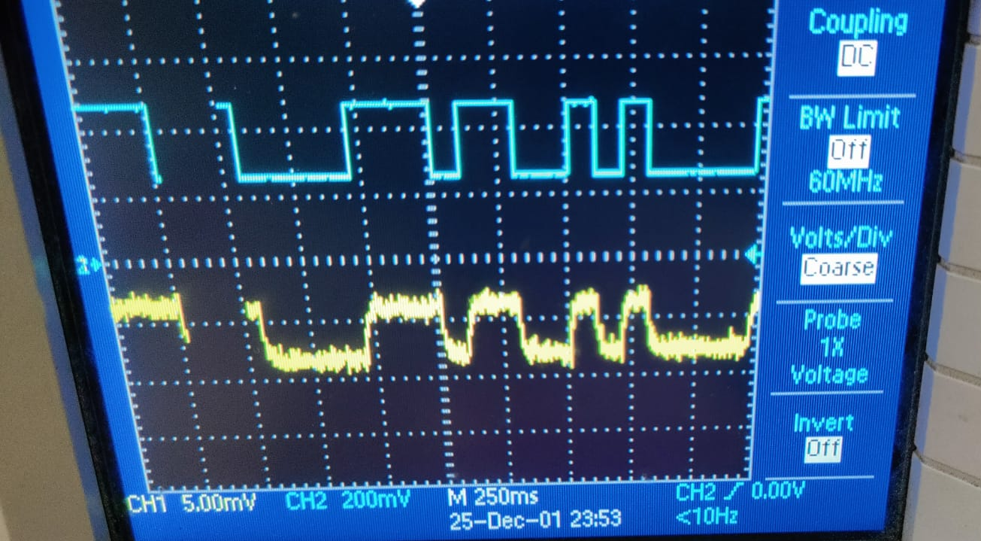
EDL Weekly Report 1
------------------------------------------------------------------------------------------------
Project Title: Low Cost 10 Mbps POF Link for Digital Transmission (JJ-7)
Group No: Tue-11
Team members
Bagul Siddhi Ganesh: 190070015
Mitali Meratwal: 190070033
Sheel Shah: 19D070052
Faculty Mentor: Prof Joseph John

Summary
Since this is the first report, we are including all progress achieved so far. We have completed the transmitter circuit that generates pseudo random on/off led patterns. The breadboard implementation can easily transmit upto 1Mhz. We have also completed the receiver TIA subcircuit, which is correctly reproducing the light pattern received at the photodiode (transmitted by the LED). The TIA is however producing weak, and slightly noisy signals. We cleaned the wiring of circuits up and now we hope to abate these effects by fine-tuning the resistor/capacitor values The rest of the report contains images we took from tinkerer’s lab/WEL as well as detailed circuit diagrams.

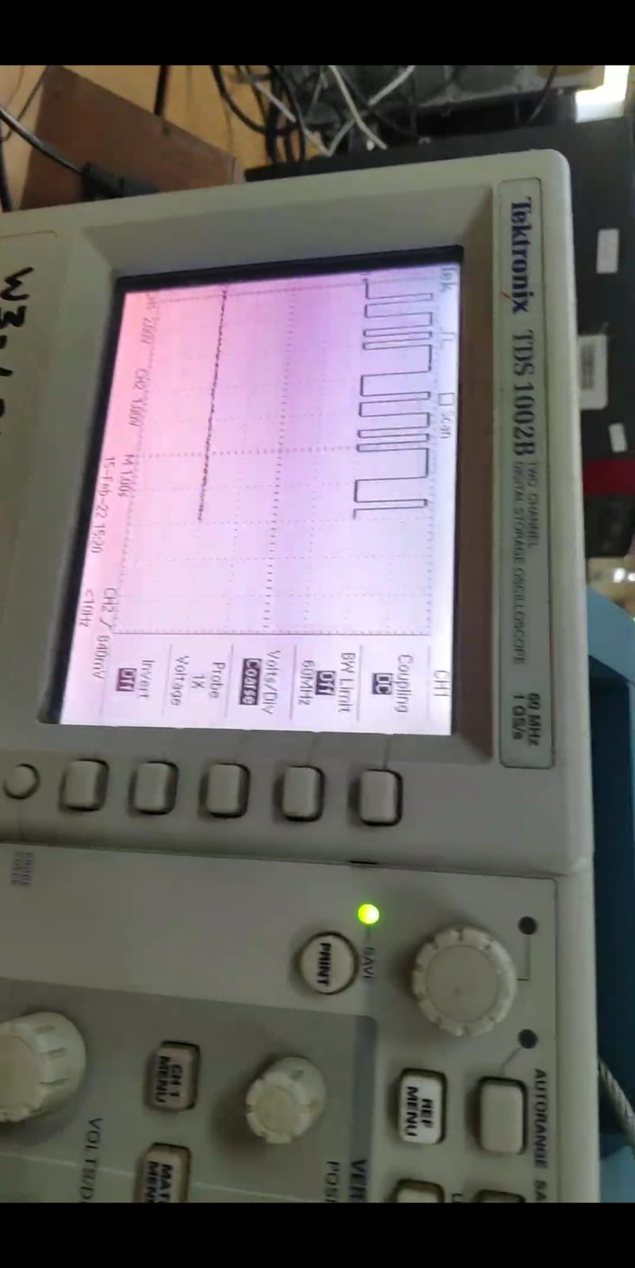
Output images

TX(PRBS) output
RX(TIA) output

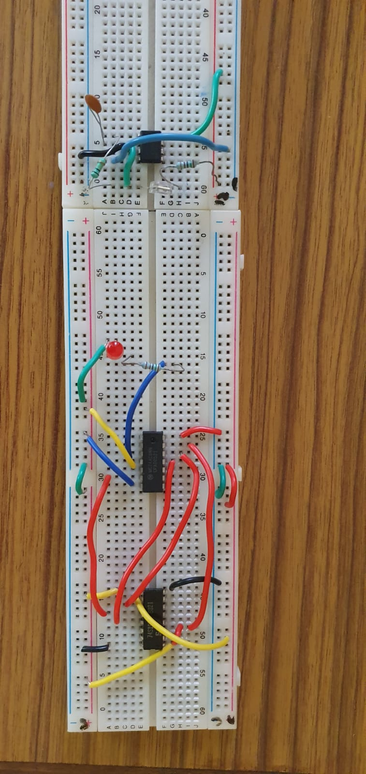
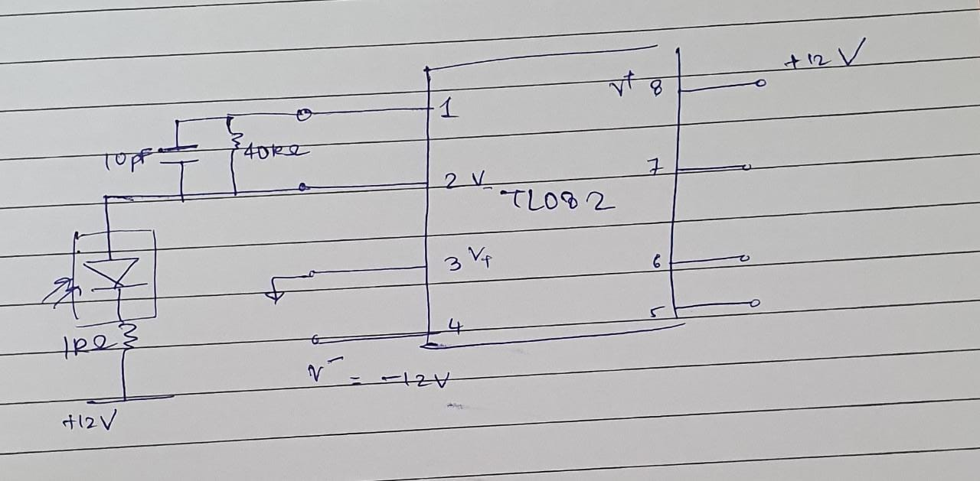
Circuit Diagrams

Breadboard implementation of Tx and Rx side by side

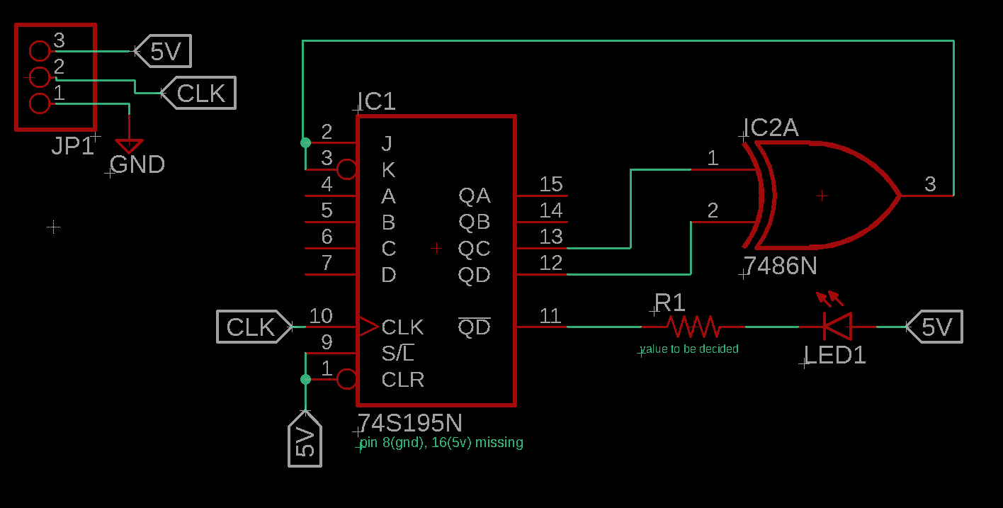

Transmitter Schematic

Receiver Schematic
Future todos
Fine tune all resistor and capacitor values to strengthen LED emission strength, increase frequency range of receiver, reduce noise in receiver, and increase voltage generated in receiver by photodiode (currently in mV).
Shorten wires for cleanliness as well as to reduce noise.
Test reception with POF as the light carrying medium.
Print connectors for the Tx and Rx end points.
(Optional) Post amplifier after TIA in receiver.
(Later) Some mechanism to eliminate all 0 case in transmitter. This is being handled manually by shifting a wire right now.

