**Homework**

**Update AddressBook application for Tablet mode**.

Initially starting application in tablet it loads contact. Consider the content_main.xml (large) layout, contactsFragment is used to load the contacts from content provider and rightPaneContainer

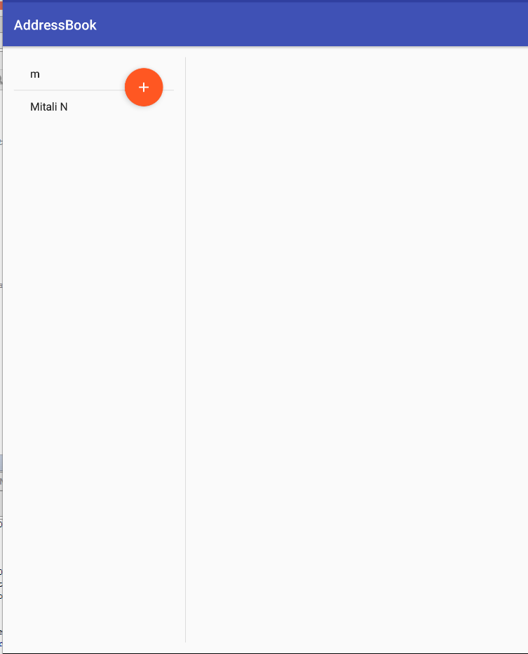

After selecting contact the details are loaded as shown in below figure. So rightPaneContainer is replaced by AddEditFragment.

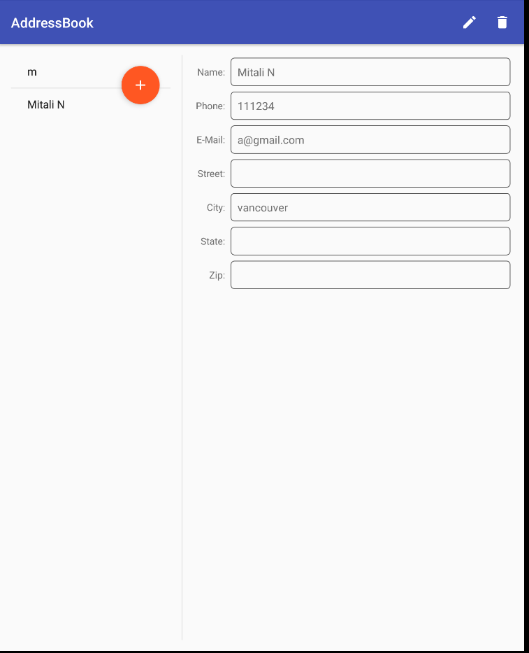

On updating the contact or deleting the contact it shows snackbars feedback.Replace toast notification with SnackBars.

