AAROGYA - AI-Powered Healthcare Operations Platform

AAROGYA
Team Name: Aarogya
Name: Mitansh Jadhav
Github Repo: https://github.com/mitanshhh/Aarogya

Problem Statement
- Critical Shortages: Unpredictable supply chains lead to undetected out-of-stock vital medicines.
- Mismanagement: Inefficient bed tracking causes overcrowding and patient triage delays.
- Absenteeism: Severe lack of accountability and staff monitoring in remote rural clinics.
- Delayed Analytics: Manual paper reporting drastically slows down district decision-making.
Problem StatementCritical ShortagesUnpredictable supply chains lead to undetected out-of-stock vital medicines.MismanagementInefficient bed tracking causes overcrowding and patient triage delays.AbsenteeismSevere lack of accountability and staff monitoring in remote rural clinics.Delayed AnalyticsManual paper reporting drastically slows down district decision-making.PS: Primary Health Centres (PHCs) across rural India still rely on fragmented records, manual resource management and delayed reporting. This leads to medicine shortages, poor staff accountability, inefficient patient care and slow administrative decisions. Without real-time visibility, district authorities often respond only after problems become critical.

The Healthcare Operations Challenge
Fragmented systems, manual tracking, and reactive decision-making in rural clinics.

Manual Inventory
Paper-based registers lead to hidden stock-outs and delayed restocking for critical medicines. Without digital thresholds, pharmacists cannot predict shortages until the shelves are completely empty, endangering patient lives.

Proxy Attendance
Lack of strict geofenced verification allows absenteeism without immediate detection. Medical Officers manually sign registers for absent peers, meaning remote clinics frequently operate without assigned doctors on-site.

No Central Oversight
District admins lack a unified dashboard to monitor bed occupancy and stock across PHCs. Data sits in isolated physical logbooks, meaning high-level resource reallocation is impossible during sudden regional emergencies.

Reactive Decisions
Facilities act only after supplies run out, lacking ML-driven demand forecasting. Without statistical models analyzing rolling dispense histories, supply chain orders are based entirely on guesswork rather than data.

No AI Insights
Massive amounts of raw data generated without automated executive summaries or risk flagging. The signal is lost in the noise, meaning critical failure points (like sudden disease outbreaks) go entirely unnoticed by administrators.

Isolated Resources
Surplus medicines at one PHC cannot be efficiently requested by a neighboring PHC. Inter-clinic communication requires manual phone calls, leading to vast inefficiencies where medicines expire in one clinic while another faces shortages.

The Aarogya Solution
A full-stack, AI-integrated management platform connecting the entire healthcare hierarchy.

1. Real-Time Visibility
What:
Centralized district command view.
How:
Live KPIs (Bed occupancy, medicine alerts) aggregated via
/api/v1/district/overview
with 15s caching.
Why:
Enables proactive administration.

2. AI Risk Analysis
What:
Automated risk identification.
How:
Gemini 2.5 Flash processes KPIs to structured JSON.
Fallback:
Rule-based handler if LLM is down.
Why:
Turns raw data into executive insights.

3. Automated Audits
What:
Monthly AI analysis to PDF.
How:
ReportLab generates structured PDFs from Gemini insights containing risks & recommendations.
Why:
Standardizes health reporting.

4. QR + GPS Attendance
What:
Anti-proxy staff check-ins.
How:
100m geofence. 5-min QR expiry. Random re-verification notifications within a 2-minute window.
Why:
Ensures true physical presence.

5. Smart Inventory
What:
Automated stock balancing.
How:
Predicts stock-outs. Triggers
ResourceRequest
states: PENDING → SHIPPED → COMPLETED.
Why:
Prevents medicine shortages.

6. Unique Patient ID
What:
Centralized patient record.
How:
Links demographics, Bed Allocation, Medicine logs, and an action Audit Timeline via
PT-XXXXXX
.
Why:
Unified health history.

Operations Under the Hood
Evidence-based feature modules extracted directly from the codebase.

📦 Inventory Management
Tracks every medical item against its
min_threshold
limits to proactively identify shortages. Issues automated low-stock warnings, feeds into the ML pipeline, and enables seamless bulk CSV uploads (with strict injection prevention) for rapid inventory synchronization.
Routes:
/api/v1/inventory
Tables:
inventory_items
,
inventory_logs
PHARMACIST, MO, DIST_ADMIN

⏱️ Attendance System
Employs the Haversine formula for physical geofence validation alongside an
APScheduler
background process for random anti-proxy checks. Supports multi-entry workflows and instant dashboard refresh every 15 seconds.
Routes:
/api/v1/attendance
Tables:
daily_qr_sessions
,
attendance_records
DOCTOR, RECEPTIONIST, LAB_TECH

🛏️ Bed Allocation
Strict state machine controlling Available/Occupied transitions in real-time. Automatically updates the district command view and is a core 30% weight factor in the deterministic PHC Health Score algorithm.
Routes:
/api/v1/beds
Tables:
beds
,
patients
RECEPTIONIST, MO

👥 Patient Audit Timeline
A chronological immutable audit log tracking all VIEW, EDIT, and CREATE events linked to a unique
PT-XXXXXX
patient ID. Fully integrated with ABHA standards and accessible via a unified profile drawer.
Routes:
/api/v1/patients
Tables:
patients
,
patient_audit_logs
RECEPTIONIST, DOCTOR, MO

🚚 Resource Transfers
A highly controlled cross-PHC state machine managing medicine shortages. Ensures that donor PHC candidates strictly reside within the same hierarchical region to prevent unauthorized cross-border transfers.
Routes:
/api/v1/district/resource-request
Tables:
resource_requests
DISTRICT_ADMIN

📄 Automated Reporting
Executes complex background aggregations to feed the Gemini API, returning structural JSON that is piped directly into
ReportLab
to generate executive-ready PDF audit logs containing risks and actionable recommendations.
Routes:
/api/v1/analytics/reports
Tables:
reports
MEDICAL_OFFICER, DIST_ADMIN

Intelligence & Access Controls
Layered intelligence backed by strict dual-layer Role-Based Access Control.

Forecasting ML (Ridge Regression)
Features: rolling 7d/30d dispenses, days since restock, footfall proxy. Forecast Horizon: 7 days. Cadence: Weekly via APScheduler.

Gemini 2.5 Flash Insights
Analyzes live operational KPIs, outputting structured JSON with risks and executive summaries. (No custom ML fallback).
Module | Dist Admin | Med Officer | Doctor
Dashboard | ✔️ | ✖️ | ✖️
Inventory | ✔️ | ✔️ | ✖️
Attendance | ✔️ | ✔️ | ✔️

Technologies Used
A modern, scalable stack focused on performance and reliability.

React 19.2 & Next.js 16.2
- React 19.2 & Next.js 16.2
- TailwindCSS 4
- Shadcn UI & Recharts
- html5-qrcode

Python 3.11 & FastAPI
- Python 3.11 & FastAPI
- SQLAlchemy 2.0 (ORM)
- Alembic Migrations
- PyJWT + bcrypt Auth
- ReportLab (PDFs)

PostgreSQL on Neon
- PostgreSQL on Neon
- scikit-learn (Ridge Regression)
- Pandas & NumPy

Gemini 2.5 Flash API
- Gemini 2.5 Flash API
- Groq (llama-3.3-70b)
- Regex Fallback Intents

Vercel
- Vercel(Frontend)
- Render(Backend API)
- Neon(Database)

Tooling & Comms
- Google Antigravity AI IDE
- Git & GitHub
- Gmail SMTP

Detailed System Architecture
A full-stack, AI-integrated microservice architecture designed for absolute data isolation and high availability.
System Architecture diagram is available in the HTML presentation.
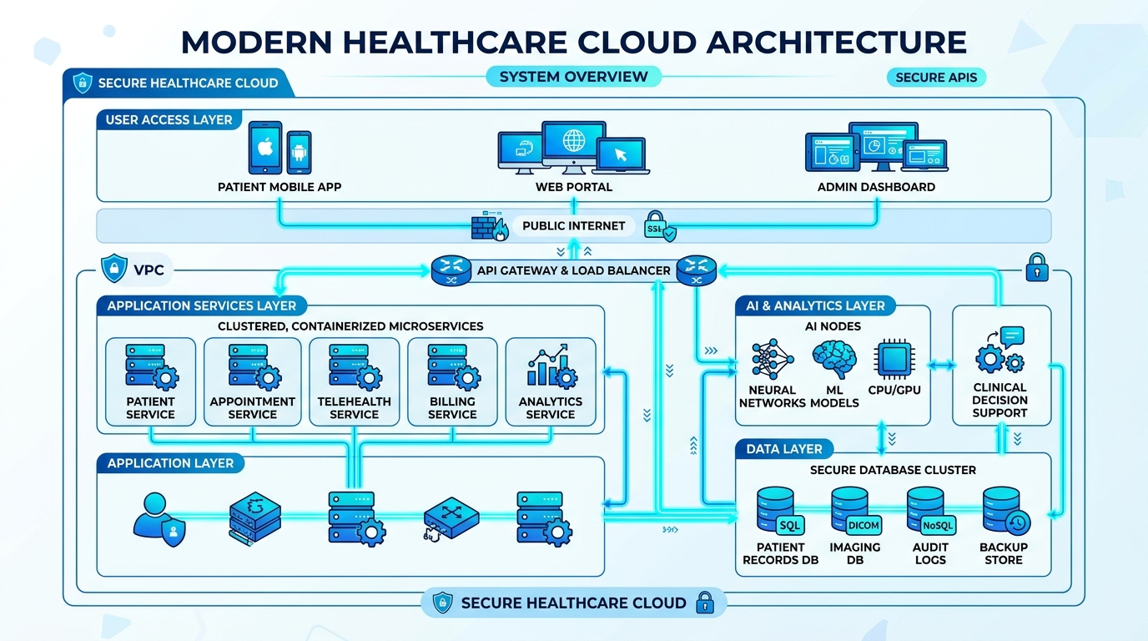

Core Operational Workflows
Secured execution paths verified in the codebase.

AI & ML Pipelines
Structured integration of deterministic models and LLMs.

1. Executive Analytics Generation
- Input:Deterministic DB aggregation (Occupancy, Footfall).
- Model:Gemini 2.5 Flash viagoogle-genai.
- Output:Strictly formatted JSON (Risks, Summary).
- Safeguard:Hardcoded JSON fallback if API is unavailable.

2. Demand Forecasting
- Input:Rolling means, days since restock, seasonality.
- Model:Ridge Regression (scikit-learn).
- Output:7-day predicted consumption.
- Action:Calculates estimated stock-out date in cache.

3. Natural Language Chatbot
- Input:User text queries.
- Processor:Groq (llama-3.3-70b) or regex rules.
- Safeguard:Strict read-only SQL generation blocklist.

4. PHC Health Score Algorithm
- Input:Live DB rows.
- Formula:30% Beds + 30% Inventory + 25% Attendance.
- Action:Real-time sorting metric for District dashboard.

Product in Action
Live on Vercel · Render · Neon

Security, Scalability & Performance
Enterprise-grade architecture applied to rural healthcare needs.

Security Architecture
- Authentication:Passwords securely hashed withbcrypt, usingHttpOnlyJWT tokens.
- Tenancy Isolation:Absolutehospital_idscoping injected dynamically into every SQL query.
- Physical Verification:Haversine GPS geofence mathematically enforces 100m proximity bounds.
- AI Safety Guards:Regex intent parsing coupled with a strict SQL blocklist guarantees read-only LLM execution.

Scalability Framework
- Stateless API Design:The FastAPI backend is entirely stateless, allowing infinite horizontal scaling on Render with automated load balancing.
- Federated Architecture:The BRICS FedAvg node aggregator deliberately prevents raw data transmission, completely bypassing central bandwidth bottlenecks and protecting data sovereignty.
- Async Processing:Complex operations like the weekly Ridge Regression ML demand forecasting are offloaded entirely to background workers viaAPSchedulercron jobs, ensuring zero impact on the critical path response times of clinical APIs.

Performance Optimization
- Database Optimization:Mission-critical Postgres columns (e.g.,patient_code,status,hospital_id) are heavily indexed using SQLAlchemy constraints, enabling microsecond querying on Neon.
- Caching Strategy:The heavy district overview dashboard endpoint is temporarily cached for 15s to absorb multi-admin spike traffic. ML inferences are pre-computed weekly and read instantly.
- Data Volume Control:CSV Bulk upload routes enforce a strict 1000-row limit with immediate memory-safe sanitization, preventing out-of-memory crashes on cheap PHC hardware.

Impact & Roadmap
From local PHC operational efficiency to BRICS-wide data sovereignty.

Fit for Today's Realities
- Ensemble AI Upgrades:Transitioning from linear Ridge Regression to complex XGBoost & LightGBM trees.
- Database Scale-Out:Postgres read replicas and geospatial sharding.
- Field Adaptability:Progressive Web App (PWA) offline-first syncing capabilities for deep rural ASHAs.
The deployed Aarogya architecture gracefully handles extreme real-world constraints inherent to rural deployments. The mathematically verified 100m Haversine geofence completely eliminates proxy attendance with zero specialized hardware. Highly-tuned Role-Based Access Control (RBAC) ensures that a PHC Pharmacist views an optimized inventory-only UI, while District Admins command the entire aggregated regional view instantaneously.

BRICS Federation AggregatorBuilt
A standalone microservice executing mathematically-proven
Federated Averaging (FedAvg)
ensures highly sensitive patient metrics never cross international borders, strictly preserving BRICS data sovereignty.

