Enr. No. : 2302030430076

Assignment : 1

[Ans 1 : ]

Step 1: Navigate to “+” -> “New repository” button to create a new repository.

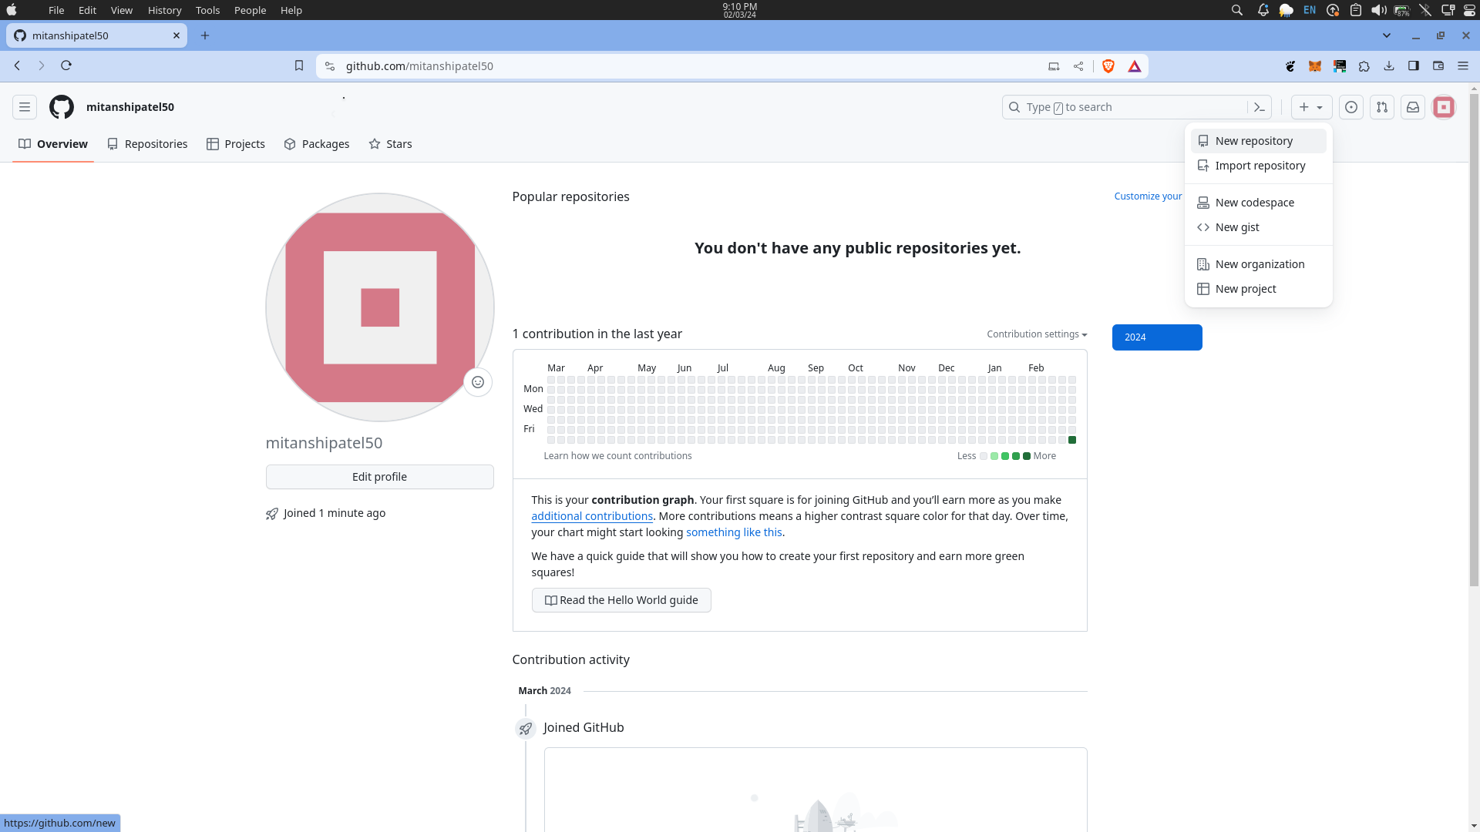

Step 2 : Give the name of the repository. Make it public or private by clicking on the given options. Add a README file if you want to. After that click on the “Create repository” button.

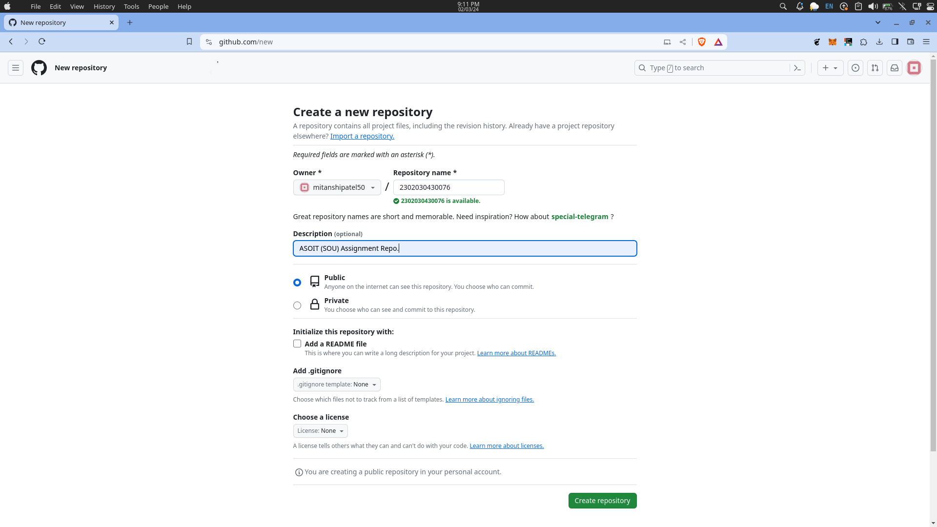

Your GitHub repository has been created successfully.

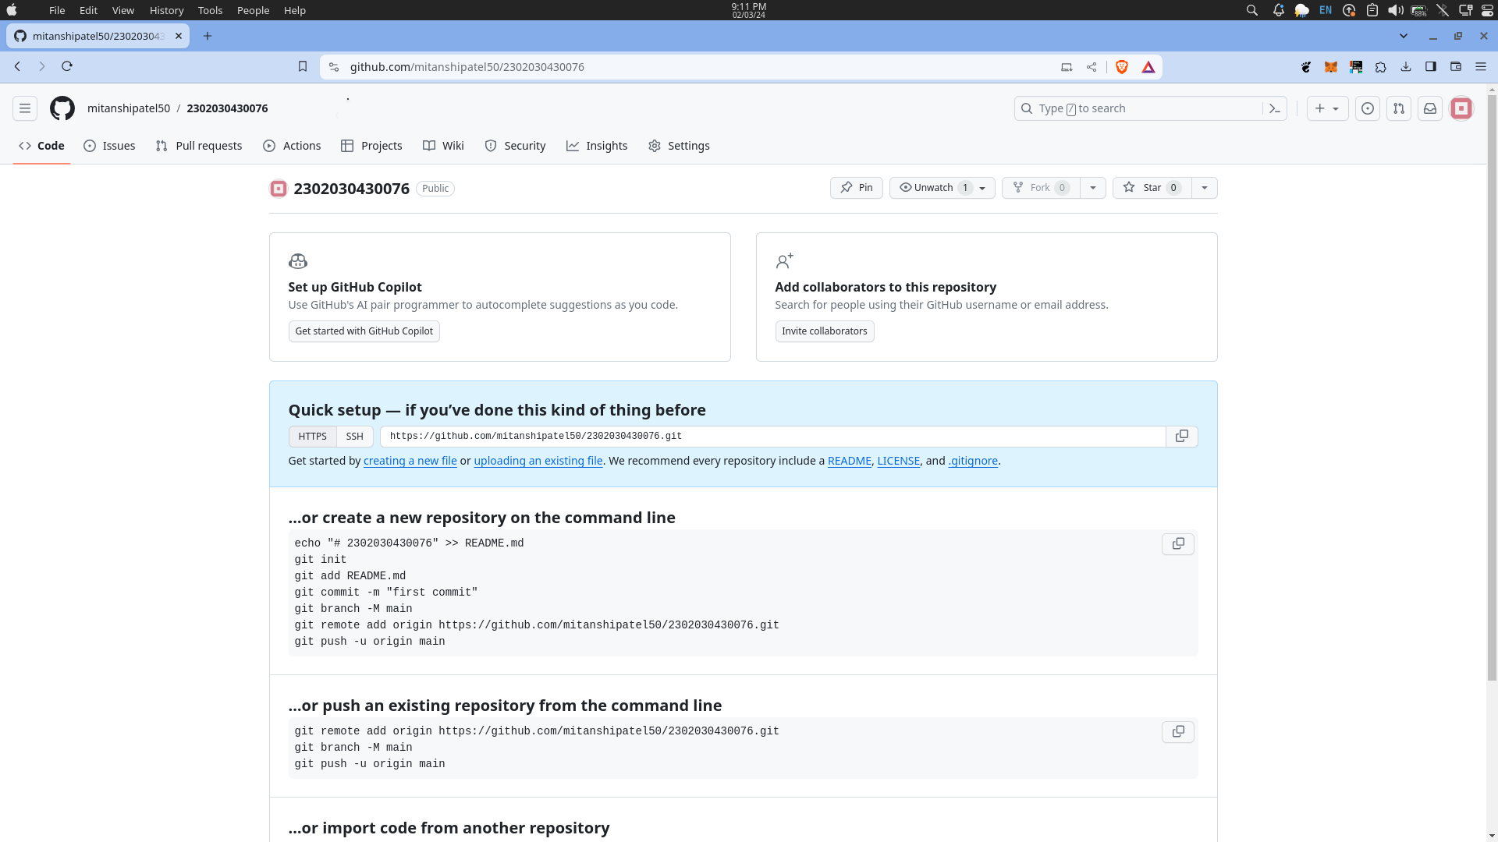

Step 3 : Scroll down and you will see the option for importing code.

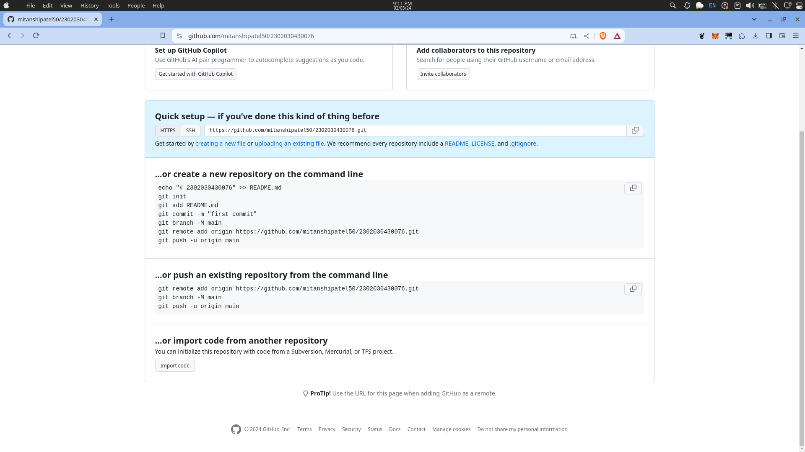

Click on “uploading an existing file” and you can start imporing the code files and folders to your REPO from your local machine or follow the commands and execute them in the terminal at the directory.

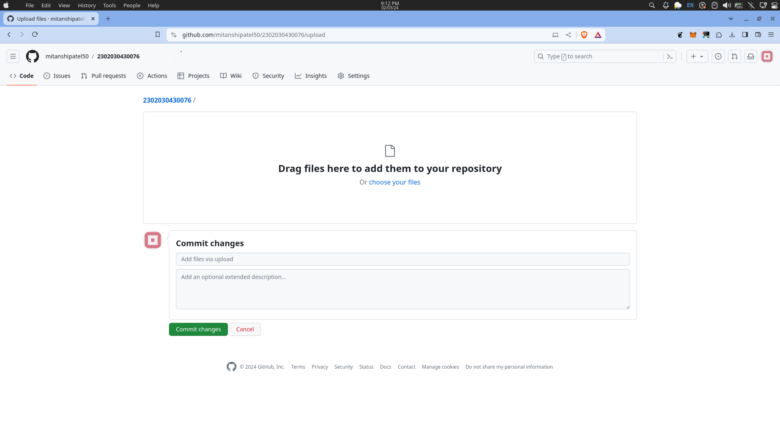

Or you can Click on “choose files” then drag and drop files or folders and upload them.

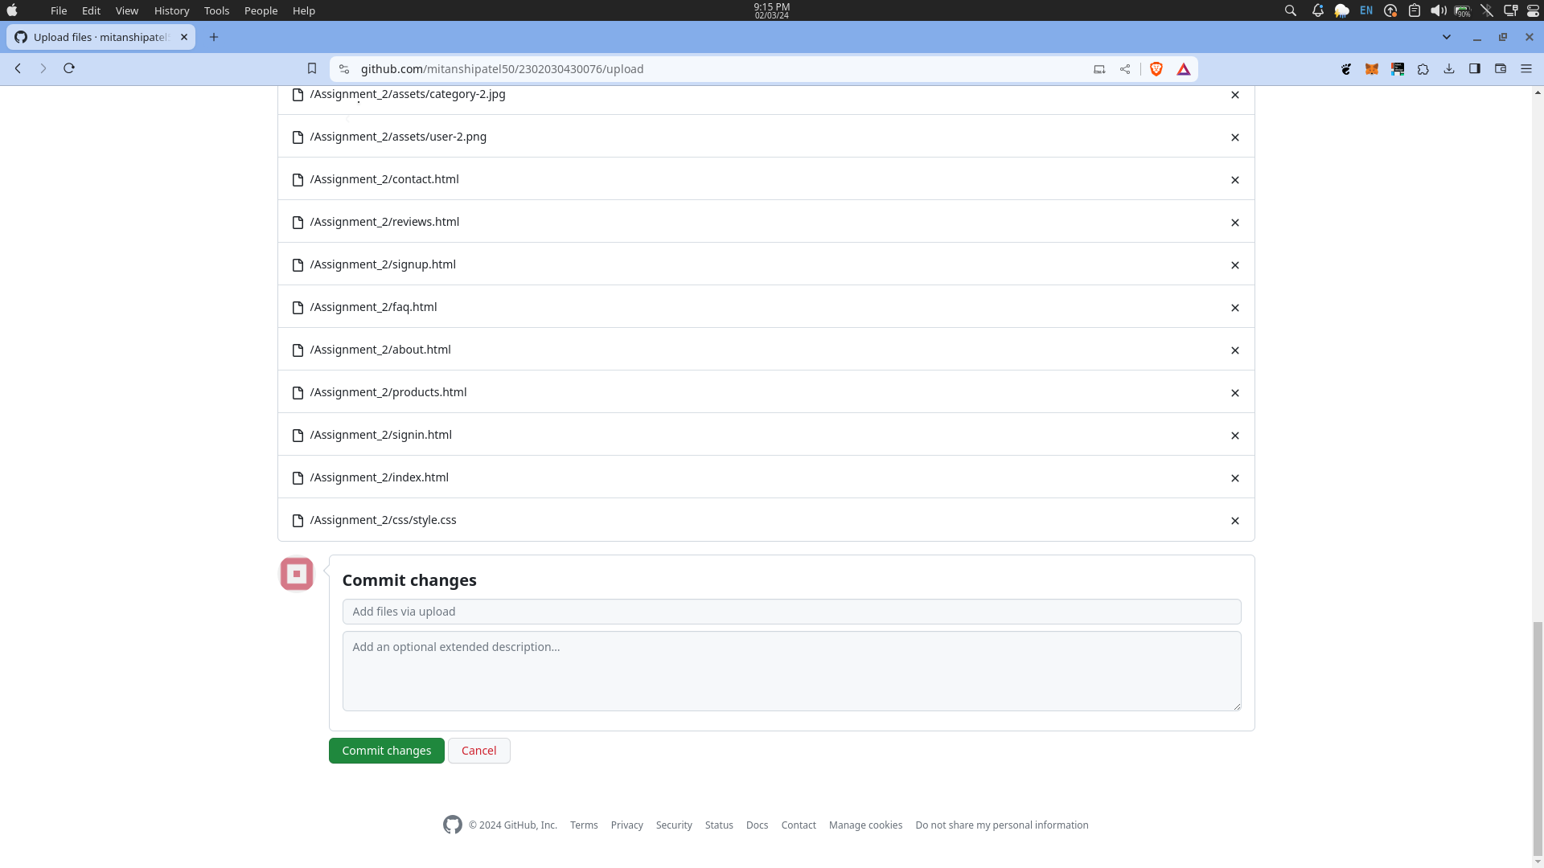

Commit the changes and your folders has been uploaded.

