Polynomial Multiplication

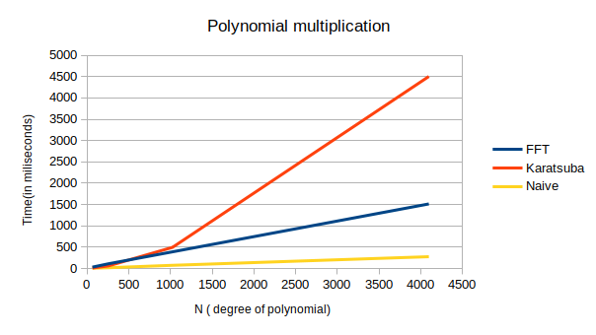

The result are opposite from expected maybe due to following reasons:
1. More number of threads (parallelism) in the naive implementation
2. Overhead in creating and maintaining extra memory in karatsuba and FFT method.

