Q21.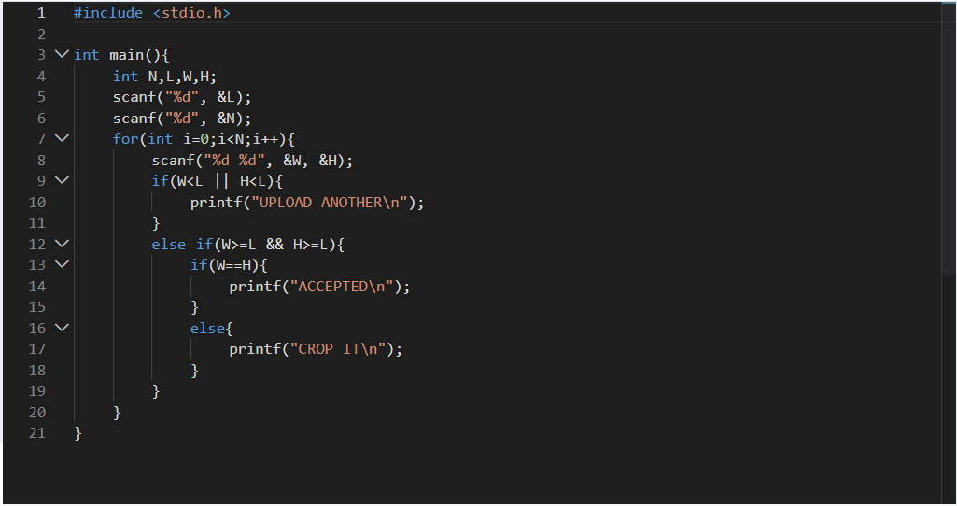
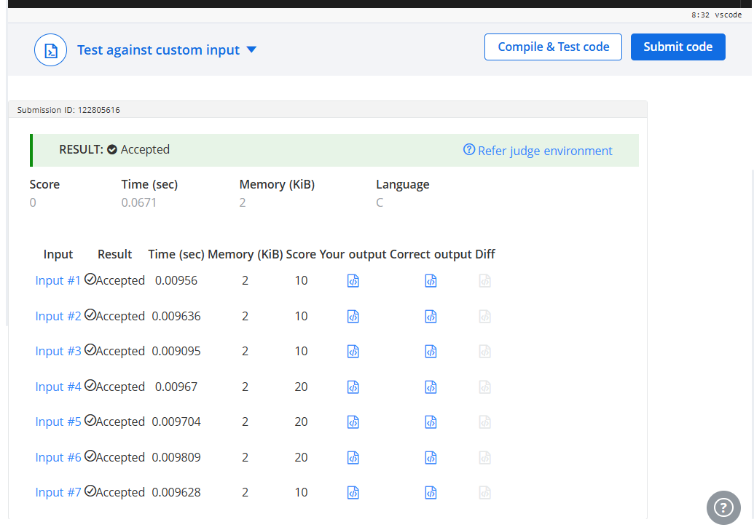

#include <stdio.h>

int main(){
int N,L,W,H;
scanf("%d", &L);
scanf("%d", &N);
for(int i=0;i<N;i++){
scanf("%d %d", &W, &H);
if(W<L || H<L){
printf("UPLOAD ANOTHER\n");
}
else if(W>=L && H>=L){
if(W==H){
printf("ACCEPTED\n");
}
else{
printf("CROP IT\n");
}
}
}
}

Q22.

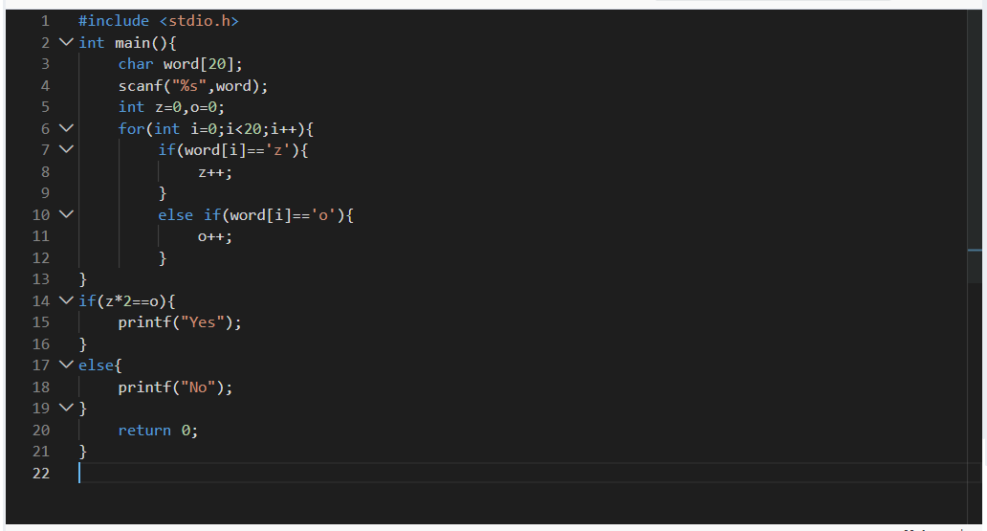
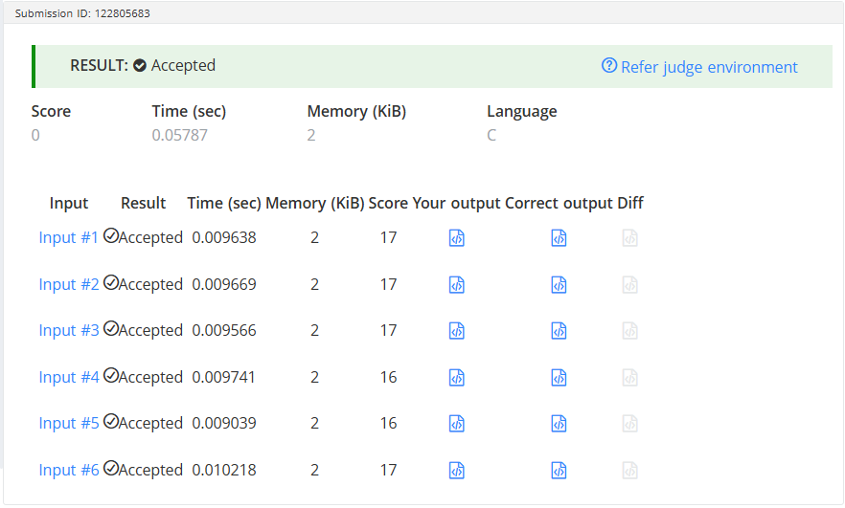
#include <stdio.h>
int main(){
char word[20];
scanf("%s",word);
int z=0,o=0;
for(int i=0;i<20;i++){
if(word[i]=='z'){
z++;
}
else if(word[i]=='o'){
o++;
}
}
if(z*2==o){
printf("Yes");
}
else{
printf("No");
}
return 0;
}

Q23. 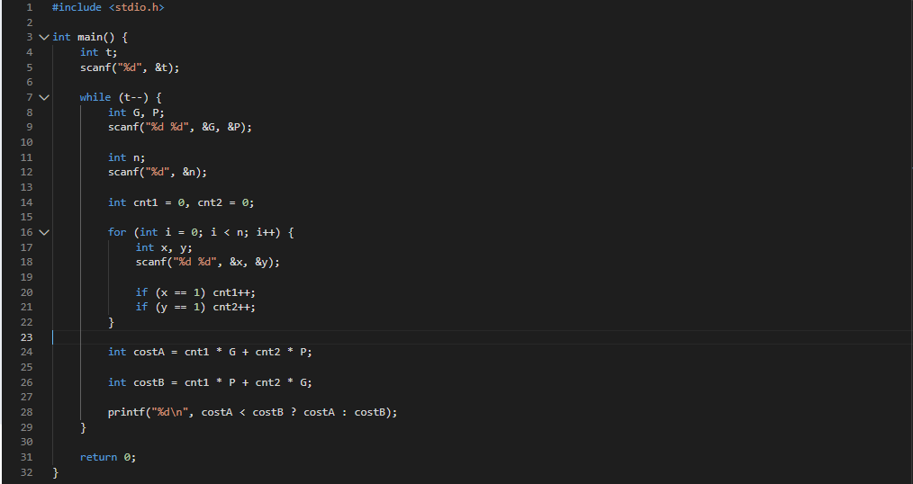
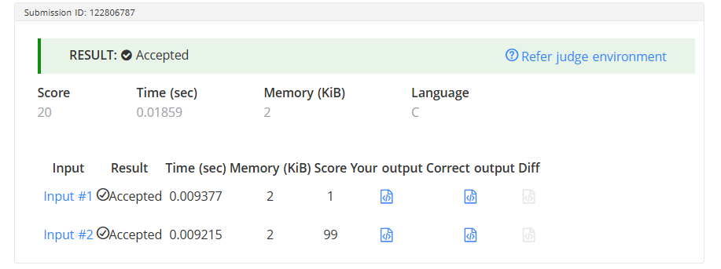
#include <stdio.h>

int main() {
int t;
scanf("%d", &t);

while (t--) {
int G, P;
scanf("%d %d", &G, &P);

int n;
scanf("%d", &n);

int cnt1 = 0, cnt2 = 0;

for (int i = 0; i < n; i++) {
int x, y;
scanf("%d %d", &x, &y);

if (x == 1) cnt1++;
if (y == 1) cnt2++;
}

int costA = cnt1 * G + cnt2 * P;

int costB = cnt1 * P + cnt2 * G;

printf("%d\n", costA < costB ? costA : costB);
}

return 0;
}

Q24.
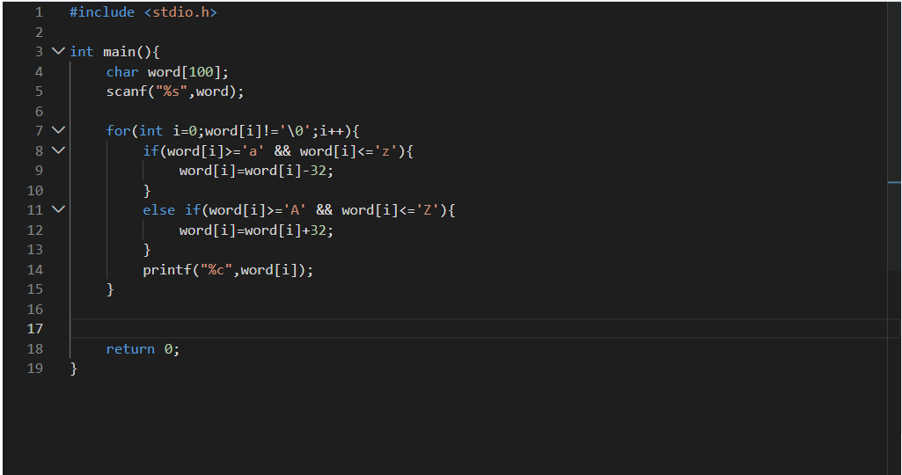
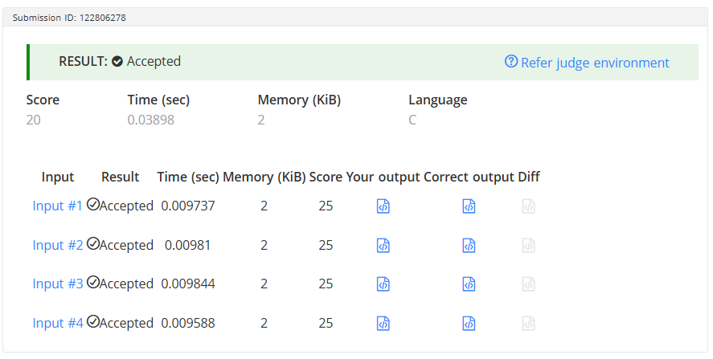
#include <stdio.h>

int main(){
char word[100];
scanf("%s",word);
for(int i=0;word[i]!='\0';i++){
if(word[i]>='a' && word[i]<='z'){
word[i]=word[i]-32;
}
else if(word[i]>='A' && word[i]<='Z'){
word[i]=word[i]+32;
}
printf("%c",word[i]);
}
return 0;
}

