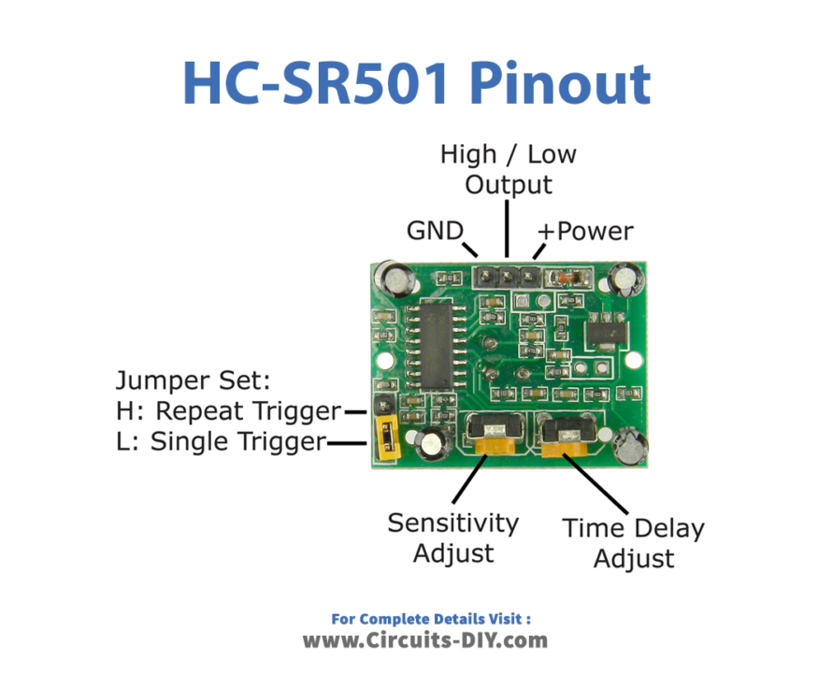

|  |  |
| --- | --- |
| HC-SR501 | Mega |
| VCC | 5volts |
| GND | GND |
| Data | Pin 2 |

|  |  |
| --- | --- |
| LED | Mega |
| Green | Pin 7 |

|  |  |
| --- | --- |
| SIM800L | Mega |
| 5VIIN (5volts) | 5volts |
| GND | GND |
| TXD | Pin 10 |
| RXD | Pin 11 |
| GND | GND |

