THE HOLLOWING OF THE
AMERICAN MIDDLE CLASS
A Comprehensive Analysis of Economic Inequality in the United States
1945 – Present

January 2026

Table of Contents

Section 1: Introduction and Scope

What Is the "Middle Class"?
When we talk about the "middle class" in America, we are not describing a fixed income bracket. Instead, we are describing an idea—the expectation that hard work should lead to a comfortable life: a home, a car, the ability to raise a family, send children to college, and retire with dignity.
For the purposes of this report, we define the middle class primarily by looking at households between the 50th and 90th percentiles of the income and wealth distribution. This encompasses households earning roughly $60,000 to $200,000 annually, though these numbers shift with inflation and geography.
More importantly, we track whether typical American households can afford the traditional markers of middle-class life: homeownership, higher education, healthcare, and upward mobility for the next generation.

What This Report Covers
This report examines economic data from 1945 to the present, focusing on:
• How wealth and income have become increasingly concentrated at the top
• The growing gap between worker productivity and worker compensation
• The explosion of executive pay relative to typical workers
• The rising cost of housing, education, and healthcare
• Changes in economic mobility—the ability to move up the ladder
• The specific policy decisions that contributed to these changes
Our goal is to present facts clearly and accessibly. We note the political party in control when major policies were enacted, but we let the data speak for itself. Readers can draw their own conclusions about causes and solutions.

How to Read the Charts
This report includes several charts and graphs. Here is a quick guide to understanding them:
Line graphs show how something has changed over time—typically decades. The horizontal axis shows years, and the vertical axis shows the measurement (dollars, percentages, etc.).
Bar charts compare different categories or time periods side by side.
The Lorenz Curve (which we will explain in detail) is a special chart that shows how equally or unequally wealth is distributed. The more it curves away from a diagonal line, the more unequal the distribution.
The Gini Coefficient is a single number that summarizes inequality: 0 means perfect equality (everyone has the same), and 1 means perfect inequality (one person has everything). Most countries fall between 0.25 and 0.60.

Section 2: The Golden Age (1945–1975)

Post-War Prosperity
The three decades following World War II represent a unique period in American economic history. The United States emerged from the war as the world's dominant industrial power, with its infrastructure intact while Europe and Japan rebuilt from rubble.
During this era, economic growth was broadly shared. From 1947 to 1973, real median family income roughly doubled. The middle 60% of households saw their incomes grow faster than the top 20%. Union membership reached its peak—nearly 35% of workers in 1954—giving ordinary workers bargaining power.
The federal minimum wage, though modest, held real purchasing power. Tax rates on the highest incomes exceeded 90% in the 1950s and remained at 70% through the 1960s. These high rates did not prevent robust economic growth; GDP expanded at an average of 3.8% annually.

What Made This Era Different
Several factors combined to create this period of shared prosperity:
Strong Unions: Collective bargaining allowed workers to negotiate for higher wages and better benefits. Even non-union workers benefited, as employers raised wages to remain competitive.
Progressive Taxation: High marginal tax rates on top earners meant that the gains from growth were redistributed through public investments in education, infrastructure, and research.
Expanding Education: The GI Bill sent millions of veterans to college, creating a more skilled workforce. Public universities remained affordable, with tuition often just a few hundred dollars per year.
Housing Programs: Federal mortgage programs made homeownership accessible to millions of families who previously could not afford it.
Regulated Finance: Banking regulations prevented excessive speculation and kept the financial sector focused on lending to productive businesses.

The CEO-Worker Relationship
In 1965, the average CEO of a major corporation earned about 21 times what a typical worker in that company earned. This ratio was seen as reasonable—executives earned significantly more, but not astronomically more, than their employees.
Importantly, during this period, worker compensation and productivity grew in tandem. When companies became more efficient, workers shared in those gains. This relationship—where rising productivity translated into rising wages—was the economic engine of middle-class prosperity.

Section 3: The Turning Point (1975–2000)

The Decoupling Begins
Something changed around 1973. Worker productivity continued to rise, but wages stopped keeping pace. Economists call this "the great decoupling"—the breaking of the historic link between how much workers produced and how much they were paid.
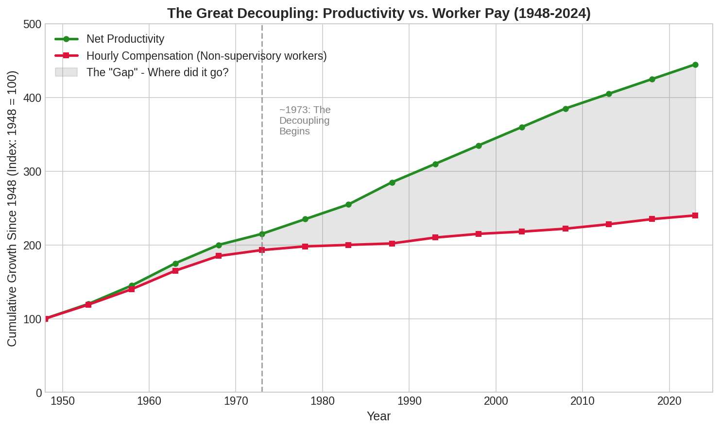
Figure 1: The Great Decoupling. After 1973, productivity continued rising while worker compensation stagnated.
From 1948 to 1973, productivity grew 96.7% while worker compensation grew 91.3%—nearly in lockstep. From 1973 to 2024, productivity grew approximately 80%, but typical worker compensation grew only about 15%. The gap between these lines represents trillions of dollars in economic gains that went somewhere other than workers' paychecks.

Where Did the Money Go?
If workers were producing more but not earning more, where did the additional value flow? The data points to several destinations:
Corporate Profits: Corporate profits as a share of national income increased substantially, particularly after 2000.
Executive Compensation: CEO pay began its explosive growth during this period. The CEO-to-worker ratio rose from 31-to-1 in 1978 to 61-to-1 in 1989 to 380-to-1 by 2000.
Shareholders: Stock buybacks and dividends returned more money to shareholders, who are disproportionately wealthy.
The Top 1%: The share of national income going to the top 1% began rising in the late 1970s and accelerated through the 1980s and 1990s.

Policy Changes in This Era

The Reagan Tax Cuts (1981 and 1986)
The Economic Recovery Tax Act of 1981 cut the top marginal tax rate from 70% to 50%. The Tax Reform Act of 1986 further reduced it to just 28%—the lowest since 1925.
Political Context: President Ronald Reagan (Republican). The Senate was controlled by Republicans (53-46) and the House by Democrats (242-192). However, both tax cuts received bipartisan support, with many Democrats voting in favor.
Impact: The immediate effect was reduced tax revenue, contributing to budget deficits. The longer-term effect was to shift the tax burden away from the highest earners. After-tax income inequality accelerated.
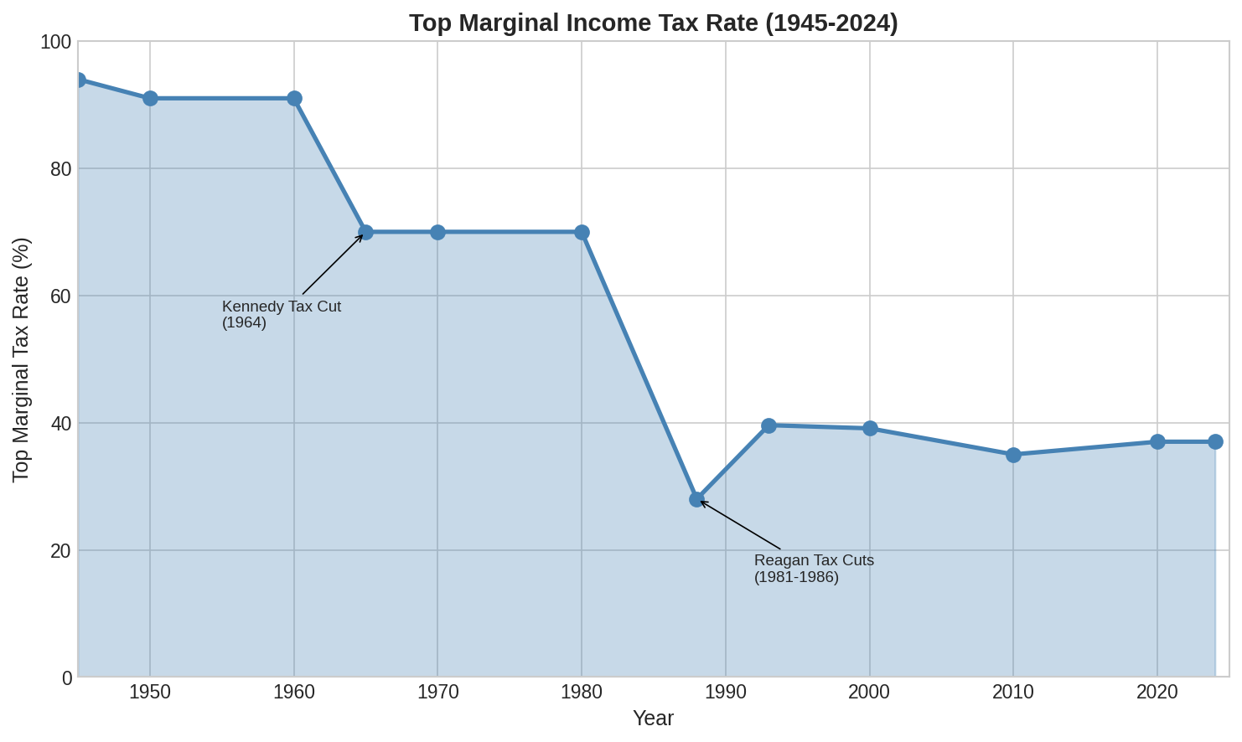
Figure 2: Top marginal tax rates fell from over 90% in the post-war era to 28% by 1988.

Union Decline Accelerates
Union membership, already declining from its 1954 peak, fell more rapidly in the 1980s. President Reagan's firing of striking air traffic controllers in 1981 signaled a new era of employer resistance to unions.
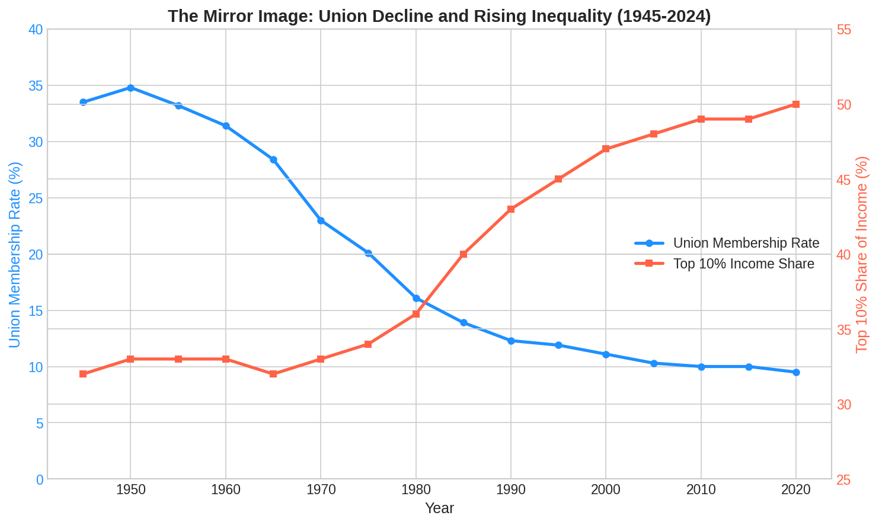
Figure 3: As union membership declined (blue line), the share of income going to the top 10% rose (red line).
The correlation between union decline and rising inequality is striking. Economists estimate that the erosion of collective bargaining explains roughly one-third of the growth in wage inequality for men since the 1970s.
Why does union membership matter? Unions compress wage differences within companies, raise wages for their members (and, through competition, for non-union workers too), and provide workers with a political voice. Their decline shifted bargaining power from labor to capital.

Section 4: Acceleration (2000–Present)

The 21st Century Gap
The trends that began in the 1970s and accelerated in the 1980s have continued into the 21st century. Several factors have intensified inequality:
Technology and Globalization: Automation and overseas manufacturing have eliminated many middle-wage jobs, creating what economists call "job polarization"—growth in high-wage and low-wage jobs, but shrinkage in the middle.
The Financial Crisis: The 2008 recession devastated middle-class wealth. Home values—the primary asset of most middle-class families—crashed. The recovery saw asset prices (stocks, real estate) rise faster than wages, benefiting those who already owned assets.
COVID-19 Pandemic: The pandemic accelerated existing trends. Remote work benefited knowledge workers while service workers faced layoffs. Stock market gains during the recovery disproportionately benefited the wealthy.

CEO Pay Reaches Historic Extremes
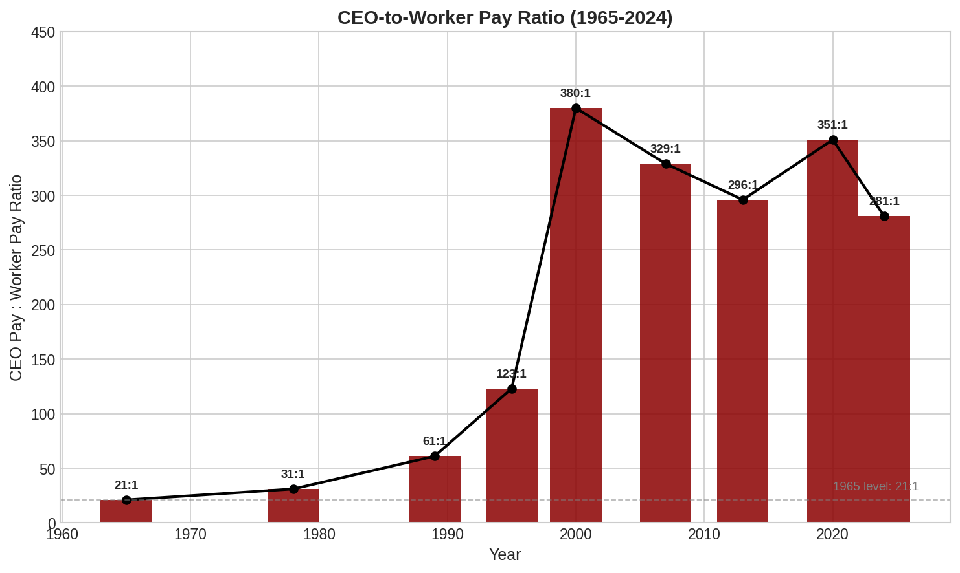
Figure 4: The CEO-to-worker pay ratio peaked at 380-to-1 in 2000 and remains above 280-to-1 today.
By 2024, the average CEO of a major corporation earned approximately $18.4 million annually—281 times the pay of a typical worker in their company. For context:
• In 1965: A CEO earned 21 times a typical worker ($15 million in today's dollars for an entire career)
• In 2024: A CEO earns that much in less than one year
CEO compensation grew 1,094% from 1978 to 2024. Typical worker compensation grew 24% over the same period. Even compared to other very high earners (the top 0.1%), CEO pay has grown far faster.

Additional Tax Cuts
Tax policy continued to favor high earners in the 21st century:
Bush Tax Cuts (2001, 2003): Reduced the top marginal rate from 39.6% to 35%, lowered capital gains taxes, and reduced estate taxes. Political context: President George W. Bush (Republican). Congress had a narrow Republican majority in both houses.
Tax Cuts and Jobs Act (2017): Reduced the top individual rate to 37% and cut the corporate rate from 35% to 21%. Political context: President Donald Trump (Republican). Congress controlled by Republicans (Senate 52-48, House 241-194).

Section 5: Deep Dive — Wealth Distribution

Who Owns America?
Wealth—the value of everything you own minus what you owe—has become dramatically concentrated. According to Federal Reserve data:
• The top 1% now holds approximately 30.5% of total U.S. household wealth ($49.2 trillion)
• The next 9% (90th-99th percentile) holds about 37.5%
• The middle 40% (50th-90th percentile) holds about 29.5%
• The bottom 50% holds just 2.5% of total wealth
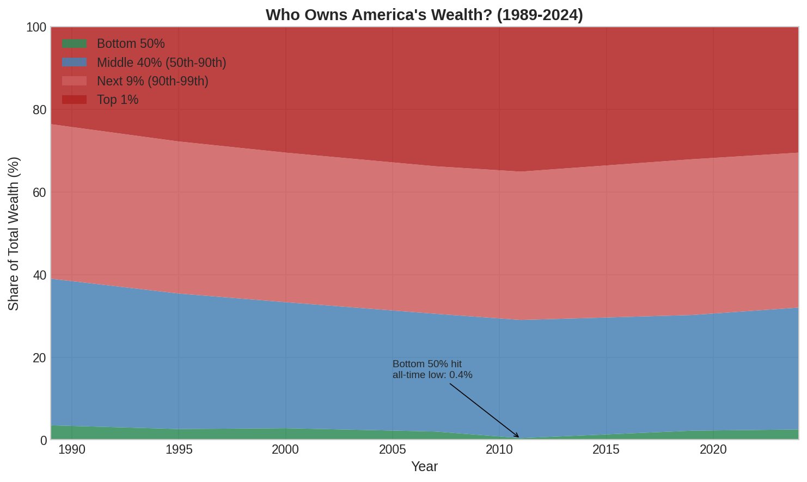
Figure 5: Wealth distribution by group from 1989-2024. The top 1% has grown while the bottom 50% has shrunk.
Put another way: The 400 wealthiest Americans now own more wealth than the bottom 150 million Americans combined.

Understanding the Lorenz Curve
The Lorenz Curve is a visual way to show inequality. Here is how to read it:
Imagine lining up all Americans from poorest to richest. The horizontal axis shows how far along that line you have gone (from 0% to 100% of the population). The vertical axis shows what percentage of total wealth you have counted so far.
If wealth were perfectly equal, this line would be diagonal—the bottom 50% would have 50% of the wealth, the bottom 90% would have 90%, and so on.
In reality, the line curves below that diagonal because poor and middle-class households own a smaller share than their population would suggest. The more it curves, the more unequal the distribution.
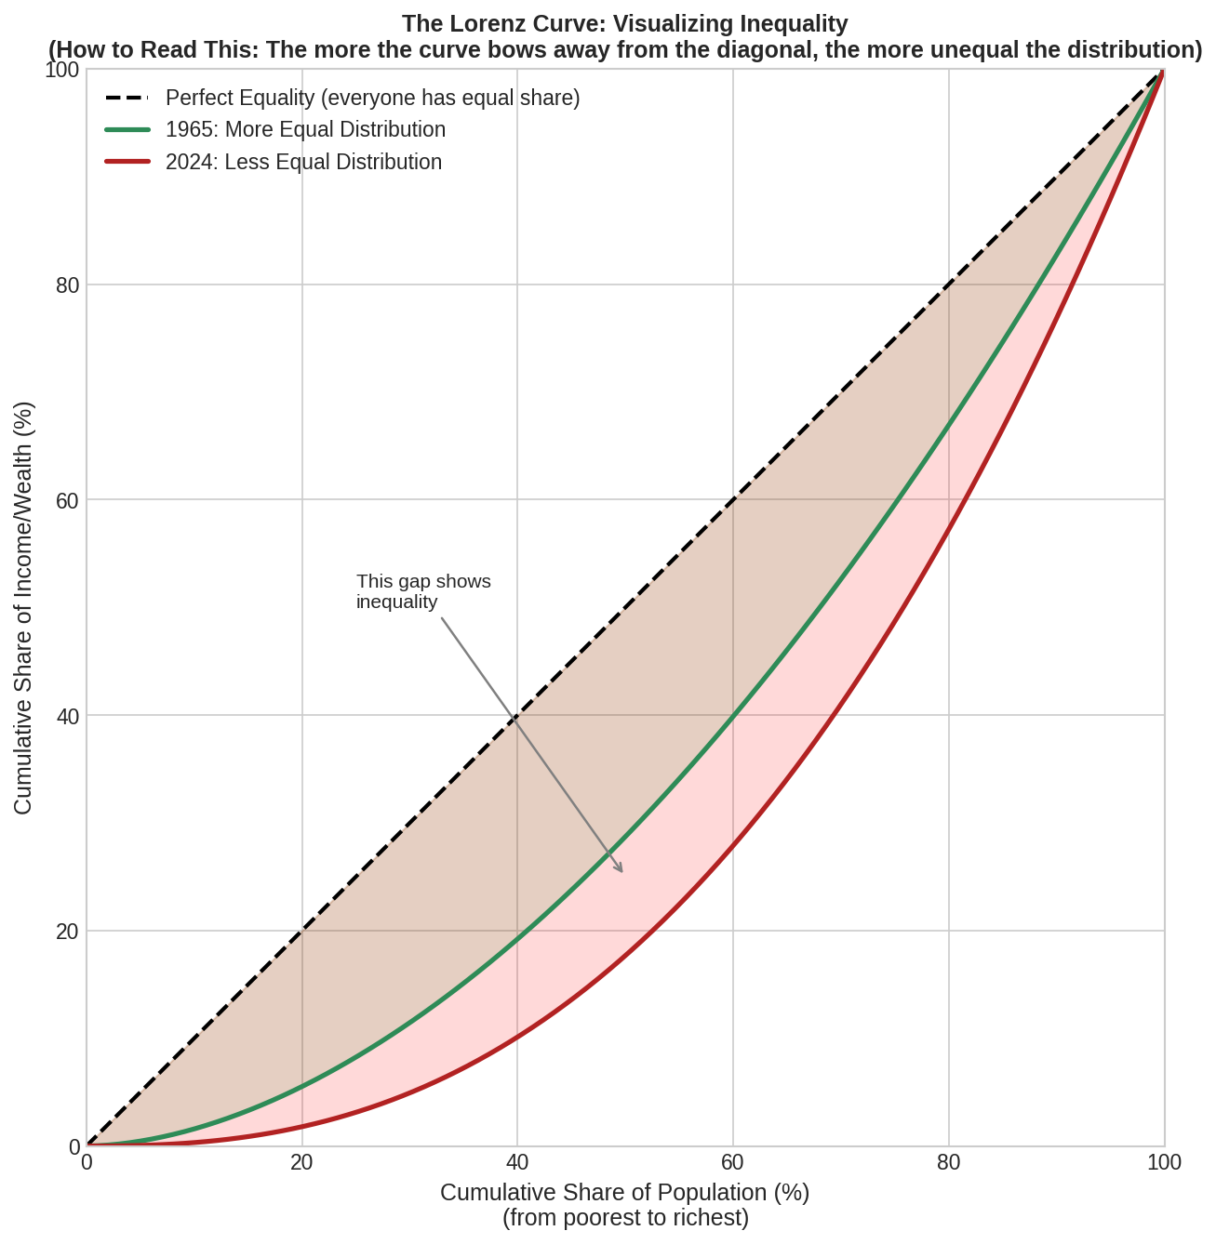
Figure 6: The Lorenz Curve shows how wealth distribution has become more unequal from 1965 to 2024.

The Gini Coefficient Explained
The Gini Coefficient condenses the Lorenz Curve into a single number between 0 and 1:
• 0 = Perfect equality (everyone has the same amount)
• 1 = Perfect inequality (one person has everything)
• Most developed countries range from 0.25 to 0.45
The U.S. Gini coefficient for income has risen from about 0.35 in 1970 to about 0.41 today. For wealth, the number is even higher—around 0.85, reflecting extreme concentration.
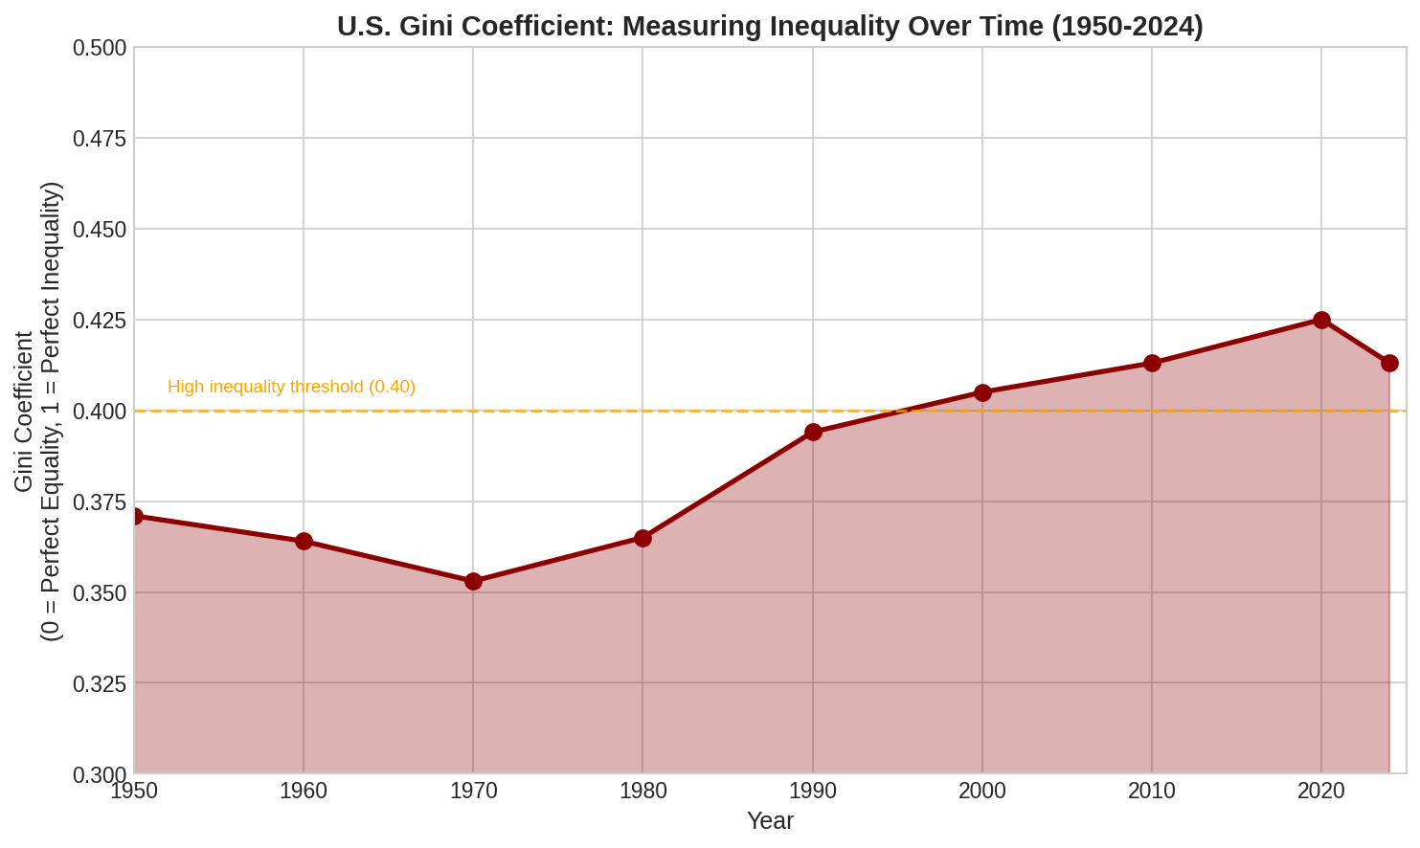
Figure 7: The U.S. Gini coefficient has risen substantially since the 1970s, indicating growing inequality.

What Different Groups Own
Not only is wealth unequally distributed in total, but different groups hold different types of assets:
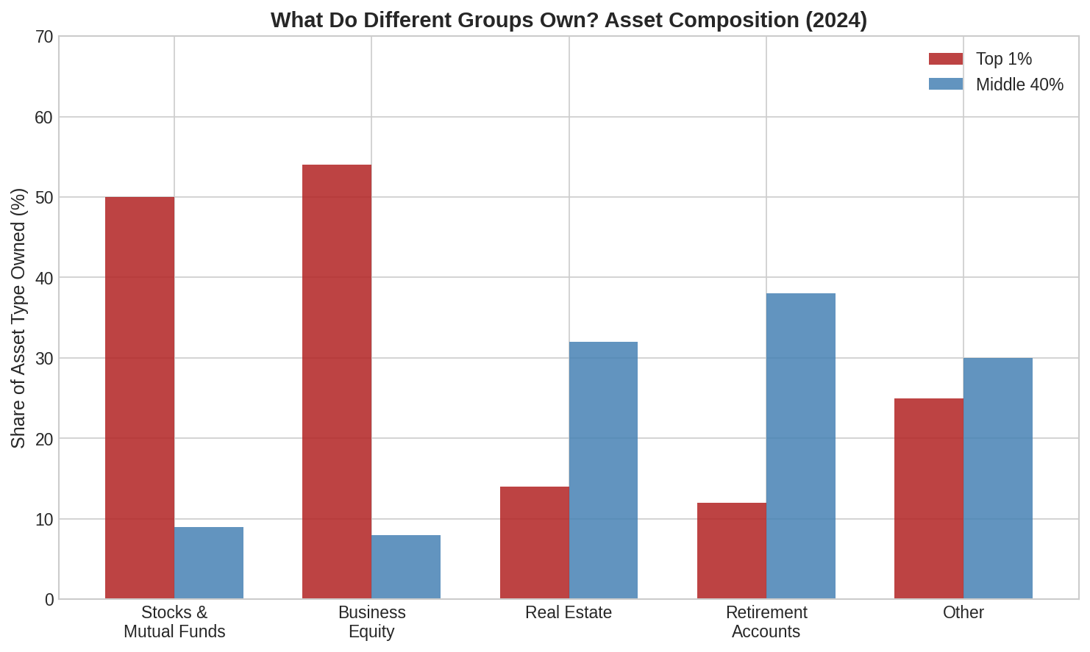
Figure 8: The top 1% owns most stocks and business equity. The middle class relies heavily on home equity and retirement accounts.
The top 1% holds about 50% of all stocks and mutual fund shares. When the stock market booms, they benefit disproportionately. Middle-class wealth is heavily concentrated in home equity—which is why the 2008 housing crash was so devastating to middle-class families.

Section 6: Deep Dive — Income and Wages

Real Wage Stagnation
While the economy has grown substantially over the past 50 years, most of that growth has not reached typical workers' paychecks.
From 1979 to 2024, real (inflation-adjusted) median weekly wages grew by only about 8-10%. That is roughly 0.2% per year—barely noticeable on an annual basis, but representing massive lost income over a lifetime.
Meanwhile, the economy (measured by GDP) grew by more than 250% over the same period. Where did that growth go?
• The top 1% of earners: Their real incomes roughly tripled
• The top 0.1%: Their incomes grew even faster
• Corporate profits: Rose from about 5% of national income to over 10%
• Capital income (dividends, interest, capital gains): Grew faster than labor income

The Minimum Wage's Lost Purchasing Power
The federal minimum wage provides a stark illustration of how policy choices affect workers.
In 1968, the minimum wage reached its peak purchasing power: $1.60 per hour, equivalent to about $14 per hour in today's dollars.
The current federal minimum wage: $7.25 per hour, unchanged since 2009.
If the minimum wage had kept pace with productivity growth since 1968, it would be over $24 per hour today. If it had kept pace with the growth in earnings of the top 1%, it would exceed $30 per hour.
Instead, a full-time minimum wage worker today earns about $15,000 per year—below the poverty line for a family of two.

Section 7: Deep Dive — The Cost of Middle-Class Life

Housing: The American Dream Deferred
Homeownership has long been central to the American Dream. But that dream has become increasingly difficult to achieve.
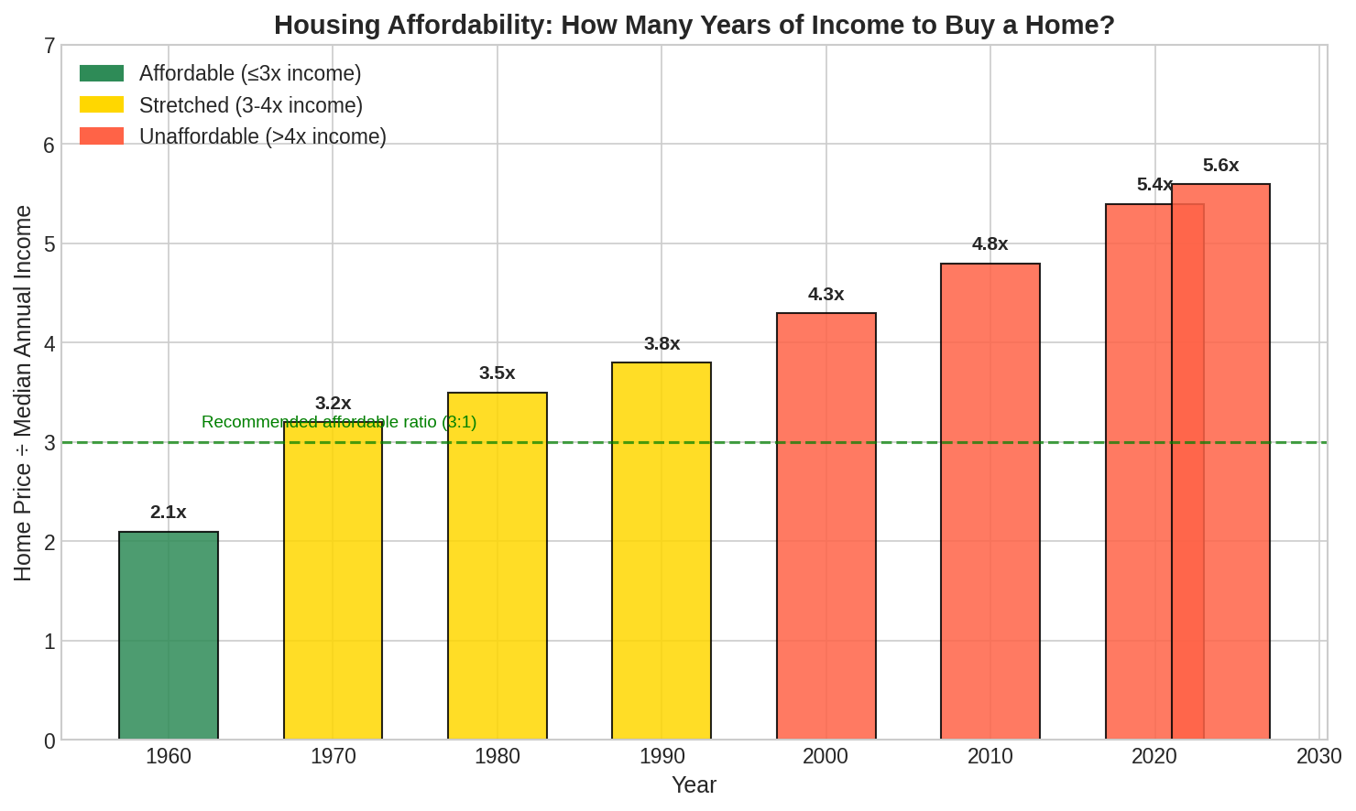
Figure 9: The ratio of home prices to median income has nearly tripled since 1960.
Key housing affordability trends:
• 1960: Median home cost 2.1 times median annual income
• 1980: Ratio rose to 3.5 times
• 2000: Ratio reached 4.3 times
• 2024: Ratio stands at 5.6 times income
A commonly cited rule suggests that housing should cost no more than 3 times annual income. By this standard, median-priced homes are now unaffordable to median-income households in most of the country.
The problem is even more severe in coastal cities: In Los Angeles, the ratio exceeds 12-to-1. In San Francisco and New York, it approaches 10-to-1.

College: From Stepping Stone to Debt Trap
Higher education was once a reliable path to the middle class. Today, it often requires taking on substantial debt.
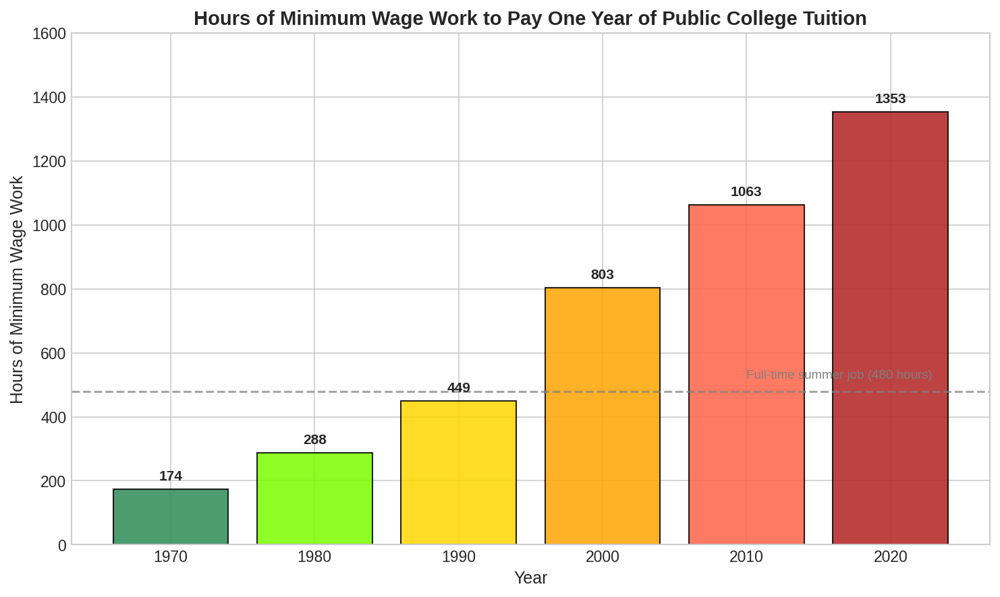
Figure 10: Hours of minimum wage work needed to pay one year of public college tuition.
The math has changed dramatically:
• 1970: 174 hours of minimum wage work paid for a year of public college tuition
• 1990: 449 hours required
• 2020: 1,353 hours required—more than a full year of 24/7 work
College tuition has increased by 1,200% since 1980. Over the same period, the Consumer Price Index rose 236%. College costs have outpaced general inflation by more than five times.
Total student loan debt now exceeds $1.75 trillion—more than credit card debt or auto loans. The average graduate carries approximately $30,000 in student loans.

Healthcare: A Growing Burden
Healthcare costs have risen even faster than education, consuming an ever-larger share of family budgets:
• 1960: Healthcare spending was 5% of GDP
• 2024: Healthcare spending exceeds 18% of GDP
For families, this means:
• Average employer-sponsored family health insurance premium: Over $23,000 annually
• Average deductible: Approximately $1,700 for individuals, higher for families
• Out-of-pocket maximums: Often $8,000 or more
Medical debt has become the leading cause of personal bankruptcy in the United States. Even families with insurance can face financial ruin from a serious illness.

Section 8: Deep Dive — Can You Still Move Up?

The American Dream in Numbers
The "American Dream" holds that anyone can succeed through hard work, regardless of their parents' wealth. How does reality compare to this ideal?
Economists measure "intergenerational mobility"—the likelihood that a child will end up in a different economic position than their parents. High mobility means the economic ladder is climbable; low mobility means your parents' status largely determines your own.
Recent research has found:
• A child born into the bottom 20% has about a 7.5% chance of reaching the top 20%
• A child born into the top 20% has about a 40% chance of staying there
• Roughly 50% of a person's income can be predicted by their parents' income
This persistence has increased over time. Americans born in the 1980s are less likely to out-earn their parents than Americans born in the 1940s.

The Great Gatsby Curve
Economist Miles Corak documented a striking pattern: countries with more inequality also have less mobility. This relationship has been called "The Great Gatsby Curve," after F. Scott Fitzgerald's novel about the gap between old money and new.
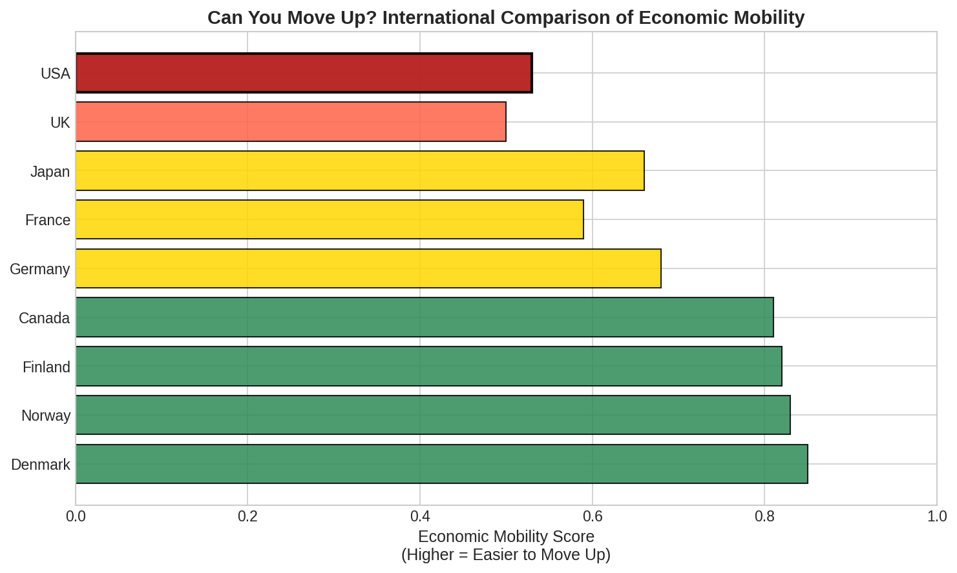
Figure 11: The U.S. ranks near the bottom of developed nations for economic mobility.
The chart compares economic mobility across developed nations. Higher scores mean it is easier to climb the economic ladder. The U.S. ranks near the bottom—below Denmark, Norway, Finland, Canada, Germany, and France.
The implications are profound: Despite America's self-image as a land of opportunity, a poor child in Denmark or Canada has a better chance of reaching the middle class than a poor child in America.

Section 9: Policy History with Political Attribution
The changes documented in this report did not happen by accident. They resulted from specific policy choices. Below we list major policies with clear effects on inequality, noting the party controlling each branch of government when they were enacted.
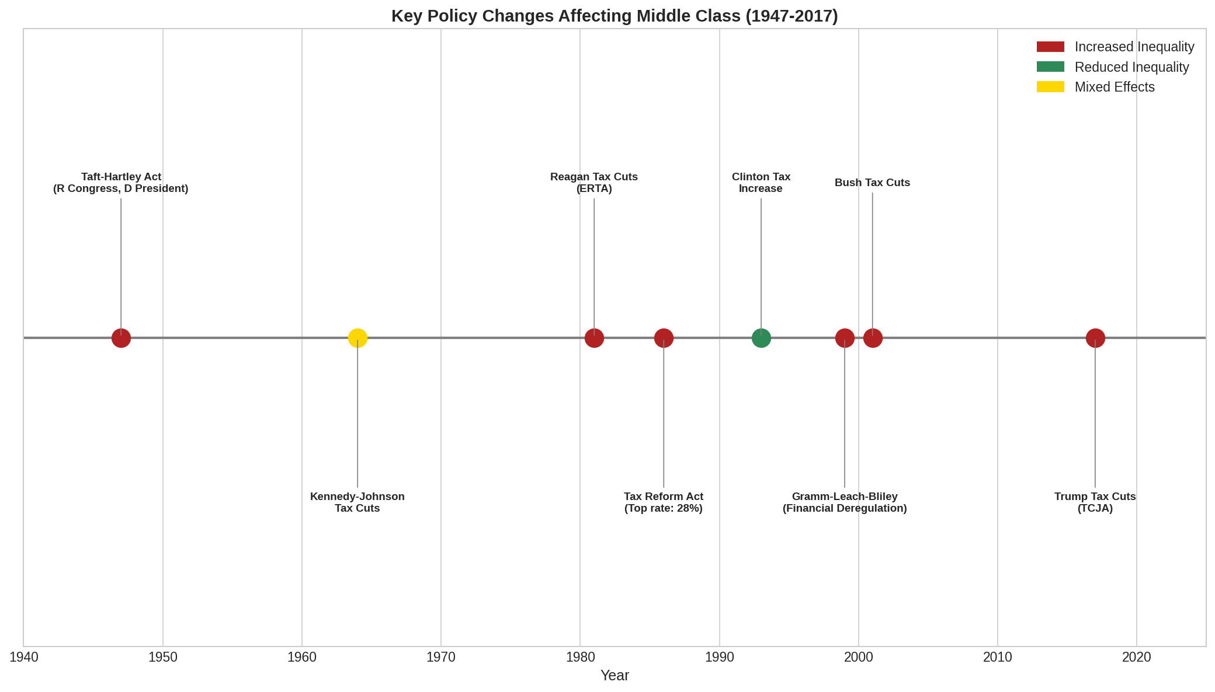
Figure 12: Timeline of major policy changes affecting economic inequality.

Detailed Policy Analysis

Taft-Hartley Act (1947)
What it did: Restricted union activities, allowed states to pass "right-to-work" laws banning mandatory union membership, and required union leaders to sign anti-communist affidavits.
Political Control: President Harry Truman (Democrat) vetoed the bill, calling it a "slave labor bill." Congress overrode his veto. House: Republican majority (246-188). Senate: Republican majority (51-45). Significant numbers of Democrats joined Republicans in the override.
Impact: Union membership peaked at 34.8% in 1954 and has declined ever since, falling to under 10% today. Economists estimate this decline explains roughly one-third of rising wage inequality among men.

Kennedy-Johnson Tax Cuts (1964)
What it did: Reduced the top marginal tax rate from 91% to 70%.
Political Control: President John F. Kennedy (Democrat) proposed the cuts; President Lyndon B. Johnson (Democrat) signed them into law. House: Democratic majority (258-176). Senate: Democratic majority (66-34).
Impact: The cuts were designed to stimulate economic growth and largely succeeded on those terms. The economy expanded, and the rate remained at 70% for nearly two decades.

Economic Recovery Tax Act (1981)
What it did: Cut the top marginal rate from 70% to 50%, reduced capital gains taxes, and indexed tax brackets to inflation.
Political Control: President Ronald Reagan (Republican). Senate: Republican majority (53-46). House: Democratic majority (242-192), but many conservative Democrats ("Boll Weevils") supported the legislation.
Impact: Combined with the 1986 reform, this began the era of dramatically lower taxes on high earners. After-tax income inequality accelerated. Federal deficits increased substantially.

Tax Reform Act (1986)
What it did: Further reduced the top rate to 28%—the lowest since 1925—while eliminating many deductions.
Political Control: President Ronald Reagan (Republican). Senate: Republican majority (53-47). House: Democratic majority (253-182). The bill received bipartisan support.
Impact: The wealthy saw their tax burden reduced significantly. The rate has never returned to pre-1981 levels.

Gramm-Leach-Bliley Act (1999)
What it did: Repealed parts of the Glass-Steagall Act, removing barriers between commercial banking, investment banking, and insurance.
Political Control: President Bill Clinton (Democrat). Senate: Republican majority (55-45). House: Republican majority (223-211). The bill received broad bipartisan support.
Impact: Contributed to financial sector consolidation and risk-taking that many economists believe helped cause the 2008 financial crisis. The crisis devastated middle-class wealth while the financial sector was bailed out.

Bush Tax Cuts (2001, 2003)
What it did: Reduced the top rate from 39.6% to 35%, cut capital gains and dividend taxes, and reduced estate taxes.
Political Control: President George W. Bush (Republican). 2001: Senate was 50-50 (Vice President Cheney broke ties). House: Republican (221-212). 2003: Senate Republican (51-48), House Republican (229-205).
Impact: Tax Policy Center estimated that 65% of the benefits went to the top 20% of earners, with 15% going to the top 1%.

Tax Cuts and Jobs Act (2017)
What it did: Reduced the top individual rate to 37%, cut the corporate rate from 35% to 21%, and temporarily reduced taxes for most individuals.
Political Control: President Donald Trump (Republican). Senate: Republican (52-48). House: Republican (241-194). No Democratic votes in either chamber.
Impact: According to the Tax Policy Center, the largest benefits went to high-income households and corporations. The corporate rate cut was permanent; individual cuts are scheduled to expire.

Section 10: Implications for Ordinary Americans

What These Numbers Mean for Families
The statistics in this report translate into daily realities for American families:
Young Adults: Face student loan debt that their parents' generation did not, housing prices that have outpaced their wages, and dimmer prospects for building wealth through homeownership.
Middle-Aged Workers: Have seen their wages stagnate while healthcare costs consumed an ever-larger share of compensation. Many have inadequate retirement savings.
Retirees: Those without pensions (most workers) depend on 401(k)s and Social Security. The stock-heavy 401(k) system benefits those with enough income to save; those without significant savings rely entirely on Social Security.
The Next Generation: Children born today face lower odds of out-earning their parents than any generation in modern American history. The economic circumstances of their parents will predict their own outcomes more strongly than in previous generations.

The Broader Social Consequences
Economic research has linked high inequality to numerous social problems:
Health Outcomes: More unequal societies have worse health outcomes across all income levels, not just for the poor.
Social Trust: Inequality correlates with lower social trust and civic engagement.
Political Influence: Concentrated wealth translates into concentrated political power, potentially creating a self-reinforcing cycle.
Economic Stability: High inequality may contribute to financial instability, as the wealthy's savings must be absorbed somewhere (often in speculative investments) while the non-wealthy must borrow to maintain living standards.

Section 11: Conclusion
The data presented in this report tells a clear story. For three decades after World War II, America built a prosperous middle class through policies that ensured economic gains were broadly shared: strong unions, progressive taxation, affordable education, and regulated finance.
Beginning in the 1970s, and accelerating in the 1980s, those policies were reversed. Union power was curtailed. Taxes on the highest earners were slashed. Educational costs soared. Financial regulations were loosened.
The results are visible in every measure of economic well-being. Wealth has concentrated at the top. Worker wages have stagnated despite rising productivity. The cost of middle-class life—housing, education, healthcare—has far outpaced income. Economic mobility has declined.
None of this was inevitable. Other developed nations made different choices and achieved different outcomes. The Nordic countries maintained strong unions and progressive taxation; they now have less inequality and more economic mobility than the United States.
The trends documented here continue to shape American life. Whether they persist, accelerate, or reverse depends on the policy choices made in the years ahead.

Appendix: Methodology and Data Sources

Primary Data Sources
This report draws on data from the following sources:
Federal Reserve Survey of Consumer Finances: The primary source for wealth distribution data. Conducted every three years, it provides detailed information on household balance sheets.
Bureau of Labor Statistics: Source for employment data, wage data, productivity statistics, and the Consumer Price Index.
U.S. Census Bureau: Source for income data, housing costs, and demographic information.
Economic Policy Institute: Source for CEO compensation data, productivity-wage comparisons, and analysis of wage trends.
Congressional Budget Office: Source for tax distribution analyses and budget projections.
World Inequality Database: Source for long-run inequality trends and international comparisons.
National Center for Education Statistics: Source for college tuition data.

Methodological Notes
Inflation Adjustments: Unless otherwise noted, dollar amounts are expressed in 2024 dollars using the Consumer Price Index (CPI-U-RS).
Wealth vs. Income: Wealth measures net worth (assets minus liabilities). Income measures annual earnings. The two are related but distinct; wealth is more concentrated than income.
Productivity: Measured as net productivity of the total economy, which accounts for depreciation.
CEO Compensation: Based on the top 350 firms by revenue, using the "realized" measure that counts stock options when exercised.
Typical Worker: Generally refers to production and non-supervisory workers, comprising about 80% of the workforce and excluding highly-paid executives.

Acknowledgment of Complexity
Economic trends have multiple causes, and reasonable people can disagree about their relative importance. This report has focused on factors where the evidence of causation is strongest, while acknowledging that globalization, technological change, demographic shifts, and cultural factors also play roles.
We have tried to present data fairly and note where there is genuine uncertainty or debate among economists. Readers are encouraged to explore the original sources and form their own conclusions.

