THE HOLLOWING OF THE AMERICAN MIDDLE CLASS
Executive Summary (1945–Present)

What Happened to the Middle Class?
For three decades after World War II, America built the largest and most prosperous middle class in history. Workers and executives shared in economic growth. A single income could support a family, buy a home, and send children to college. That era has ended.
Today, the bottom 50% of Americans own just 2.5% of the nation's wealth—down from 3.5% in 1989. Meanwhile, the top 1% has increased their share from 24% to over 30%. CEOs who once earned 21 times a typical worker's pay now earn 281 times as much. Productivity has doubled since 1973, but workers' wages have barely budged.
This report examines the data behind these changes and identifies the policy decisions that shaped them.

Key Findings

1. Wealth Has Become Dramatically Concentrated
In 2024, the top 1% of Americans hold $49.2 trillion—more than the bottom 90% combined. The middle class (50th-90th percentile) has seen its share of wealth decline from 35.5% in 1989 to about 29.5% today. The bottom 50% hit an all-time low of just 0.4% of total wealth in 2011.
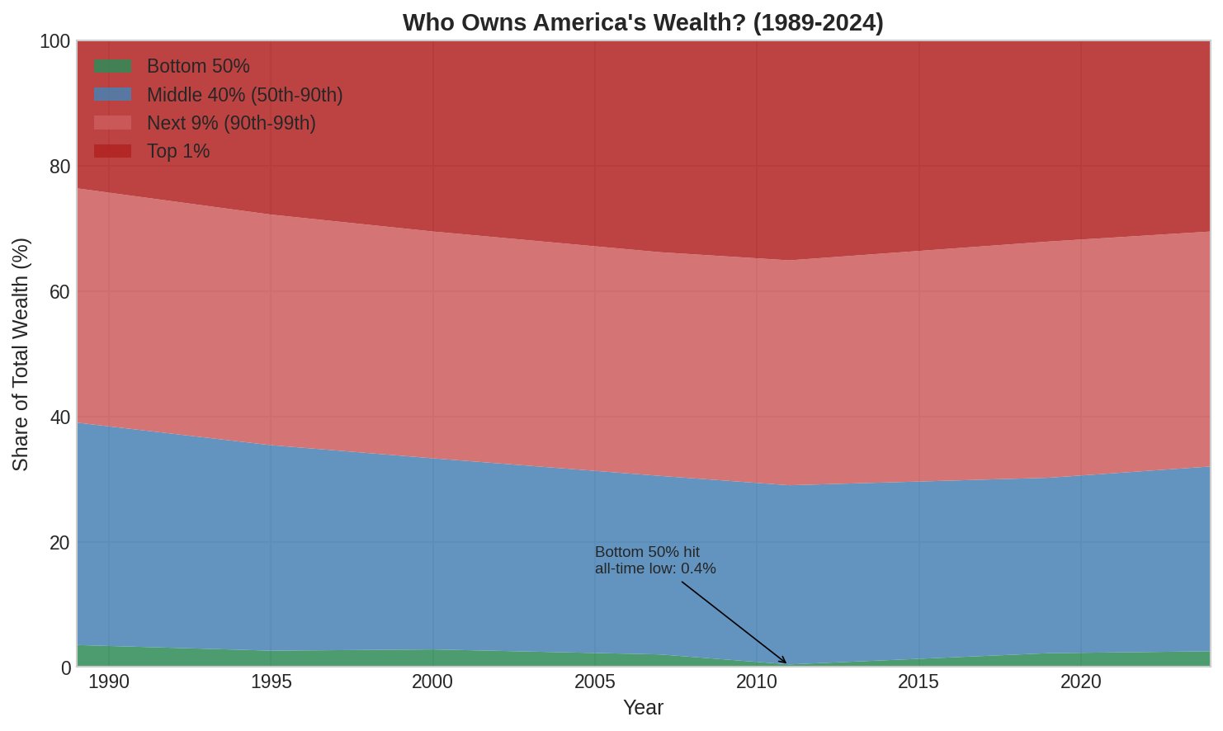

2. CEO Pay Has Exploded
In 1965, CEOs earned 21 times what their typical worker earned. By 2000, that ratio peaked at 380-to-1. Even after recent declines, the 2024 ratio stands at 281-to-1. CEO compensation grew 1,094% from 1978 to 2024, while typical worker compensation grew just 24%.
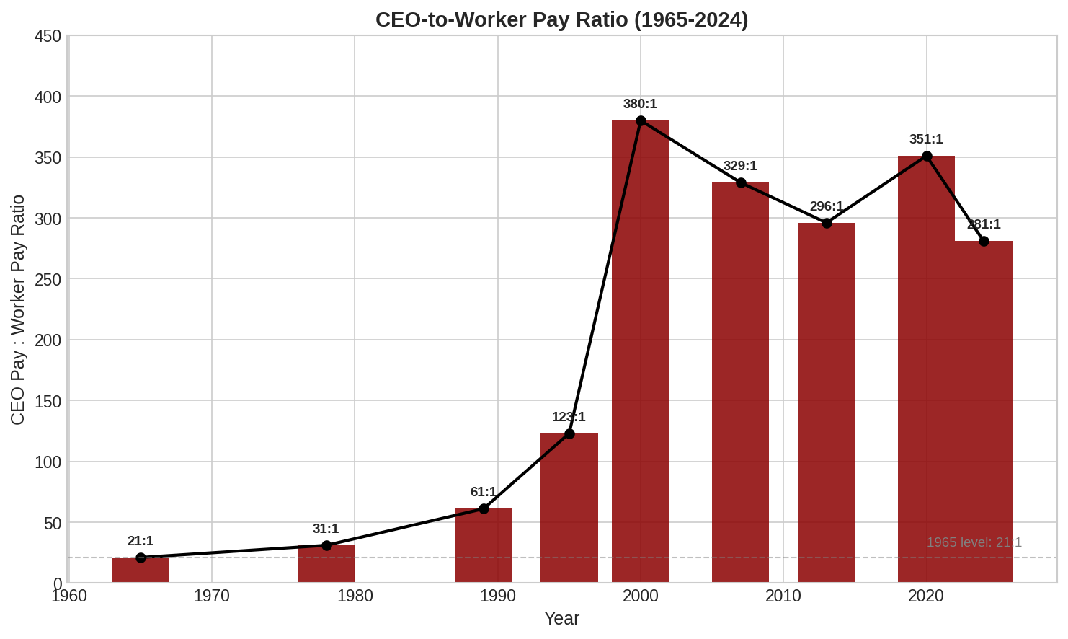

3. Workers Stopped Sharing in Productivity Gains
From 1948 to 1973, worker pay and productivity grew in lockstep—both roughly doubling. After 1973, they diverged sharply. From 1973 to 2024, productivity rose about 80%, but typical worker compensation grew only about 15%. The gains went elsewhere: to shareholders, executives, and the top of the income distribution.
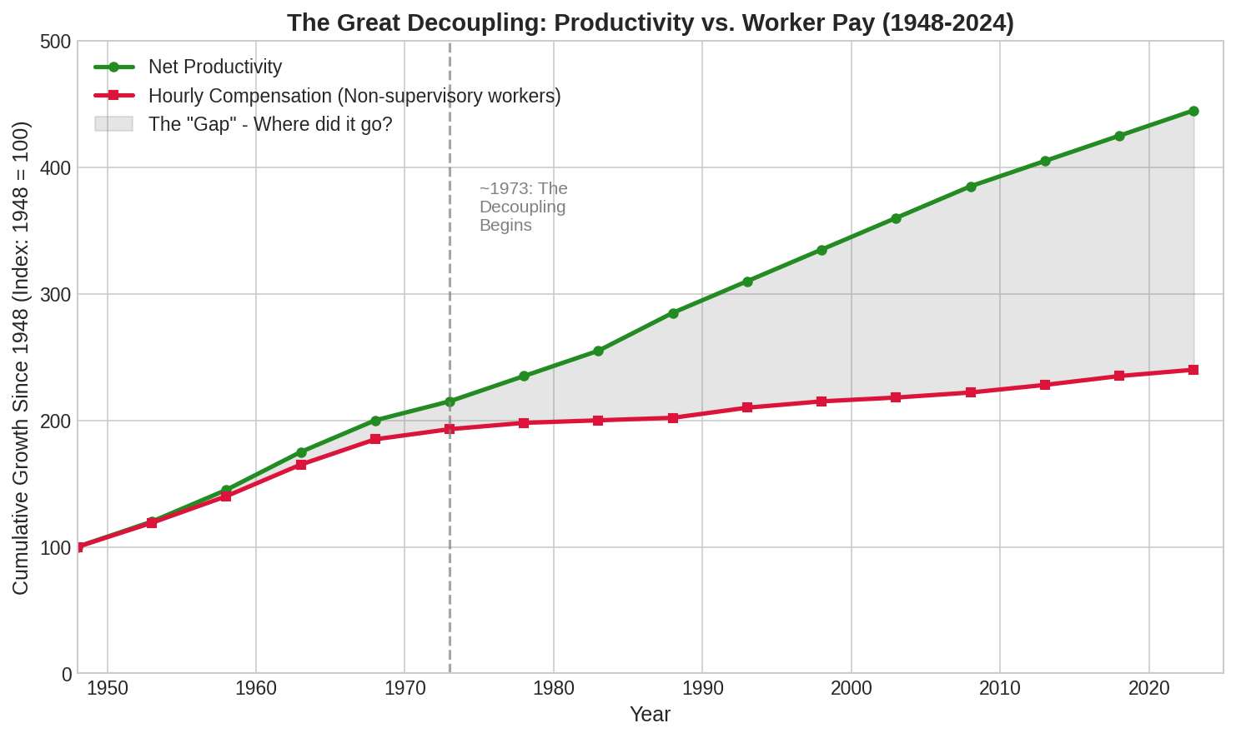

4. The Middle-Class Lifestyle Has Become Unaffordable
Housing: In 1960, a median home cost 2.1 times the median annual income. By 2024, that ratio has risen to 5.6 times—nearly three times harder to afford. College: In 1970, a summer of minimum-wage work could pay a year's tuition. Today, it covers less than a third. College costs have risen 1,200% since 1980, while wages rose 236%.
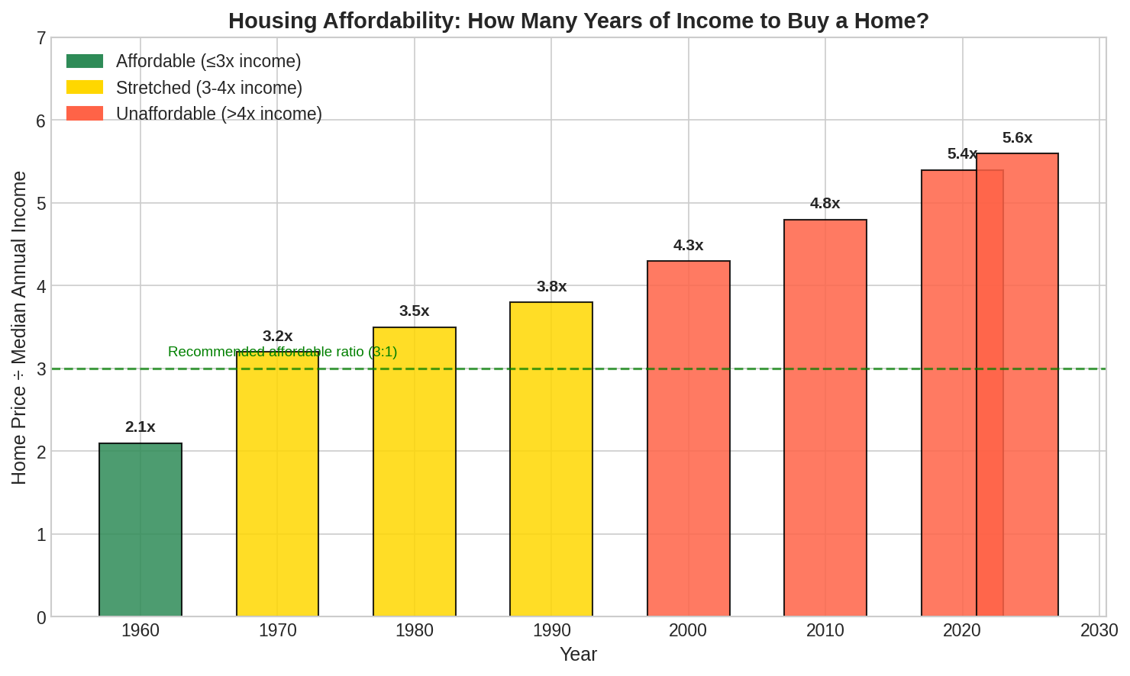

5. The American Dream Is Harder to Achieve
Despite America's self-image as a land of opportunity, the U.S. now ranks near the bottom among developed nations for economic mobility. A child born poor in Denmark is more likely to reach the middle class than a child born poor in America. The "Great Gatsby Curve" shows that high inequality correlates with low mobility—and America sits at the wrong end of both measures.
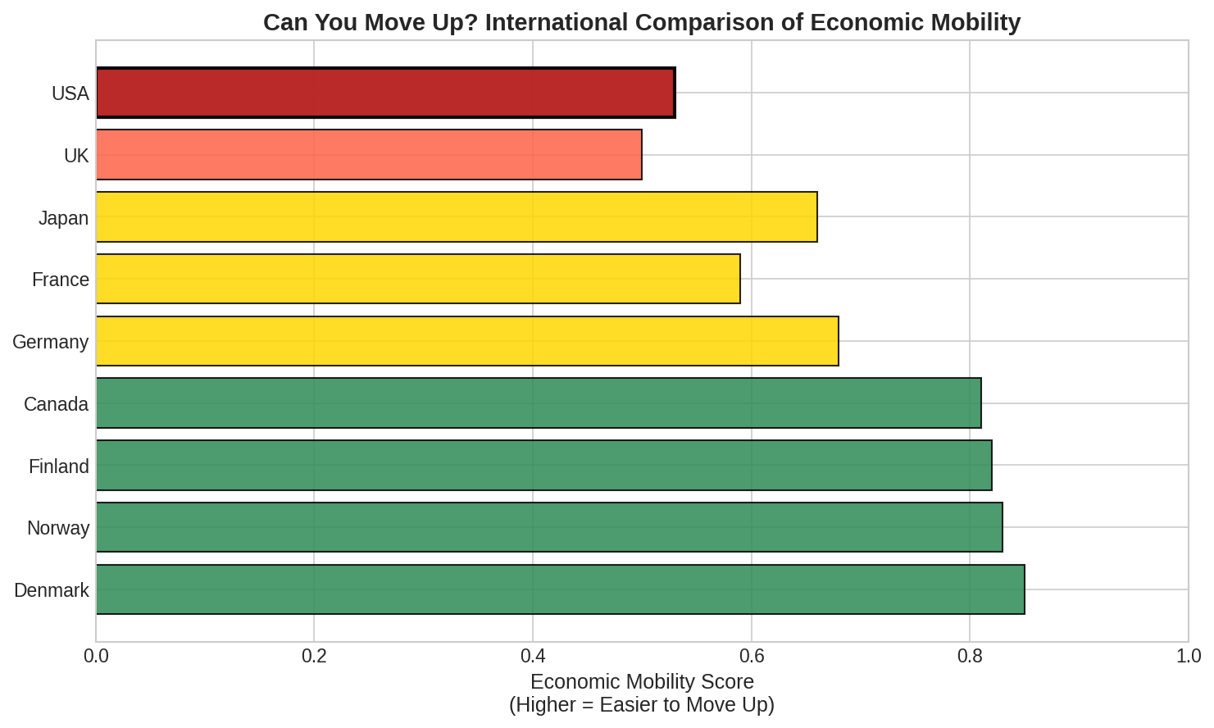

What Caused This?
Several major policy changes contributed to rising inequality:
Year | Policy | Impact
1947 | Taft-Hartley Act | Restricted union organizing; began union decline from 35% to 10%
1981-86 | Reagan Tax Cuts | Top rate dropped from 70% to 28%—lowest since 1925
1999 | Financial Deregulation | Removed barriers between banking and securities
2001-17 | Further Tax Cuts | Bush and Trump cuts further benefited top earners

What This Means
The data tells a clear story: the economic gains of the past 50 years have flowed overwhelmingly to the top. The middle class has shrunk, not because of inevitable economic forces, but as a result of policy choices. Union protections were weakened. Tax rates on the highest earners were slashed. The minimum wage lost purchasing power. Educational costs soared while public investment declined.
The consequences are profound: declining economic mobility, growing wealth concentration, and a generation facing dimmer prospects than their parents. Whether these trends continue—or reverse—depends on the policies chosen in the years ahead.
Data Sources: Federal Reserve Survey of Consumer Finances, Bureau of Labor Statistics, Economic Policy Institute, Congressional Budget Office, U.S. Census Bureau, World Inequality Database.

